EXAM 1 Advanced Update 2020- ko video chữa đề
Câu hỏi 1
You want to test a new e-commerce application using exploratory testing. Which of the following would be a good charter to use to guide the testing of a particular element of the software?
a.
Purchase a variety of items using valid and invalid credit and debit cards
b.
Log in and buy some items.
c.
Log in, search, buy items, remove some from the shopping cart, buy more
d.
Test the e-commerce application by emulating a user

Đáp án: A

Lời giải: sử dụng exploratory testing thì phải dùng kinh nghiệm và kết hợp của nhiều thứ với nhau mới tìm ra lỗi khác được, ví dụ nhiều action, nhiều điều kiện, nhiều data khác nhau

Câu hỏi 2
For a tax system the earnings 1.000 are tax free, the add more 2.500 are charged at 10%, the add more 25.000 at 20% and the remainder above 40%. All values are rounded to 1. What test case could result from a boundary value analysis?
a.
1500
b.
3501
c.
4499
d.
28001

Đáp án: B

Câu hỏi 3
You have A use case: 1. Returning user logs into the application. 1A. User is new and decides to create an account 1B. User creates account and is returned to login 2. User selects calendar duration (6, 12 or 18 months) 3. User selects standard day captions 3A. User chooses custom day captions 3B. User is taken to other application to define captions 3C. After captions defined, user is returned 4 User selects standard pictures 4A. User chooses custom pictures 4B. User is taken to other application to upload pictures 4C. After pictures are uploaded, user is returned 5. User enters shipping information 6. User purchases calendar 6A. User cancels purchase 7. User exits You have tested the following:1, 2, 3, 4a, 4b, 4c, 5, 6, 7 1, 2, 3a, 3b, 3c, 4, 5, 6, 7 What level of coverage?
a.
40% of minimum coverage
b.
50% of minimum coverage
c.
80% of minimum coverage
d.
100% of minimum coverage

Đáp án: A

Lời giải: 1 case cho luồng basic flow, 4 case mỗi case cho 1 TH exception. Tổng cần 5 case để đi hết 100%, Đề bài mới cho 2 case nên ta có 2/5=40%

Câu hỏi 4
To address reliability, a number of measurement will be taken throughout the development and testing process. Select TWO appropriate measures that are typically taken as part of reliability engineering and/or testing of an application
a.
Define Operational Profiles
b.
State Transition Testing
c.
Usability testing
d.
Perform design FMEAs
e.
Exploratory test

Đáp án: A,D

Lời giải: Cái này tra thêm sách Vol 1 Chapter 5 có nói về việc dựa vào Define Operational Profiles lịch sử vận hành của các hệ thống để đưa ra yêu cầu cho test reliability

Câu hỏi 5
You have received the following use case steps: 1. Returning user logs into the application. 1A. User is new and decides to create an account 1B. User creates accountand is returned to login 2. User selects calendar duration (6, 12 or 18 months) 3. User selects standard day captions 3A. User chooses custom day captions 3B. User is taken to other application to define captions 3C. After captions defined, user is returned 4. User selects standard pictures 4A. User chooses custom pictures 4B. User is taken to other application to upload pictures 4C. After pictures are uploaded, user is returned 5. User enters shipping information 6. User purchases calendar 6A.User cancels purchase 7. User exits What is the minimum number of test cases needed to test this use case?
a.
2
b.
4
c.
5
d.
7

Đáp án: C

Lời giải: 1 case cho luồng basic flow, 4 case mỗi case cho 1 TH exception. Tổng cần 5 case để đi hết 100%

Câu hỏi 6
You are testing an e-commerce application and are concentrating on testing the handling of debit and credit cards. Of particular interest is the handling of purchases that exceed or meet the credit card or debit card limit. There have been a number of defects documented regarding purchases that exceeded the limit on the card. Which of the following is the best set of techniques to use for this situation?
a.
Boundary value analysis and domain analysis.
b.
State transition diagrams and decision tables.
c.
Cause-effect diagrams and boundary value analysis
d.
Error guessing and checklist-based testing

Đáp án: A

Lời giải: dựa vào "exceeded the limit on the card." thì đã ra kỹ thuật BVA ( hoặc domain test cũng là gợi ý test giới hạn IN, ON, OUT, OFF)

Câu hỏi 7
Analyzing the requirement, "The system shall allow cash advances of at least 200 Euros for all supported credit cards. The correct list of credit cards is American Express, Diners, VISA, Mastercard and Eurocard." There are arguments to be made for several test design techniques. Which of the following test design techniques is MOST likely to be used for identifying test cases for the requirement?
a.
Boundary value analysis
b.
Equivalence Partitioning
c.
Classification Tree Method
d.
State Transition Testing

Đáp án: B

Lời giải: Requirement này là test 5 card và ít nhất 200 Euros thì chỉ có EP là phù hợp

Câu hỏi 8
Which of the following proposals best supports the given scenario?
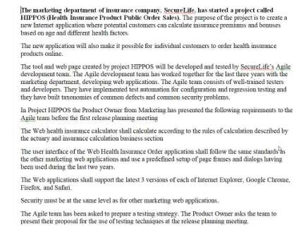
a.
Defect base testing
b.
Exploratory testing and defect-based testing
c.
Exploratory testing
d.
State Transition Testing

Đáp án: B

Lời giải: chapter 5. Test security chỉ có dựa vào past defect là hợp lý, ngoài ra team này làm theo Agile nên cần có thêm exploratory testing

Câu hỏi 9
I. Consultative test strategy II. Reactive test strategy III. Analytical test strategy IV. Process-compliant test strategy Consider also the following examples of test activities: 1. Prioritize the test cases, based on the results of a FMEA analysis, to ensure early coverage of the most important areas and discovery of the most important defects during test execution 2. Execute usability testing driven by the guidance of a sample of users (external to the test team) 3. Perform exploratory testing sessions throughout the system test phase 4. On an Agile project, execute tests that cover the test conditions identified for each user story of a feature planned for an iteration Which of the following correctly matches each test strategy with an appropriate example?
a.
I-2; II-3; III-4; IV-1
b.
I-3; II-2; III-1; IV-4
c.
I-1; II-2; III-3; IV-4
d.
I-2; II-3; III-1; IV-4

Đáp án: D

Lời giải: refer 2.2.1 Test plan, 7 cái chiến lược test. 1. có FMEA là risk based nên đi với III, 2. có guidance of users nên đi với I, 3 có exploratory testing nên đi với II, 4 có Agile đi với IV

Câu hỏi 10
A new banking system has 2 customers' types, 2 account types and will operate in two different countries? How many test cases will be needed using the pair wise testing technique and the appropriate 2-wise orthogonal array?
a.
2
b.
4
c.
5
d.
8

Đáp án: B

Lời giải: 2x2 là cặp lớn nhất

Câu hỏi 11
An organisation has already implemented a static analysis tool and is considering whether code reviews would have any added value. Which of the following defect types can only be found by means of code reviews?
a.
Conformance to coding standards
b.
Conformance to design
c.
Endless loop
d.
Cyclomatic complexity too high

Đáp án: B

Lời giải: Câu này dễ nhầm nè: code reviews là hoạt động này tôi sẽ chọn Conformance to design vì review chủ yếu dựa vào tài liệu. Có một câu khác đổi câu hỏi là static analysis tool thì mới chọn Conformance to coding standards ( phải tool mới làm đc điều này, manual không thể)

Câu hỏi 12
To support code review, a checklist will be developed. Which TWO question from list would you implement as part of code review checklist?
a.
Are any magic numbers ( numberic literals) used, other than 0 and 1?
b.
Can each item be implemented with the techinques, tools and resources available?
c.
Is it possible during the acceptance test to verify whether the item has been satisfied?
d.
Is the item specific in an exact, unambiguous way?
e.
Is there any logic containing no statements and no explanation as to why it is empty?

Đáp án: A,E

Lời giải: refer checklist review code trong syllabus của TTA nhé

Câu hỏi 13
A test team is keeping logs of the incidents that thay observe. They use a commonly- available word processor to write the incident reports in individual file. Which are held in shared storage. They track the incidents along with some incident details, in a spreadsheet. You have now also been given the task to identify the key fields for logging the incident reports. So far the following fields have been in use in the Excel sheet: -Incident description -Date -Author -State Which of the following would you recommend as the best combination of fields to add?
a.
Priority, version of software under test, incident identification
b.
Date to be fixed, priority, incident identification
c.
Developer assigned to the fix, version of software under test, incident identification
d.
Priority, version of software under test, date to be fixed

Đáp án: A

Lời giải: refer 7.2.2 Defect Report Fields. vì họ làm excel nền phải thêm cột ID ( nếu log vào tool cột này đã tự động), A được nhiều thông quan trọng nhất

Câu hỏi 14
Give is the following defect removal chart reported at the end of system tessing- showing total defects detected and closed defects (fixed and successully retested..) A number of open defects are classified as critical. All tests have been executed. Based on the chart above, what is the most appropriate next test phase?
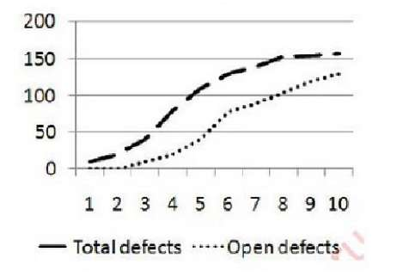
a.
Acceptance testing to verify the business process
b.
Acceptance testing to verify operational requirements
c.
Requirements testing as part of testing regulatory compliance
d.
Another system test cycle to verify defect resolution

Đáp án: D

Lời giải: Cái báo cáo đó chỉ ra lỗi vẫn còn open, all test case đã chạy hết rồi nhưng chưa có tỉ lệ pass, fail. Cần thêm vòng test nữa chứ ko kết thúc đc bây giờ

Câu hỏi 15
Explain how the above mentioned report may differ from a report that you produce for the project manager, who is a test specialist. Select TWO items from the following options that can be used to report to the project manager and would not be included in a report to senior management.
a.
Show details on effort spent
b.
List of all outstanding defects with their priority and severity
c.
Give product risk status
d.
Show trend analysis
e.
State recommendations for release

Đáp án: A,B

Lời giải: Báo cáo gửi cho project manager thì phải gửi thông tin cụ thể chi tiết của dự án vì ông này theo sát dự án, gửi cho senior management là ông ở mức cao nên bỏ những thông tin quá chi tiết cụ thể đi

Câu hỏi 16
Which of the following would you recommend as the most important field to add?
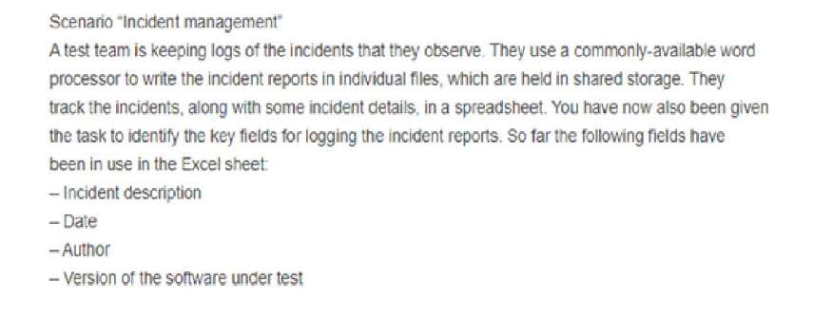
a.
Priority
b.
Incident identification
c.
Developer assigned to the fix
d.
Date to be fixed

Đáp án: A

Câu hỏi 17
Given the following figures for the testing on a project, and assuming the failure rate for initial tests remains constant and that all retests pass, what number of tests remain to be run?
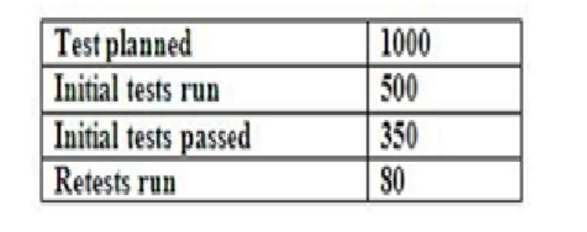
a.
700
b.
720
c.
784
d.
570

Đáp án: B

Câu hỏi 18
Which three major conments would you make having reviewed following incident report?
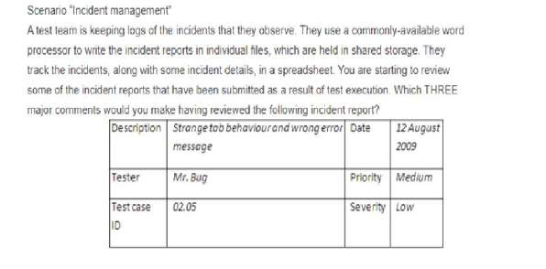
a.
Should have been two defect reports
b.
Ambiguous description
c.
Both severity and priority do not make sense
d.
Actual cause is missing
e.
Reproducibility is not indicated
f.
Defect type is missing
g.
Date to be fixed not defined

Đáp án: A,B,E

Câu hỏi 19
Which TWO types of risks are related to complaint (i) and (ii)?
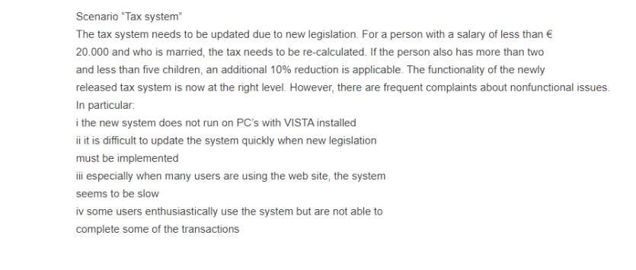
a.
Functionality
b.
Usability
c.
Efficiency
d.
Portability
e.
Maintainability

Đáp án: D,E

Câu hỏi 20
Which of test case is invalid?
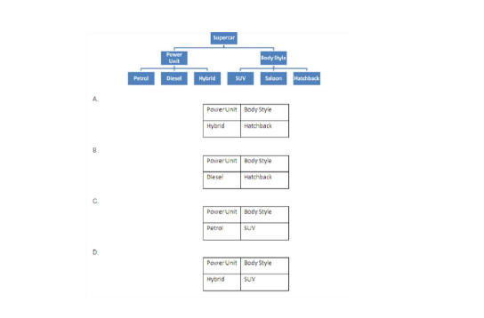
a.
A
b.
B
c.
C
d.
D

Đáp án: D

Câu hỏi 21
The development manager asks you to identify suitable test coverage entry criteria for the “Supercar” system test. Which of the following would you recommend as appropriate for entry criteria to a system testing phase? (i) 100% business requirements coverage (ii) 100% statement coverage (iii) 75% decision coverage (iv) Availability of test release notes (v) Design review completed
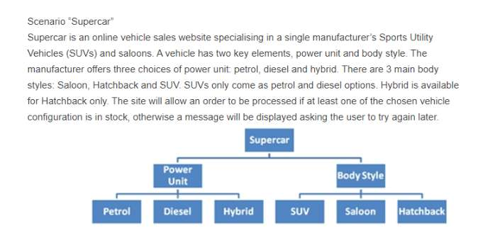
a.
(ii), (iii), (iv)
b.
(ii), (iv), (v)
c.
(i), (iv), (v)
d.
(i), (ii), (iii)

Đáp án: A

Câu hỏi 22
Based on this image
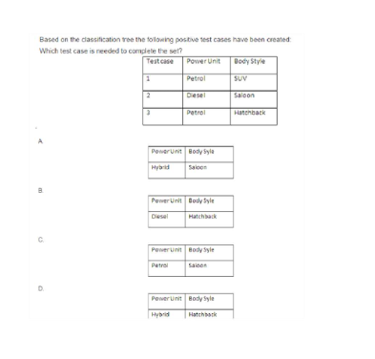
a.
A
b.
B
c.
C
d.
D

Đáp án: D

Câu hỏi 23
You have been asked to write a testing strategy for the company. Which statement best explains how risk can be addressed within the testing strategy?
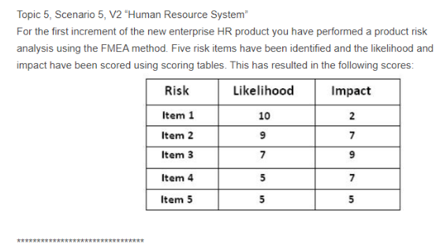
a.
A test strategy should address identified generic product risks and present a process for mitigating those risks in line with the testing policy.
b.
A test strategy identifies the specific product for a project risk and defines the approach for the test project.
c.
A test strategy is derived from the test policy and describes the way risk assessments are performed in projects.
d.
A test strategy is the result of a project risk analysis and defines the approach and resources for testing.

Đáp án: A

Lời giải: Refer 2.1 test strategy là tài liệu ở mức công ty, quy định những methods chung chung cho tất cả các dự án thực hiện theo, nên các cái quá cụ thể sẽ không đc ghi trong test strategy

Câu hỏi 24
Part of the testing strategy indicates that you are going to be using systematic test design techniques. Your manager has asked that you present the main advantages of using these techniques at the next board meeting. Identify THREE main benefits of using systematic test design techniques within this company.
a.
Easier to quickly adapt testing to changing requirements compared to experienced-based testing
b.
Targets certain types of faults
c.
Will guide experienced testers to find defects
d.
Provides a way to differentiate depth of testing based on product risks by using different techniques
e.
More enhanced documentation and therefore higher repeatability and reproducibility
f.
Will make non-systematic testing redundant
g.
Will reduce the need for early reviews

Đáp án: B,D,E

Câu hỏi 25
In addition to risk, identify TWO other components of a testing strategy.
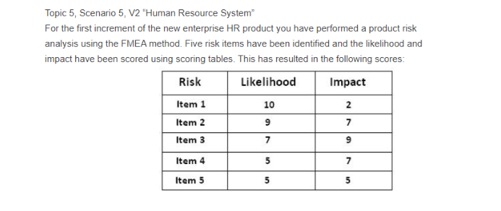
a.
The entry and exit criteria for each test phase
b.
Test training needs for the project resources
c.
The test design techniques to be used
d.
Test performance indicators
e.
The test schedule

Đáp án: A,C

Câu hỏi 26
What is the Risk Priority Number for risk item number 2?
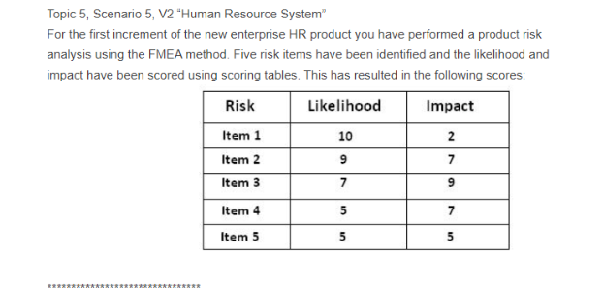
a.
16
b.
2
c.
1
d.
63

Đáp án: D

Lời giải: Risk level = likelihood x impact

Câu hỏi 27
What would be a test approach regarding the test design techniques to be applied that would fit an item with the highest risk?
a.
Component testing: decision testing; System testing: exploratory testing
b.
Component testing: decision testing; System testing: decision table testing
c.
Component testing: statement testing; System testing: equivalence partitioning
d.
Component testing: statement testing; System testing: decision table partitioning

Đáp án: B

Lời giải: rủi ro cao, dùng kỹ thuật cao, component test thì decision testing là cao hơn statement testing, system test thì dùng decision table chặt chẽ logic hơn kỹ thuật khác

Câu hỏi 28
A number of options have been suggested for the level of independence to be employed for the testing on the next project, and are shown below. i. External test specialists perform non-functional testinG. ii. Testing is outsourced. iii. Testing is carried out by the developer. iv. A separate test team carries out the testing. v. Testing is performed by the business. vi. Testing is performed by a different developer. Which of the following orders the above in a correct order of independence?
a.
i, ii, iv, vi
b.
ii, i, v, vi
c.
ii, v, i, iii
d.
i, iv, v, vi

Đáp án: B

Lời giải: Refer chương 10 đã bổ sung các mức độ của test independence

Câu hỏi 29
Which of the following are valid reasons for adopting a different life cycle (from the V model), for increments after the first year? i. We do not have a clear understanding of the requirements from a customer perspective. ii. We see the risk of delivering requested functionality late as being higher than the risk of delivering a lower quality product. iii. We do not have a budget for additional regression testing which is needed to ensure that existing functionality is not compromised by future iterations. iv. The company test strategy does not fit well within the V life cycle model.
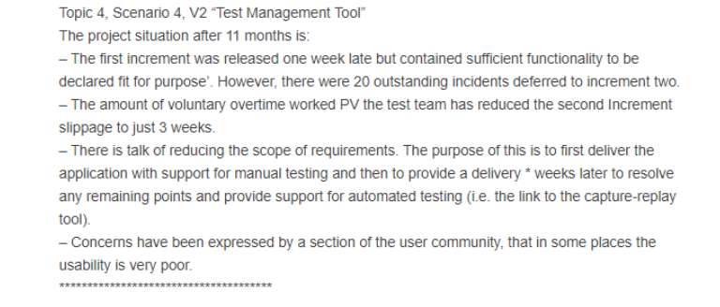
a.
(i) and (ii)
b.
(i) and (iv)
c.
(ii) and (iii)
d.
(ii) and (iv)

Đáp án: A

Câu hỏi 30
Topic 3, Scenario 3 “Tool Selection and Implementation” Your company is considering whether or not to purchase a test tool suite from a respectable vendor. Your manager has searched the internet for comparable products but none of them meets his specific requirements. A tool demonstration has been arranged for next week and your team has been invited to attend. The tool suite consists of a test management tool, test execution tool and a requirements management tool. There is the possibility of adding a performance testing tool at a later stage. You have decided to attend the demo but raise some issues before hand regarding expectations. **************************** Select THREE issues from the options provided that should at least be raised.
a.
Has there been sufficient comparison of tools?
b.
What are the problems we are trying to address?
c.
Do we have a set of tool requirements to validate the tool against?
d.
How will the implementation be organized?
e.
Which project will be selected to perform the tool pilot?
f.
Is customized training available?
g.
How will the change process be managed?

Đáp án: A,B,C

Câu hỏi 31
When preparing for an exploratory test, which of the following sets of artefacts would be the most appropriate to produce?
a.
Charter outlining tasks (tests) to be performed and objectives to be met, plus a set of heuristics to follow
b.
Charter outlining tasks (tests) to be performed and objectives to be met, plus a set of heuristics to follow and the completed session sheets
c.
Charter outlining tasks (tests) to be performed and objectives to be met, plus a set of defect types to be targeted and a list of new issues encountered
d.
Charter outlining objectives to be met, plus a set of heuristics to follow

Đáp án: A

Lời giải: Câu này học thuộc, ko giải thích đc

Câu hỏi 32
Which are tool only used to Developer?
a.
Coverage measurement
b.
Dynamic analysis tool
c.
Test comparators
d.
Data preparation
e.
Incident management

Đáp án: A,B

Lời giải: Refer chapter 9, bảng Category of tools, Các công cụ chỉ dùng cho Developer được đánh dấu (D)

EXAM 2 AL2021-de-thi-update-2021-39663

Câu hỏi 1
Regarding these risk items, which one of the following should the Test Manager do? [K4]
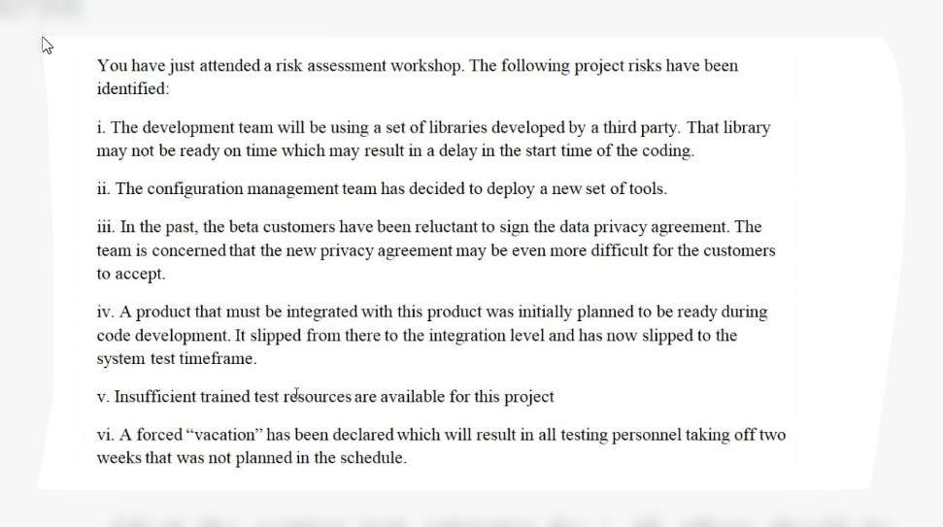
a.
Adjust the existing test estimates for i. All others should be monitored by project management.
b.
Set triggers for i, iii, iv, v. Initiate control measures for vi. Monitor ii.
c.
Monitor i, ii, iii. Set a trigger date for iv. Initiate control measures for v. Adjust the existing test estimates for vi.
d.
Ignore i and ii as those are issues for the development team. Adjust existing test estimates for iv, v, vi. Transfer iii to the business team.

Đáp án: C

Lời giải: chapter 3. Ignore là ko đc loại D, A cũng loại vì chưa biết risk có xảy ra ko đã điều chỉnh estimation, còn lăn tăng BC
Câu hỏi 2
You have been asked to create a presentation regarding the role of quality management in your organization. Which of the following points should be included in your presentation to ensure that the audience understands the scope and importance of quality management? (pick three)
a.
Quality management requires software quality assurance activities to be integrated into the project lifecycle.
b.
Quality assurance and testing should not be merged into one team so that the focus of quality assurance is not confused with the scheduling aspects of testing.
c.
Quality management practices must be assessed by an external audit team to ensure compliance.
d.
Unit test documentation is a deliverable that is part of quality management.
e.
Quality management excludes activities to deliver projects within budget.
f.
The test plan is the basis for forming quality policies for an organization.
g.
Tracking metrics is an important aspect of quality management.

Đáp án: A,D,G

Câu hỏi 3
Which one of the following is an efficiency metric for the test process?
a.
The average number of days from defect discovery and reporting to the ultimate resolution of the defect report
b.
The number of defects detected by testing divided by the sum of the number of defects detected by testing and the number of defects subsequently detected by users
c.
The person hours of test design and implementation effort divided by the number of test basis elements covered by the tests cases produced
d.
The total amount of effort expended on a project, including all activities in the fundamental test process

Đáp án: C

Câu hỏi 4
Which one of the following statements best summarizes which test strategies can be used for this project?
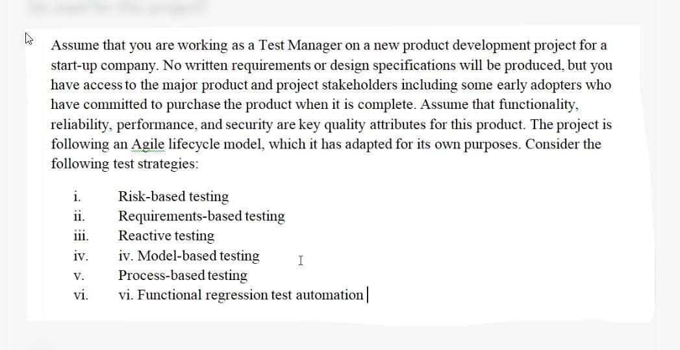
a.
Strategies i, iii, iv, v, and vi can be used.
b.
All of these strategies can be used.
c.
Strategies i, iv, and vi can be used.
d.
Strategies i, v, and vi can be used.

Đáp án: A

Câu hỏi 5
Which one of the following is LEAST likely to be involved in the review of requirements specifications?
a.
Business Analyst
b.
Customer
c.
User
d.
Project Manager

Đáp án: D

Câu hỏi 6
Which one of the following BEST matches the following scenarios with the most effective means of communication? i. Brainstorming to identify risks to the test project and item under test ii. Informing offshore testers regarding updates to incident status iii. Reporting the weekly test status to interested stakeholders iv. Informing the Project Manager of the suspension of testing due to test environment failure v. Communicating dates for the internal test conferences for the next year vi. Reporting an incident to a specific developer
a.
email – iii; post to intranet – iv; group meeting – vi; face-toface – ii.
b.
email – ii; post to intranet – vi; group meeting – iv; face-toface –v.
c.
email –iv; post to intranet –vi; group meeting – v; face-toface – i.
d.
email –v; post to intranet – iii; group meeting – i; face-toface – iv.

Đáp án: D

Câu hỏi 7
A multi-use testing tool, MULTI-TOOL, is used within your organization to support all testing projects. It includes test management, incident management and dynamic testing support tools. However, the clients for a major new project use the INCITOOL incident management tool, and require this tool to be used for this project. It has been suggested that INCITOOL be integrated into MULTI-TOOL and replace the current incident management functionality. Which one of the following activities is LEAST likely to be performed in response to this suggested change?
a.
A contract will be signed to make the client jointly-responsible for maintenance of the integrated INCITOOL data and functionality.
b.
An impact analysis shall be performed to determine which users will be affected by the change and by how much.
c.
An analysis of the technical feasibility of the change and the available capabilities of staff to perform the change will be performed.
d.
The migration of the MULTI-TOOL incident database into INCITOOL shall be studied to determine if this is possible without compromising the quality of the original data.

Đáp án: A

Câu hỏi 8
Scenario 5 “Testing for TransGlobe” provides the context for this question. As Test Manager in IO-IS you have made a draft of an induction training program for the new testers in the offshore team. Pick the three options that are LEAST likely to be included in your draft.
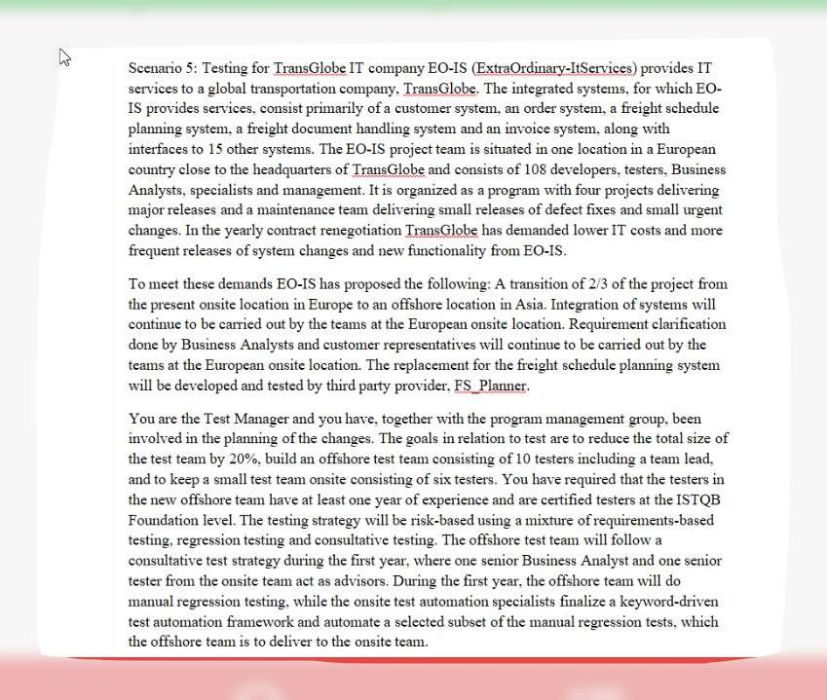
a.
Training in using TransGlobe’s systems and familiarity with project documentation
b.
Training in using the debugging tools for the web applications
c.
Test training in standard test fundamentals
d.
Walkthrough of the test model and test procedures used by IO-IS
e.
Overview of and walkthrough of samples from the existing regression tests
f.
Introduction to java and walkthrough of selected java modules
g.
Training in using the test management and defect management tools used by IO-IS

Đáp án: B,C,F

Câu hỏi 9
Analyze the scenario to determine the appropriate level of testing required of the onsite test team in relation to the third party freight schedule planning system provided by FS_Planner. Which three of the options will most likely be chosen?.
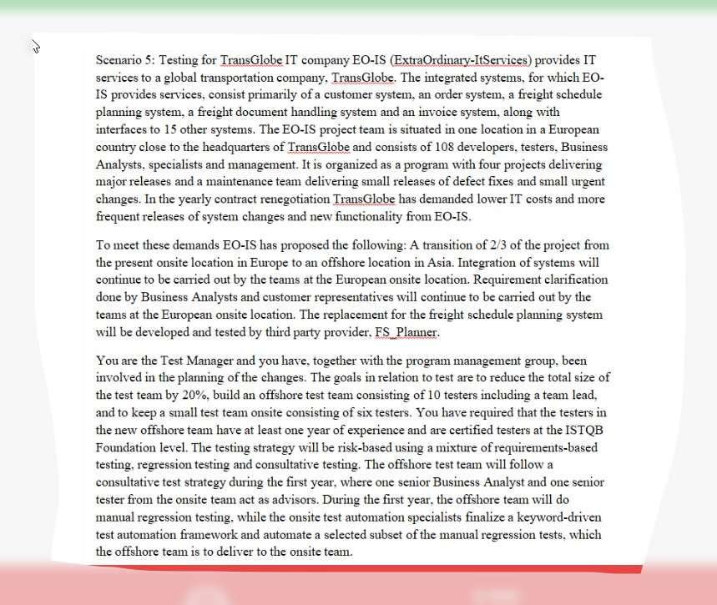
a.
Regression testing at component level
b.
Regression testing at integration level
c.
User acceptance testing
d.
Manual regression testing at system level
e.
System integration testing
f.
Automated system regression tests
g.
Hardware software integration testing

Đáp án: C,E,F

Câu hỏi 10
Select one of the following options. [K4]
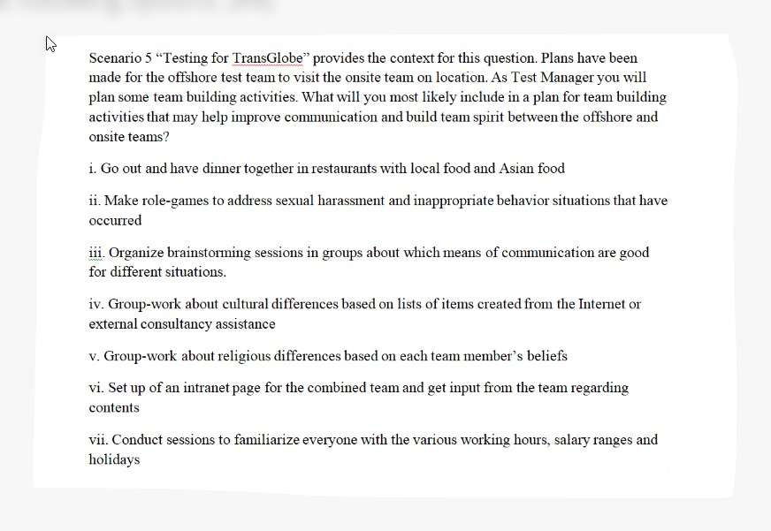
a.
i, iii, iv,vi
b.
i, ii, iii, vi
c.
iii, iv, v, vii
d.
I, ii, iii, iv

Đáp án: A

Câu hỏi 11
Scenario 5 “Testing for TransGlobe” provides the context for this question. The delivery manager at the offshore site has defined S.M.A.R.T goals for both the developers and testers of the offshore teams working for IO-IS on the systems of TransGlobe. Your task as Test Manager is to review and comment on the goals regarding the offshore testers. Which two of the following items do you consider most appropriate as S.M.A.R.T goals seen in relation to the test strategy defined for the first year of transition?
a.
Able to prevent 98 % of all regression defects to escape to production after three months
b.
Able to design test cases without consulting onsite senior Business Analysts and senior onsite tester after four months
c.
Able to create automated regression test scripts after six months
d.
Able to operate all standard functions of the test management and defect management tool after two weeks
e.
Able to execute 90% of the manual regression tests after three months

Đáp án: D,E

Câu hỏi 12
Which technique is most appropriate to use for the suitability test? For the on-line portal a test will be planned that will focus on suitability. Which technique is most appropriate to use for the suitability test?
a.
Use Cases
b.
Equivalence Partitioning and Boundary Value Analysis
c.
State Transition Testing
d.
Pairwise Testing

Đáp án: A

Lời giải: Refer chapter 5, test cho suitability là 1 sub-characteristics của functional đó, chọn kỹ thuật use case để tìm các lỗi trong business flow và lỗi trong thực tế sử dụng của hệ thống
Câu hỏi 13
It is possible that the test execution phase will be shortened and that test cases will need to be prioritised. What is the main reason to prioritise the test cases?
a.
Get the areas the programmer is most worried about finished first
b.
Get finished within the time and budget available
c.
Ensure that when you stop you have done the best tests in the time available
d.
To ensure as many tests as possible are run

Đáp án: C

Lời giải: Chú ý vào câu "test execution phase will be shortened" giai đoạn test bị cắt ngắn thì cần phải sắp xếp priority cho TC, vì đảm bảo rằng những cái quan trọng nhất sẽ test trước tiên và bạn có thể dừng test trong thời gian hạn hẹp cho phép chứ ko cần chạy hết test case như D, hay A, B đều vô lý
Câu hỏi 14
A remote subsystem developer has delivered a module that decides whether to sound an alarm based on three inputs (a HEAT sensor, a SMOKE sensor, and a user-triggered BUTTON). An alarm should sound if both the HEAT sensor and the SMOKE sensor are triggered, or if the alarm BUTTON is triggered. What is the minimum set of test combinations from the following sets of input values that achieve 100% Decision Condition coverage? 1. HEAT=true, SMOKE=true, BUTTON=false 2. HEAT=true, SMOKE=true, BUTTON=true 3. HEAT=true, SMOKE=false, BUTTON=false 4. HEAT=false, SMOKE=false, BUTTON=true 5. HEAT=false, SMOKE=false, BUTTON=false 6. HEAT=false, SMOKE=true, BUTTON=false
a.
3 and 6
b.
1 and 4
c.
2, 4, and 6
d.
2 and 5

Đáp án: D

Câu hỏi 15
Which of the following is a positive logical test that is complete, is correct, and covers this risk item?
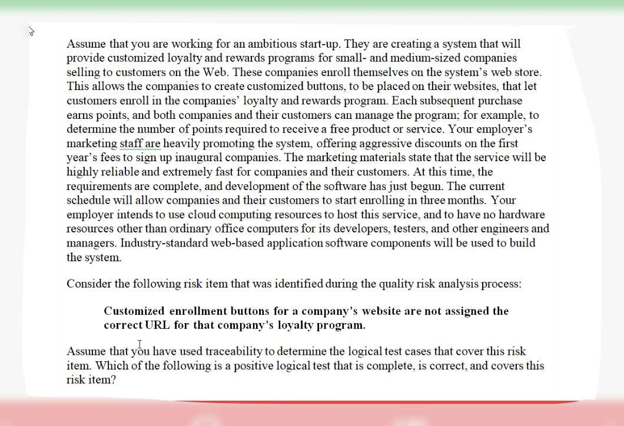
a.
Click rapidly on company enrollment button to see what happens.
b.
Click on URL for our home page; check that home page displays.
c.
Click on company enrollment button; verify that you go to that company’s enrollment page.
d.
Click on company enrollment button; verify that you go to our home page.

Đáp án: C

Câu hỏi 16
You have received the following use case steps: 1. Returning user logs into the application. 1a. User is new and decides to create an account 1b. User creates account and is returned to login 2. User selects calendar duration (6, 12 or 18 months) 3. User selects standard day captions 3a. User chooses custom day captions 3b. User is taken to other application to define captions 3c. After captions defined, user is returned 4. User selects standard pictures 4a. User chooses custom pictures 4b. User is taken to other application to upload pictures 4c. After pictures are uploaded, user is returned 5. User enters shipping information 6. User purchases calendar 6a. User cancels purchase 7. User exits What is the minimum number of test cases needed to test this use case?
a.
2
b.
4
c.
5
d.
7

Đáp án: C

Lời giải: Basic flow: 1 ◊ 2 ◊ 3 ◊ 4◊ 5 ◊ 6 ◊ 7 Exception 1: 1a, 1b Exception 2: 3a, 3b, 3c Exception 3: 4a, 4b, 4c Exception 4: 6a
Câu hỏi 17
In what ways should a Technical Test Analyst respond to risks that are identified after testing has started?
a.
Work closely with end-users to better define needs in areas identified as having additional risk
b.
Re-order test cases if test results have caused a reprioritization of risks
c.
Re-order test cases if numerous usability issues are noted during demonstrations
d.
Continue testing to the original risk analysis and address new risks when the scheduled testing is completed

Đáp án: A

Câu hỏi 18
You have now also been given the task to identify the key fields for logging the incident reports. So far the following fields have been in use in the Excel sheet: - Incident description - Date - Author - State Which of the following would you recommend as the best combination of fields to add?
a.
Priority, version of software under test, incident identification
b.
Date to be fixed, priority, incident identification
c.
Developer assigned to the fix, version of software under test, incident identification
d.
Priority, version of software under test, date to be fixed

Đáp án: A

Câu hỏi 19
Identify TWO main advantages of this approach to incident management
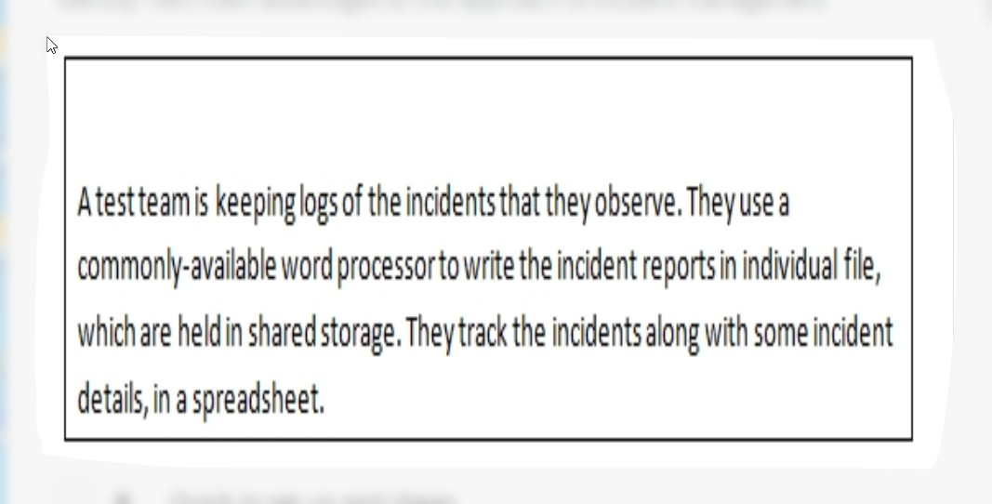
a.
Quick to set up and cheap
b.
Electronic rather than manual
c.
Allows attachments (e.g. screen prints) to be linked to the incident reports
d.
Can easily be integrated with open source tools
e.
Large files are not a problem

Đáp án: A,B

Câu hỏi 20
You are testing a set of signal changes at a railway station. The system is newly build using a traditional V-model approach. A full set of documentation is available that can be used as a test basis. Furthermore the system is identified as being safety critical. Which technique would you most likely use?
a.
Equivalence Partitioning
b.
Exploratory Testing
c.
State transition Testing
d.
Boundary Value Analysis

Đáp án: C

Câu hỏi 21
As a technical test analyst, you have found out during test case design that the design document is incomplete. Which is an example of a good way to communicate that problem in an email?
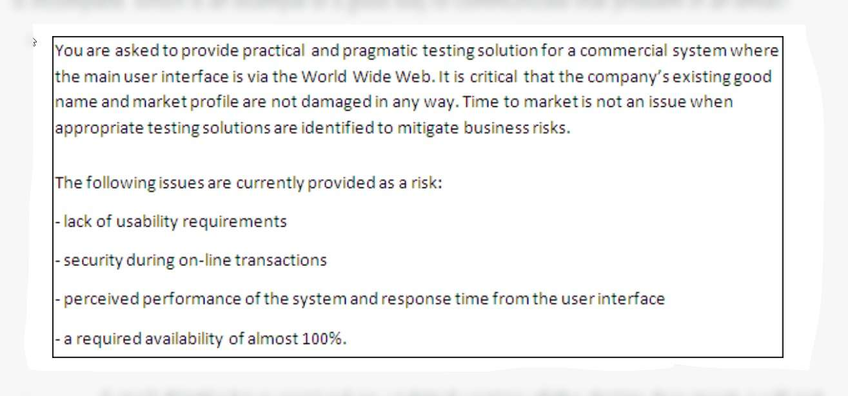
a.
E-mail: “Until I have received an updated version of the design document, I will not do any work on the test design.”
b.
E-mail: “When will it be possible to receive the missing information? Test design is impeded by a lack of clarity here.”
c.
E-mail: “Here we go again. The developer gave us incomplete and ambiguous design specifications. Typical.”
d.
Do not communicate the problem, just log the delaying effect of the information problem and be ready to explain the delays to the test manager later.

Đáp án: B

EXAM 3 AL2019-exam-tta1-4213

Câu hỏi 1
Definition-use pairs are identified during which of the following static analysis activities? Number of correct answers: 1
a.
Control flow analysis
b.
Data flow activities
c.
Coding standards analysis
d.
Cyclomatic complexity analysis

Đáp án: B

Câu hỏi 2
As part of a risk analysis, technical risks are analyzed. Which TWO factors influence technical risk? Number of correct answers: 2
a.
Complexity of technology
b.
Frequency of use of the affected failure
c.
Interfacing and integration issues
d.
Damage to image
e.
Lack of reasonable workaround

Đáp án: A,C

Câu hỏi 3
The result of a product risk analysis performed on components I, II and III of the airplane control system shows the following risk matrix: The project wants to mitigate the risks by defining different types of coverage depending on the risk level of the components. Which of the following would be a meaningful solution for setting the coverage targets? Number of correct answers: 1
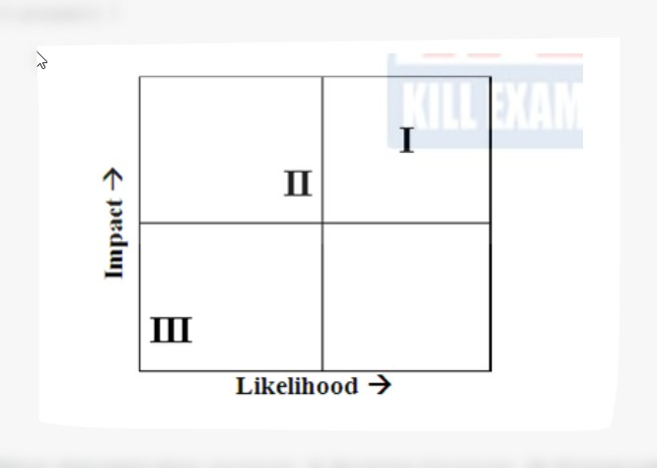
a.
I: Condition determination coverage, II: Decision Coverage, III: Statement coverage
b.
I: Condition determination coverage, II: Statement coverage, III: Decision coverage
c.
I: Decision coverage, II: Condition determination coverage, III: Statement Coverage
d.
I: Multiple condition coverage, II: Decision coverage, III: Condition determination coverage

Đáp án: A

Câu hỏi 4
If you are flying with an economy ticket, there is a possibility that you may get upgraded to business class, especially if you hold a gold card in the airline’s frequent flier program. If you don’t hold a gold card, there is a possibility that you will get ‘bumped’ off the flight if it is full and you check in late. This is shown in the figure hereafter. Note that each box (i.e. statement) has been numbered. Three tests have been run: Test 1: Gold card holder who gets upgraded to business class Test 2: Non-gold card holder who stays in economy Test 3: A person who is bumped from the flight What is the statement coverage of these three tests? Number of correct answers: 1
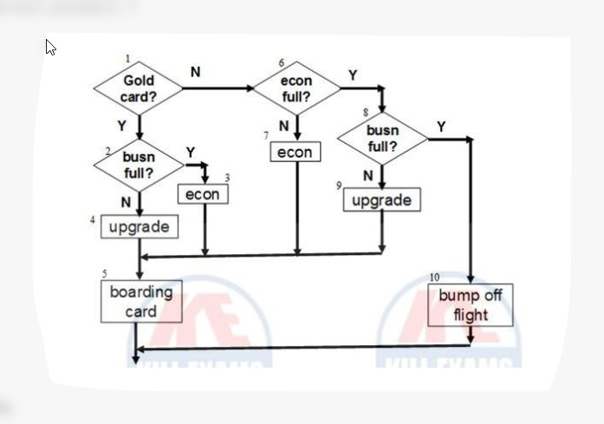
a.
60%
b.
70%
c.
80%
d.
90%

Đáp án: C

Câu hỏi 5
An embedded software company is considering to improve the quality of its software components to be delivered to the integration team. After studying various experience papers that report a higher level of quality for software components, two main alternative techniques are identified: static analysis and dynamic analysis. In deciding which one is most applicable and how they relate to each other a detailed study is performed. Which of the following are TWO key similarities between static analysis and dynamic analysis? Number of correct answers: 2
a.
Both are performed using requirements as its major input document
b.
Both are usually undertaken by integration testers
c.
Both are usually undertaken by development during coding and unit testing
d.
Both are related to reviews
e.
Both usually use a toolv

Đáp án: C,E

Câu hỏi 6
If we say that a set of tests has achieved 100% structural decision coverage on a particular module in a program, what does that mean? Number of correct answers: 1
a.
That all bugs present in that module were necessarily revealed by those tests.
b.
That every control flow branch had been executed at least once by those tests.
c.
That every dataflow in that module was exercised at least once bythose tests.
d.
That every path through that module was exercised at least once by those tests

Đáp án: B

Câu hỏi 7
Which of the following is a dynamic analysis technique related to improving application performance? Number of correct answers: 1
a.
Code complexity analysis
b.
Profiling
c.
Network package sniffing
d.
Spelling and grammar checking

Đáp án: B

Câu hỏi 8
A component has been analyzed as being highly critical. Which of the following structure-based test design techniques provides the highest level of coverage? Number of correct answers: 1
a.
Statement testing
b.
Decision testing
c.
Condition determination testing
d.
Multiple condition testing

Đáp án: C

Câu hỏi 9
Consider the following fault attack: “Force all possible incoming errors from the software/OS interfaces to the application”. Which of the following is the kind of failure you are looking for when using this attack? Number of correct answers: 1
a.
Application crashes when unsupported characters are pasted into an input field using the windows clipboard
b.
Front page of the application has incorrect spelling of the company name
c.
Application fails to display financial numbers in the correct currency format in reports
d.
Application miscalculates total monthly balance due on credit cards

Đáp án: A

Câu hỏi 10
The comment frequency of the code fragment is 13%. To which ISO 9126 quality attribute does a good level of comment frequency especially contribute? Number of correct answers: 1
a.
Portability
b.
Maintainability
c.
Usability
d.
Efficiency

Đáp án: A

Câu hỏi 11
Which specification-based technique could be used to enhance coverage for this code fragment? Number of correct answers: 1
a.
Boundary value analysis
b.
Exploratory testing
c.
State transition testing
d.
Use case testing

Đáp án: A

Câu hỏi 12
Consider the following code fragment If (a>b) and (b>c) then b = (a+c)/2 End if Assume that in the following options, each of the three numbers in parenthesis represent the inputs for a test case, where the first number represents variable “a”, the second number represents variable “b”, and the third number represents variable “c”. Which of the following gives a set of test case inputs that achieves 100% decision coverage for this fragment of code with the minimum number of test cases? Number of correct answers: 1
a.
(5, 3, 2)
b.
(5, 3, 2); (5, 4,0)
c.
(5, 4, 0); (4, 5, 0)
d.
(4, 5, 0); (5, 4, 5)

Đáp án: C

Câu hỏi 13
For the control flow, what is the correct labelling? Number of correct answers: 1
a.
Nodes Link Region
b.
Nodes Region Link
c.
Region Link Nodes
d.
Region Nodes Link

Đáp án: A

Câu hỏi 14
During code reviews, it is the author’s responsibility… Number of correct answers: 1
a.
to address all major and minor defects as stated in the defect log
b.
to fix all major and minor defects as stated in the defect log
c.
to take action on only improvement suggestions from the defect log
d.
to correct source documents that have major defects

Đáp án: A

Câu hỏi 15
Which TWO additional structure-based test design techniques could be used to dynamically test the code? Number of correct answers: 2
a.
Condition testing
b.
Multiple condition testing
c.
Equivalence partitioning
d.
Cause/effect graphing
e.
Code reviews

Đáp án: A,B

Câu hỏi 16
You have tested the program and have found that with “bonus” a boundary value has not been implemented according to design. You have written an incident report. Which of the following is the incident report of the highest quality? Number of correct answers: 1
a.
Description: Boundary value not correctly implemented Priority: High Repeatability: Yes Tester: WVU Test case: 35 (test specification “bonus program”), V1.2
b.
Description: Boundary value not correctly implemented for bonus Priority: Medium Tester: WVU Test case: 35 (test specification “bonus program”)
c.
Description: Boundary value not correctly implemented for bonus (line 26: 10 according to design, now 5 implemented) Priority: High Repeatability: Yes Tester: WVU Test case: 35 (test specification “bonus program”), V1.2
d.
Description: Boundary value not correctly implemented for bonus Priority: High Repeatability: Yes Tester: WVU Test case: 35 (test specification “bonus program”), V1.2

Đáp án: C

Câu hỏi 17
Which of the following is the most important benefit of making exploratory testing part of your test approach for the “Bonus Program”? Number of correct answers: 1
a.
The ability to utilize a very experienced test team
b.
The ability to accurately predict the residual risk prior to delivery
c.
The ability to prevent defects during requirements analysis
d.
The ability to test effectively without a complete test basis

Đáp án: D

Câu hỏi 18
An organisation has already implemented a static analysis tool and is considering whether code reviews would have any added value. Which of the following defect types can only be found by means of code reviews? Number of correct answers: 1
a.
Conformance to coding standards
b.
Conformance to design
c.
Endless loop
d.
Cyclomatic complexity too high

Đáp án: B

Câu hỏi 19
The Bonus Program is perceived by management to be critical. Defects in the program would almost immediately lead to financial loss. In the past an improvement program has been run to implement review based on IEEE 1028. Knowledge and skills on both formal and informal reviews are available. There is also an existing pool of review leaders. Which of the following review types would you choose to review the program? Number of correct answers: 1
a.
Informal review
b.
Inspection
c.
Walkthrough
d.
Management review

Đáp án: B

Câu hỏi 20
Which of the following is a valid way to calculate the cyclomatic complexity? Number of correct answers: 1
a.
Number of decisions + 2
b.
Number of enclosed regions - 1
c.
Number of statements - 2
d.
Links - Nodes + 2

Đáp án: D

Câu hỏi 21
Applying exploratory testing (ET) during unit testing is being considered. Which ET deliverable would be the primary candidate for informal reviews? Number of correct answers: 1
a.
Test log &coverage outline
b.
Test charter
c.
Heuristics
d.
Test case specification

Đáp án: B

Câu hỏi 22
To support code reviews a checklist will be developed. Which TWO questions from the list would you implement as part of the code review checklist? Number of correct answers: 2
a.
Are any magic numbers (numeric literals) used, other than 0 or 1?
b.
Can each item be implemented with the techniques, tools, and resources available?
c.
Is it possible during acceptance testing to verify whether the item has been satisfied?
d.
Is the item specified in an exact, unambiguous way?
e.
Is there any logic containing no statements and no explanation as to why it is empty?

Đáp án: A,E

Câu hỏi 23
The application of multiple condition testing is also being considered. Which specification-based technique is largely based on the principle of multiple condition testing? Number of correct answers: 1
a.
Equivalence Partitioning
b.
State Transition Testing
c.
Decision Table Testing
d.
Use Cases

Đáp án: C

Câu hỏi 24
Which additional set of test cases is needed to achieve both 100% statement coverage and 100% decision coverage? Number of correct answers: 1
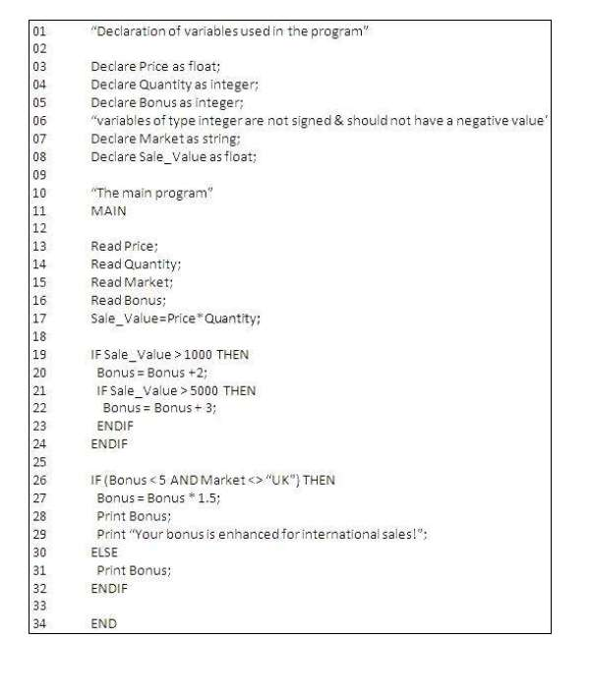
a.
1
b.
2
c.
3
d.
4

Đáp án: C

Câu hỏi 25
When performing code reviews, which of the following defect types will be most difficult to find? Number of correct answers: 1
a.
Dead code
b.
Variable used that is not defined
c.
Memory issues
d.
Conformance to design

Đáp án: C

Câu hỏi 26
It has been decided to improve the efficiency and effectiveness of unit testing by acquiring a number of test tools. Which TWO of the following tools would you select to support unit testing? Number of correct answers: 2
a.
Dynamic analysis
b.
Review tool
c.
Coverage measurement tool
d.
Monitoring
e.
Test management

Đáp án: A,C

Câu hỏi 27
What are the TWO most significant pitfalls the organisation should be aware of? Number of correct answers: 2
a.
Lack of good process as a baseline
b.
Cost of maintenance of test scripts
c.
Test management will become more time-consuming
d.
Need to train testers and gain skills
e.
Coverage measurements are often difficult

Đáp án: B,D

Câu hỏi 28
A new web site has been launched for a conference organisation. There are a number of links to other related websites for information purposes. Customers like the new site but complaints are being made that some (not all) of the links to other sites do not work. Number of correct answers: 1
a.
Performance tool
b.
Hyperlink tool
c.
Usability testing tool
d.
Static analysis tool

Đáp án: B

Câu hỏi 29
A developer has spent three days looking at a system that crashes now and then. The problem was caused by two coding faults: i. A variable was being used but had not been defined; ii. There was a ‘goto’ statement to an undefined label Number of correct answers: 1
a.
Static analysis tool
b.
Code coverage tool
c.
Dynamic analysis tool
d.
Test execution tool

Đáp án: A

Câu hỏi 30
What are the TWO most significant benefits a test execution tool should bring to the organisation? Number of correct answers: 2
a.
Less expensive and time consuming regression testing
b.
More structured incident management
c.
Improved control and monitoring
d.
Visibility on test coverage
e.
More coverage during regression testing

Đáp án: A,E

Câu hỏi 31
Select TWO solutions how the team could achieve significant benefits in the use of this tool within the next 6 months? (3 credits, for 1 out of 2 correct 1 credit) Number of correct answers: 2
a.
Introduce data-driven or keyword driven scripting techniques
b.
Change the development process
c.
Select and implement a test management tool to complement the test suite
d.
Identify critical parts of the system and concentrate on automating some of those tests for that particular area
e.
Get business testers involved in the automation process

Đáp án: A,D

Câu hỏi 32
You have been asked to select a number of tools to support the performance testing. Which TWO of the following tools would you recommend? Number of correct answers: 2
a.
Test management tool
b.
Load testing tool
c.
Static analysis tool
d.
Monitoring tool
e.
Test oracle tool

Đáp án: B,D

Câu hỏi 33
Which of the following is the best example of a reliability failure for the application? Number of correct answers: 1
a.
Slow response time
b.
Excessive memory consumption
c.
Random application termination
d.
Failure to encrypt data
Đáp án: C

Câu hỏi 34
It has been suggested to organise a performance test to find out more regarding the third risk. Which of the following would you use to quantify the situation and as a basis for defining a performance exit criteria? Number of correct answers: 1
a.
Defect analysis time
b.
Change parameter success ratio
c.
Number of errors made by the user
d.
Time to perform the function

Đáp án: D

Câu hỏi 35
To address reliability a number of measures will be taken throughout the development and testing process. Select TWO appropriate measures that are typically taken as part of reliability engineering and/or testing of an application. Number of correct answers: 2
a.
Define Operational Profiles
b.
State Transition Testing
c.
Usability testing
d.
Perform design FMEAs
e.
Exploratory test

Đáp án: D

Câu hỏi 36
It has been decided by management to ask an external consultant to perform a reliability assessment. The external consultant will use a checklist to support the assessment. Select TWO checklist items that are most likely to be part of a reliability checklist. Number of correct answers: 2
a.
Are traceability matrices provided to the requirements?
b.
Is all code supported by a reviewed design document?
c.
Is the comment frequency at the correct level?
d.
Is a dual set of hardware available?
e.
Are features available for a periodic check of the database consistency?

Đáp án: D,E

Câu hỏi 37
At which test level would performance testing most likely be performed? Number of correct answers: 1
a.
Component Testing
b.
Integration Testing
c.
System Testing
d.
User Acceptance Testing

Đáp án: C

Câu hỏi 38
A company wants to develop a web site to implement an on-line sales channel. Which TWO ISO 9126 quality attributes are most likely to be of importance? Number of correct answers: 2
a.
Usability
b.
Accuracy
c.
Portability
d.
Fault-tolerance
e.
Install ability

Đáp án: A,C

Câu hỏi 39
To address the second risk mentioned in the scenario, security testing will be performed. Which test techniques would be most applicable for security testing? Number of correct answers: 1
a.
Boundary Value Analysis
b.
Statement Testing
c.
Use Cases
d.
Fault Attacks

Đáp án: D

Câu hỏi 40
Consider the following decision table, How many cases are left when this decision table is collapsed? Number of correct answers: 1
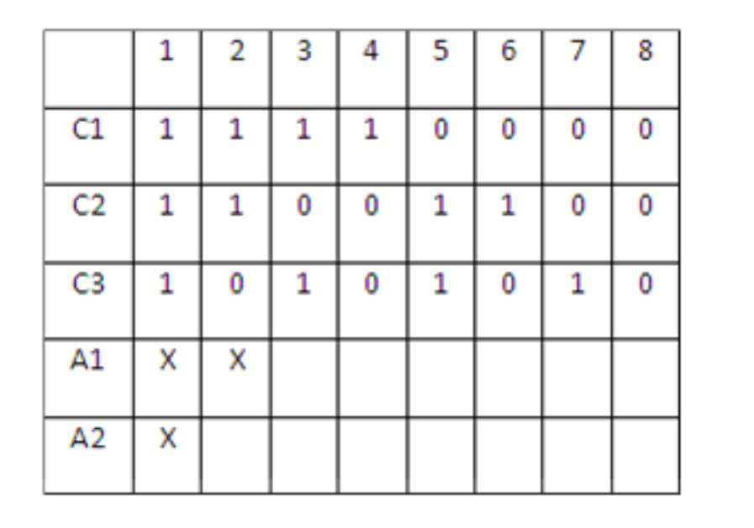
a.
2
b.
3
c.
4
d.
5

Đáp án: C

Câu hỏi 41
You are testing a set of signal changes at a railway station. The system is newly build using a traditional V-model approach. A full set of documentation is available that can be used as a test basis. Furthermore the system is identified as being safety critical. Which technique would you most likely use? Number of correct answers: 1
a.
Equivalence Partitioning
b.
Exploratory Testing
c.
State transition Testing
d.
Boundary Value Analysis

Đáp án: C

Câu hỏi 42
For equivalence partitioning based on this specification, how many input classes can be determined?
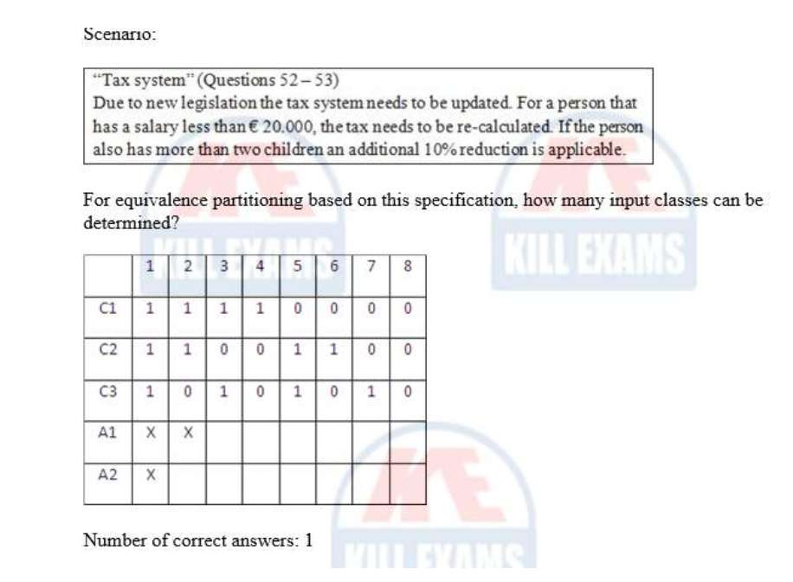
a.
4
b.
5
c.
6
d.
8

Đáp án: A

Câu hỏi 43
How many test cases are required to test a specification that has three conditions using a decision table testing which is not collapsed? Number of correct answers: 1
a.
2
b.
4
c.
6
d.
8

Đáp án: D

Câu hỏi 44
For equivalence partitioning based on this specification, how many output classes can be determined?
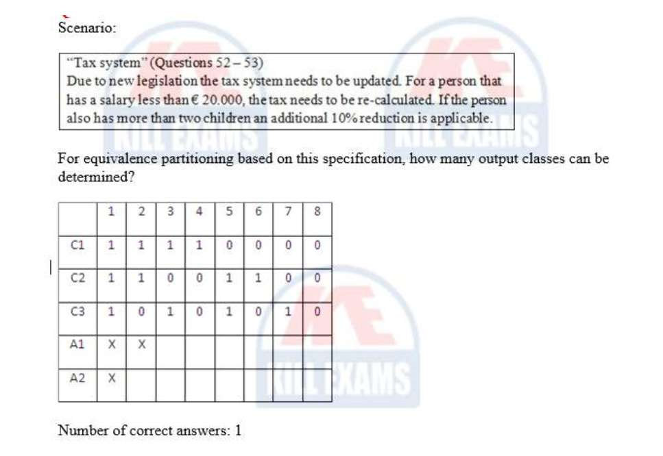
a.
2
b.
3
c.
4
d.
5

Đáp án: B

Câu hỏi 45
Which of the following is an example of testing as part of the software design phase? Number of correct answers: 1
a.
A design review meeting
b.
An architect translating requirements into design
c.
Performing unit tests against design
d.
A test log showing code coverage achieved

Đáp án: A

Câu hỏi 46
Which TWO of the following artefacts can be useful as a test oracle the first time a test case is run? Number of correct answers: 2
a.
Incident report.
b.
Requirements Specification
c.
Test summary report
d.
Legacy system
e.
Test plan

Đáp án: B,D

Câu hỏi 47
As a technical test analyst, you have found out during test case design that the design document is incomplete. Which is an example of a good way to communicate that problem in an email? Number of correct answers: 1
a.
E-mail: “Until I have received an updated version of the design document, I will not do any work on the test design.”
b.
E-mail: “When will it be possible to receive the missing information? Test design is impeded by a lack of clarity here.”
c.
E-mail: “Here we go again. The developer gave us incomplete and ambiguous design specifications. Typical.”
d.
Do not communicate the problem, just log the delaying effect of the information problem and be ready to explain the delays to the test manager later.

Đáp án: B

Câu hỏi 48
Identify the most significant risk introduced by this approach to incident management. Number of correct answers: 1
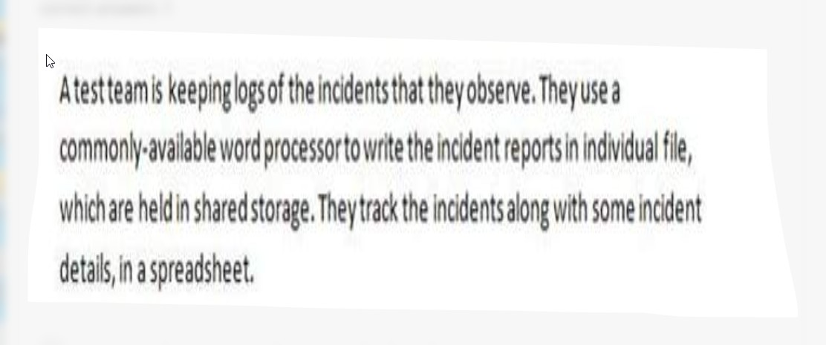
a.
Excel list may not be in synchronisation with Word documents
b.
Low level of usability
c.
Spreadsheet/text files may not be complete
d.
Does not map to IEEE 1044

Đáp án: A

Câu hỏi 49
As a technical test analyst, which documents would you typically create? Number of correct answers: 1
a.
Test plan, test design, test cases and test log
b.
Test plan, test log, test design and test summary report
c.
Test script, test log, incident report and test design
d.
Incident report, test item transmittal report, test cases and test procedure

Đáp án: C

Câu hỏi 50
In which of the following test documents would you expect to find the preconditions to start executing a set of test cases? Number of correct answers: 1
a.
Level test plan
b.
Test procedure specification
c.
Test design specification
d.
Master test plan

Đáp án: B

Câu hỏi 51
The development manager asks you to identify suitable test coverage entry criteria for a component test. Which TWO of the following would you recommend as appropriate for entry criteria to a component testing phase? Number of correct answers: 2
a.
100% statement coverage B.
b.
No critical outstanding defects
c.
Test log available
d.
Code review completed
e.
Static analysis shows no major violations

Đáp án: D,E

Câu hỏi 52
As a technical test analyst, you are involved in a risk analysis session using the Failure Mode and Effect Analysis technique. You are calculating risk priorities. Which of the following are the major factors in this exercise? Number of correct answers: 1
a.
Severity and priority
b.
Functionality, reliability, usability, maintainability, efficiency and portability
c.
Likelihood and impact
d.
Financial damage, frequency of use and external visibility

Đáp án: A,C

Câu hỏi 53
Identify TWO main advantages of this approach to incident management. Number of correct answers: 2
a.
Quick to set up and cheap
b.
Electronic rather than manual
c.
Allows attachments (e.g. screen prints) to be linked to the incident reports
d.
Can easily be integrated with open source tools
e.
Large files are not a problem

Đáp án: A,B

Câu hỏi 54
Which of the following would you recommend as the best combination of fields to add? Number of correct answers: 1
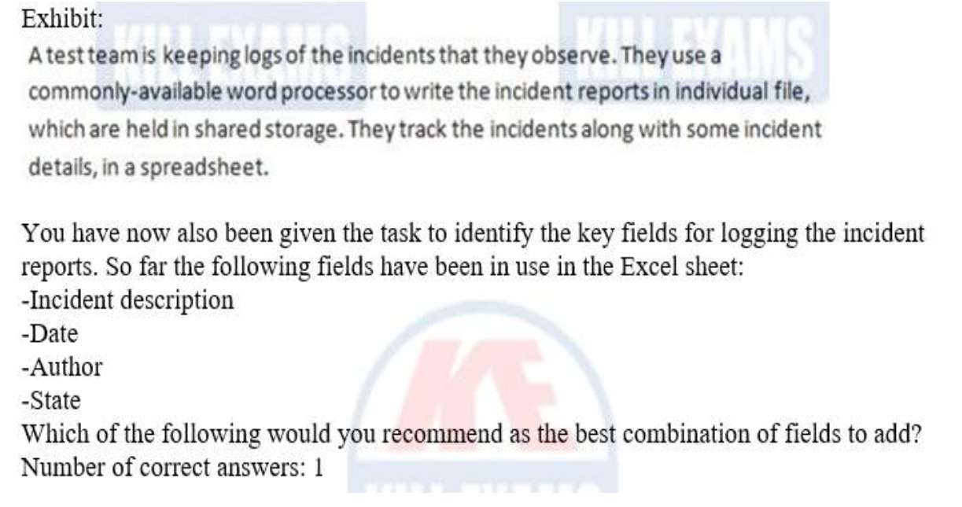
a.
Priority, version of software under test, incident identification
b.
Date to be fixed, priority, incident identification
c.
Developer assigned to the fix, version of software under test, incident identification
d.
Priority, version of software under test, date to be fixed

Đáp án: A

Câu hỏi 55
Defects are discovered through test analysis and design because… Number of correct answers: 1
a.
the tasks involve extracting information from the test basis
b.
developers are involved in writing test cases
c.
the cost of fixing a defect will increase if found later on
d.
the author of the test basis will have made errors

Đáp án: A

Câu hỏi 56
How many test cases are needed to test code fragment lines 26 – 32 to achieve 100% multiple condition coverage? Number of correct answers: 1
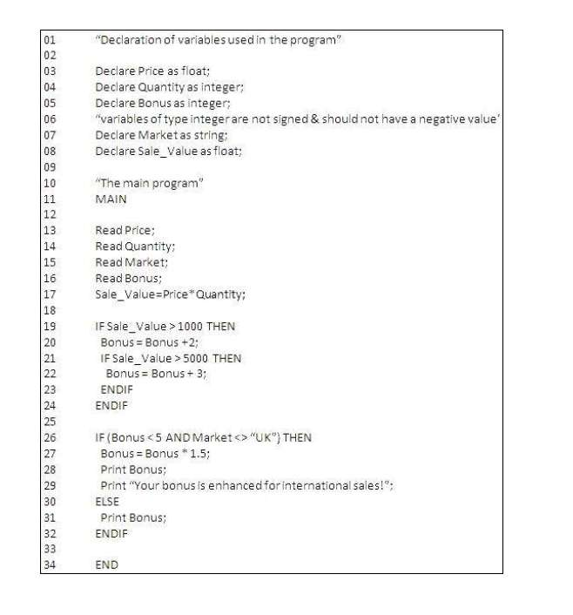
a.
2
b.
3
c.
4
d.
8
Đáp án: D

EXAM 4 AL2025- Update 2025

Câu hỏi 1
The result of a product risk analysis performed on components I, II and III of the airplane control system shows the following risk matrix: (image) The project wants to mitigate the risks by defining different types of coverage depending on the risk level of the components. Which of the following would be a meaningful solution for setting the coverage targets?
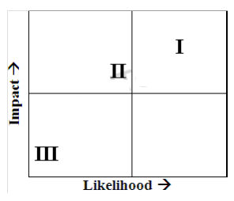
a.
I: Condition determination coverage, II: Decision Coverage, III: Statement coverage
b.
I: Condition determination coverage, II: Statement coverage, III: Decision coverage
c.
I: Decision coverage, II: Condition determination coverage, III: Statement Coverage
d.
I: Multiple condition coverage, II: Decision coverage, III: Condition determination coverage

Đáp án: A

Lời giải: Cái bảng về risk level = Impact * likelihood ( chương 3) thì theo đó I là risk có level cao nhất, III là risk có level thấp nhất. Dựa vào lý thuyết của chương 4 white box test sách đầy đủ để chọn các kỹ thuật mà cao nhất trong thực tế cho I là Condition determination coverage ( bởi vì Multiple condition coverage là cao nhất theo lý thuyết nhưng thực tế ko xảy ra nên ko chọn D) tiếp theo Decision coverage cho II và cuối cùng III thấp nhất nên chọn statement coverage
Câu hỏi 2
Which of the following is a comma-separated, sequenced list of test cases that covers these risks in a way that is appropriate to the level of risk and that minimizes test effort?
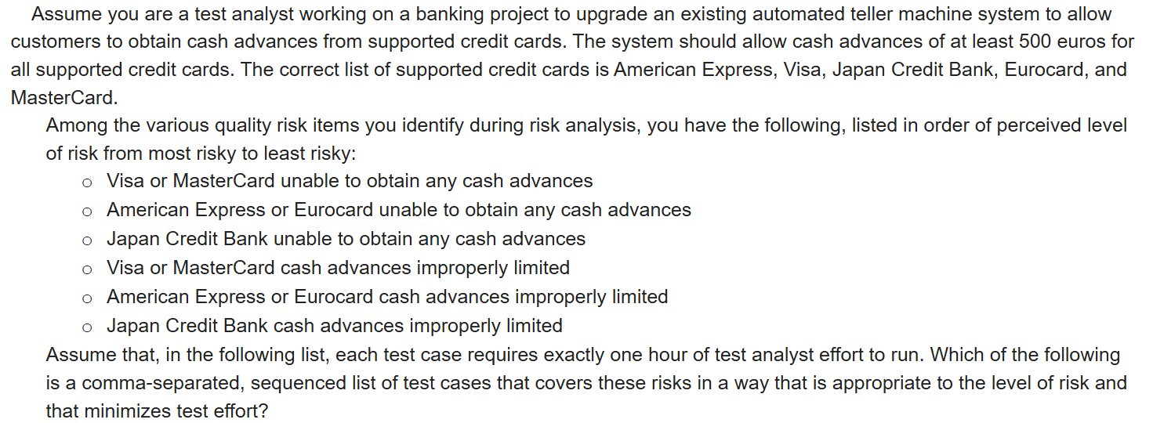
a.
Test minimum American Express and Eurocard advances; test minimum Visa and MasterCard advances; test minimum Japan Credit Bank advances.
b.
Test minimum and maximum Visa and MasterCard advances; test minimum and maximum American Express and Eurocard advances; test minimum and maximum Japan Credit Bank advances.
c.
Test minimum Visa and MasterCard advances; test minimum American Express and Eurocard advances; test minimum Japan Credit Bank advances; test maximum Visa and MasterCard advances; test maximum American Express and Eurocard advances; test maximum Japan Credit Bank advances.
d.
Test maximum American Express and Eurocard advances; test maximum Visa and MasterCard advances; test maximum Japan Credit Bank advances.

Đáp án: B

Lời giải: Câu hỏi nó vừa hỏi TC nào vừa chạy các Risk có level theo thứ tự từ cao xuống thấp và lại tối ưu effort chạy nhất. Thế thì 1 thẻ khi test mình test luôn cả Minimum và cả maximimum là tối ưu nhất, nên theo ảnh thứ tự chạy dựa vào risk level và tối ưu nhất là đáp án B
Câu hỏi 3
Which review type are Formal peer review?
a.
Management review
b.
Walkthrough
c.
Technical review
d.
Inspection
e.
Audit

Đáp án: B,C,D

Lời giải: Formal peer review là hình thức review theo quy trình với 1 nhóm từ 3 người trở lên để review các tài liệu của dự án nên ta chọn Walkthrough, technical review và inspection
Câu hỏi 4
You have identified a usability risk with the mobile application you are currently testing. When the application loses connectivity with the web server, the user is not informed of the problem and all information entered after that point is lost. What is a reasonable assessment of this risk?
a.
The impact is high because the user will lose their data. The likelihood depends on how often connectivity will be lost.
b.
The impact is low because the user can retype their information. The likelihood is high because the original data is lost.
c.
The impact is medium because the user should expect this type of behavior. The likelihood is medium because the problem will be intermittent.
d.
The impact is high because the user will not understand what is happening and will likely call the helpdesk. The likelihood is low because the network connectivity is reliable and unlikely to have any issues.

Đáp án: A

Lời giải: Risk của cái này thì impact là cao vì người dùng mất hết dữ liệu còn likehood thì chưa có đủ dữ liệu để đánh giá.
Câu hỏi 5
As an acceptance tester you want to test the $100 withdrawal process described by the following BPMN model. (image) You would like to achieve decision coverage. Consider the following test cases: Test 1: balance = $100, receipt = YES Test 2: balance = $99 Test 3: balance = $120, receipt = NO Test 4: balance = $2500, receipt = YES Which of the following is the minimal set of test cases allowing to achieve full decision coverage?
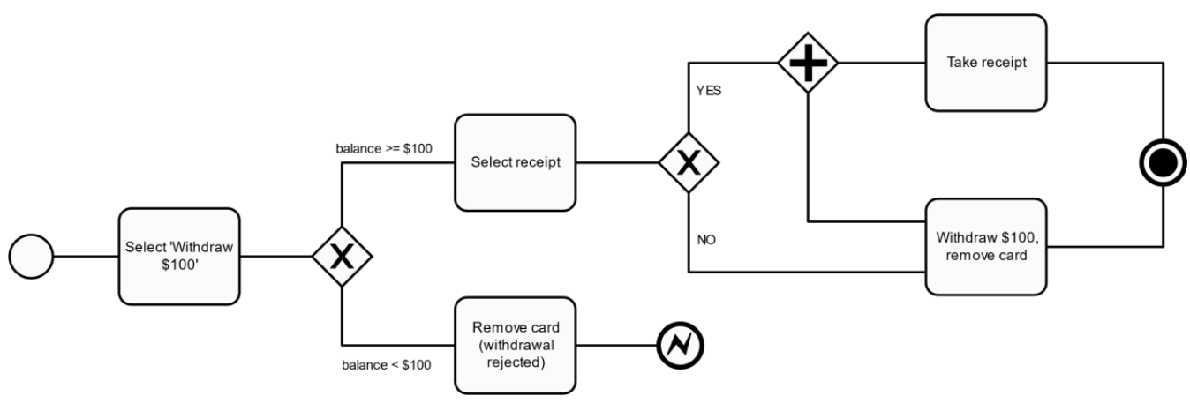
a.
Test 1, Test 2, Test 4
b.
Test 1, Test 2
c.
Test 2, Test 3
d.
Test 1, Test 2, Test 3

Đáp án: D

Lời giải: Nhìn vào sơ đồ ta chọn Test case mà nó đi được nhiều decision outcome chưa run nhất có thể để chọn,Test 1: balance = $100, receipt = YES ---> đi qua Select 100$, select Reciept Yes nên đi qua 2 lệnh (take receipt và withdraw 100$, ký hiệu + là thực hiện 2 lệnh), Test 2: balance = $99 là TH ko đủ 100$ để rút, Test 3: balance = $120, receipt = NO là TH đủ 100$ để rút và ko lấy Receipt nên 3 TC này là đủ đi hết các Decision outcome rồi
Câu hỏi 6
You have identified that you expect to have a load of 100,000 users for a high interest race and 20,000 users for a low-interest race. There are 5,000 users who seem to always be connected, even when nothing is happening. High-interest races are the semi-finals and finals for any particular contest. A race normally lasts for 5 minutes and there are usually 8 racers in the semi-finals and 4 racers in the finals. A low-interest race is any of the first 30 races that lead to determining who will be in the semi-finals. Which of the following is a correct diagram of the proper load profile for one contest (the x axis shows hh:mm and the y axis shows number of users)?
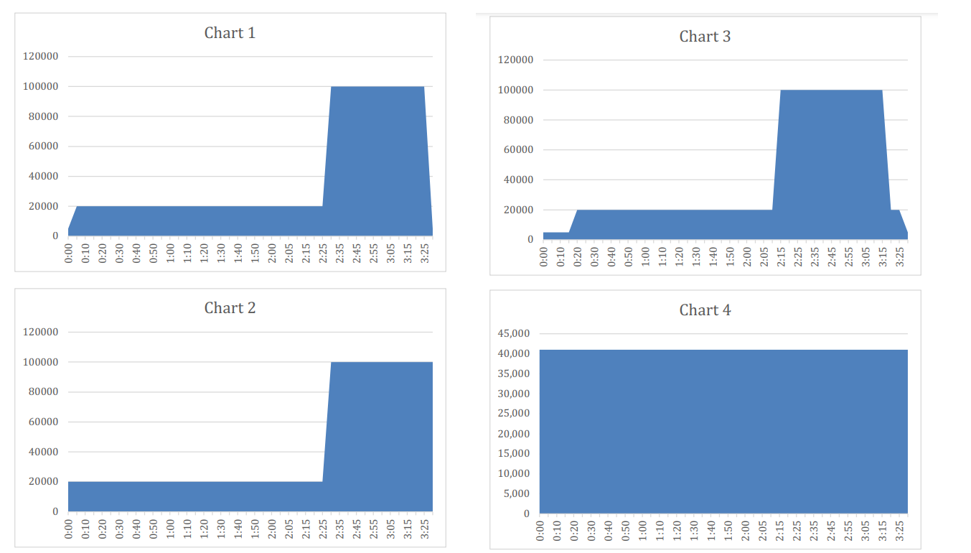
a.
Chart 1
b.
Chart 2
c.
Chart 3
d.
Chart 4

Đáp án: A

Lời giải: A đúng nhất về hồ sơ của 1 cuộc đua, nó cho thấy lúc ko có gì thường vẫn có 5.000 user theo dõi, ở giai đoạn tranh suất bán kết là low-interest race khi đó có 20.000 user theo dõi và ở đoạn chung kết thì high interest race có 100.000 user theo dõi. Chart 4 luôn có 40.000 user theo dõi là sai rồi. chart 2 thì sai ở đoạn finals là lúc high interest nên ko thể xuống thấp thế đc, chart C thì nó ko thể hiện đc lúc ko có cuộc đua chỉ có 5.000 user theo dõi thôi chứ ko phải lúc nào cũng là 20.000 user
Câu hỏi 7
You have been given the following story: “As a plant lover who travels frequently, I want to have an automated watering system, so that my plants won’t die.” You have also been given the following acceptance criteria: 1. The water should turn on when the temperature is > 85 degrees and the moisture content of the soil changes from “normal” to “dry”. 2. The water should be dispersed for 5 minutes at the rate of 0.5 ounces per minute. Which one of the following provides the proper values to use to achieve 100% two-value boundary value analysis coverage with the minimum number of test cases?
a.
Temperature at 85 and 86, moisture at “dry” and “normal”
b.
Temperature at 85 and 86, moisture at “dry” and “normal”, water disbursement for 5 minutes and 5 minutes 1 second, rate at 0.5 and 0.4
c.
Temperature at 85 and 86, moisture at “dry” and “normal”, water disbursement for 5 minutes and 4 minutes 59 seconds, rate at 0.5 and 0.6
d.
emperature at 85 and 84, moisture at “dry” and “normal”

Đáp án: A

Lời giải: Ở đây các bạn hay nhầm đoạn này "2. The water should be dispersed for 5 minutes at the rate of 0.5 ounces per minute." cái này là output ý là nước phải chảy ra trong vòng 5 phút và tốc độ là 5 ounce per minute ( cái này đưa vào expected result) nên ở đây BVA chọn A thôi
Câu hỏi 8
You have been given the following story: “As a plant lover who travels frequently, I want to have an automated watering system, so that my plants won’t die.” You have also been given the following acceptance criteria: 1. The water should turn on when the temperature is > 85 degrees and the moisture content of the soil changes from “normal” to “dry”. 2. The water should be dispersed for 5 minutes at the rate of 0.5 ounces per minute. Which of the following is the first test case that should be written for the acceptance-test driven implementation?
a.
Set the soil moisture level to “wet”, then increase the heat and verify that the moisture level changes to “normal” and then to “dry” and then to “parched”
b.
Set the temperature > 85 degrees and verify that the temperature is increased accordingly
c.
Set the temperature to < 85 degrees and the moisture to “dry” and verify that no water is dispersed
d.
Set the temperature to > 85 degrees and the moisture to “dry” and verify that water is dispersed

Đáp án: D

Lời giải: Test case kiểm tra TH success phải là case viết đầu tiên
Câu hỏi 9
Which of the following answers best describes the test activities (assuming it is possible to perform all of them) you should plan for?
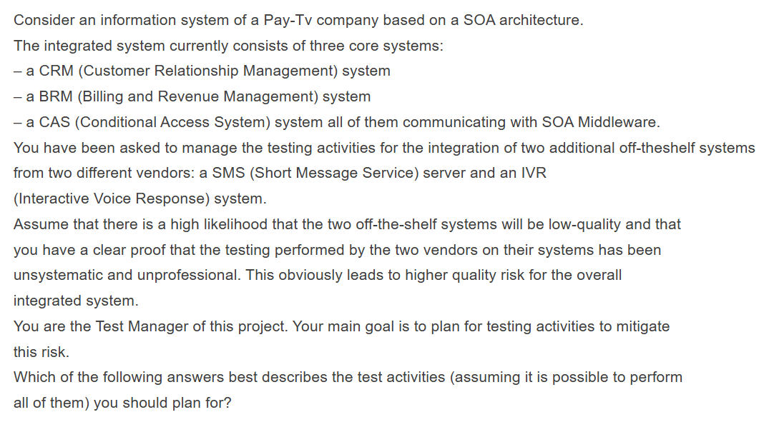
a.
You should plan for an informal and minimal acceptance test of the two off-the-shelf systems and then a single end-to-end test of the overall integrated system
b.
You should directly plan for a single end-to-end test focused on end-to-end tests of the overall integrated system without an acceptance test of the two off-the-shelf systems
c.
You should plan for two levels: a system integration test and an end-to-end test of the overall integrated system
d.
You should plan for adequate re-testing of both the systems followed by a system integration test and an end-to-end test of the overall integrated system

Đáp án: D

Lời giải: Ở câu hỏi nó bảo giả sử bạn có thể làm đc tất cả các test đó vì thế. Khi mua các hệ thống này về phải re-testing cho các hệ thống, sau đó tiến hành system integration test khi tích hợp vào hệ thống cũ, rồi làm Acceptance test ( end to end)
Câu hỏi 10
You are going to be testing a small camera. To keep it simple, there are only two buttons: the power button and the shutter button. The camera will act as an automatic focus and exposure camera when the shutter button is pressed halfway and then stopped for 0.4 seconds before the button press is completed. If the shutter button is simply pressed all the way without stop-ping, the camera will act as a single exposure, infinity focus camera. Given the following state transition diagram, how many rows would its matching state transition table contain?
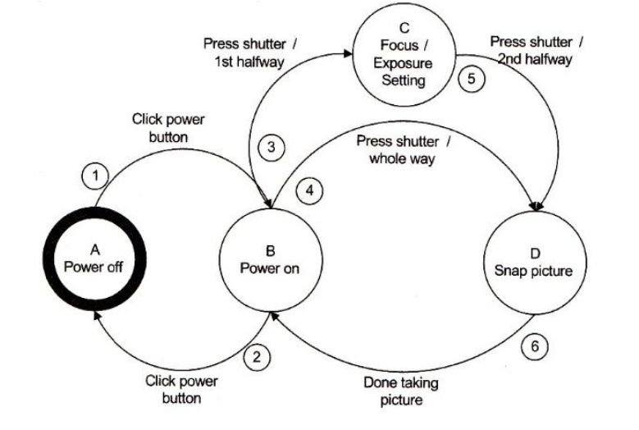
a.
6
b.
18
c.
20
d.
24

Đáp án: B

Lời giải: Điếm lần lượt từ 0-switch, 1-switch, và 2-switch ra số TC là số rows. Đáp án trên mạng là 18 mà chưa biết cách giải
Câu hỏi 11
Which of values are suitable to put on the blank 1 and 2?
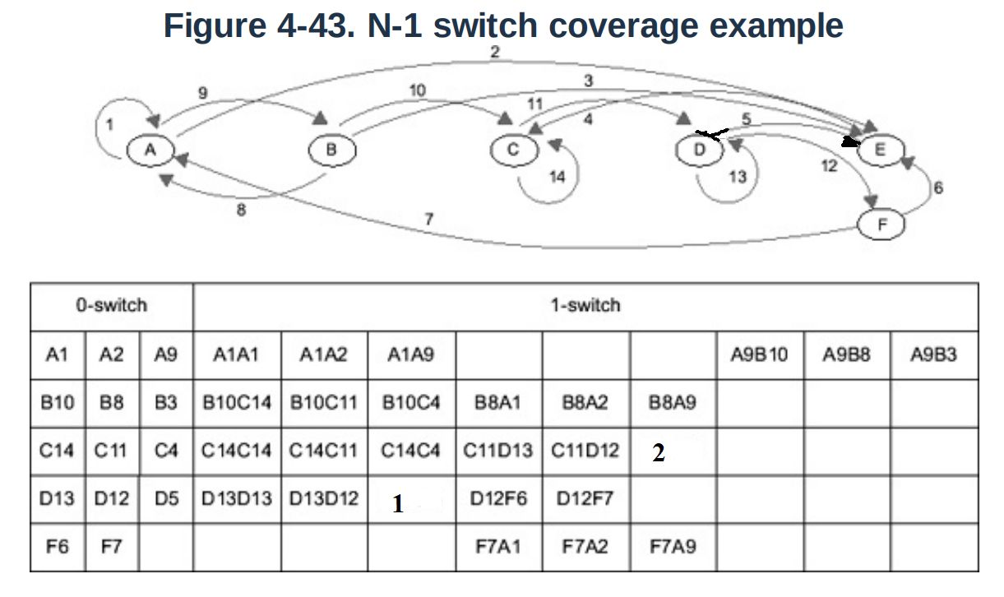
a.
1. D13D11 2. C11D12
b.
1. D13D13 2. C11E5
c.
1. D13D5 2. C11D5
d.
1. D13D5 2. C11D12

Đáp án: C

Lời giải: Điền vào ô trống thôi, các bạn tự điền nốt cái 1-switch ở ô 1 và ô 2. Hình ảnh từ sách bị sai mũi tên, mình vừa sửa lại mũi tên để làm bài này đúng hơn
Câu hỏi 12
Which technique is most appropriate to use for the suitability test? For the on-line portal a test will be planned that will focus on suitability. Which technique is most appropriate to use for the suitability test?
a.
Use Cases
b.
Equivalence Partitioning and Boundary Value Analysis
c.
State Transition Testing
d.
Pairwise Testing

Đáp án: A

Lời giải: Use case là kỹ thuật phù hợp nhất để test cho suitability ( tính phù hợp)
Câu hỏi 13
Given the following figures for the testing on a project, and assuming the failure rate for initial tests remains constant and that all retests pass, what number of tests remain to be run?
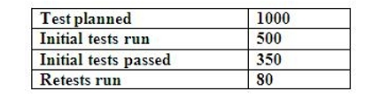
a.
700
b.
720
c.
784
d.
570

Đáp án: B

Lời giải: Tổng có 1000 TC, 500 TC đã chạy, 350 cái đã pass vậy là fail 150 TC. Chú ý đầu bài nói "remains constant and that all retests pass" tỷ lệ là ko thay đổi và TC nào retest rồi thì đều pass. Như vậy 500 TC chưa chạy, với tỉ lệ dựa vào 500TC đầu đã chạy thì sẽ có 150 TC sẽ fail. vậy tổng TC còn lại cần test là 500 + 70 +150 = 720 TC
Câu hỏi 14
A remote subsystem developer has delivered a module that decides whether to sound an alarm based on three inputs (a HEAT sensor, a SMOKE sensor, and a user-triggered BUTTON). An alarm should sound if both the HEAT sensor and the SMOKE sensor are triggered, or if the alarm BUTTON is triggered. What is the minimum set of test combinations from the following sets of input values that achieve 100% Decision Condition coverage? 1. HEAT=true, SMOKE=true, BUTTON=false 2. HEAT=true, SMOKE=true, BUTTON=true 3. HEAT=true, SMOKE=false, BUTTON=false 4. HEAT=false, SMOKE=false, BUTTON=true 5. HEAT=false, SMOKE=false, BUTTON=false 6. HEAT=false, SMOKE=true, BUTTON=false
a.
3 and 6
b.
1 and 4
c.
2, 4, and 6
d.
2 and 5

Đáp án: D

Lời giải: White box test phần data flow: 100% Decision Condition coverage là đảm bảo cả Conditions và cả Decision đều đc chạy T,F ít nhất 1 lần
Câu hỏi 15
You have been assigned the checklist entry that requires you to review the specification for inconsistencies between individual requirements (i.e. conflicts between requirements). Which of the following CORRECTLY identifies inconsistencies between pairs of requirements?
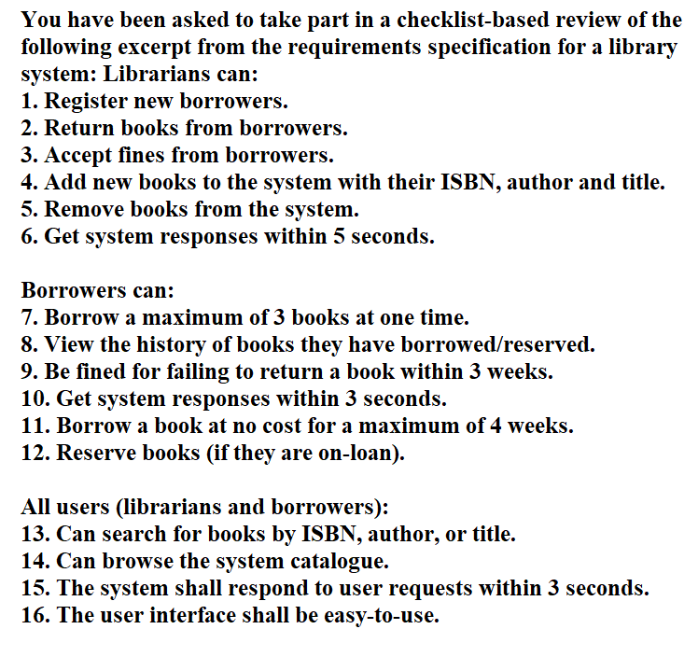
a.
6-10, 6-15, 7-12
b.
6-15, 9-11
c.
6-10, 6-15, 9-11
d.
6-15, 7-12

Đáp án: B

Lời giải: Câu hỏi đang hỏi cặp requirement nào đang ko thống nhất với nhau: Nhìn vào con số dễ thấy nhất là đang lệch nhau giữa 6- Response time 5s và 15- 6- Response time 3s, 9- trả muộn sau 3 week thì bị phạt và 11- ko tính phí với sách đc mượn maximun là 4 week.
Câu hỏi 16
You have to review the following user story that will be developed and tested during the next Sprint: As a potential conference attendee, I want to be able to register for the conference online, so that registration is simple and paperless. The following acceptance criteria are also mentioned: i. Payment can be made via PayPal, Debit or Credit Cards ii. An acknowledgement email is sent to the attendee after submitting the form iii. Protection against spam is working as expected iv. Information from the form is stored in the registrations database v. All incorrect user inputs are flagged by the system Which of the following correctly shows which acceptance criteria are testable?
a.
ii, iv, v are testable
b.
i, iii, v are testable
c.
i, ii, iv are testable
d.
iii, iv, v are testable

Đáp án: C

Lời giải: Cái AC nào có đẩu đủ thông tin để test. i là test đc vì card rõ ràng, ii test đc cần gửi email sau khi summit form, iii ko test đc vì ko rõ ràng về việc "as expected" là chưa đủ rõ ràng, iv các thông tin đc lưu vào Database thì test đc, v ko test đc vì "inputs are flagged" thông tin ko chính xác chưa đc mô tả rõ . Nên chọn C.
Câu hỏi 17
The principle of Cyclomatic complexity (CC), considering E as edges or links, N as nodes, P as independent paths
a.
CC= E-N +2P
b.
CC= N-E +2P
c.
CC= N-E +P
d.
CC= N-E +P

Đáp án: A

Lời giải: Xem sách Vol 3 để có hướng dẫn cách tính này hoặc search trên mạng về công thức của cyclomatic complexity
Câu hỏi 18
Your test team consists of four members (Mary, Bob, Mark, Dave) with different interpersonal skills. The following skills assessment spreadsheet shows the characteristics of the team members with respect to a list of interpersonal-skills (for each characteristic only the member with the highest level of that characteristic is indicated and marked with ‘X’): (image) On the next project a member of your test team will have to perform some routine tasks requiring collaboration with other teams. Who in your test team would you expect to be most suitable at doing these tasks?
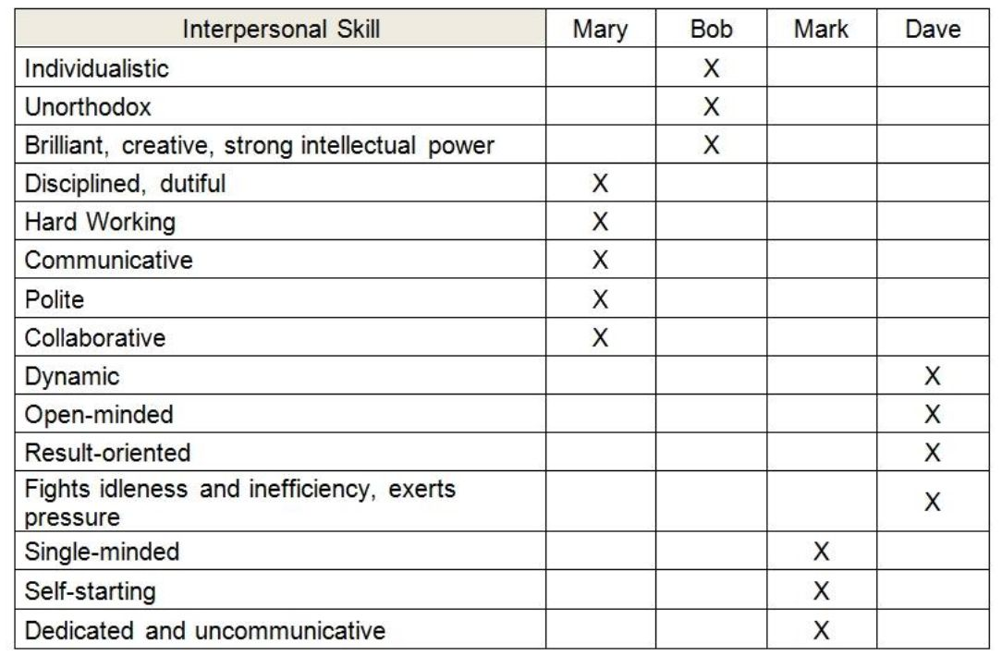
a.
Mary
b.
Bob
c.
Mark
d.
Dave

Đáp án: A

Lời giải: Dự án mới họ cần 1 người có khả năng kết nối với các team khác tốt vì thế các kỹ năng về collaborative phải tốt.
Câu hỏi 19
You are testing a photo-enforcement system for traffic control in an intersection. The requirements state a photo shall be taken if the signal light is red (RED) or the car is speeding (SPEED) and if the front wheels of the car are over the line marking the beginning of the intersection (WHEELS). Consider these sets of values: 1. RED + SPEED + WHEELS 2. RED + SPEED + not WHEELS 3. RED + not SPEED + WHEELS 4. RED + not SPEED + not WHEELS 5. not RED + SPEED + WHEELS 6. not RED + SPEED + not WHEELS 7. not RED + not SPEED + WHEELS 8. not RED + not SPEED + not WHEELS Assume the logic in the code is as follows: If ((RED or SPEED) and WHEELS) then Take the photo Else Do not take the photo Which sets of values provide the minimum tests to achieve 100% multiple condition coverage?
a.
All the sets are needed
b.
3, 4, 5, and 7
c.
1, 3, and 8.
d.
1, 5, 7, and 8.

Đáp án: A

Lời giải: Multiple condition thì cần 2 mũ n test case, mà ở đây n là số condition, ta có 3 condition là RED, SPEED và WHEELS nên cần 8 TC
Câu hỏi 20
You are testing a photo-enforcement system for traffic control in an intersection. It has been determined that a photo should be taken if the signal light is red (RED) or the car is speeding (SPEED) and if the front wheels of the car are over the line marking the beginning of the intersection (WHEELS). Consider these sets of test values: 1. RED + SPEED + WHEELS 2. RED + SPEED + not WHEELS 3. RED + not SPEED + WHEELS 4. RED + not SPEED + not WHEELS 5. not RED + SPEED + WHEELS 6. not RED + SPEED + not WHEELS 7. not RED + not SPEED + WHEELS 8. not RED + not SPEED + not WHEELS Assume the logic in the code is: IF ((RED OR SPEED) AND WHEELS) THEN TAKE THE PHOTO ELSE DO NOT TAKE THE PHOTO Which sets of values provides the minimum tests to achieve 100% modified condition/decision coverage?
a.
1, 3, and 8.
b.
2 and 8.
c.
3, 4, 5, and 7.
d.
1, 5, 7, and 8.

Đáp án: C

Lời giải: MC/DC cần n+1 TC, ở đây ta có 3 cái condition là RED, SPEED, WHEELS nên cần có 4 TC và phải đảm bảo mỗi Conditon khi là T thì cho kết quả khác với khi là F nên ta cần 4 TC theo thứ tự sau:1. (T or F) + T --> T 2. (T or F) + F--> F ( 2 case này là WHEELS thỏa mãn) 3. (F or T) + T--> T ( case 2 và 3 thì SPEED thỏa mãn) 4. (F or F) + T --> F ( case 1 và 4 thì RED thỏa mãn)
Câu hỏi 21
The following piece of code: How many test cases are needed at least to cover decision coverage testing? [K3] Procedure XXXX READ (Age) "This statement gets the actual age from the input device READ (Gender) "This statement gets the gender age from the input device READ (CustomerCountry) "This statement gets the country, alias IF (Age >18) THEN CustomerType = "Main Target Customer" CustomerPotential = 1.000 IF Gender = "Male" THEN CustomerProductSet — "Technique" ELSE CustomerProductSet = "Clothes" END IF END IF CustomerIsTarget = "Yes" IF CustomerCountry<> "Vietnam" THEN CustomerIsTarget= "No" CustomerIslnternational = "Yes" CustomerPotential = CustomerPtential *1.1 ELSE Customerlslnternational = "No" END IF END Procedure
a.
2
b.
3
c.
4
d.
5

Đáp án: B

Câu hỏi 22
Assume you would like to create a model describing a loan request process in a bank. The loan request process starts when the customer submits a loan application. The bank then reviews the application. Regardless of whether the loan request is approved or not, a letter is sent to inform the customer of the decision. If the request is approved, the loan contract is created. You have drawn the following business process model using BPMN 2.0. (image) Which one of the following sentences is true with respect to this process model?
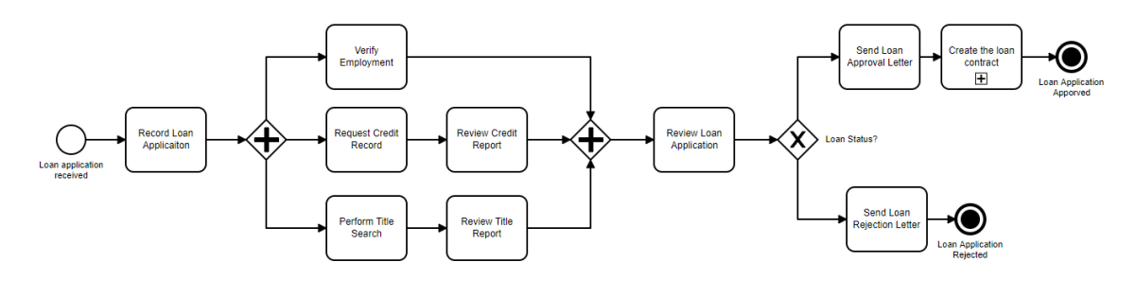
a.
Verifying employment is not done when the loan status is rejected
b.
Creating the loan contract is defined as a sub-process
c.
Performing title search and requesting credit report are sequential tasks
d.
A review credit report is optional when reviewing the loan application

Đáp án: B

Lời giải: a) Is not correct: “Verify Employment” is systematically done after the “Record Loan Application” task and prior to “Review Loan Application” in which the decision regarding the loan application is taken. b) Is correct: “Create the Loan Contract” is defined as a subprocess c) Is not correct: a parallel gateway splits the flow between “Perform Title Search” and “Request Credit Report” tasks. d) Is not correct: the task “Review Credit Report” has to be done before “Review Loan Application” in the process flow.
Câu hỏi 23
Consider the following test cases that are used to test an accounting system: (image) Given this information, what is the proper order in which to execute these test cases?
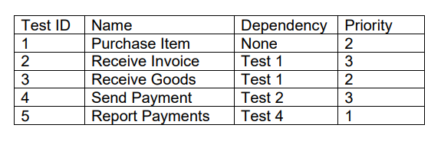
a.
5, 1, 3, 2, 4
b.
1, 2, 4, 5, 3
c.
1, 3, 2, 4, 5
d.
3, 4, 5, 1, 2

Đáp án: B

Lời giải: Đầu tiên bạn phải dựa vào cột Dependency trước, những case mà ko bị phụ thuộc mới chạy đc, ở đây chỉ có TC 1 là None nên TC 1 chạy trước tiên, sau đó TC 2,3 phụ thuộc vào TC 1 nên đc cân nhắc chạy tiếp theo, TC 2 cao hơn 3 nên chạy sau TC 1, tiếp theo TC3, TC4 có thể chạy đc vì TC 4 phụ thuộc vào TC2, TC 4 ưu tiên cao hơn TC3 nên sẽ chạy tiếp theo, cuối cùng còn TC3, TC5 chạy nốt. Đáp án B thì TC5 chạy trước TC 3 thì vi phạm về độ ưu tiên nhưng vì nó vi phạm ở đoạn cuối, còn đáp án C thì TC3 chạy trước TC2 vi phạm về ưu tiên và vi phạm rất sớm ở ngay vị trí chạy thứ 2 đã vi phạm nên người ta chọn B
Câu hỏi 24
You have been given the following set of test cases to run. You have been instructed to run them in order by risk and to accomplish the testing as quickly as possible to provide feedback to the developers as soon as possible. Given this information, what is the best order in which to run these tests?
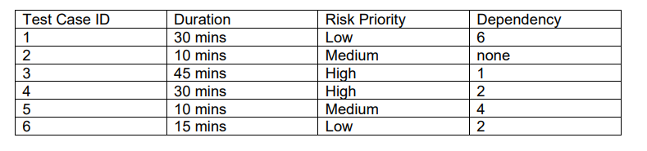
a.
2, 4, 5, 6, 1, 3
b.
4, 3, 2, 5, 6, 1
c.
2, 5, 6, 4, 1, 3
d.
6, 1, 3, 2, 4, 5

Đáp án: A

Lời giải: Xem cột dependency trước: None chỉ có TC 2 nên 2 chạy đầu tiên, sau đó TC 4, 6 phụ thuộc vào 2 nên tiếp tục đc cân nhắc chạy, TC 4 có risk cao hơn nên chạy tiếp theo, Sau đó TC 6 và TC 5 cân nhắc đc chạy ( vì TC 5 phụ thuộc vào TC4), cứ vậy ta chọn đc A
Câu hỏi 25
You are the Technical Test Analyst working on the testing of software that will control the movement of a roof on a new national sports stadium that seats 100,000 spectators. A failure analysis has shown that if the software system fails then it may cause the roof to break up and fall on the spectators. The government has requested that the level of testing for this software exceeds that that required by standard ISO 61508. Which is the level of test coverage you would expect to be achieved in the testing of the control software for the stadium roof?
a.
Decision coverage + Modified Condition/Decision coverage.
b.
Decision coverage + Statement coverage
c.
Modified Condition/Decision coverage
d.
Multiple Condition coverage

Đáp án: D

Lời giải: Câu này chú ý "the level of testing for this software exceeds that that required by standard ISO 61508." họ muốn mức độ test vượt quá exceeds các yêu cầu của ISO 61508, trong khi mái nhà sân vận động là 1 ứng dụng critical safety cần đạt MC/DC theo chuẩn ISO, nên cái mà cao hơn MC/DC là đáp án D.
Câu hỏi 26
A company wants to develop a web site to implement an on-line sales channel. Which TWO ISO 9126 quality attributes are most likely to be of importance?
a.
Boundary usability
b.
Accuracy
c.
Portability
d.
Fault-tolerance
e.
Installability

Đáp án: A,C

Lời giải: Chương 5 các đặc tính của ISO9126 , vừa sửa lại các đáp án theo đúng đề thi các bạn vừa thi về nhé, sửa lại nội dung và câu trả lời
Câu hỏi 27
Of the following statements: 1. Ownership of the improvement process may be with a dedicated team 2. The scope of improvement typically covers no more than one or two projects 3. Presentation and negotiation skills are particularly relevant in achieving consensus on objectives and recommendations 4. The selected approach is often less formal 5. Detailed analysis of assessment results is required to find commonalities between the different projects Which are features of a Top-down improvement approach?
a.
2 and 4 are true, 1, 3, and 5 are false
b.
1, 3, and 5 are true, 2 and 4 are false
c.
1, 2, and 4 are true,3 and 5 are false
d.
All statements are true

Đáp án: B

Lời giải: Syllabus của Exper Test improvement, mục 6.4.2 chú ý vào các keyword này để nhớ nó là Top-down: a dedicated team, different projects, consensus on objectives and recommendations
Câu hỏi 28
The tax system needs to be updated due to new legislation. For a person with a salary of less than $20.000 and who is married, the tax needs to be re-calculated. If the person also has more than two and less than five children, an additional 10% reduction is applicable. The functionality of the newly released tax system is now at the right level. However, there are frequent complaints about non-functional issues: i. the new system does not run on PC's with VISTA installed ii. it is difficult to update the system quickly when new legislation must be implemented iii. especially when many users are using the web, the system seems to be slow iv. some users enthusiastically use the system but are not able to complete some of the transactions. Which TWO types of risks complaint i and iv?
a.
Functionality
b.
Usability
c.
Efficiency
d.
Portability
e.
Maintainability

Đáp án: B,D

Lời giải: Cái i là liên quan đến cài đặt trên OS VISTA nên chọn Portability, ii là một vài user sử dụng hệ thống nhưng ko thể hoàn thiện đc 1 vài giao dịch là liên quan đến usability, ii liên quan đến cập nhật luật thuế mới khó khăn là liên quan đến maintainability, iii là liên quan đến performance
Câu hỏi 29
Given this information, which scenarios will require system tuning and further testing?
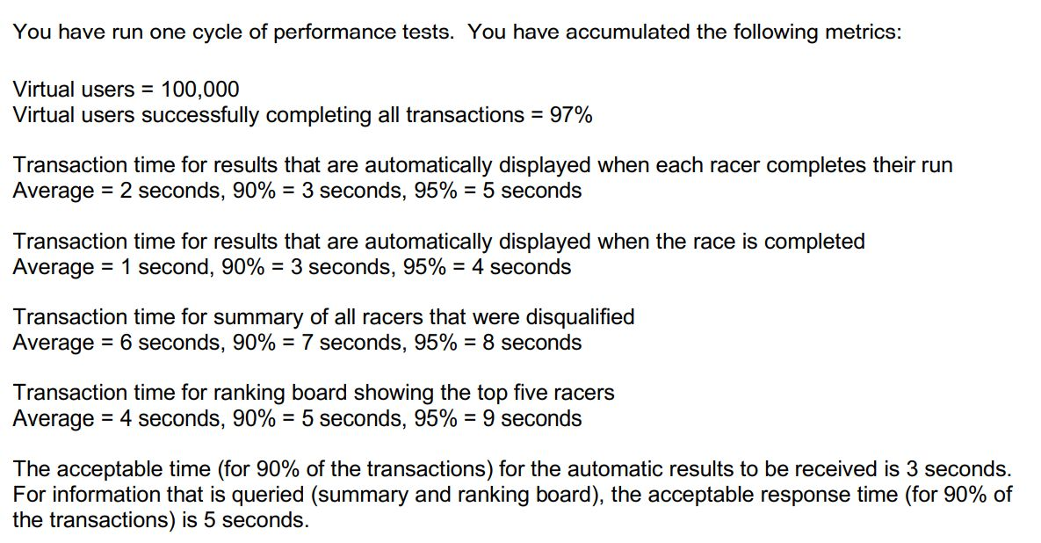
a.
All of them because these results are for only one run
b.
The automatic displays because their 95% numbers are too slow
c.
The summary of disqualifications because all times are too slow
d.
The ranking board because this is a time critical part of the system and the 95% numbers are too slow

Đáp án: C

Lời giải: C is correct. The disqualifications time is too slow, particularly for the 90%, but it’s also too slow even for the average. Tuning and retesting will be required. A may be correct and will probably need to happen, but not until C is resolved. B and D are worrying about the 95% numbers, but those are not in the requirements.
Câu hỏi 30
THIS approach that an experienced Technical Test Analyst uses a high-level, generalized list of items to be noted, checked, or remembered, or a set of rules or criteria against which a test object has to be verified. What is THIS approach called?
a.
Checklist base
b.
Structrue base
c.
Error guesting
d.
Exploratory base

Đáp án: A

Câu hỏi 31
If the project follows the IEEE 829 documentation standard, which of the following statements about the IEEE 829 templates could be correct?
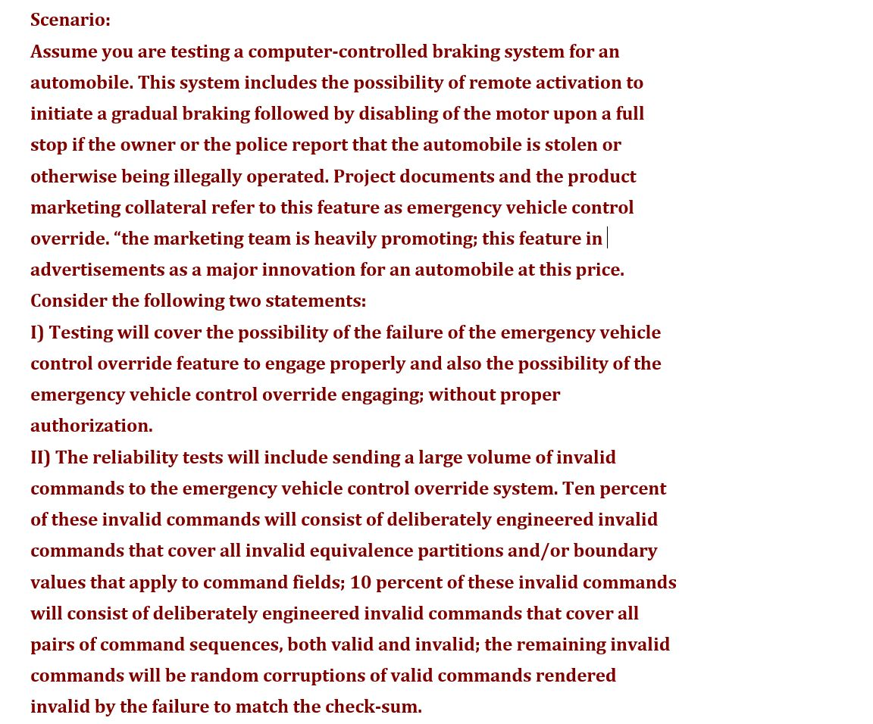
a.
I belongs in the Test Design Specification, while II belongs in the Test plan
b.
I belongs in the Test Plan, while II belongs in the Test Design Specification
c.
I belongs in the Test Cease Specification, while II belongs in the Test Plan
d.
I belongs in the Test Design Specification, while II belongs in the Test Item Transmittal Report

Đáp án: B

Câu hỏi 32
If the project is following a risk-based testing strategy, which of the following is a quality risk item that would result in the kind of testing specified in statements I) and II) above?

a.
The emergency vehicle control override system fails to accept valid commands.
b.
The emergency vehicle control override system is too difficult to install.
c.
The emergency vehicle control override system accepts invalid commands.
d.
The emergency vehicle control override system alerts unauthorized driver.

Đáp án: C

Câu hỏi 33
The following code snippet reads through a file and determines whether the numbers contained are prime or not. 1 Read (Val); 2 While NOT End of File Do 3 Prime := TRUE; 4 For Holder := 2 TO Val DIV 2 Do 5 if Val – (Val DIV Holder) * Holder= 0 Then 6 Write (Holder, � is a factor of �, Val); 7 Prime := FALSE; 8 Endif; 9 Endfor; 10 if Prime = TRUE Then 11 Write (Val, � is prime�); 12 Endif; 13 Read (Val); 14 Endwhile; 15 Write (‘End of run) Calculate the cyclomatic complexity of the code.
a.
3
b.
5
c.
7
d.
9

Đáp án: B

Câu hỏi 34
You are senior technical test analyst for a test organization that is rapidly falling behind the curve, each release, you are less able to perform all of the testing tasks needed by your project. You have very little budget for tools or people, and the timeframe for the project is about to be shortened. The testers in the group tend to have very little in the way of technical skills. Currently, 100 percent of your testing is manual, with about 15 percent of that being regression testing. Which of the following decisions might help you catch up to the curve?
a.
Allow the testers to use open-source tools to pick low-hanging fruit
b.
Put a full automation project into place and try to automate all testing
c.
Find an inexpensive requirements/test management tool to roll out
d.
Build your own automation tool so it does not cost anything

Đáp án: A

Câu hỏi 35
Which of the following metrics would be used best to prove this point during review trial? select TWO
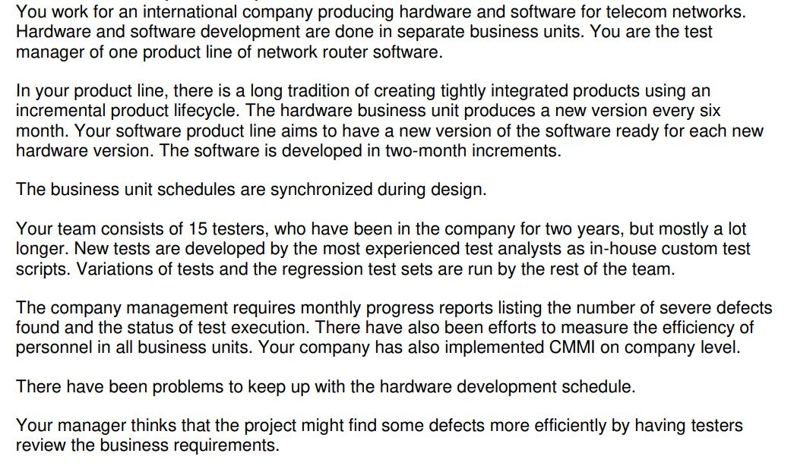
a.
Number of defects found in dynamic testing
b.
Dynamic test coverage
c.
Review and dynamic testing hours
d.
Number of severe defects in review
e.
Test execution status

Đáp án: A,D

Lời giải: câu 34 đề TM 2012 trên istqb.org
Câu hỏi 36
Assume you are managing the system testing execution phase of a project. The system test execution period for that project is scheduled for eighteen weeks and the release date is scheduled at the end of system testing. During the sixth week of system test execution, at the staff meeting, the project manager informs you that the project deadlines are changed and the release date that is only three weeks ahead. This new release will not allow the completion of the system tests. Suppose also that you have followed a riskdriven test approach for this project. Which of the following statements represents the worst way to lead your test team in the next three weeks? select TWO
a.
Neglect your management activities and work side-by-side with your test team executing tests
b.
Considering the executed tests, you should reduce the test coverage back on the risk analysis and adjust downward the priority of the associated risk items
c.
Convince all the people of your test team that each of them is an important and needed member, and that their contribution is fundamental to the success of the team
d.
Favor and encourage a proactive attitude where people ask for new tasks as soon as they finish their current tasks
e.
Neglect execute tests, only focus on product risks

Đáp án: A,E

Lời giải: Câu 39 đề TM12 thêm đáp án E
Câu hỏi 37
Which of these people, based on this analysis, would you expect to be most suitable to work specifically as tester?
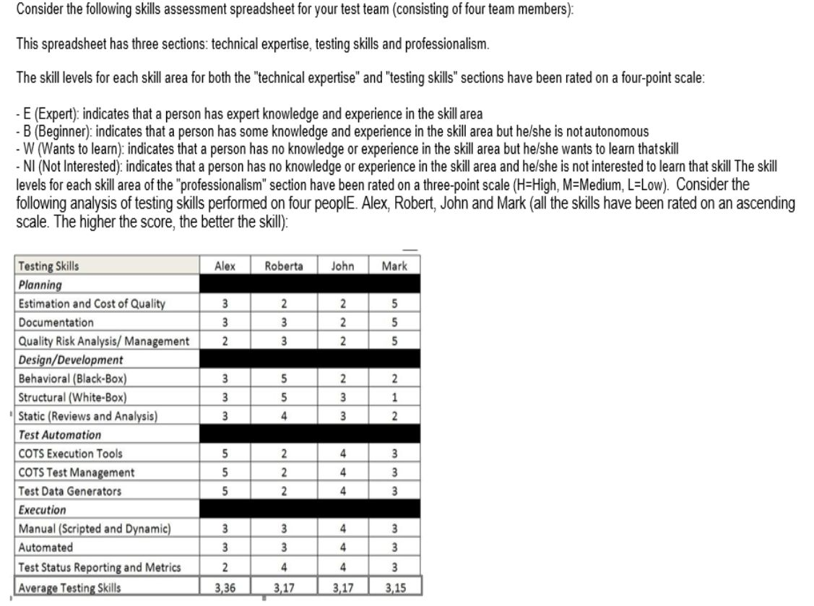
a.
Alex
b.
Roberta
c.
John
d.
Mark

Đáp án: C

Lời giải: câu 37 đề TM12 họ sưả câu hỏi đi hỏi ai là phù hợp làm tester,
Câu hỏi 38
You are working on a project that tracks health history information for patients across a region. The number of records handled by the system is in the millions due to the large number of patients in the region. Patient information must be accessible to doctors in offices, hospitals, and urgent care facilities. The information should be presented to the requestor within three seconds of request, particularly for patients with critical allergies and preconditions. You have been asked to prepare a presentation for the business stakeholders regarding your plan for performance testing. Which of the following is an example set of information that should be shared with these stakeholders?
a.
Once configured, the performance test system will require data loading. Once loaded, we will next proceed to running a small set of sample scripts to verify the output. When those succeed, we will proceed with the performance test script which ramps up users at a rate of 10 per minute until we reach the target number of concurrent users. This load will then be maintained for 2 hours
b.
The performance test system will cost $240,000 which will include the hardware and setup. This system will allow us to create a test system that is representative of the production system and will allow us to simulate production-like conditions
c.
Because the cost of a performance test system is prohibitive, we will conduct the performance testing in the production environment using live data
d.
The product risks include data contention issues, data access issues, locking issues that will reject concurrent requests, network bandwidth constraints, data seek errors, data seek slowdowns or bottlenecks, and difficulty for the user in processing the returned data

Đáp án: A

Lời giải: Câu 20 đề thi của test performance trên istqb.org
Câu hỏi 39
Assume you are a test manager in charge of integration testing, system testing, and acceptance testing for a bank. You are working on a project to upgrade an existing automated teller machine system to allow customers to obtain cash advances from supported credit cards. You have received a requirements specification that states that the system should allow cash advances from 10.000 to 10.000.000 inclusively, for all supported credit cards. Assume that the bank is required contractually to support the following credit cards: American Express, Visa, Japan Credit Bank, Eurocard, and MasterCard. The bank has given you the responsibility of organizing a review of the requirements specification. Which of the following is a risk for this review?
a.
You do not know the supported credit cards.
b.
You do not include the proper stakeholders in the review.
c.
You do not know which test levels to address
d.
You do not receive the requirements specification

Đáp án: B

Lời giải: câu này trong chapter 6 của sách Vol 1, Vol 2
Câu hỏi 40
The transactions boundaries are specified by BEGIN-TRANSACTION and END-TRANSACTION statements. For recovery purpose (in case of data lost), the system needs to keep track of all these states. Calculate the cyclomatic complexity:
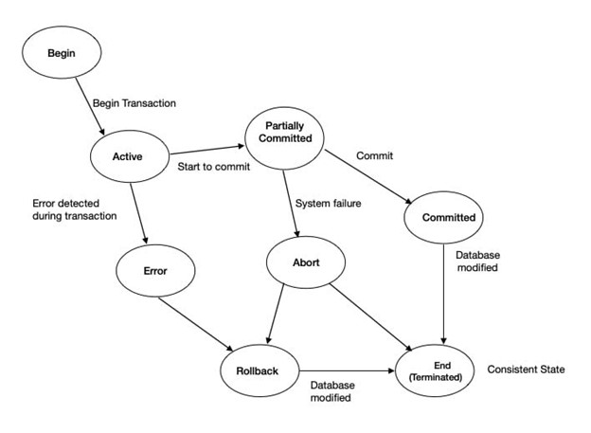
a.
1
b.
2
c.
3
d.
4

Đáp án: D

Lời giải: trạng thái mà có 2 mũi tên đi ra là các đang cho thấy nó là hàm điều kiện. Công thức tính cyclomatic complexity = số conditions +1 ( Hình trên thấy có 3 cái conditions)
Câu hỏi 41
Which one of the following statements is correct according to this situation and the mentioned acceptance criteria?
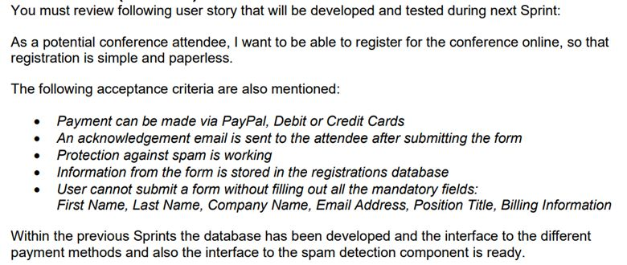
a.
All the mentioned acceptance criteria follow the meaning of INVEST characteristics
b.
The acceptance criteria do not fulfill INVEST criteria and is therefore of bad quality
c.
This user story is more like an Epic and therefore the mentioned acceptance criteria do not fit
d.
As there are no non-functional acceptance criteria mentioned, the team has forgotten to use quantitative questionnaires

Đáp án: A

Lời giải: INVEST là viết tắt của: Independent - Negotiable-Valuable- Estimable-Small-Testable, refer: ISTQB-CTAL-ATT_Sample-Exam-Questions_v1.0.2 đề này 1.0 ko tìm dc trên istqb.org. Answer link này: https://d288qud2qgn4l3.cloudfront.net/media/resources/ISTQB-CTAL-ATT_Sample-Exam_Answers_V1.0.pdf
Câu hỏi 42
A functionality from Swiss Banking system is available in all environments 24 X 7 and it needs service for different transactions from a 3rd party software component. Does this SUT qualify for Service virtualization? I. No, as there is an interface with an external service. II. Yes, to perform time controlled non-functional testing of SUT. III. Yes, to lower the cost of test infrastructure set-up as compared to the cost of testing with real 3rd party service due to the fact that virtual service does not need to include all of the functionality and test data of the actual external service. IV. No, as external services have some sort of inherent wait time associated with network travel time and virtual service can respond instantaneously as it is in the same network/environment as our SUT.
a.
I
b.
II and III
c.
III and IV
d.
II, III and IV

Đáp án: D

Lời giải: Refer phân tra loi https://d288qud2qgn4l3.cloudfront.net/media/resources/ISTQB-CTAL-ATT_Sample-Exam_Answers_V1.0.pdf
Câu hỏi 43
Which of the following statements describing the consequences of specifying test conditions at a detailed level is NOT true? select TWO
a.
In multiple environments where the test basis is continuously changing, it is recommended to specify test conditions at a detailed level in order to achieve a better maintainability
b.
The specification of test conditions at a detailed level can be effective when no formal requirements or other development work products are available
c.
The specification of test conditions at a detailed level can require the implementation of an adequate level of formality across the team
d.
For system testing, the specification of test conditions at a detailed level, carried out early in the project as soon as the test basis is established, can contribute to defect prevention
e.
For system testing, the specification of test conditions at a detailed level, carried out early in the project as soon as the test basis is established, can contribute to defect prevention, can achieve a better maintainability

Đáp án: A,E

Lời giải: cau 44 de TM12 them dap an E
Câu hỏi 44
Assuming N unique atomic conditions, MC/DC can usually be achieved in N+1 unique test cases. MC/DC rules like that: i. At least one test where the decision outcome would change if the atomic condition X were TRUE ii. At least one test where the decision outcome would change if the atomic condition X were FALSE iii. Find data that force execution through that path and use it in a test case. WHich of following is TRUE about MC/DC
a.
i,ii is TRUE, iii is FALSE
b.
i,iii is TRUE, iiis FALSE
c.
i,ii,iii is TRUE
d.
i,ii, iii is FALSE

Đáp án: A

Lời giải: Cái này xem chương 4 sách đầy đủ có phần định nghĩa của MC/DC
Câu hỏi 45
Considering the previous scenario and disregarding the performance times, what information would be most interesting to the technical stakeholders?
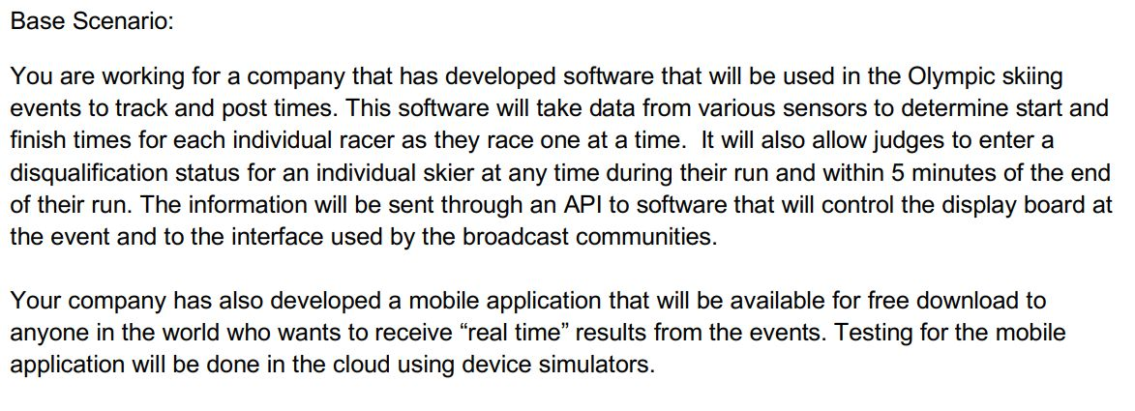
a.
How the virtual users were created
b.
The ramp-up and ramp-down times needed for all users
c.
What caused 3% of the transactions to fail to complete
d.
Which environment was used for the tests

Đáp án: C

Lời giải: Refer câu 21 đề thi ASTQB Performance testing. Giải thích của họ: C is correct. Technical users will want to know what happened with the 3% that failed. As they are troubleshooting, they may be interested in D, but that won’t be the first area to investigate. A and B are not correct because the creation of the users and the time required to complete the transactions is not in question here
Câu hỏi 46
Which of the following is the BEST example of a Gherkin-style test for a web-based banking application?
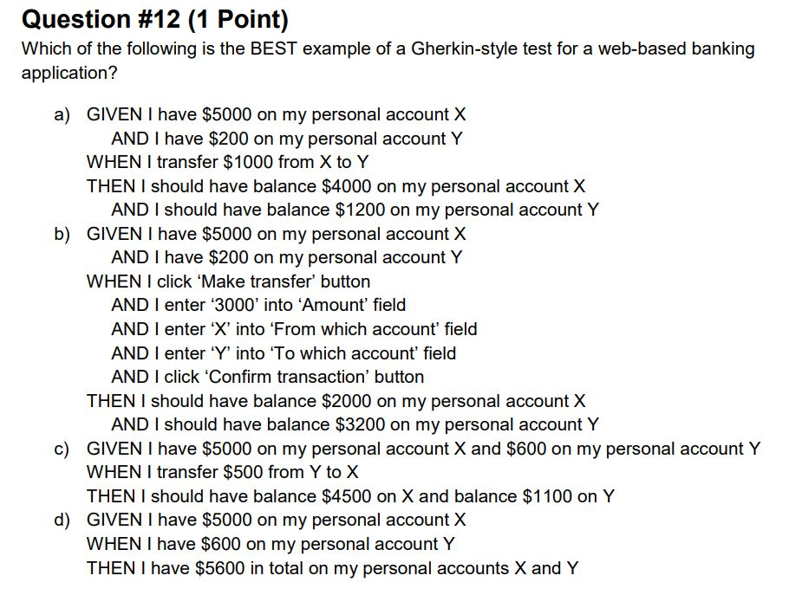
a.
GIVEN I have 5000 on my personal account X AND I have 200 on my personal account Y WHEN I transfer 1000 from X to Y THEN I should have balance 4000 on my personal account X AND I should have balance 1200 on my personal account Y
b.
GIVEN I have 5000 on my personal account X AND I have 200 on my personal account Y WHEN I click ‘Make transfer’ button AND I enter 3000 into Amount field AND I enter ‘X’ into ‘From which account’ field AND I enter ‘Y’ into ‘To which account’ field AND I click ‘Confirm transaction’ button THEN I should have balance $2000 on my personal account X AND I should have balance $3200 on my personal account Y
c.
GIVEN I have 5000 on my personal account X and 600 on my personal account Y WHEN I transfer 500 from Y to X THEN I should have balance 4500 on X and balance 1100 on Y
d.
GIVEN I have 5000 on my personal account X WHEN I have 600 on my personal account Y THEN I have 5600 in total on my personal accounts X and Y\

Đáp án: A

Lời giải: Refer câu 12 đề ISTQB Acceptance Testing. giải thích của họ: a) Is correct: this is a good example of a Gherkin-style test: GIVEN section describes the preconditions (a situation; a precondition), WHEN – a specified behavior (an action on the system) and THEN – the expected result (post condition, expected change) b) Is not correct: according to [AcT Syllabus], WHEN section should not refer to the user interface elements, but should only describe the action we want to invoke. c) Is not correct: this scenario contains an error in the THEN section – it should state that we have $5500 on X and $100 on Y. d) Is not correct: this scenario states an obvious state on the system resulted from simple calculation that does not need to be a part of acceptance test scenario.
Câu hỏi 47
Assume you are testing functionality of the interface of an elevator. One of the requirements is that the elevator can work only if the total weight of the passengers does not exceed 200 kg. The elevator can reach the following floors: Ground Floor, 1st floor and 2nd floor. You want to create an acceptance test using the Gherkin language. You can use the following phrases for this purpose: i. the total weight of passengers is greater than 200 kg ii. the elevator is on the Ground Floor iii. a button ‘1st floor’ was pressed iv. the elevator goes to the 1st floor v. a passenger standing at the 2nd floor calls the elevator vi. a message ‘too many passengers’ is displayed on the screen Which statements correctly matches constructs of Given/When/Then with a relevant phrase in order to create TC
a.
GIVEN ii) WHEN i) THEN vi)
b.
GIVEN ii) WHEN iv) THEN v)
c.
GIVEN iii) WHEN ii) THEN iv)
d.
GIVEN ii) WHEN v) AND vi) THEN i)

Đáp án: A

Lời giải: Refer câu 11 đề ISTQB Acceptance Testing. Giải thích của họ: a) Is correct: this test represents a situation in which the elevator cannot operate, since the total weight of the passengers exceeds the allowed limits. ii) represents a situation, i) represents an action (event), and vi) the expected result. b) Is not correct: this test does not cover a reasonable operation/scenario – it just describes that some combination of events iv) and v) may occur, but does not contain any reasonable, expected result in the THEN section c) Is not correct: this test is not complete, since it does not take into account the restriction on the total weight of the passengers, given in the requirements. d) Is not correct: this test would represent a correct reasoning (if the weight message is shown then the
Câu hỏi 48
Which of the following test execution schedules BEST considers the priorities and technical and logical dependencies?
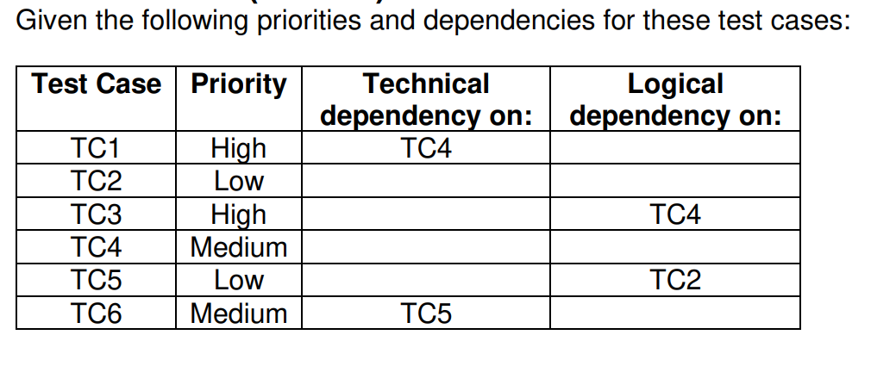
a.
TC1 – TC3 – TC4 – TC6 – TC2 – TC5
b.
TC4 – TC3 – TC1 – TC2 – TC5 – TC6
c.
TC4 – TC1 – TC3 – TC5 – TC6 – TC2
d.
TC4 – TC2 – TC5 – TC1 – TC3 – TC6

Đáp án: B

Lời giải: Thứ tự chạy là xem Dependency trước , TC ko phụ thuộc sẽ chạy trước như vậy có TC2, TC4 là dc chạy trước, TC4 ưu tiên cao hơn chạy đầu tiên, tiếp theo TC2, TC1, TC3 chạy đc tiếp theo ( vì 1 và 3 phụ thuộc vào TC4), TC1 hoặc TC3 chạy thứ 2 đều đc vì có độ ưu tiên như nhau. Cứ làm như vậy. A sai vì TC1 ko thể chạy trước TC4, D sai vì TC2, TC5 có độ ưu tiên thấp lại đc chạy trước, C sai vì TC5 chạy trước TC2 là không thể. Còn mỗi B đúng
Câu hỏi 49
Given the table below, which of the following sets of methods should you apply?
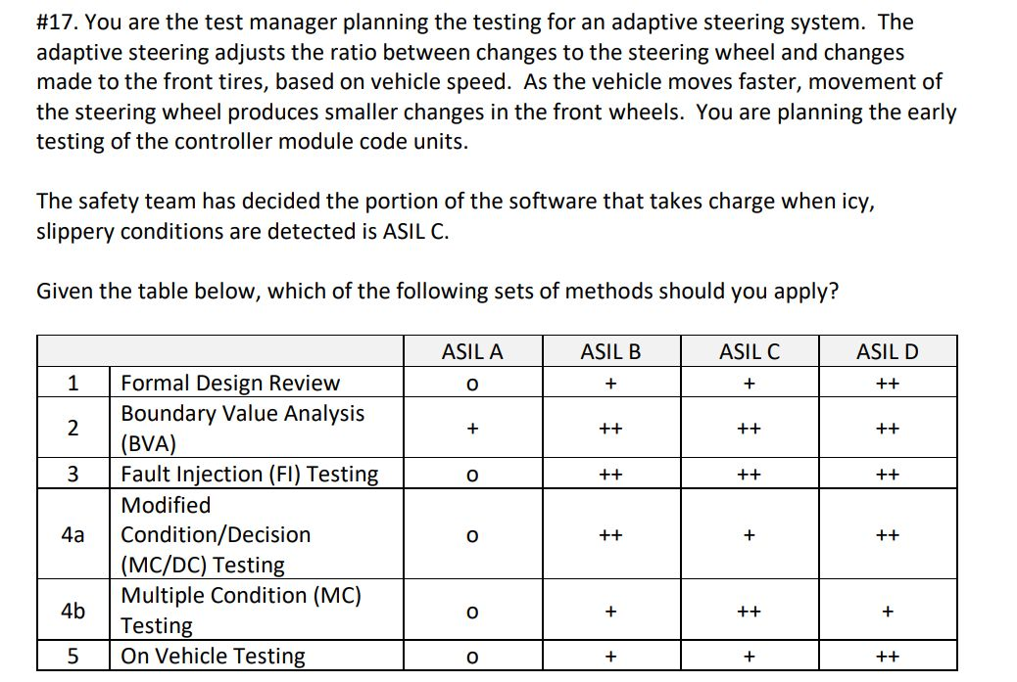
a.
Apply BVA, FI, MC/DC; consider applying Formal Design Review and On Vehicle Testing
b.
Apply BVA, FI, MC; consider applying Formal Design Review and On Vehicle Testing
c.
Apply Formal Design Review, BVA, FI, MC/DC, MC; consider applying On Vehicle Testing
d.
Apply Formal Design Review, BVA, MC/DC, MC, On Vehicle Testing; consider applying FI

Đáp án: B

Lời giải: Câu 17 đề ASTQB Automotive exam, họ giải thích: B is correct. For ASIL C, BVA, FI and MC are highly recommended. Formal Design Review and On Vehicle are recommended. MC/DC is not needed because the tester can choose either MC/DC or MC and MC has the higher recommendation. A is not correct because it uses MC/DC when it should use MC because MC has the higher recommendation on the optional choice. C is not correct because it requires FDR when that is only recommended and also has both MC/DC and MC when only one is needed. D is not correct because it requires FDR and On Vehicle when these are only recommended and does not apply FI testing.
Câu hỏi 50
Using this table, which statement is true?
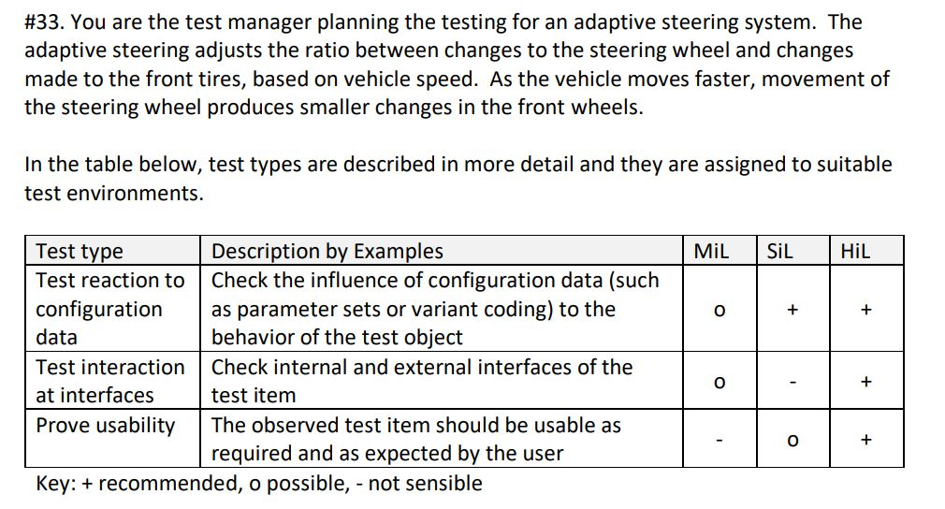
a.
Tests of the reaction to configuration data should be done in either the SiL or the HiL environment, but cannot be done in the MiL environment
b.
Test of the interactions at interfaces are optional in the SiL environment
c.
Tests for usability can be done in the SiL environment and should be done in the HiL environment
d.
The SiL environment should only be used to test the reaction to configuration data

Đáp án: C

Lời giải: Câu 33 đề astqb automotive exam họ trả lời C is correct as this answer reflects the content of the last row “Prove usability”. A is incorrect because the ‘o’ in the MiL column indicates such testing is possible. B is incorrect because the ‘-‘ in the SiL column indicates such testing is not sensible. D is incorrect because the bottom row has an ‘o’ in the SiL column, so testing is possible and should be considered. (see syllabus section 3.2.4.2, table 4)
Câu hỏi 51
To achieve 100% Modified Condition/Decision Coverage (MC/DC) which set of test cases should be used?
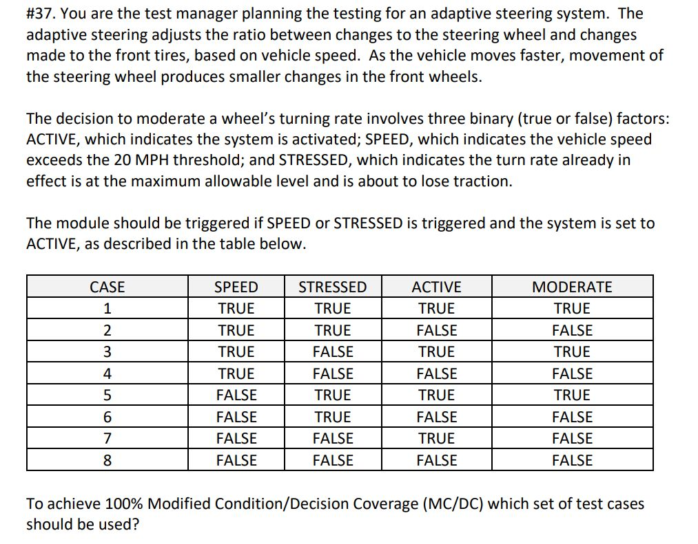
a.
Cases 3, 5, 6, and 7
b.
Cases 1, 2, 3, and 4
c.
Cases 2, 4, 6, and 8
d.
Cases 1, 3, 5, and 7

Đáp án: A

Lời giải: Câu 37 đề automotive exam. đọc đề thì hiểu là MODERATE là cái decision outcome dự vào các điều kiện của 3 biến, hàm của nó là If ((SPEED or STRESS) and ACTIVE) then MODERATE. đi tìm TC để đạt 100% MC/DC
Câu hỏi 52
Which test techniques should be selected and in which order (from highest priority to lowest priority) should the tests be conducted?
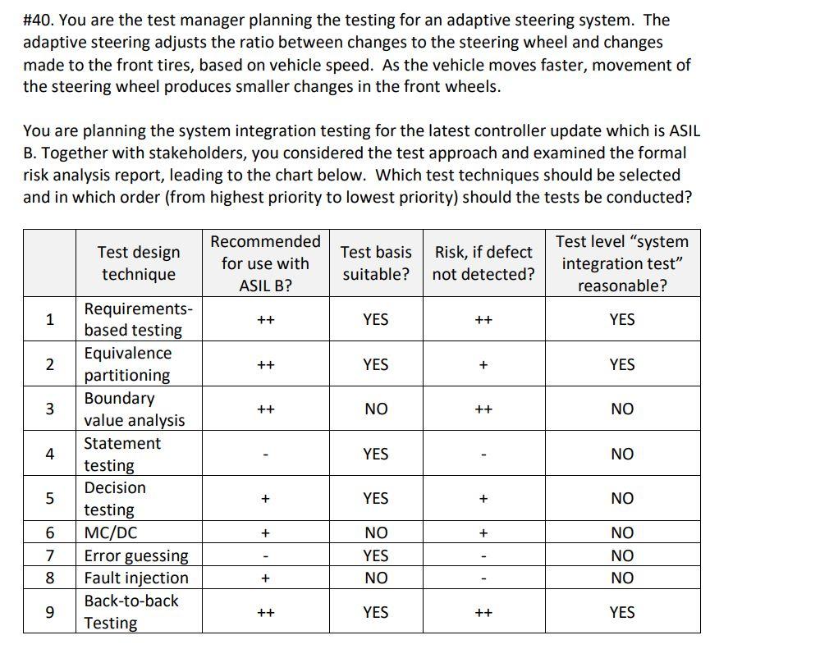
a.
1, 9, 2
b.
1, 2, 3, 9
c.
1, 2, 9, 5, 4, 7
d.
1, 9, 2, 3, 5, 6, 8

Đáp án: A

Lời giải: câu 40 đề automotive exam, họ giải thích là A is correct. 1, 9 and 2 are the only options that are suitable and reasonable for this level of testing. 1 would logically come first as it will likely be the basis for the rest of the testing. 9 is a higher risk than 2, so should be tested first.
Câu hỏi 53
Có một câu hỏi về S.M.A.R.T nhưng chúng tôi chưa tìm dc, bạn nhớ viết tắt của nó là Specific (Cụ thể) Measurable (Đo lường được) Achievable (Có thể đạt được) Relevant (Liên quan) Time-bound (Có thời hạn). Chưa tìm đc câu hỏi
a.
A
b.
B
c.
C
d.
D

Đáp án: A

Câu hỏi 54
Which of the following metrics would NOT be used to prove this point during review trial?
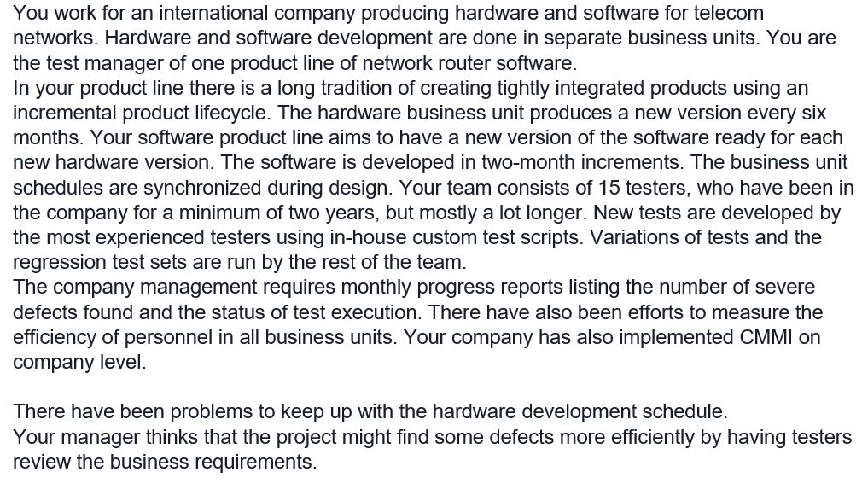
a.
Number of defects found in dynamic testing
b.
Test execution status
c.
Review and dynamic testing hours
d.
Number of defects found in reviews

Đáp án: B

Câu hỏi 55
You are a QA manager of a project where each feature must be checked with a very large number of input combinations. You think the approach of data-driven testing could be the correct solution. You want to prepare a Proof of Concept (PoC) to decide if using DDT technique would help or not. Which is the best option from the list below?
a.
Ask the test automation team to create several TCs covering the different features, read the input data from a file and run the tests
b.
Ask the test automation team to adapt some existing TCs to work with given test data
c.
Ask the test automation team to prepare a TC for one of the features, read a sample of the input data and execute the test
d.
Ask the test automation team to prepare a general TC which reads the input data from file and executes all the tests

Đáp án: C

Lời giải: Refer câu 16 của đề ATT là Agile Technical Test trên istqb.org
Câu hỏi 56
A company is planning its test process improvements and has asked for your advice on how best to organize the improvement. You are given the following background information: - The company is experiencing test process problems within many of its projects - Planned improvements to test automation shall be implemented at an offshore location - The organization has not assigned responsibility for developing the test process Which of the following organizational forms would you consider to be most appropriate? select 2 options
a.
A Test Process Group is set up within a major in-house project and staffed from within the project. The Test Process Group implements improvements which are relevant to the project and reports to the project leader
b.
A Test Process Group is set up to co-ordinate improvement activities between the different projects. Staff from a discontinued in-house project are permanently assigned to the Test Process Group
c.
Establish a Management Steering Group (MSG) to coordinate test process improvements across the organization. The MSG has ownership of the test process. A Technical Working Group is set up to co-ordinate the test automation improvements and ensure good communication takes place
d.
Establish a Management Steering Group (MSG) to implement test process improvements across the organization. The MSG has ownership of the test process and manages the contractual issues with the offshore company implementing the test automation

Đáp án: B,C

Lời giải: Câu này là câu 51 đề update 2023, nhưng thi thật họ bắt chọn 2 đáp án. Theo syllabus mục 7.1.1 có đoạn định nghĩa về "Test Process Group (TPG) as a group of individuals who may cooperate with other quality-related organizations" vì thế mình ko chọn A vì within a major in-house project là ko hợp lý, và loại D cũng vì từ Implement Test process ko hợp lý bằng C có từ coordinate test process improvements. Nên nếu chọn 1 ĐA thì chọn C theo sách, nếu bắt chọn 2 thì chọn B và C
Câu hỏi 57
Why should a Test Process Group ultimately be established on a permanent basis? select 2 options
a.
It can direct the testing of the project to be process-compliant
b.
It can be used for experience sharing concerning testing
c.
It can enable the institutionalization of changes to the testing process over a longer period
d.
It can take on the coordinating of all process improvements in the organization

Đáp án: C,D

Lời giải: Là câu số 7 của đề Expert-ITP-Part_2_ISTQB.ORG trong hệ thống này, nhưng đi thi họ bắt chọn 2 đáp án đúng. Nếu chọn 1 thì vẫn sẽ là C, nếu bắt chọn 2 thì mình chọn thêm D vì A và B đang nói về chỉ đạo test và chia sẻ kinh nghiệm test nó ko liên quan đến cái chức năng của nhóm a Test Process Group, mình chọn D vì nó đưa ra đc coordinating of all process improvements, họ nhấn mạnh trong mục 7.1.1 của sách syllabus
Câu hỏi 58
Which of the following statements is correct? select 2 options
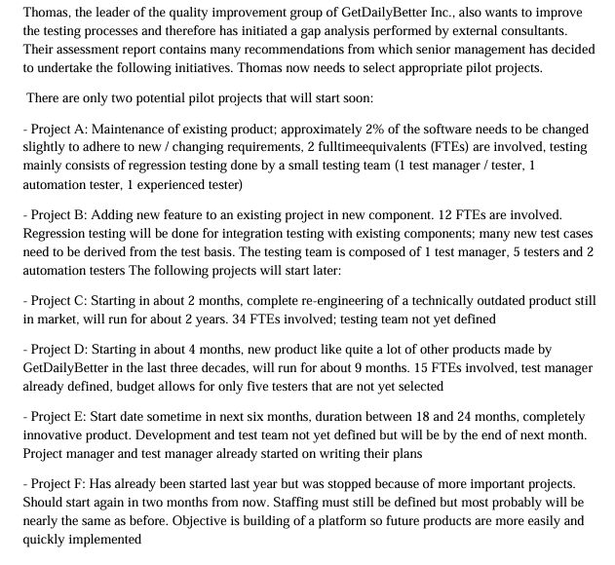
a.
Project A is a better pilot project for implementing a test automation strategy than Project D because it is a very typical project for GetDailyBetter Inc.
b.
Project E is not a good project to pilot the usage of new testing techniques because innovations are always too risky
c.
Project F is ideal to pilot the new defect report forms and analysis tools because quality is very important when building platforms
d.
Project D is favored to projects B and C in piloting the definition of test levels with entry and exit criteria, new test level plans and usage of new metrics

Đáp án: D

Lời giải: Refer câu số 7 trong Improvement Process Part 2 expert trên istqb.org. Đi thi bắt chọn 2 đáp án, Đáp án D theo sách là đáp án đầu tiên đúng, theo giải thích của D họ bảo project D phù hợp nhất, sau đó đến project B rồi mới đến project C. Nếu đề có project B hoặc project C thì chọn thêm cái này.
Câu hỏi 59
Which of the following statements about the IEEE 1028 standard is true?
a.
It requires the use of inspections
b.
It addresses only management reviews and audits
c.
It requires the use of pair programming and pair testing
d.
It defines inspections, walkthroughs, and technical reviews

Đáp án: D

Lời giải: IEEE 1028: A standard for software inspections (review) Tra cứu trên mạng nó là 1 chuẩn mô tả về các hình thức của review
Câu hỏi 60
Why is it important for a team to implement only a few improvements in an iteration?
a.
If the team tries to implement too many improvements, they may feel defeated and lose motivation
b.
If the team tries to implement too many improvements it may disrupt their ability to produce at a sustained pace
c.
If the team tries to implement too many improvements it may set a management expectation of radical change with each iteration
d.
If the team tries to implement too many improvements they may lose sight of the definition of “done”

Đáp án: B

Lời giải: Câu 10 đề Agile foundation trên trang astqb.org, họ giải thích là B is correct. Trying to make too many changes may result in disruption of the sustained pace they are trying to achieve
Câu hỏi 61
Consider the following code fragment: if (a>b) && (b>c) { b = (a+c/2; } Assume that, in the following options, each of the three numbers in parentheses represents the inputs for a test case, where the first number is a, the second number b, and the third number c. Which of the following gives a set of test case inputs that achieves decision coverage for this fragment of code in the minimum number of test cases?
a.
(5, 3, 2)
b.
(5, 3, 2); (5, 4, 0)
c.
(5, 4, 0); (4, 5, 0)
d.
(4, 5, 0); (5, 4, 5)

Đáp án: C

EXAM 5 AL2019-TA1- không video chữa đề

Câu hỏi 1
Which of the following BEST explains the use of cause-effect graphing? [K2] 1 credit
a.
Useful to gain a graphical overview of a program's logical structure and are typically used as the basis for creating decision tables.
b.
Used with the purpose that with a limited set of test cases a reasonable level of coverage can be achieved.
c.
Used to test the ability of the software to enter into and exit from defined states via valid and invalid transitions.
d.
Used as a clear method to verify testing of all pertinent combinations of conditions and to verify that all possible combinations are handled by the software under test

Đáp án: A

Lời giải: Refer 4.1.4 Cause effect graph: • Generated from any source which describes the functional logic (i.e., the "rules") of a program, such as user stories or flow charts. • Useful to gain a graphical overview of a program's logical structure. Used as the basis for creating decision tables
Câu hỏi 2
How do user stories and testing relate in an agile project? [K2] 1 credit
a.
User stories provide the flow of events which are to be used by the tester to define test cases.
b.
User stories provide the user requirement and acceptance criteria being two important inputs for the tester.
c.
The tester will typically gather and document the user stories, and use them for testing.
d.
User stories drive the regression test.

Đáp án: B

Lời giải: refer 4.1.9 User Story Testing User stories include functionality and non-functional criteria, and also include acceptance criteria that must be met for the user story to be considered complete
Câu hỏi 3
A new banking system has 2 customers' types, 2 account types and will operate in two different countries? How many test cases will be needed using the pair wise testing technique and the appropriate 2-wise orthogonal array? [K3] 3 credits
a.
2
b.
4
c.
5
d.
8

Đáp án: B

Lời giải: refer 4.1.8 Pairwise Testing/ Orthogonal Arrays/ 2-wise, cặp 2x2 là lớn nhất nên bảng có 4 rows= 4 test case, 3 cột
Câu hỏi 4
Tax system A tax system needs to be updated due to new legislation. For a person with a salary of less than 20.000 and who is married, the tax needs to be re-calculated. If the person also has more than two and less than five children, an additional 10% reduction is applicable. How many cases are required to test the "Tax system" specification using a decision table which is not collapsed? [K3] 2 credits
a.
2
b.
4
c.
6
d.
8

Đáp án: D

Lời giải: Refer 4.1.3 Decision tables. Bảng full decision thì số cột là 2 mũ n ( n là số input conditions) đây ta có 3 inputs: a salary of less than 20.000, who is married, has more than two and less than five children
Câu hỏi 5
Tax system A tax system needs to be updated due to new legislation. For a person with a salary of less than 20.000 and who is married, the tax needs to be re-calculated. If the person also has more than two and less than five children, an additional 10% reduction is applicable. How many input classes can be distinguished when applying equivalence partitioning to the "Tax System" specification? [K3] 2 credits
a.
5
b.
6
c.
7
d.
8

Đáp án: C

Lời giải: Vẽ ra theo phương pháp Equivalence partitioning: salary có 2 class: <20.000 và >= 20.000, Married và not married, children: <=2 con, từ 3-4 và 5 con trở lên. Tổng là 7 class
Câu hỏi 6
Tax system A tax system needs to be updated due to new legislation. For a person with a salary of less than 20.000 and who is married, the tax needs to be re- calculated. If the person also has more than two and less than five children, an additional 10% reduction is applicable. Applying equivalence partitioning to the "Tax System" specification, which of the following set of equivalence classes is most effective in testing the processing the number of children? [K3] 2 credits
a.
2, 4 and 6 children
b.
2, 4 and 5 children
c.
1, 3 and 6 children
d.
3, 4 and 6 children

Đáp án: B

Lời giải: theo EP: children có 3 phân vùng: <=2 con, từ 3-4 và 5 con trở lên, thì cả A,BC đều đúng, ta chọn B vì nó tốt nhất test cả được giá trị biên
Câu hỏi 7
For a tax system the earnings 4.000 are tax free, the following 1.500 are charged at 10%, the following 28.000 at 20% and the remainder above 40%. All values are rounded to 1. What test case could result from a boundary value analysis? [K3] 2 credits
a.
1500
b.
33501
c.
4499
d.
28001

Đáp án: B

Lời giải: Chia mức lương để tính thuế ta có các vùng: <= 4.000, <=5.500, <=33.500 và lớn hơn 33.500. nên giá trị BVA là đáp án B
Câu hỏi 8
How many cases are left when this decision table is collapsed? [K3] 3 credits
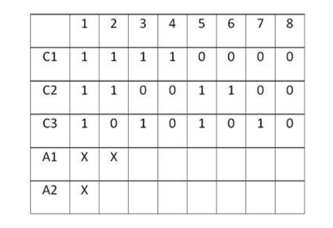
a.
2
b.
3
c.
4
d.
5

Đáp án: C

Lời giải: Thu gọn bảng từ full decision thành collapse decision, ta gọn từ cột 5-8 về thành 1 cột vì action cho ra giống nhau, cột 3-4 về một cột. Cuối cùng ta còn 4 cột
Câu hỏi 9
A temperature unit holds the temperature between - 10 degrees Celcius and 10 degrees Celcius. If the temperature drops below 10 or rises above 10 then an alarm rings. Boundary Value Analysis tests are drawn up using the approach of two test cases per boundary. The temperatures to be tested are: [K3] 2 credits
a.
11, 10, -11, -10
b.
11, 10, 9, -11, -10, -9
c.
11, 9, -9, -11
d.
10, 9, -9, -10

Đáp án: A

Câu hỏi 10
A specification states: "If the fossil is Jurassic in origin then it must be catalogued under Mesozoic post Triassic and cross referred to politic limestone. If it is a tooth, then it must be catalogued under Dental remains. If the fossil is both Jurassic in origin and a tooth it will be catalogued under Mesozoic post Triassic and cross referred to politic limestone only. " The tester analyses this for decision table testing and finds the following conditions and actions: C1: Jurassic C2: tooth A1: Catalogue as Mesozoic post Triassic A2: Cross refer to politic limestone A3: Catalogue as Dental remains How many test cases will a collapsed decision table have? [K3] 2 credits
a.
2
b.
3
c.
4
d.
5

Đáp án: B

Câu hỏi 11
Analyzing the requirement, "The system shall allow cash advances of at least 200 Euros for all supported credit cards. The correct list of credit cards is American Express, Diners, VISA, Mastercard and Eurocard." There are arguments to be made for several test design techniques. Which of the following test design techniques is LEAST likely to be used for identifying test cases for the requirement? [K4] 3 credits
a.
Boundary value analysis
b.
Equivalence Partitioning
c.
Classification Tree Method
d.
State Transition Testing

Đáp án: A

Lời giải: Ít phù hợp nhất
Câu hỏi 12
A route calculation for a car navigation system has been developed using the following state table: How many test cases are needed to achieve 0-switch coverage?
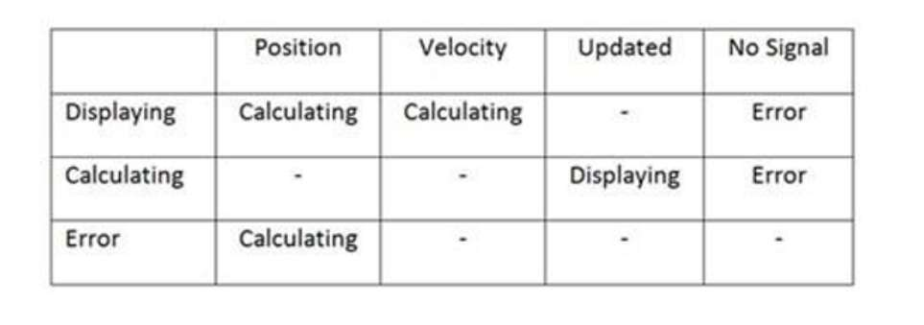
a.
3
b.
6
c.
7
d.
12

Đáp án: B

Câu hỏi 13
How many invalid test cases can be identified from the "Route Calculation" state table provided? You may assume all actions are different and independent. [K3] 3 credits
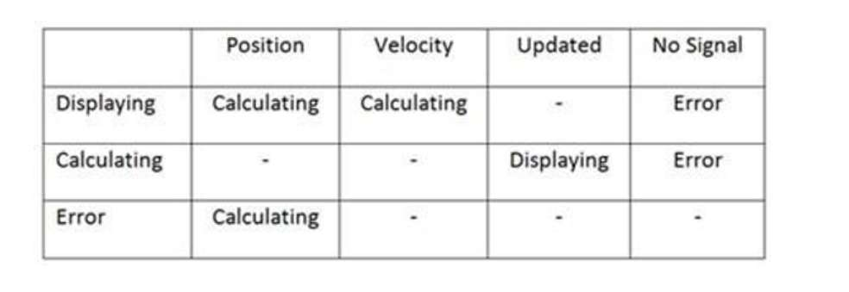
a.
6
b.
8
c.
102
d.
12

Đáp án: A

Câu hỏi 14
Apart from state transition testing, which other specification-based technique would you additionally choose to test the interfaces between components of "Route Calculation" and thus typically find different types of defects? Identify the MOST likely technique from the following list. [K4] 3 credits
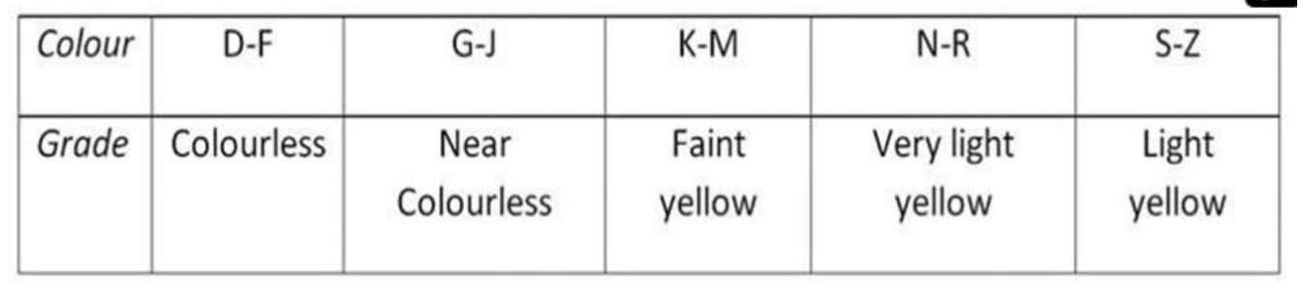
a.
Equivalence Partitioning
b.
Use Case Testing
c.
Orthogonal Arrays
d.
Decision Testing

Đáp án: A

Câu hỏi 15
A diamond retailer is introducing a new stock taking system. Each diamond is assigned a character that represents the colour. The valid domain for the character ranges from D to Z. The colour is then graded using the following scale: Which of the following test sets will provide the best equivalence partitioning coverage?
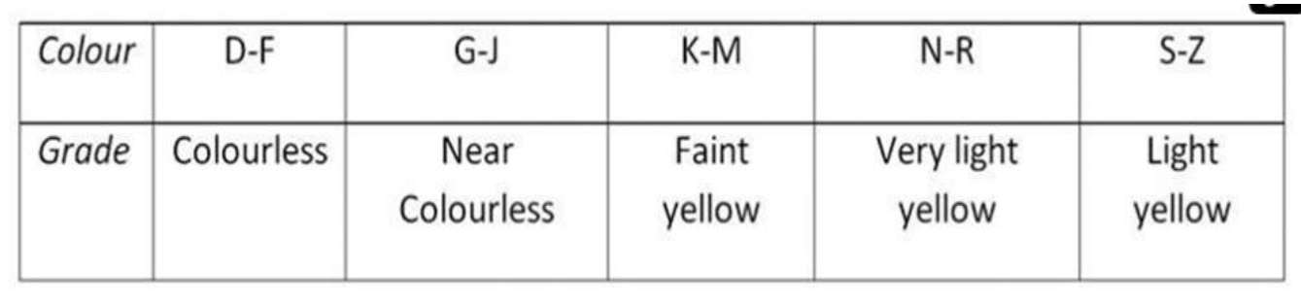
a.
D, F, G, H, K, M, N, P, T, Z
b.
D, G, K, N, S
c.
A, E, H, L, P, T,
d.
E, H, L, M, U,

Đáp án: C

Câu hỏi 16
For an ATM banking project introduced earlier, "When the user first inserts a valid credit card type, the system considers the user to be in an unauthenticated state. When requesting a cash advance, the user must be in an authenticated state. The user authenticates by entering the proper PIN code. When authenticating the user, the system shall allow the user to enter their PIN code up to three times before failing the authentication and rejecting the card. On the first and second try, the system shall prompt the user to re-enter the PIN code." Suppose you are concerned that, depending on the exact number of invalid PIN codes entered, the system might behave improperly. Which of the following test design techniques is specifically targeted at such failures? [K4] 3 credits
a.
Equivalence Partitioning extended by boundary value analysis
b.
Pairwise Testing with orthogonal arrays
c.
State Transition Testing using 1-switch coverage
d.
Classification Tree Method

Đáp án: C

Lời giải: theo sơ đồ state transition tìm ra lỗi chính xác số lần nhập invalide PIN
Câu hỏi 17
Study the "Supercar" classification tree, which of the following statements is correct? [K3] 2 credits
a.
The classification tree is correct and complete
b.
The options for for
c.
Order information is missing
d.
The error message is missing

Đáp án: B

Lời giải: Đọc cái đề bài ở câu 31 sẽ ra đáp án vì sao chưa define cho in-stock
Câu hỏi 18
Using the state diagram (based on the "Route Calculation"), how many test cases are needed to achieve 1-switch coverage?
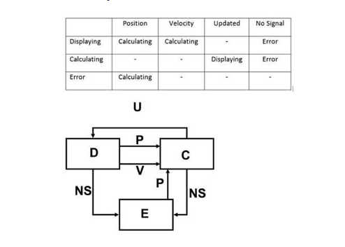
a.
9
b.
10
c.
11
d.
12

Đáp án: C

Lời giải: Tôi quay về chọn 11 vì chỉ đếm đc 11. Mạng nó để 12 kệ nó
Câu hỏi 19
Using the "Tax System" specification scenario as described above, using boundary value analysis, which would be the most interesting test set to explicitly test one single boundary value as defined in the "Tax System" specification?
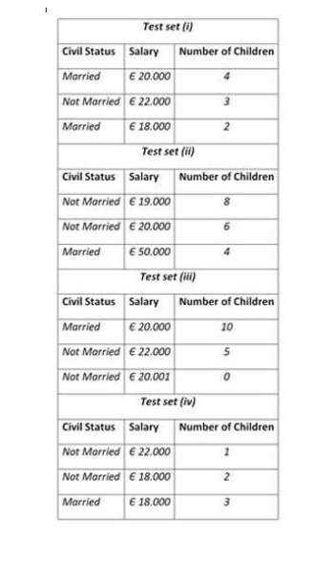
a.
(i)
b.
(ii)
c.
(iii)
d.
(iv)

Đáp án: D

Lời giải: Cái này vẽ ra.
Câu hỏi 20
You are testing the processing of a critical traffic control system to which various regulations apply. The processing of the input variables is dependent of defined ranges within which the actual retrieved data values can lie. Which of the following test techniques will you use to the processing functionality of the traffic control system? [K4] 3 credits
a.
defect taxonomies
b.
exploratory testing
c.
equivalence partitioning enhanced with boundary value analysis
d.
state transition testing

Đáp án: C

Lời giải: Đề bài có đoạn "the input variables is dependent of defined ranges within which the actual retrieved data values can lie." input dựa vào các vùng Ranges được lấy từ dữ liệu thực tế để test, Range đó là ra đáp án C à.
Câu hỏi 21
Which of the following descriptions is an example of the use of defect taxonomies? Number of correct answers: 1 [K2] 1 credit
a.
Grouping defects found in execution by functional areas
b.
Following a defect management process through testing
c.
Running tests with the aim of finding as many defects as possible
d.
Using a list of known defect types to penetrate the security of computer systems

Đáp án: D

Lời giải: Refer 4.3.1 Defect Taxonomies/ Category: Câu hỏi là "the use of defect taxonomies" giống như mục đích sử dụng chứ ko hỏi định nghĩa như câu A,
Câu hỏi 22
Which of the following statements fits the principles of experience-based testing? [K2] 1 credit
a.
Coverage calculations can be used to determine the amount of testing required
b.
Different people will have a different experience level regarding usability testing
c.
Models can be used to derive the required test cases
d.
Experience in test execution is more important than experience in test design

Đáp án: D

Lời giải: refer chương 4: Categories of Test Techniques . Loại C vì là của black box, A là white box, B người ở đây có kinh nghiệm sử dụng chứ ko phải là kinh nghiệm test. Chọn D
Câu hỏi 23
A new web site must operate correctly with different browsers (Internet Explorer, Google Chrome, Firefox, Netscape, Mozilla), using different plug-ins (Realplayer, Mediaplayer), will be receiving pages from different servers (IIS, Apache and WebLogic) and will be running on various server operation systems (windows 2007, XP, Linux) Which of the following test techniques will you use to test this new web site in its various environments? [K4] 3 credits
a.
pairwise testing
b.
exploratory testing
c.
use case testing
d.
decision table testing

Đáp án: A

Lời giải: refer 4.1.8 Pairwise Testing/ Orthogonal Arrays/ 2-wise - combinations of the values of configuration
Câu hỏi 24
A car navigation system needs to be integrated in the overall car software. Interoperability testing is thus considered to be important. Which of the following techniques is most likely be used to support interoperability tests? [K2] 1 credit
a.
Equivalence Partitioning
b.
Statement testing
c.
Vulnerability Scan
d.
Defect Taxonomies

Đáp án: A

Lời giải: 5.1.2 Interoperability (= Interaction test) (Compatibility) - Cover all the intended target environments (including variations in the hardware, software, middleware, operating system, etc.) to ensure the data exchange will work properly - Test types: use cases, pairwise testing, classification trees = Equivalence partition nếu ko yêu cầu combination gì với nhau
Câu hỏi 25
A company wants to develop a web site to implement an on-line sales channel. The company has decided to do some usability testing, but resources are limited. The usability testing has therefore to be done as efficient as possible. Which THREE techniques would you recommend? [K4] 3 credits, 2 out of 3 correct 1 credit
a.
SUMI
b.
Usability laboratory
c.
Use case testing
d.
Heuristic evaluation
e.
Equivalence partitioning
f.
Pairwise testing
g.
Exploratory testing

Đáp án: A,C,D

Lời giải: refer 5.1.3 Usability Test techniques: Heuristic evaluation (Reactive), review, surveys and questionnaires (such as SUMI (Software Usability Measurement Inventory) and WAMMI (Website Analysis and MeasureMent Inventory). Đã chọn Heuristic evaluation thì ko chọn Exploratory testing vì 2 cái là bằng nhau
Câu hỏi 26
As part of defining an approach the usability, acceptance criteria need to be defined. Which of the following acceptance criteria would be appropriate for operability? [K4] 3 credits
a.
Percentage of participants who completed each task correctly
b.
Mean extent to which each task was completely and correctly achieved, scored as a percentage
c.
Mean time taken to complete each task (for correctly completed tasks)
d.
SUMI user satisfaction score

Đáp án: C

Lời giải: Refer chương 5. "acceptance criteria" phải được định nghĩa rõ ràng về usability và tốt nhất phải đo đạc được, ngoài ra ko chọn D nhé vì đang đo cho phần Operational testing là phần vận hành của System administrator của hệ thống. Tốt nhất là đo thời gian trung bình các task họ làm
Câu hỏi 27
A SUMI test was performed at an early stage within the system test. Hereafter you find the results of the SUMI test. Based on these results, what would you recommend as the most appropriate approach for usability testing? [K4] 3 credits
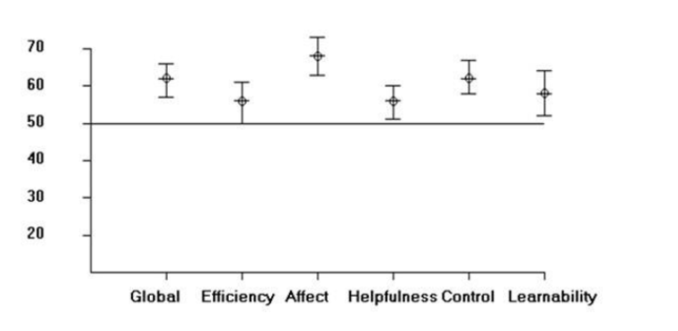
a.
Since the SUMI scores are largely above market average no further action on usability is needed
b.
Since the standard deviation of most SUMI scales is much too large, a new SUMI test must be performed
c.
Since the scores are not really showing a high level of user-satisfaction additional usability testing based on use case is needed
d.
Since the SUMI results do not provide details, an additional focused heuristic evaluation on the lower scales is recommended

Đáp án: D

Lời giải: refer 5.1.3 Usability. Các bảng này chưa đủ chi tiết, cần thêm thông tin tập trung vào các khoảng giá trị thấp
Câu hỏi 28
During the test execution defects are found on non-compliancy to requirements, calculations that produce incorrect results, and improper handling of data or situations. Which of the following test types is most likely being performed? [K2] 1 credit
a.
Usability testing
b.
Interoperability testing
c.
Accuracy testing
d.
Suitability testing

Đáp án: C

Lời giải: Refer chương 5. Để ý "incorrect results" là ra được C. Correctness = accuracy
Câu hỏi 29
Which of the following comments would be the MOST important one you would make? [K3] 2 credits
a.
Description of flow is not detailed enough
b.
Specific characteristics of actor(s) are missing
c.
No usability acceptance criteria
d.
User tasks not defined

Đáp án: B

Lời giải: Câu này thiếu hình ảnh, tìm mãi mạng mà ko có, bỏ qua đi
Câu hỏi 30
You are a test analyst in the banking domain. You have received the following requirement: "The system shall allow cash advances of at least 200 Euros for all supported credit cards. The correct list of credit cards is American Express, Diners, VISA, Mastercard and Eurocard. Which one of the findings described below is true regarding this requirement? [K3] 2 credits
a.
The requirement is ambiguous in terms of supported cards
b.
The paragraph indicates potential performance problems
c.
The paragraph is unclear in terms of advance limits
d.
The paragraph indicates potential usability problems

Đáp án: C

Lời giải: Chú ý "at least 200 Euros" là không rõ ràng
Câu hỏi 31
Supercar is an online vehicle sales website specializing in a single manufacturer's Sports Utility Vehicles (SUVs) and saloons. A vehicle has two key elements, power unit and body style. The manufacturer offers three choices of power unit: petrol, diesel and hybrid. There are 3 main body styles: Saloon, Hatchback and SUV. SUVs only come as petrol and diesel options. Hybrid is available for Hatchback only. The site will allow an order to be processed if at least one of the chosen vehicle configuration is in stock, otherwise a message will be displayed asking the user to try again later. As a tester you are asked to review the "Supercar" specification before starting to design the corresponding test cases. Which of the comments below would you make? [K3] 2 credits
a.
I have no comments, specification looks ok
b.
Boundaries for stock levels are ambiguous
c.
Dependencies power unit and body styles are ambiguous
d.
It is not clear which message will be displayed when

Đáp án: D

Lời giải: Đọc đề bài thấy message chưa được nói rõ
Câu hỏi 32
As a tester you are asked to review the ATM use case provided below. The use case will be used as a basis for functionality testing to be performed later. Which one of the comments, described hereafter, would be the MOST important one you would make? [K3] 2 credits
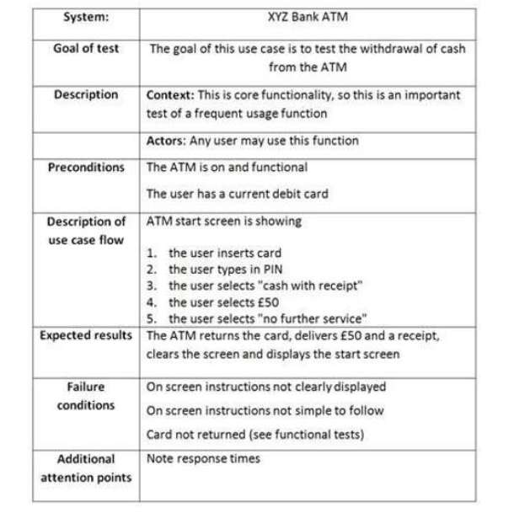
a.
Acceptance criteria not defined
b.
Business priority is missing
c.
Post condition not defined
d.
Alternative flows are missing

Đáp án: D

Lời giải: Refer: 4.1.6 Use case testing: 1 Use case includes: + 1 basic flow (mainstream) + n alternative flow (exception) + some errors
Câu hỏi 33
You are starting to review some of the incident reports that have been submitted as a result of test execution. Which THREE of the comments would be your main findings when you have reviewed the following incident report? [K4] 3 credits, 2 out of 3 correct 1 credit
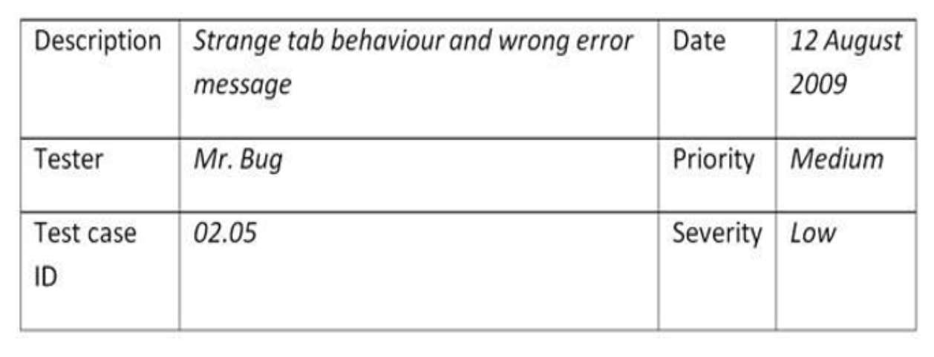
a.
Should have been two defect reports
b.
Ambiguous description
c.
Actual cause is missing
d.
Reproducibility is not indicated
e.
Defect type is missing
f.
Date to be fixed not defined
g.
Both severity and priority do not make sense

Đáp án: A,B,D

Lời giải: refer chapter 7. Đầu tiên mô tả này là 2 lỗi riêng biệt "strange tab" và "wrong error message" Description không rõ ràng, khả năng Reprocedure không chỉ ra. Do lỗi mới log ở giai đoạn Reconization nên các thông tin khác của lỗi là chưa bắt buộc và cần thiết nên ta loại Actual cause, Defect type,
Câu hỏi 34
How does phase containment contribute to reducing the cost of development? [K2] 1 credit
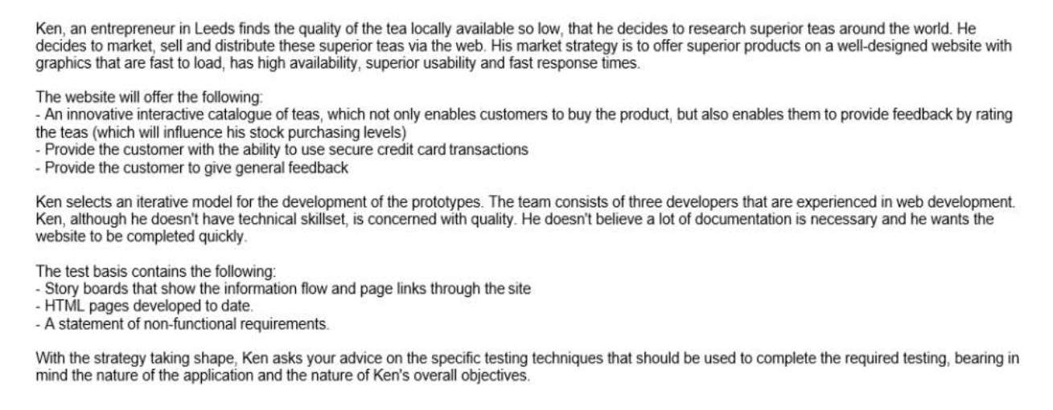
a.
By eliminating defects as early as possible to minimize defect propagation
b.
By ensuring that the deliverables from any life cycle phase are tested only in that phase
c.
By using specific test techniques at each level and only at that level
d.
By concentrating the testing effort on the phases where failures occur

Đáp án: A

Lời giải: Refer 7.2.1. Phase containment means the defect was introduced and found in the same phase and didn’t “escape” to a later phase. Triệt tiêu lỗi càng sớm càng tốt ngay trong phase nó phát sinh lỗi
Câu hỏi 35
Which TWO of the following items may more frequently need to be explained in greater detail for non- functional defect reports than for a functional defect report? [K2] 1 credit
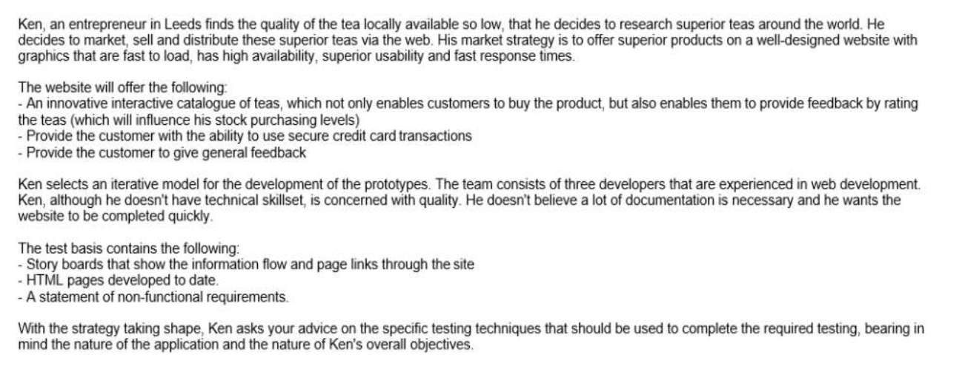
a.
Expected results
b.
Steps to reproduce the defect
c.
Test data used to identify the fault
d.
Level of load on the system at the time of failure
e.
Actual results

Đáp án: A,D

Lời giải: Refer 7.2.2 Defect Report Fields. • Non-functional defect reports: require more details regarding the environment, other performance parameters (e.g., size of the load), sequence of steps and expected results nên chọn A,D nếu được chọn hơn sẽ chọn thêm B
Câu hỏi 36
Your test team is currently executing interoperability testing. Consider the following excerpt from the failure description of an interoperability defect report: 1. Connect external camera to a Windows Vista PC. 2. Start the camera application on the PC. Application starts normally and recognizes connected camera. 3. Attempt to download the recorded data from the camera. 4. Data does not download. 5. Attempt to download the data three times. Data will not down--load. Based on this information alone, which of the problems described hereafter exists in this defect report? [K4] 3 credits
a.
Lack of structured testing
b.
Inadequate classification information
c.
Insufficient isolation
d.
Poorly documented steps to reproduce

Đáp án: B,C

Lời giải: Refer chapter 7. Ở đây tra trên mạng thì họ chọn là B, nhưng cũng câu này trong chương 7 gần tương tự thì đáp án sách Vol 1 là C. Mình thiên về C hơn vì nó thiếu thông tin để cô lập lỗi cụ thể là chưa nói về connect qua cổng nào giữa camera và PC. Mình vẫn chọn 2 cho an toàn
Câu hỏi 37
Consider the following description in a defect report "Nasty bug trashed contents of new file that I created by formatting some text in symbol font, wasting my time." Which TWO of the following comments would you immediately make based on the defect description above? [K4] 3 credits, 1 out of 2 correct 1 credit
a.
Needs to be neutralized
b.
Steps to reproduce are unclear
c.
No attempt to isolate the defect
d.
More than one defect in one report
e.
Possible duplicate

Đáp án: A,B

Lời giải: Refer chương 7. "Nasty bug" "wasting my time" là câu cửa miệng khi bực mình Lỗi rác rưởi, nên cần có A, và các bước mô tả không rõ ràng nên cần B
Câu hỏi 38
We now make the assumption that in the scenario described as above, exploratory testing was selected as being the main test technique. You have now been given the task of specifying, executing and recording the exploratory test sessions. Select TWO of the options below to define what you will typically use for specifying, executing and recording the sessions? [K3] 2 credits
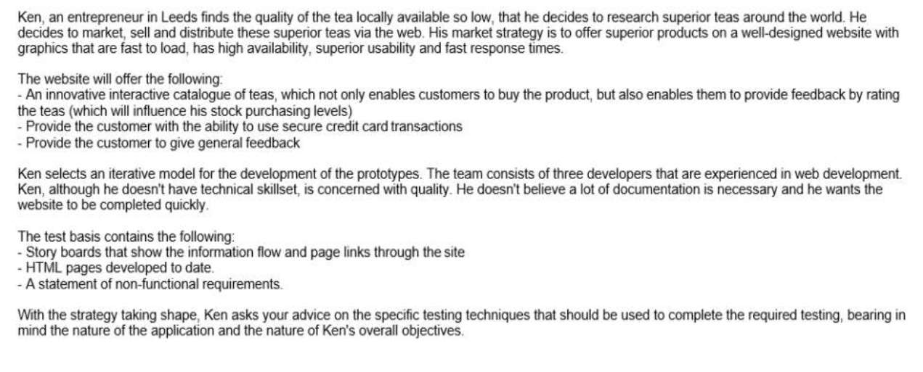
a.
Record the results in email and send the email to the test manager.
b.
Use external testers on the team to provide a new approach and fresh view to the testing effort.
c.
Create test charters for planned test session.
d.
Use debriefing sessions with stakeholders and other testers to discuss the findings and new risks identified
e.
Define concrete test cases to be executed by the developers.

Đáp án: C,D

Lời giải: refer 4.3.4 Exploratory Testing: use session-based: write a test charter contain some guidelines for test within a defined time-box, ta dựa vào keyword test session, test charter, time-box để chọn
Câu hỏi 39
Which of the of the following represents the best choice of testing techniques in this scenario? [K4] 3 credits
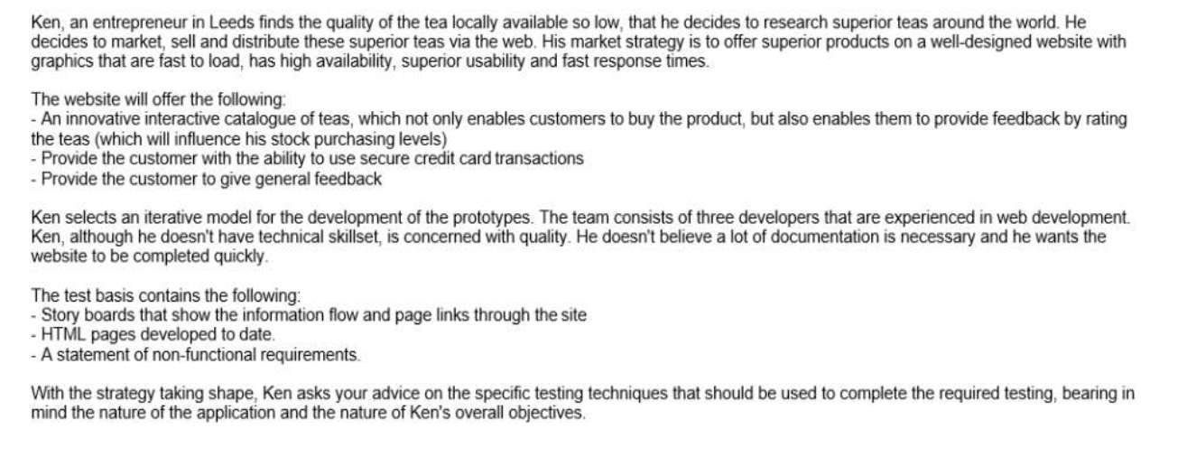
a.
Equivalence partitioning and boundary value analysis using the storyboard ideas as a basis to maximize functional coverage.
b.
Decision testing to ensure that there is no redundant code
c.
Exploratory testing to maximize the value of the team' experience
d.
State transition testing to test the web site's availability statuses

Đáp án: C

Lời giải: Test team đã có kinh nghiệm test Web, dự án theo Agile, rất ít tài liệu nên kỹ thuật phù hợp nhất là Exploratory testing
Câu hỏi 40
In an organization using keyword-driven automation, which of the following activities typically is the responsibility of the test analyst? [K2] 1 credit
a.
Write the code to automate the key processes
b.
Work with the users to define the key usability aspects of the software
c.
Identify the key business processes that must be tested
d.
Write manual tests for the key business processes that can then be automated

Đáp án: C

Lời giải: Refer syllabus của TA, 6.3.3 Automated Test Execution Tools. Nói chung TA không thể viết code được nên chỉ có thể đưa ra các yêu cầu về nghiệp vụ cần phải được test tự động, TTA sẽ là người viết code và thư viện.
Câu hỏi 41
To enhance both the effectiveness and efficiency of the test design phase the purchase of a test design tool is being considered. Which one of the statements here after best characterizes a test design tool? [K2] 1 credit
a.
It validates models of the software
b.
It enables tests to be executed automatically
c.
It enables individual tests to be traced to requirements
d.
It generates test inputs or executable tests from requirements

Đáp án: D

Lời giải: refer 9.1. Test design là công cụ hỗ trợ sinh ra test inputs, test case. Loại C vì là của requirement management tool, B là của automation tool. A ko rõ
Câu hỏi 42
Which of the following criteria on test progress would enable the business to determine a likely `go live' date? (i) Number of tests planned versus number of tests executed (ii) Number of high priority defects outstanding (iii) The test team's timesheets in order to show how much effort has been devoted to testing (iv) Number of tests passed and number failed (v) Number of defects found in each development area (vi) The rate at which defects are being found [K2] 1 credit
a.
(ii), (iii), (iv)
b.
(i), (iii), (v)
c.
(i), (ii), (vi)
d.
(iv), (v), (vi)

Đáp án: C

Lời giải: Refer 2.1. Tiêu chí xác định ngày Go live là Exit criteria dựa vào 5 tiêu chí: coverage, defect, cost, time, residual risk chọn i, ii, vi. iii là timesheets loại, iv ko ra được coverage, v về mật độ lỗi dùng cho giai đoạn chạy xác định chỗ nào cần test nhiều hơn
Câu hỏi 43
As a test analyst you are involved in the early stages of an acceptance test for a Product Data Management system. You are asked to write test designs and test cases based on use cases. An early version of the system is also already available. It is a known fact that on the implementation level many things will change (including the user-interface). The tests will be carried by end-users with much domain knowledge who have also been involved in the project defining the user requirements and reviewing documentation. What is the BEST option regarding the level of detail and documentation required for test cases in the project? [K4] 3 credits
a.
Detailed concrete test cases since many re-runs of the tests are expected
b.
Logical test cases supported by concrete test cases to allow for traceability and enable future changes
c.
Concrete test cases only since the end-users have extensive domain knowledge
d.
Logical test cases only since the end-user have extensive domain knowledge and many changes are expect reducing testware maintenance efforted thus

Đáp án: D

Lời giải: Vì "end-users with much domain knowledge " là người định nghĩa ra requirement rồi nên ko cần test case chi tiết, và vì "many things will change " nên ko thể viết tài liệu chi tiết đc, rất tốn effort
Câu hỏi 44
As a test analyst you are gathering data to support accurate metrics. Which of the THREE metrics would be MOST appropriate to use to monitor product quality? [K2] 1 credit
a.
Defects found versus defects expected
b.
Test resources spent versus budget
c.
Compliance to entry criteria
d.
Product risks outstanding and new risks introduced
e.
Tests run and tests passed

Đáp án: A,D,E

Câu hỏi 45
Which of the following tasks and responsibilities do NOT belong to that of a test analyst in the context of evaluating exit criteria and reporting? [K2] 1 credit
a.
The test analyst should be able to use the reporting tools
b.
The test analyst is responsible for supplying accurate information
c.
The test analyst will contribute to the final report at the end of the testing
d.
The test analyst should write final test reports objectively

Đáp án: D

Lời giải: Chapter 10 đã có bảng task của test leader và tester. Chọn D vì đây là task của test leader không phải của Test analyst
Câu hỏi 46
What is the MOST important reason why test conditions should be understandable by stakeholders? [K2] 1 credit
a.
They should be able to review the test conditions and provide feedback to the test analyst
b.
They should be able to use them as a basis for designing test cases
c.
They should be able to use them to establish traceability to requirements
d.
Test documentation should always be understandable by all stakeholders

Đáp án: A

Lời giải: refer 2.3. stakeholders hiểu là các bên liên quan đến đội test như PM, BA, Developer, Customer, supporter...., nếu họ hiểu được họ sẽ review và có phản hồi cho test
Câu hỏi 47
Working together with the test manager during test planning, which of the following activities is NOT expected to be performed by the test analyst? [K2] 1 credit
a.
Review the test estimates of the test manager
b.
Review the test plan for non-functional testing
c.
Organize adequate test resources
d.
Being involved in risk management sessions

Đáp án: C

Lời giải: refer chapter 10 có bổ sung bảng task của test manager và test analyst. Mấy công việc của organization này là của Test manager
Câu hỏi 48
Which of the following statements is TRUE with respect to when the test analyst should become involved during different lifecycle models? [K2] 1 credit
a.
In a sequential V-model project the test analyst should start test analysis and design concurrently with coding
b.
In Agile projects the test analyst should start test analysis and design concurrently with coding
c.
In a sequential model project the test analyst should start test analysis and design concurrently with software design
d.
In an embedded iterative model the test analyst should expect to be involved in the standard planning and design aspects

Đáp án: D

Lời giải: refer 1.1 Development models. nói chung TA vào dự án càng sớm càng tốt. AB sai vì vào lúc "concurrently with coding", C sai vì concurrently with software design, chỉ có D là sớm nhất
Câu hỏi 49
Which of the following is a type of testing that someone in the role of a test analyst, should typicall consider and plan for?
a.
Security testing
b.
Reliability testing
c.
Accessibility testing
d.
Performance testing

Đáp án: C

Lời giải: refer chapter 5 bảng ISO 25010, accessibility là thuộc tính con của Usability
Câu hỏi 50
Which of the following is a typical work product that the Test Analyst would deliver as part of the test closure activities? [K2] 1 credit
a.
A list of all deferred defects
b.
A list of all rejected defect reports
c.
A list of all defects found in production and fixed in this release
d.
A list of all resolved defects

Đáp án: A

Lời giải: Refer 2.8 Test Closure Activities, Mục Test completion - All planned tests should be either run or skipped ? All known defects should be either fixed, deferred e, or accepted?
Câu hỏi 51
You are working as a tester on a project to develop a point-of-sales system for grocery stores. Which of the following is a product risk that could be identified for such a system? [K3] 2 credits
a.
The arrival of a more reliable competing product on the market
b.
Delivery of an incomplete test release to the first cycle of system test
c.
An excessively high number of defect fixes fail during re-testing
d.
Failure to accept allowed credit cards

Đáp án: D

Lời giải: refer 3.2 Risk categories. ABC đều là project risk, D là product risk
Câu hỏi 52
Which of the following is the LEAST appropriate action to mitigate product risks for a web application? [K3] 2 credits
a.
Initiate reviews of test design
b.
Use professional and skilled testers with appropriate technical knowledge
c.
Run tests in multiple operational environments
d.
Allocate more time to high risk areas

Đáp án: A

Lời giải: refer chương 10 bảng task của TM và TA, "LEAST appropriate action" hành động ít phù hợp để giảm risk là "Initial" là task của TM làm ban đầu, làm 1 ít để hướng dẫn người khác làm theo nên ít giá trị giảm product risk
Câu hỏi 53
According to the ISTQB Advanced syllabus, which of the following would be the MOST effective method of communication between test team members who are distributed across several time zones? [K2] 1 credit
a.
Accurate recording of defect information in the defect tracking system
b.
Accepting frequent builds from the developers to keep all testers working on the same version at the same time
c.
Skype meetings for personal interaction
d.
Weekly, mandatory meeting with all personnel present

Đáp án: A

Lời giải: refer 3.5 Distributed, Outsourced, and Insourced Testing. Test Analyst solutions: • Pay special attention to effective communication and information transfer • Defects that are accurately recorded can be routed to co-workers for follow-up as needed
Câu hỏi 54
A company offering house insurance policies has several policy options. They depend on the following factors: - Building type: house, semi-detached, apartment building, cottage Material: wood, concrete, brick, mixed Location: city, suburb, countryside, wilderness It has been decided to use the pair wise test technique and apply 2-wise coverage. To design the test case an appropriate orthogonal array needs to be located. Like this image Which of the following orthogonal arrays is to be selected for testing the house insurance policies? [K3] 3 credits
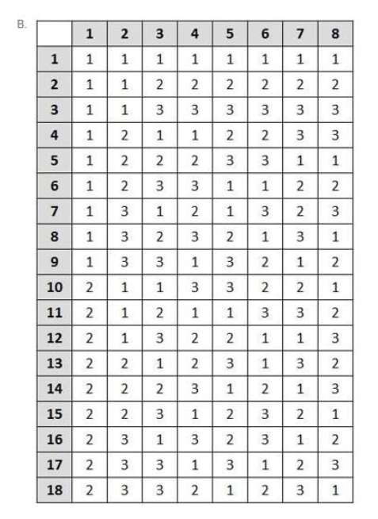
a.
orthogonal arrays 5 columns and 18 rows
b.
orthogonal arrays 8 columns and 18 rows
c.
orthogonal arrays 3 columns and 16 rows
d.
orthogonal arrays 3 columns and 12 rows

Đáp án: C

Lời giải: refer 4.1.8 Pairwise Testing/ Orthogonal Arrays/ 2-wise, cặp 4x4 là lớn nhất quyết định số row của bảng là 16, Đề bài cho 3 factors hay còn gọi là 3 cái inputs nên có 3 cột.
Câu hỏi 55
Based on the classification tree show below, how many test cases are required using the classification tree method? [K3] 2 credits
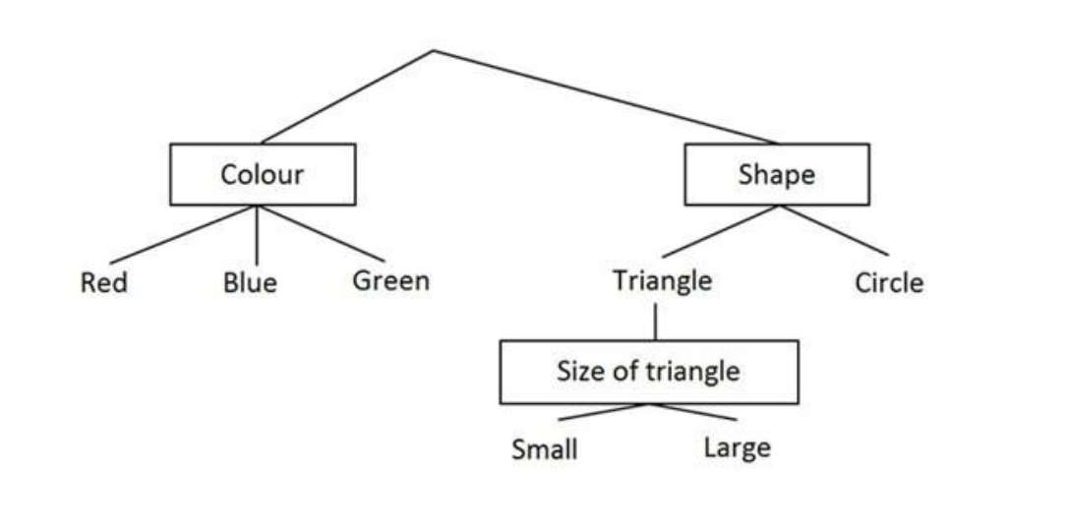
a.
2
b.
3
c.
4
d.
6

Đáp án: B

Lời giải: refer: 4.1.7 Classification Tree Method • Similar to equivalence partitioning: a leaf in a classification tree is similar to a class in an equivalence partitioning. Nếu không nói gì thì nó giống với EP, input nào nhiều giá trị nhất sẽ quyết định số test case tối thiểu
Câu hỏi 56
You are applying pairwise testing and using orthogonal arrays. The following steps are all part of the process to be followed. i) Determine the number of choices for each variable ii) Map the test problem onto the orthogonal array iii) Construct the test cases iv) Identify the variables v) Locate an appropriate orthogonal array What is the correct order of the above mentioned process steps? [K3] 2 credits
a.
i, ii, iv, v, iii
b.
iv, ii, v, iii, i
c.
iv, i, iii, v, ii
d.
iv, i, v, ii, iii

Đáp án: D

Lời giải: Refer 4.1.8 Pairwise Testing/ Orthogonal Arrays/ 2-wise các bước để lập bảng ma trận
Câu hỏi 57
While identifying scenario's for the use case "copy A4 A4" for a new copier, the following scenario's were identified: Basic scenario: single side to single side Deviations: single side to double side, copy of a set, copy using the automatic document feeder Failures: no paper in paper tray, paper jam, out of staples How many test cases will be needed to achieve minimum coverage? [K3] 2 credits
a.
1
b.
4
c.
5
d.
7

Đáp án: D

Lời giải: minimum coverage thì cứ mỗi 1 trường hợp được test bởi 1 test case là đủ
Câu hỏi 58
While identifying scenario's for the use case "copy A4 A4" for a new copier, the following scenario's were identified: Basic scenario: single side to single side Deviations: single side to double side, copy of a set, copy using the automatic document feeder Failures: no paper in paper tray, paper jam, out of staples During interviews with both development and end-users it has been established that the failure scenario's can occur during the basic scenario and during each of the deviations. How many test cases will be needed to achieve full coverage both for valid and invalid situations? [K3] 2 credits
a.
10
b.
12
c.
16
d.
20

Đáp án: C

Lời giải: full coverage both for valid and invalid thì ta phải tính thế này: valid là 1 case cho basic + 3 case cho Deviations, Invalid là 3 cái error nhân với (1 case cho basic + 3 case cho Deviations) là trường hợp đang sử dụng máy copier thì gặp lỗi gọi là case invalid.
Câu hỏi 59
You are testing an ATM based on the following use case; ATM start screen is showing 1. The user inserts card 2. The user types in PIN 3. The user selects `cash with receipt' 4. The user selects 50 5. The user selects `no further service' Expected results - The ATM provides 50 to the user - The ATM return the card and balance slip - The ATM clears the screen - The ATM returns to start menu In your test log which of the following could be noted as part of additional attention points? [K3] 2 credits
a.
Issues regarding time-behavior
b.
Issues regarding interoperability
c.
More test cases needed to achieve full coverage
d.
Expected results not clearly defined

Đáp án: A

Lời giải: additional attention points cái này chỉ cần kéo lên xem bảng của câu số 32 ra đáp án A
Câu hỏi 60
Supercar Supercar is an online vehicle sales website specializing in single manufacturer's Sports Utility Vehicles (SUVs) and saloons. A vehicle has two key elements, power unit and body style. The manufacturer offers three choices of power unit: petrol, diesel and hybrid. There are 3 main body styles: Saloon, Hatchback and SUV. SUVs only come as petrol and diesel options. Hybrid is available for Hatchback only. The site will allow an order to be processed if the chosen vehicle configurations are in stock, otherwise a message will be displayed asking the user to try again later. Which test case is needed to complete the set? [K3] 2 credits
a.
Power Unit: Hybrid, Body Style: Saloon
b.
Power Unit: Diesel, Body Style: Hatchback
c.
Power Unit: Petrol, Body Style: Saloon
d.
Power Unit: Hybrid, Body Style: Hatchback

Đáp án: D

Lời giải: Câu này hiểu "complete the set" như là cần 1 case valid để kiểm tra các TH cơ bản Valid cho đủ với đề bài

EXAM 6 Advanced TM12- không video chữa đề
Câu hỏi 1
Based only on the given information, which of the following statements is true? K4 3 credits
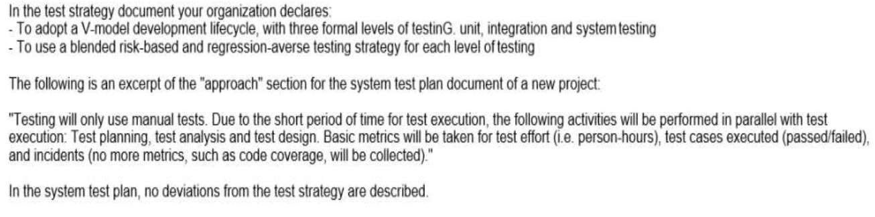
a.
The approach described in the system test plan document is consistent with the test strategy
b.
The approach described in the system test plan document is consistent with the risk-based testing strategy, but it is inconsistent with the regression testing strategy
c.
The approach described in the system test plan document is consistent with the regression testing strategy, but it is inconsistent with the risk-based testing strategy
d.
The approach described the system test plan document is inconsistent with both the risk-based and regression testing strategies
Lời giải: Refer 2.2.1, Bạn cần gạch đầu dòng yêu cầu của công ty về test strategy và yêu cầu của dự án test approach ra nháp, bạn sẽ thấy sự mâu thuẫn của công ty và dự án. Test strategy của công ty: V-model, risk based, Regression-averse ( tự động hóa cao nhất), test approach của dự án là: manual test.

Đáp án: D

Câu hỏi 2
In the next two months some new features will be constantly added to new releases of a project you are working on as Test Manager. You have identified as one of the main project risks, that the requirements specification will still be incomplete when your team starts the test design and implementation phase. Some requirements will most likely be completed too late to allow a proper test preparation. You and your test team have already worked on several similar past projects in the same organization. Which one of the following options would you expect to be the most effective at mitigating this risk? K4 3 credits
a.
Don't prepare any test and just run the regression test suite to check that the new features don't introduce regression
b.
Make reasonable assumptions about the missing details and design lightweight tests that can be easily updated during test execution
c.
Don't design any test until the test execution starts, then communicate that test execution is blocked due to incomplete requirements
d.
Even if there are only few details missing, escalate the risk to the project manager without preparing any tests
Lời giải: Chapter 3 mục 3.2.3 , xem sách bản full có 10 cái Top risks khi nói về trường hợp Blank spot requirement thì cần thiết kế test case dạng đơn giản, đưa ra các giả định để test và dễ dàng update khi có đủ thông tin

Đáp án: B

Câu hỏi 3
Consider: I. Consultative test strategy II. Reactive test strategy III. Analytical test strategy IV. Process-compliant test strategy Consider also the following examples of test activities: 1. Prioritize the test cases, based on the results of a FMEA analysis, to ensure early coverage of the most important areas and discovery of the most important defects during test execution 2. Execute usability testing driven by the guidance of a sample of users (external to the test team) 3. Perform exploratory testing sessions throughout the system test phase 4. On an Agile project, execute tests that cover the test conditions identified for each user story of a feature planned for an iteration Which of the following correctly matches each test strategy with an appropriate example? K2 1 credit
a.
I-2; II-3; III-4; IV-1
b.
I-3; II-2; III-1; IV-4
c.
I-1; II-2; III-3; IV-4
d.
I-2; II-3; III-1; IV-4
Lời giải: Xem chapter 2, 2.2.1, có 7 cái test strategy, match các key word của bài với các nội dung của 7 cái test strategy này với nhau sẽ ra đáp án. cái số 1 có FMEA là phương pháp Risk based nên match với Analytical, số 2 guide bởi user match với Consultative, số 3 exploratory testing match với Reactive, số 4 Agile process match với Process compliance

Đáp án: D

Câu hỏi 4
You are the Test Manager of a new project that will have three formal levels of testinG. unit, integration and system testing. The testing strategy you decide to adopt a blend of risk-based testing and reactive testing strategies. Which of the following answers describes the most consistent example of implementation of this test strategy during the execution of the system tests? K2 1 credit
a.
Your test team executes exploratory tests following a session-based test management approach throughout the system test phase
b.
Your test team executes system tests under the guidance of a sample of users throughout the system test phase
c.
Your test team executes scripted tests designed and implemented before the execution of the system test phase, to cover the identified product risks. It also performs exploratory testing sessions throughout the system test phase
d.
Your test team autonomously performs some exploratory testing sessions and, at the very end of the system testing phase, it also executes more system tests under the guidance of a sample of users
Lời giải: bạn chọn đáp án làm sao nó chỉ ra được 2 cái mà dự án này đang dùng "risk-based testing and reactive testing strategies."

Đáp án: C

Câu hỏi 5
You are the Test Manager of a new project aimed at developing a software system that must be certified at level B of the DO-178B standard. The project will follow a V-Model software development life cycle and it will have four formal levels of testing: component, integration, system and acceptance testing. You must produce the test plan documentation for this project by providing an adequate coordination across the four levels of testing in order to assure audit ability. Which of the following answers would you expect to best describe how to organize the test plan? K3 2 credits
a.
Produce a single master test plan that covers in detail all four levels, describing the particular activities for all test levels
b.
B. Produce a master test plan that covers three levels (component, integration, system test) and a separate acceptance test plan
c.
Produce a master test plan describing the relationship between the four levels, and four separate detailed level test plans, one for each level
d.
Produce four separate detailed level test plans, one for each level, without a master test plan

Đáp án: C

Lời giải: Dự án lớn, có 4 test levels nên phải có 1 master test plan chung cho cả dự án, mỗi level test plan cho mỗi test level

Câu hỏi 6
Based on the historical data of 5 past and similar projects, you have calculated these average numbers of defects detected in system testinG. - For each 10000 LOC (lines of code), 200 defects - For each person-month of development team effort, 49 defects You want to use this information to perform estimation for a new project. The project manager tells you that he/she has estimated 20000 new LOC for this new project. Four developers work for four months on this project before system testing. During system testing, 797 defects are discovered. Assume that the system test of this new project is using the same amount of work as spent in the past projects. Based on this information only, which of the following statement is certainly true about this project? K3 3 credits
a.
The code for the new project contains a higher defect density than the code of the past projects
b.
The number of defects found during the system test phase on the new project is approximately proportional to the development team effort
c.
40000 LOC have been delivered to system testing (against the 20000 LOC planned by the project manager)
d.
More LOC than planned have been delivered to system testing with a higher defect density than the past projects

Đáp án: B

Câu hỏi 7
You are estimating the effort for the integration testing activities of a new project. Consider the following factors, which can affect that estimation: I.Availability of re-usable test systems and documentation from previous, similar projects II. Unexpected timing of components arrival III. Stability of the integration test team (no turnover) IV. Many and geographically distributed sub-teams Which of the following statements is true? K2 1 credit
a.
I. and II. can negatively affect the estimation; III. and IV. usually favor the accuracy of the estimation effort
b.
II. and III. can negatively affect the estimation; I and IV. usually favor the accuracy of the estimation effort
c.
II. and IV. can negatively affect the estimation; I and III. usually favor the accuracy of the estimation effort
d.
III. and IV. can negatively affect the estimation; Iand II. usually favor the accuracy of the estimation effort

Đáp án: C

Lời giải: refer 2.2.2 Test Estimation: ở đây xác định nhân tố ảnh hưởng tiêu cực và nhân tố ảnh hưởng tích cực là đc

Câu hỏi 8
The following chart plots the cumulative number of defects opened against the cumulative number of defects closed during system testing of a software product. Which of the following statements is true? K2 1 credit
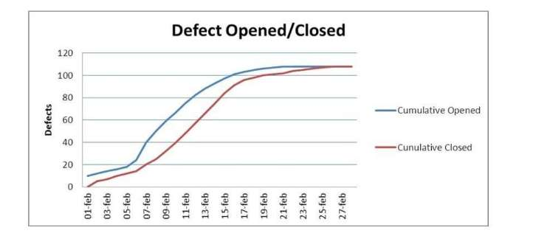
a.
The chart indicates that you have plenty of problems left to find
b.
The chart can be used to reveal test progress problems
c.
The chart seems to indicate that the defect management process is not working well
d.
The chart seems to indicate that the defect management process is working well

Đáp án: D

Lời giải: Nhìn vào chart thấy tiến độ sửa lỗi bắt kịp tiến độ tìm lỗi, và lỗi tìm đc đang đi ngang

Câu hỏi 9
Which one of the following metrics to be produced needs traceability between the test cases and each item in a proper test basis? K2 1 credit
a.
Requirements coverage
b.
Trends in the lag time from defect reporting to resolution
c.
Mean time between failures for the system
d.
Cumulative number of reported defects versus cumulative number of resolved defects

Đáp án: A

Câu hỏi 10
Which of the following subsystems, based on the risk scores of the table, is most risky? K4 3 credits
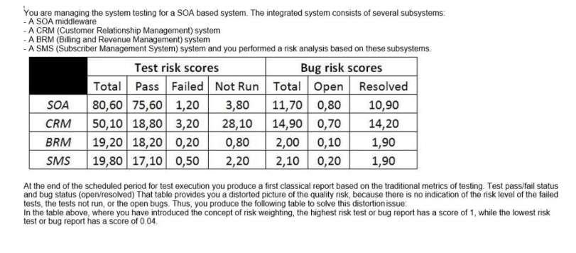
a.
SOA
b.
CRM
c.
BRM
d.
SMS

Đáp án: B

Câu hỏi 11
For which of the following activities would the costs be classified as a cost of detection?
a.
Writing test specifications according to the test design
b.
Training developers to better understand the new features of the coding language they will use on the project
c.
Re-running a test case, during the system testing phase, to verify that a fix eliminates a previously found defect
d.
Fixing field failures
Đáp án: A

Câu hỏi 12
Assume you have some data related to confirmation testing during system testing of a past project. In that project 240 bug reports have been opened once, 80 were opened twice, 10 were opened three times and no bug reports have been opened more than three times. You estimate that a bug report, which has failed its confirmation test, costs, on average, 3 person-hours. Which of the following statements correctly describe the value of these confirmatory testing activities based on cost of quality? K3 2 credits
a.
300 person-hours have been spent on the project during the system testing phase, because of the failed confirmation tests and this cost belongs to the costs of internal failure
b.
340 person-hours have been spent on the project during the system testing phase, because of the failed confirmation tests and this cost belongs to the costs of external failure
c.
340 person-hours have been spent on the project during the system testing phase, because of the failed confirmation tests and this cost belongs to the costs of internal failure
d.
300 person-hours have been spent on the project during the system testing phase, because of the failed confirmation tests and this cost belongs to the costs of detection

Đáp án: A

Câu hỏi 13
Which of the following answers describes a factor that may reduce the effort spent when using distributed test teams without negatively affecting system quality? K2 1 credit
a.
Difficulties in communication between the distributed test teams due to time zone differences
b.
With several distributed test teams, every team assumes that some test conditions are covered by other teams but actually no one covers them
c.
With several distributed test teams, two or more teams assume some test conditions are covered by their team and their team alone. But all of the teams actually cover them
d.
With several distributed test teams, all of the distributed test teams use a single unified test dashboard

Đáp án: D

Lời giải: refer 3.5 Distributed, Outsourced, and Insourced Testing. Cách tốt để TM quản lý dc team phân tán là • Alignment of methodologies vì thế mà phải "use a single unified test dashboard"

Câu hỏi 14
You are the Test Manager on a project following an iterative life-cycle model. The project should consist of nine iterations of one month duration each. It is planned to develop the most important features to have a stable core of the application in the first three iterations and to add the additional features in the last six iterations. At the beginning of the first iteration, only a draft version of the requirements specification document for the core features is available. Assume that during each of the first three iterations, the chosen features are fully completed and unit tested. Which of the following statements is true in this context? K4 3 credits
a.
The system test phase should start when all the requirements are frozen
b.
You should allocate a large effort for system testing during the first three iterations
c.
You should allocate all the effort for the system test phase only in the last iteration
d.
You should apply the same test strategy as used in a sequential life cycle model

Đáp án: B

Lời giải: Mô hình iterative bạn nhớ là mỗi giai đoạn test nhiều test levels khác nhau, nên system test được thực hiện rất sớm và tập trung luôn vào 3 iteration đầu tiên

Câu hỏi 15
Which of the following statements, about the test reporting activities for a project adopting an iterative lifecycle model with very short iterations (e.g. two weeks iterations), is correct? K2 1 credit
a.
Test reporting activities can't be influenced by the use of an iterative lifecycle model with short iterations
b.
Test reporting activities are not important for projects adopting an iterative lifecycle model with short iterations
c.
Test reporting activities are less important for projects adopting an iterative life cycle model with short iterations. They should be performed at the end of the last iteration
d.
Test reporting activities are still important with an iterative lifecycle. The reports can be used to conduct post-iteration review sessions before starting with the next iteration

Đáp án: D

Lời giải: Nói chung iterative ngắn hay dài thì cũng phải làm báo cáo test, và nó giúp summary thông tin test, sử dụng cho retrospective meeting

Câu hỏi 16
Consider an agile team adopting Extreme Programming (XP) with five developers and one tester without any coding experience. To which of the following activities would you expect the tester will contribute most? K2 1 credit
a.
Developing unit tests
b.
Executing unit tests
c.
Planning and executing tests during the integration test phase to detect interface defects
d.
Supporting the customer in the execution of acceptance testing

Đáp án: D

Lời giải: XP là 1 model của Agile, phát triển nhanh, thường xuyên demo cho KH nên TA hỗ trợ KH làm acceptance test là có ý nghĩa

Câu hỏi 17
The main objectives the senior management team wants to achieve are: - to reduce the costs associated with dynamic testing - to use reviews to ensure that the project is on course for success and following the plan - to use reviews as a well-documented and effective bug-removal activity following a formal process with well-defined roles - to determine the effectiveness of reviews in terms of phase containment - to improve phase containment effectiveness Which of the following answers would you expect to describe the best way to achieve these objectives? K4 3 credits
a.
You should plan for lightweight exit-phase reviews at the end of each development and testing phase, and plan for a process of gathering information from testing to perform an analysis aimed at identifying the larger cluster of defects
b.
You should plan for formal exit-phase reviews at the end of each development and testing phase, and plan for a process of gathering information from testing to perform an analysis aimed at identifying the larger cluster of defects
c.
You should plan for formal exit-phase reviews at the end of each development phase and testing phase, and plan for a process of gathering information from testing to perform an analysis of the bugs found during testing to determine the people responsible for those bugs
d.
You should plan for formal exit-phase reviews at the end of each development and testing phase, and plan for a process of gathering information from testing to perform an analysis of the bugs found during testing to determine the phase in which they have been introduced

Đáp án: D

Lời giải: refer 6.1.4 Managing Formal Reviews. Để đạt được các objective trên phải áp dụng các tiêu chí của formal review : planning đầy đủ, define entry exit criteria, có đo đạc metrics

Câu hỏi 18
Consider the following list of statements about audits and management reviews: I. Audits are usually more effective than management reviews at finding defects II. Audits and management reviews have the same main goals, the only difference is related to the roles and level of formality III. A typical outcome of an audit includes observations and recommendations, corrective actions and a pass/fail assessment IV. An audit is not the appropriate mechanism to use at the code review in order to detect defects prior to dynamic testing Which of the following statements is true? K2 1 credit
a.
I. and III. are true; II. and IV. are false;
b.
II. and III are true; I. and IV. are false;
c.
I, III and IV are true; II. is false;
d.
III. and IV. are true; I and II are false;

Đáp án: D

Lời giải: refer 6.1 Review types and responsibility: xem định nghĩa về audit và management review

Câu hỏi 19
You are a Test Manager working for a software organization where reviews have never been applied. After a meeting with your managers examining a business case for reviews, (including their costs, benefits, and potential issues), the management finally decides to adopt formal reviews for future projects. You have been given a budget that you have spent to provide training in the review process and to introduce the review process on a pilot project. On that pilot project the introduction of reviews has been very positive in terms of positive involvement from all the participants. All the reviews applied to different documents have been very effective for their purposes (especially at revealing defects). Which of an important factor for the introduct of formal reviews which is missing? 3 P
a.
Management support
b.
Participant support
c.
Definition and use of metrics to measure the ROI (Return On Investment)
d.
Training in the review process

Đáp án: C

Lời giải: Câu này dựa vào keyword của đề bài ta thấy "the management finally decides to adopt formal reviews for future projects." là có A rồi, "provide training in the review process" là có D rồi, "positive involvement from all the participant" là có B rồi, thiếu mỗi C

Câu hỏi 20
Which of the following factors could negatively influence a review? K2 1 credit
a.
Include people with the adequate level of knowledge, both technical and procedural
b.
Include people who are detail-oriented and scrupulous at finding issues
c.
Include as many people as possible in order to have more viewpoints about possible problems on the item under review
d.
Include people able to contribute to a clear, thoughtful, constructive and objective discussion

Đáp án: C

Lời giải: Nhân tố ảnh hưởng tiêu cực đến Review là "as many people " mà ko phải là những người cần thiết, ở đây chỉ nói nhiều người

Câu hỏi 21
You are the Test Manager of a project that adopts a V-model with four formal levels of testinG. unit, integration, system and acceptance testing. On this project reviews have been conducted for each development phase prior to testing, which is to say that reviews of requirements, functional specification, high-level design, low-level design and code have been performed prior to testing. Assume that no requirements defects have been reported after the release of the product. Which TWO of the following metrics do you need in order to evaluate the requirements reviews in terms of phase containment effectiveness? K3 2 credits
a.
Number of defects found during the requirements review
b.
Total number of defects attributable to requirements found during unit, integration, system and acceptance testing
c.
Total number of defects found during functional specification review, high-level design review, low- level design review, code review, unit testing, integration testing, system testing and acceptance testing
d.
Time to conduct the requirements review
e.
Total number of defects attributable to requirements, found during functional specification review, high-level design review, low-level design review, code review, unit testing, integration testing, system testing and acceptance testing

Đáp án: A,E

Lời giải: refer chapter 7, phase containment là "the defect was introduced and found in the same phase " nên ta phải có 2 thông tin: A lỗi tìm đc bởi review, E lỗi tìm được ở các phase sau requirement và được sếp vào thuộc tính là sai requirement

Câu hỏi 22
Which of the following information would you expect to be the most useful to perform a defect clustering analysis? K2 1 credit
a.
The trend in the lag time from defect reporting to resolution
b.
The defect component information
c.
The lifecycle phase in which the defect has been introduced
d.
The defect removal efficiency information

Đáp án: B

Lời giải: " a defect clustering" cụm lỗi thì bạn cần báo cáo Pareto chart thống kê lỗi theo module hoặc function để xem lỗi đang tập trung vào đâu nhiều nhất

Câu hỏi 23
During the system testing phase a tester from your test team observes a failure in the system under test and he/she decides to create an incident report. The incident report is currently in a "new" state, indicating it needs to be investigated. Which THREE of the following information items can't yet be present in the incident report? K3 2 credits (2 credits out of 3 credits correct, 1 credit point)
a.
The type of defect that caused the failure
b.
The actual and the expected result highlighting the failure
c.
The lifecycle phase in which the defect has been introduced
d.
What really caused the failure (actual cause)
e.
Steps to reproduce the failure, including screenshots, database dumps and logs where applicable

Đáp án: A,C,D

Lời giải: refer 7.3 Defect Classification theo keyword mà chọn các thông tin ACD là cần phân loại ở giai đoạn investigation chứ không phải Recognization ( lỗi đang ở trạng thái New)

Câu hỏi 24
Assume you are working on a defect management process to be used by a software organization to track the current status of the defects reports for several projects. When a defect is found for investigation a defect report is created in "Opened" state that is the unique initial state. The defect report status has also a unique finale state that is the "Closed" state. The following state transition diagram describes the states of this defect management process: Where only the initial ("Opened") and final ("Closed") states are indicated while the remaining states (V, W, X, Y, Z) have yet to be named. Which of the following assignments would you expect to best complete the defect management process? K3 2 credits
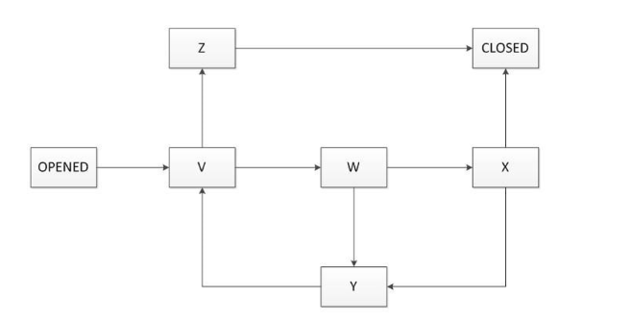
a.
V=Rejected , W=Corrected , X=Validated, Y=Re-Opened, Z=Assigned
b.
V=Assigned, W=Validated , X=Corrected, Y=Re-Opened, Z=Rejected
c.
V=Assigned, W=Corrected , X=Validated, Y=Re-Opened, Z=Rejected
d.
V= Corrected, W=Assigned, X=Validated, Y=Corrected, Z=Rejected

Đáp án: C

Lời giải: Chapter 7

Câu hỏi 25
Consider a defect report and assume that a part of its lifecycle includes the following states: New: Is the initial state Working. Means that the developers are addressing the defect in order to produce a fix for the defect Clarification: Means that the developers need more information from the tester to address the defect and produce a fix for the defect and the tester is working to provide this information to the developers Verification: Means that a fix for the defect has been produced and the tester is running the adequate tests to verify whether the fix solves the defect CloseD. is the final state Which of the following answers represents an invalid sequence of states that can't lead the bug report to the "Closed" state?
a.
New, Working, Verification, Working, Clarification, Working, Verification, Closed
b.
New, Working, Clarification, Working, Verification, Closed
c.
New, Working, Verification, Closed
d.
New, Working, Verification, Working, Clarification, Working, Closed

Đáp án: D

Lời giải: refer chapter 7. Thứ tự các trạng thái của lỗi mà không đi đến Đóng, chọn D vì Working xong chưa được Verification thì ko thể Closed được.

Câu hỏi 26
Consider the following statements describing the importance of improving the test process: I. Test process improvement is important because being focused only on the test process it can provide recommendations to improve the test process itself, but it can't indicate or suggest improvement to areas of the development process II. Because it is much more effective than software process improvement to improve the quality of a software system III. Because several process improvement models (STEP, TPI Next, TMMi) have been developed over the years IV. Because every organization should always achieve the maximum level of maturity of testing described in in the test improvement models such as TMMi Which of the following answers is correct? K2 1 credit
a.
I. and IV. are true; II. and III. are false
b.
I., II., III. and IV are false
c.
I., II. and III are true; IV. is false
d.
I., II. and III. are false; IV. is true

Đáp án: B

Lời giải: chapter 8. I sai vì only, II sai vì "more effective than software process improvement " ko đúng, ko có so sánh này, III cũng đều sai, IV sách không nói là lúc nào cũng phải đạt dược level cao nhất

Câu hỏi 27
Which of the following statements about the TMMi test process improvement model is true? K2 1 credit
a.
In TMMi all the process areas at lower levels must be 75% complete by achieving specific and generic goals in order to claim the higher level
b.
TMMi provides an approach for test process improvement such as the IDEAL (Initiating, Diagnosing, Establishing, Acting and Learning) model
c.
TMMi has a staged architecture for process improvement with seven maturity levels
d.
At TMMi level 1 testing is chaotic without a defined process, and it is often seen as the same as debugging

Đáp án: D

Lời giải: refer 8.4 Improving the Testing Process with TMMi: Level 1 được coi là dự án cứ test và fix bug mà không theo quy trình nào cả. đáp án A thông tin 75% là ko có trong sách, C sai vì 7 level, B sai vì nó bảo giống IDEAL

Câu hỏi 28
Which of the following statements about the STEP test process improvement model is true? K2 1 credit
a.
In the STEP model, tests validate the requirements and use cases when they are developed
b.
The STEP model stresses defect detection and demonstration of capability, whereas the defect prevention is a secondary potential goal of testing
c.
The STEP model assures that the system requirements specification and the test design specification processes don't overlap
d.
In the STEP model, testware design occurs after coding

Đáp án: A

Lời giải: Refer 8.7 Improving the Testing Process with STEP để loại đc BCD

Câu hỏi 29
A chart showing the trend in the lag time from defect reporting to resolution during system testing is also available. The chart shows that the daily closure period is consistently and significantly above the rolling closure period for a long period of the system testing phase. Almost all defects found during system testing have been related to the system as a whole, not related to single units or integrations issues. Almost all quality risks have been addressed during the unit and integration testing phase and no residual quality risks were present in the integrated system. Exploratory testing sessions performed during system testing, targeted at finding defects in these quality risk areas. Which one of areas would you considered more in the retrospective meeting in order to be improved?
a.
The requirements review
b.
The defect management process
c.
The quality risk analysis process
d.
The system design and architecture design reviews

Đáp án: B

Lời giải: retrospective cần đưa ra quy trình quản lý defect management vì đề bài cập nhật đến các vấn đề về báo cáo lỗi ( nhưng không nói là nó đã tốt hay chưa nhé, chỉ là báo cáo chỉ ra "the lag time" "daily closure period "
Câu hỏi 30
After the presentation, you are asked to explain the chart. Assume you have applied a full risk-based testing strategy. Which of the following answers would you expect to best describe the pie chart? K4 3 credits
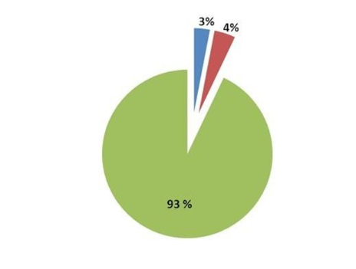
a.
All the risk items have been covered with tests. No more risk items remain to test
b.
According to the full risk-based testing strategy applied, it is very likely that the highest-risk items, tests and bugs remain in the blue and red areas. Therefore, it is very risky to release the application
c.
Only the lowest-risk items, tests and bugs should remain in the blue and red areas. Therefore the application can be released at any time subject to management of the items identified in those areas
d.
97 percent of the risk items has been tested. No open bugs or test failures remain. Only 3 percent of risk items remains to be covered by the remaining test

Đáp án: C

Lời giải: Vì dự án này theo chiến lược risk based nên chắc chắn là rủi ro cao đã đc chạy trước rồi, nhìn vào cái hình ta thấy còn 1 tỷ lệ nhỏ những cái rủi ro chưa test hoặc chưa sửa hết là của low-risk

Câu hỏi 31
Assume you are managing a test automation project for a mission-critical system. Because vendor provided tools and open source solutions don't meet the needs of this project, you ask your test team to develop a custom automation framework. Which of the following management issues associated to the development of this custom automation framework is least likely to manage? K2 1 credit
a.
Proper testing for the custom automation framework must be performed
b.
The custom automation framework will require an adequate documentation
c.
The changes to the custom automation framework should be communicated to all external users of this tool under the GNU license
d.
The custom automation framework will need proper maintenance

Đáp án: C

Lời giải: Câu hỏi là ít phù hợp nhất. Chọn C vì "communicated to all external users" làm sao mà trao đổi với tất cả các user bên ngoài đc

Câu hỏi 32
In your organization the following tools of the same vendor are currently in use. a requirements management tool, a test management tool and a bug tracking tool. You are the Test Manager. You are currently evaluating a test automation tool of the same vendor (to complete the vendor's tool suite) against an interesting open-source test automation tool under the GNU GPL (General Public License). There are no initial costs associated to that open-source tool. Which of the following statements associated to the selection of the open-source tool is correct in this scenario? K2 1 credit
a.
The open-source tool can be modified but only if the community of developers of that tool gives you the formal permission to modify it
b.
There are no initial costs for the open-source tool but you should carefully consider the costs associated to the integration with the existing tools and also evaluate the recurring costs
c.
There are no initial costs for the open-source tool because open-source tools are usually low-quality, while vendor tools have always a better quality than the corresponding open-source tools
d.
The open-source tool can be modified but it can't be distributed further in any way

Đáp án: B

Lời giải: Open source là rẻ và không mất chi phí mua tool

Câu hỏi 33
Which of the following are the three main concerns related to that open-source tool selection? K4 3 credits (2 credits out of 3 credits correct, 1 credit point)
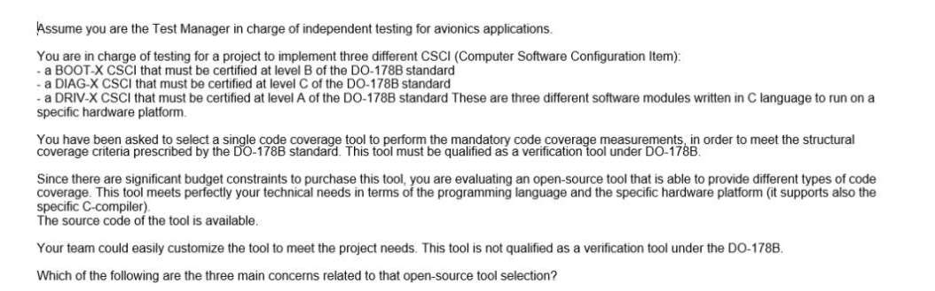
a.
Does the tool support all the types of code coverage required from the three levels A, B, C of the DO-178B standard?
b.
Is the installation procedure of the tool easy?
c.
Does the tool require a system with more than 4GB of RAM memory?
d.
Is the licensing scheme of the tool compatible with the confidentiality needs of the avionics company?
e.
What are the costs to qualify the tool as a verification tool under the DO-178B?
f.
Does the tool have a good general usability?

Đáp án: A,D,E

Lời giải: refer 9.2.3 Return on Investment (ROI): chi phí cost, bản quyền license, và tool có đo được các loại công thức về coverage không. B loại 4GB ko phải tool nào yêu cầu thế, E loại vì usability là không cần thiết với đội làm kỹ thuật

Câu hỏi 34
Which of the following phases in the lifecycle of the new tool has NOT been adequately considered in this description? K2 1 credit
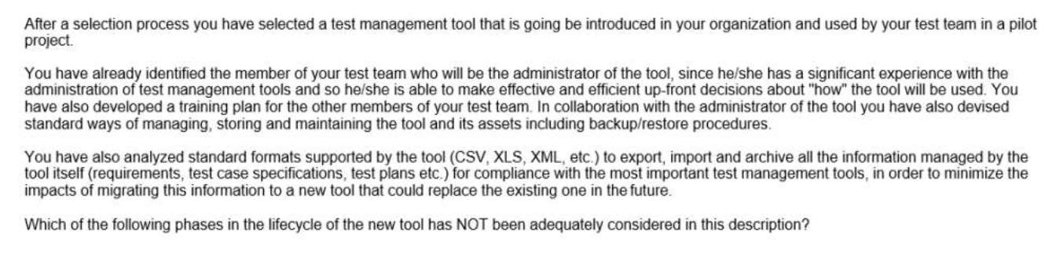
a.
Acquisition
b.
Support and maintenance
c.
Evolution
d.
Retirement
Đáp án: C

Lời giải: xem video, Evolution là tiến hóa, cải tiến tool là không được nhắc đến

Câu hỏi 35
Assume you are a Test Manager involved in system testing of a CRM application for a Pay-TV company. Currently the application is able to support a proper number of users assuring the required responsiveness. Since the business is expected to grow, you have been asked to evaluate the ability of the application to grow to support more users while maintaining the same responsiveness. Which of the following tools would you expect to be the most useful at performing this evaluation? K2 1 credit
a.
Coverage tools
b.
Test management tools
c.
Static analysis tools
d.
Performance tools

Đáp án: D

Lời giải: dựa vào đề bài " grow to support more users" chọn D

Câu hỏi 36
Which of these people, based on this analysis, would you expect to be most suitable to work specifically as test designer? K4 3 credits
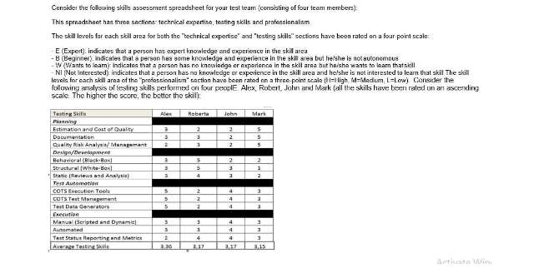
a.
Alex
b.
Roberta
c.
John
d.
Mark

Đáp án: B

Câu hỏi 37
Who in your test team would you expect to be most suitable at doing these tasks? K4 3 credits
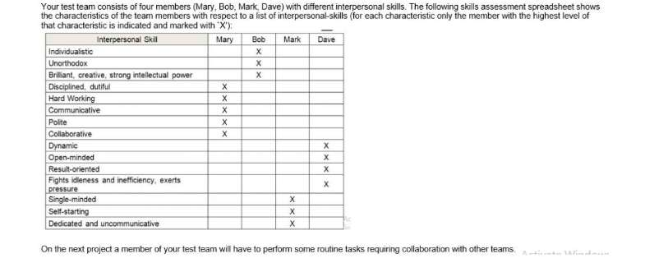
a.
Mary
b.
Bob
c.
Mark
d.
Dave

Đáp án: A

Lời giải: Nhìn vào bảng chọn người phù hợp là người có kỹ năng tốt nhất

Câu hỏi 38
Assume you are managing the system testing execution phase of a project. The system test execution period for that project is scheduled for eighteen weeks and the release date is scheduled at the end of system testing. During the sixth week of system test execution, at the staff meeting, the project manager informs you that the project deadlines are changed and the release date that is only three weeks ahead. This new release will not allow the completion of the system tests. Suppose also that you have followed a risk-driven test approach for this project. Which of the following statements represents the worst way to lead your test team in the next three weeks? K2 1 credit
a.
Neglect your management activities and work side-by-side with your test team executing tests
b.
Considering the executed tests, you should reduce the test coverage back on the risk analysis and adjust downward the priority of the associated risk items
c.
Convince all the people of your test team that each of them is an important and needed member, and that their contribution is fundamental to the success of the team
d.
Favor and encourage a proactive attitude where people ask for new tasks as soon as they finish their current tasks

Đáp án: A

Lời giải: Câu hỏi là cách nào tệ nhất, chọn A vì bạn bỏ qua công việc quản lý, chạy vào test cùng với test team chưa chắc đã hiệu quả, ko quản lý, hướng dẫn, động viên, ra quyết định cho test thì còn nhiều issue nữa

Câu hỏi 39
An agile development team decides to hire a tester who has always worked. - in independent test teams, reporting the problems found in a defect tracking system - in safety-critical projects, with a stronger focus on the quality of the product than on time and budget. This agile team is focused on short-term goals to get the product released on time and within budget. Which of the following answers would you expect to be most likely true in this scenario? K2 1 credit
a.
Agile teams like the presence of a tester in their teams and the tester will be able to adapt to the new context without any issue
b.
The developers will immediately follow the guidelines described by the tester
c.
The tester can continue to report the problems found in a defect tracking system and be more focused on the quality than on time and budget constraints
d.
The tester's mission could be to verify adherence to requirements, instead of reporting formally the problems in a defect tracking system

Đáp án: D

Lời giải: Vì là dự án Agile, tập trung vào việc hoàn thành theo thời gian ngắn nên cần phải đưa nhiệm vụ rõ ràng cho tester tập trung kiểm tra requirement, sử dụng giao tiếp và các kỹ thuật informal để làm việc nhanh hơn là report bug formal

Câu hỏi 40
Which of the following would you expect to be most likely an example of a motivating factor for testers? K2 1 credit
a.
The resources allocated for the testing activities are not sufficient and don't allow the testers to contribute to the quality of the product
b.
The testers contribution to the quality of the software products developed from an organization is recognized with increased responsibilities
c.
The same regressions tests are executed manually by the same testers, for every product release, without any progression in content
d.
The testers are asked to perform, in parallel with their testing tasks, other tasks unrelated to their testing responsibilities

Đáp án: B

Lời giải: refer 10.3 Motivation

Câu hỏi 41
Which of the following would you expect to be most likely an example of a demotivating factor for testers? K2 1 credit
a.
The management asks the testers to be kept informed about the intensity, quality and results of testing
b.
The testers' recommendations to improve the system or its testability are adopted by the development team
c.
The same regressions tests are manually executed by the same testers, for every product release, without regression test tools
d.
The testers are assessed on whether and how often they detect important and critical failures
e.
Test quality is measured by counting the number of customer/user reported problems.

Đáp án: C,E

Lời giải: refer 10.3 Motivation, triệt tiêu động lực của tester là khi họ phải làm đi làm lại 1 việc bằng tay hàng ngày đáp án C và chất lượng của test được đo bằng cách đếm số lỗi của KH đáp án E. Mình hiểu là số lỗi của KH dùng để đánh giá chất lượng của cả dự án thì đúng hơn.

Câu hỏi 42
Based only on the given information, which of the following answers would you expect to be the best option to achieve your objective? K4 3 credits
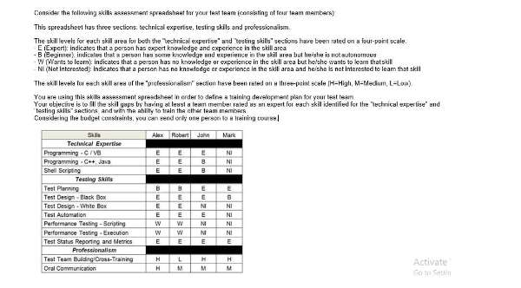
a.
Send Robert to a performance testing training course
b.
Send Alex to a performance testing training course
c.
Send John to a performance testing training course
d.
Send Mark to a test automation training course

Đáp án: B

Lời giải: Map vào cái bảng kỹ năng bạn chọn người có thiên hướng về kỹ thuật test tốt và kỹ năng đào tạo tốt để sau này họ về đào tạo cho team của bạn

Câu hỏi 43
Which of the following statements describing the consequences of specifying test conditions at a detailed level is NOT true? K2 1 credit
a.
In an environment where the test basis is continuously changing, it is recommended to specify test conditions at a detailed level in order to achieve a better maintainability
b.
The specification of test conditions at a detailed level can be effective when no formal requirements or other development work products are available
c.
The specification of test conditions at a detailed level can require the implementation of an adequate level of formality across the team
d.
For system testing, the specification of test conditions at a detailed level, carried out early in the project as soon as the test basis is established, can contribute to defect prevention

Đáp án: A

Lời giải: Refer 2.3 Test analysis: test basis is continuously changing thường xuyên thì rất mất thời gian để cập nhật Test condition chi tiết

Câu hỏi 44
Which of the following test activities would you expect to be the less important ones to achieve the test objectives in this scenario? K4 3 credits
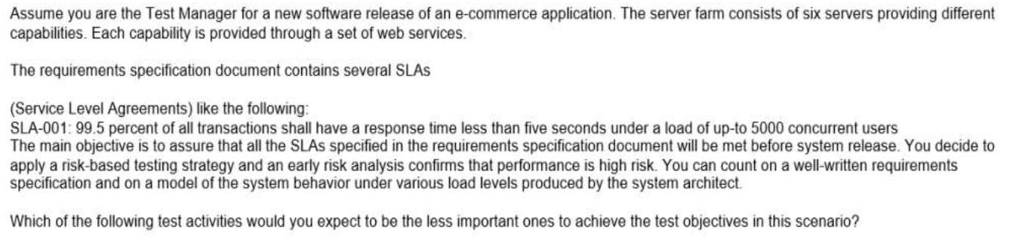
a.
Perform unit performance testing for each single web service
b.
Monitor the SLAs after the system has been released into the production environment
c.
Perform system performance testing, consisting of several performance testing sessions, to verify if all the SLAs have been met
d.
Perform static performance testing by reviewing the architectural model of the system under various load levels

Đáp án: B

Lời giải: chọn B vì "after the system has been released" sau khi bàn giao thì không còn làm gì đc nữa, ko thể đưa ra các test control để đạt được test objective nữa

Câu hỏi 45
Which of the following answers best describes the test activities (assuming it is possible to perform all of them) you should plan for? K4 3 credits
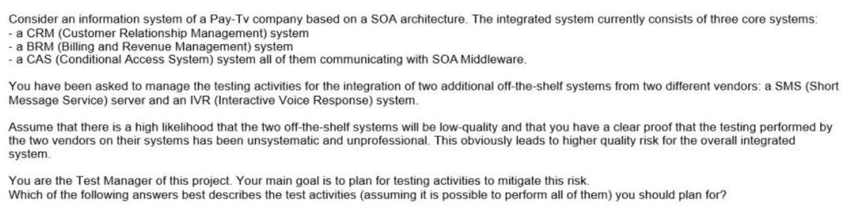
a.
You should plan for an informal and minimal acceptance test of the two off-the-shelf systems and then a single end-to-end test of the overall integrated system
b.
You should directly plan for a single end-to-end test focused on end-to-end tests of the overall integrated system without an acceptance test of the two off-the-shelf systems
c.
You should plan for two levels: a system integration test and an end-to-end test of the overall integrated system
d.
You should plan for adequate re-testing of both the systems followed by a system integration test and an end-to-end test of the overall integrated system

Đáp án: D

Lời giải: refer 1.3 systems of systems. Đầu tiên bạn mua hệ thống về phải làm Cái test nghiệm thu từng hệ thống, sau đó test tích hợp với hệ thống của mình, rồi lại test lại toàn bộ các hệ thống ( để bài nó bảo nếu có thể nên ta ko cần nghĩ đến time và effort)

Câu hỏi 46
The following are the exit criteria described in the test plan of a software product: EX1. The test suite for the product must ensure that at least each quality risk item is covered by at least one test case (a quality risk item can be covered by more test cases). EX2. All test cases in the test suite must be run during the execution phase. EX3. Defects are classified into two categories: "C" (critical defect) and "NC" (non-critical defect). No known C defects shall exist in the product at the end of the test execution phase. Which of the following information is useless when the specified exit criteria is evaluated? K2 1 credit
a.
A traceability matrix showing the relationships between the product risk items and the test cases
b.
A list of all the open defects with the associated classification information extracted from the defect tracking system
c.
A chart, showing the trend in the lag time from defect reporting to resolution, extracted from the defect tracking system
d.
The execution status of all the test cases extracted from the test management tool

Đáp án: C

Lời giải: refer 2.2.1. Tiêu chí kết thúc để đánh giá cho việc có release được hay không, chọn C ít hữu ích vì "trend in the lag time from defect reporting to resolution"

Câu hỏi 47
Which of the following is an example of the test closure activity indicated as "lessons learned"? K2 1 credit
a.
Archive all the test results of the acceptance testing phase
b.
Deliver a list of the open defects of a software product released into production to the service desk team
c.
Participate in a meeting at the end of a project aimed at better managing the events and problems of future projects
d.
Deliver an automated regression test suite, used during the system test phase of a software product released into production, to the team responsible for maintenance testing

Đáp án: C

Lời giải: refer 2.8 Test Closure Activities: Lesson learned = Retrospective meeting trong Agile, tham gia thảo luận về những issue, risks, các điểm cần cải tiến cho tương lai ta chọn C, A là của Archiving, BD là của Handover

Câu hỏi 48
Which of the following answers would you expect to best describe the residual risks associated with the identified product risks, at the end of the first week of test execution? K3 2 credits
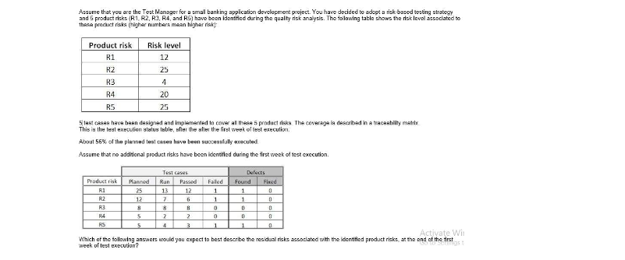
a.
Since R3 is the only risk for which all test cases have passed, the risk has been reduced by 20%
b.
The test execution status table indicates that the risk has been reduced by 56%
c.
The residual risk level can't be determined, because it requires that all the test cases have been executed
d.
The test execution table doesn't give an indication of the risk level of the open defects and the test cases that failed or are not run yet

Đáp án: D

Lời giải: Nhìn vào đề bài đang không chỉ ra mối quan hệ giữa risk level được tính toán như thế nào với số lượng lỗi tìm được và TC chạy được
Câu hỏi 49
Which of the following is a positive logical test that is complete and correct, and covers the REQ-SEL- 4 requirement? K3 2 credits
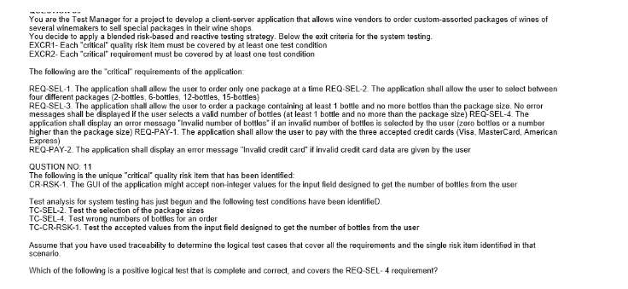
a.
Select a 6-bottles package, then try to insert 5 bottles; verify that no error messages are displayed
b.
Select a 6-bottles package, then try to insert 7 bottles; verify that no error messages are displayed
c.
Select a 6-bottles package, then try to insert 7 bottles; verify that the
d.
Select a 6-bottles package, then try to insert 7 bottles;

Đáp án: C

Câu hỏi 50
What is the MINIMUM number of test conditions that must be added to fulfill both the EXCR1 and EXCR2 exit criteria? K3 2 credits
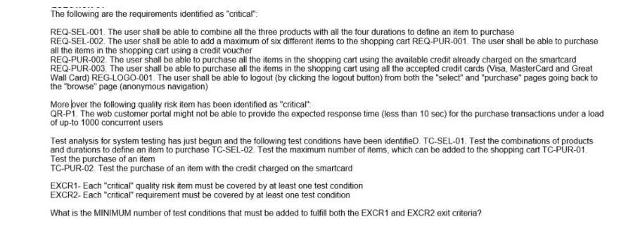
a.
1
b.
2
c.
3
d.
4

Đáp án: C

Lời giải: Chú ý ID của test case được đặt cho phép bạn map với REQ hoặc RISK, bạn chỉ cần map số REQ, RISK với TC là tìm ra số còn thiếu, vì EXCR1, EXCR2 yêu cầu có ít nhất một TC thiết kế cho mỗi REQ, RISK

Câu hỏi 51
Which of the following answers describes the best execution schedule in this scenario? K3 3 credits
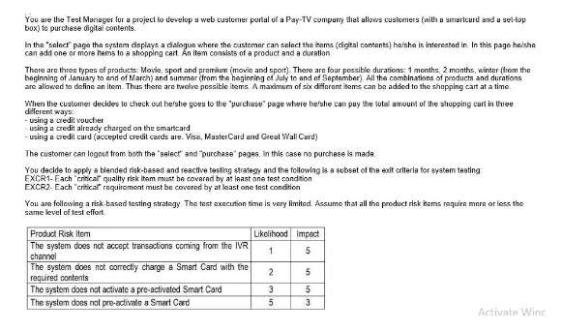
a.
1- Test the acceptance of transactions coming from the IVR channel2- Test the correct charge of the Smart Card with the required contents3- Test the correct pre-activation of the Smart Card4- Test the correct activation of the Smart Card
b.
1- Test the correct pre-activation of the Smart Card; 2- Test the correct charge of the Smart Card with the required contents; 3- Test the correct activation of the Smart Card; 4- Test the acceptance of transactions coming from the IVR channel
c.
1- Test the correct activation of the Smart Card2- Test the correct pre-activation of the Smart Card3- Test the correct charge of the Smart Card with the required contents4- Test the acceptance of transactions coming from the IVR channel
d.
1- Test the correct pre-activation of the Smart Card 2- Test the correct activation of the Smart Card3- Test the correct charge of the Smart Card with the required contents4- Test the acceptance of transactions coming from the IVR channel

Đáp án: D

Lời giải: Bảng này mô tả risk, bạn nhân 2 cột likelihood và impact để tính ra risk level. Risk nào cao nhất thì phải chạy trước

Câu hỏi 52
What is the MINIMUM number of test conditions that must be added to fulfill both the EXCR1 and EXCR2 exit criteria? K3 2 credits
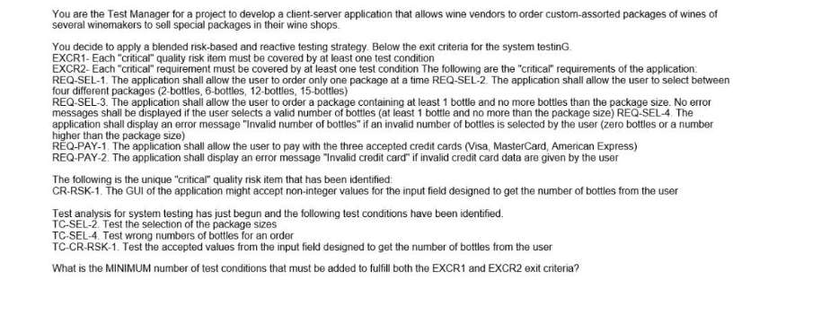
a.
4
b.
3
c.
2
d.
1

Đáp án: A

Lời giải: Chú ý ID của test case được đặt cho phép bạn map với REQ hoặc RISK, bạn chỉ cần map số REQ, RISK với TC là tìm ra số còn thiếu, vì EXCR1, EXCR2 yêu cầu có ít nhất một TC thiết kế cho mỗi REQ, RISK

Câu hỏi 53
Which of the following answers describes the best test execution schedule in this scenario? K3 2 credits
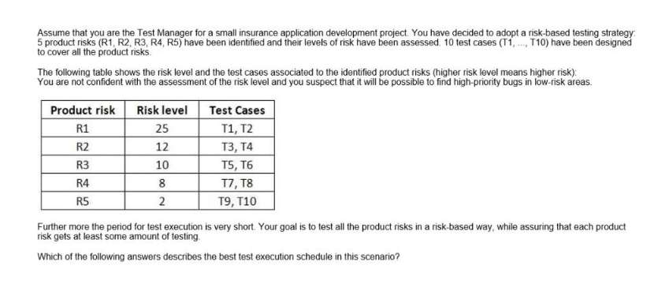
a.
T1, T2, T3, T4, T5, T6, T7, T8, T9, T10
b.
T1, T3, T5, T7, T9, T2, T4, T6, T8, T10
c.
T10, T9, T8, T7, T6, T5, T4, T3, T2, T1
d.
T10, T8, T6, T4, T2, T9, T7, T5, T3, T1

Đáp án: B

Lời giải: Vì là chiến lược theo chiều rộng nên mỗi rủi ro cần được đánh giá ít nhất bởi một TC để xem rủi ro nào xảy ra lỗi, còn thời gian sẽ tiếp tục chạy lượt 2

Câu hỏi 54
Which of the following statements represents the most effective contribution of the stakeholders to the completion of the failure mode analysis table? K4 3 credits
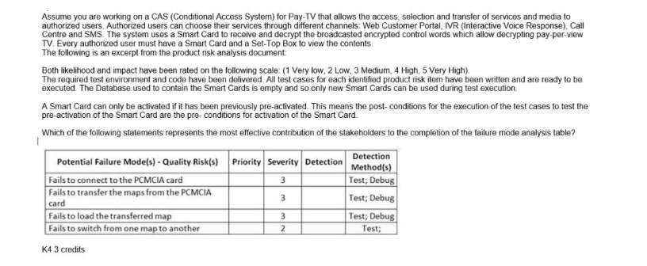
a.
The aircraft pilot and the customer representative should contribute to assess the detection. The chief software engineer, the system architect and the expert tester should contribute to assess the priority.
b.
The aircraft pilot and the customer representative should contribute to assess the priority. The chief software engineer, the system architect and the expert tester should contribute to assess the detection.
c.
The system architect and the chief software engineer should contribute to assess the priority. The expert tester is the only one who should contribute to assess the detection.
d.
The aircraft pilot is the only one qualified to contribute to assess the priority and thus should be assigned this task. The customer representative should contribute to assess the detection.

Đáp án: B

Lời giải: refer 3.4 How to Do Risk-Based Testing, related-test project risk. Chú ý các đối tượng stakeholder có vài trò khác nhau: BA, Product Owner, TA, Customer care, customer hữu ích trả lời về Impact, Developer, designer, TTA, technical leader hữu ích trả lời về likelihood

Câu hỏi 55
What is the MINIMUM number of the remaining test cases that must be successfully executed to fulfill the EX1 exit criteria? K3 2 credits
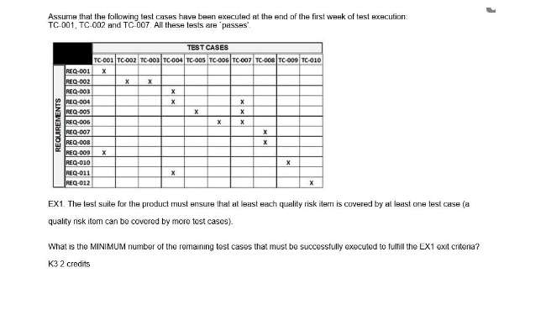
a.
4
b.
5
c.
6
d.
7

Đáp án: A

Lời giải: Chú ý TC ID có đánh mã theo REQ ID nên dễ dàng map được TC và REQ, RISK, tìm ra số case thiếu

Câu hỏi 56
You can count on well-written requirements, but you can't count on an adequate contribution of the stakeholders to the quality risk analysis. You have to mitigate the insufficient contribution of the stakeholders because the risk-based testing approach shall minimize the product risks. Your test team has one expert tester in security testing. Which of the following test activities would you expect to be the less important in this context? K4 3 credits
a.
Extract from the defect tracking system of the previous project all the security defects and failures, and classify them to support design and execution of specific tests
b.
Automate all functional and non-functional system tests
c.
Apply systematic and exploratory testing for integration and system test
d.
Perform exploratory testing sessions with adequate charters covering security aspects

Đáp án: B

Lời giải: Chọn B vì "Automate all" là không thể, không quan trọng

Câu hỏi 57
During the follow-up phase the following conditions are checked: X1. The code has been completely reviewed X2. All the identified defects have been correctly fixed and the modified code has been compiled successfully and run through all the static analyzers used by the project without warnings and errors X3. The modified code is available under the configuration management system with a new version number for the specified CI If these conditions are fulfilled then the review process terminates. Which of the following characteristics of a formal review is missing in this description? K2 1 credit
a.
Defined entry and exit criteria
b.
Checklists to be used by the reviewers
c.
Deliverables such as reports, evaluation sheets or other review summary sheets
d.
Metrics for reporting on the review effectiveness, efficiency, and progress

Đáp án: D

Lời giải: refer 6.1.4 Managing Formal Reviews
Câu hỏi 58
Assume you are managing the system testing phase of a project. The system test execution period is scheduled to twenty weeks. All tests are manual tests. You are following a risk-driven test approach. During the last staff meeting the project manager tells you new deadlines that will not allow completion of all the system tests. Which of the following would you expect to be the best way to respond to this situation? K2 1 credit
a.
Prioritize executing the tests for the highest product risks and track these risks
b.
Remove testers from your test team, so that they can be assigned to other projects
c.
Automate all remaining tests
d.
No action is needed, test as much as possible in the remaining time period

Đáp án: A

Lời giải: dự án này theo hướng "a risk-driven test approach" nên phải sắp xếp ưu tiên dựa vào rủi ro

Câu hỏi 59
You are performing a quality risk analysis for a CSCI (Computer Software Configuration Item) used to implement a CBIT (Continuous Built-In Test) module of a safety-critical system. During the quality risk analysis you are trying to identify the ways in which failures of the CBIT module can occur, for each of them trying to determine the potential causes and likely effects, and the risk level (calculated as the product of three factors: severity, occurrence and detection). Which of the following risk analysis techniques are you working with? K2 1 credit
a.
A lightweight product risk analysis technique
b.
Failure Mode and Effect Analysis
c.
Wide Band Delphi
d.
Cost of Exposure

Đáp án: B

Lời giải: refer 3.2 Risk categories "a safety-critical system"

Câu hỏi 60
Based only on the given information, which of the following is NOT a product risk that could be identified during the quality risk analysis? K4 3 credits
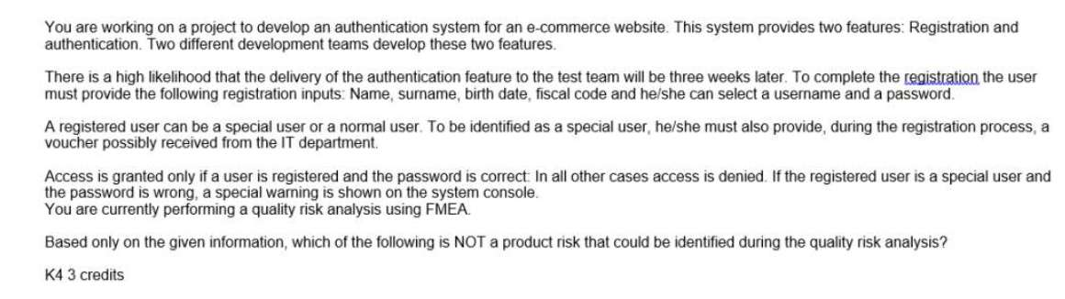
a.
The late delivery of the authentication feature to the test team causes delays in the start of test execution and this could result in a shorter test period
b.
The authentication system denies access for a special user with a wrong password, but doesn't display a special warning on the system console
c.
The authentication system grants access to a normal user with a wrong password
d.
The authentication system grants access to a special user with a wrong password

Đáp án: A

Lời giải: ba câu BCD loại trừ đì vì nó ko phải là risk mà là lỗi

Câu hỏi 61
Which of the following statements describing how identified product quality risks should be mitigated and managed, is true? K2 1 credit
a.
The extent of re-testing and regression testing activities should be based on the risk level
b.
The identification of new risks, the re-assessment of the level of existing risks and the evaluation of the effectiveness of risk mitigation activities should only occur at the very beginning of a project
c.
Risk mitigation of product quality risks can be effective only after starting test execution
d.
The priority of the development and execution of tests should not be based on the risk level but only on the likelihood

Đáp án: A

Lời giải: 3 câu còn lại BCD loại trừ đi vì vô lý

Câu hỏi 62
Which of the following statements about management of product quality risks in mature organizations with respect to the lifecycle, is true? K2 1 credit
a.
Mature organizations address product quality risks associated to non-functional characteristics only during the system test phase
b.
Mature organizations are aware that the contribution of testing to analysis of product quality risks is very important. The analysis should occur throughout the entire lifecycle
c.
Mature organizations don't waste time identifying the sources of risks. They only focus on identifying product quality risks
d.
Mature organizations are aware that risk management of product quality risks only occurs during testing

Đáp án: B

Lời giải: Câu B đúng, hiểu nôm na là phải quản lý risk xuyên xuốt life cycle

Câu hỏi 63
Assume you are currently working on a project developing a system where functional requirements are very well specified. Unfortunately non-functional requirements do almost not exist. You are the Test Manager. You have to choose a technique for test selection that allows testing of non- functional characteristics, especially reliability. Which of the following techniques for test selection do you expect being most useful in this scenario? K2 1 credit
a.
A model-based technique based on the creation of operational profiles
b.
Ambiguity reviews
c.
Test condition analysis
d.
Cause-effect graphing

Đáp án: A

Lời giải: Search thêm trên Vol 1 về test Reliability có đề cập đến kỹ thuật dựa vào operational profiles là phù hợp để test, hiểu nôm na là dựa vào lịch sử vẫn hành của hệ thống để đưa ra yêu cầu test cho non-functional khi nó ko có requirement

EXAM 7 AL2023-Update 2023-ko video chữa đề
Câu hỏi 1
Consider the following code fragment: if (a>b && (b>c) { b = (a+c/2; } Assume that, in the following options, each of the three numbers in parentheses represents the inputs for a test case, where the first number is a, the second number b, and the third number c. Which of the following gives a set of test case inputs that achieves decision coverage for this fragment of code in the minimum number of test cases?
a.
(5, 3, 2)
b.
(5, 3, 2); (5, 4, 0)
c.
(5, 4, 0); (4, 5, 0)
d.
(4, 5, 0); (5, 4, 5)
e.
(5, 3, 2); (5, 4, 5)

Đáp án: C,E

Lời giải: Chapter 4 whitebox test, cả C,E đều thỏa mãn chạy đc TF
Câu hỏi 2

The main objectives the senior management team wants to achieve are: - to reduce the costs associated with dynamic testing - to use reviews to ensure that the project is on course for success and following the plan - to use reviews as a well-documented and effective bug-removal activity following a formal process with well-defined roles - to determine the effectiveness of reviews in terms of phase containment - to improve phase containment effectiveness Which of the following answers would you expect to describe the best way to achieve these objectives? K4 3 credits
a.
You should plan for lightweight exit-phase reviews at the end of each development and testing phase, and plan for a process of gathering information from testing to perform an analysis aimed at identifying the larger cluster of defects
b.
You should plan for formal exit-phase reviews at the end of each development and testing phase, and plan for a process of gathering information from testing to perform an analysis aimed at identifying the larger cluster of defects
c.
You should plan for formal exit-phase reviews at the end of each development phase and testing phase, and plan for a process of gathering information from testing to perform an analysis of the bugs found during testing to determine the people responsible for those bugs
d.
You should plan for formal exit-phase reviews at the end of each development and testing phase, and plan for a process of gathering information from testing to perform an analysis of the bugs found during testing to determine the phase in which they have been introduced
e.
You should plan for informal exit-phase reviews at the end of each development and testing phase, and plan for a process of gathering information from testing to perform an analysis of the bugs found during testing to determine the phase in which they have been introduced

Đáp án: D

Lời giải: refer 6.1.4 Managing Formal Reviews. Để đạt được các objective trên phải áp dụng các tiêu chí của formal review : planning đầy đủ, define entry exit criteria, có đo đạc metrics
Câu hỏi 3
Which of the following activities would the costs be classified as a cost of detection?
a.
Writing test specifications according to the test design
b.
Training developers to better understand the new features of the coding language they will use on the project
c.
Re-running a test case, during the system testing phase, to verify that a fix eliminates a previously found defect
d.
Fixing field failures
e.
Re-running a test case after the system testing phase

Đáp án: A

Câu hỏi 4
Which of the following is a type of testing that someone in the role of a test analyst, working with the test manager, should typically consider and plan for?
a.
Security testing
b.
Reliability testing
c.
Accessibility testing
d.
Performance testing
e.
Automation test

Đáp án: C

Lời giải: Refer chapter 5 bảng ISO25010, mảng mà TA phải chịu trách nhiệm thì Accessibility testing là thuộc tính con của Usability test
Câu hỏi 5
Which of the following tasks and responsibilities do NOT belong to that of a test analyst in the context of evaluating exit criteria and reporting?
a.
The test analyst is responsible for supplying accurate information
b.
The test analyst should be able to use the reporting tools
c.
The test analyst will contribute to the final report at the end of the testing
d.
The test analyst should write final test reports objectively
e.
The test analyst should create master test plan

Đáp án: D,E

Lời giải: Refer chapter 10 đã bổ sung bảng task của test leader và tester.
Câu hỏi 6
Identify THREE main advantages of this approach to incident management.
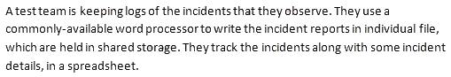
a.
Quick to set up and cheap
b.
Electronic rather than manual
c.
Allows attachments (e.g. screen prints) to be linked to the incident reports
d.
Can easily be integrated with open source tools
e.
High level of Usability
f.
Large files are not a problem

Đáp án: A,B,E

Lời giải: Quản lý lỗi bằng một công cụ Word process, mỗi lỗi là 1 file riêng và được quản lý các thông tin quan trọng trong 1 spreedsheet, nên chọn đc ABE, Còn lại các vấn đề kỹ thuật khác ko đc nhắc đến trong bài nên ta ko thể bảo nó có chứa Large file đc ko ở F, Integrated với tool khác đc ko cũng ko biết ở D, attachments ko rõ ở C
Câu hỏi 7
What is the MINIMUM number of test conditions that must be added to fulfill both the EXCR1 and EXCR2 exit criteria?
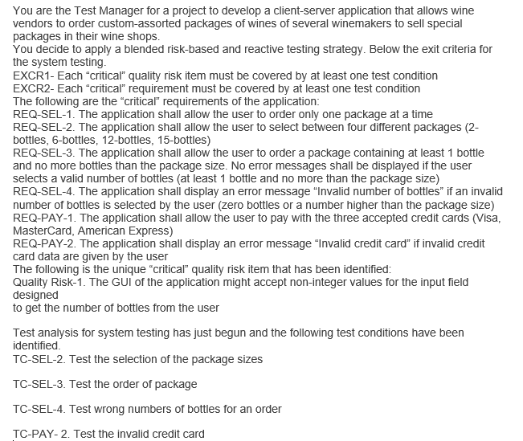
a.
1
b.
2
c.
3
d.
4

Đáp án: C

Lời giải: Câu này cứ đếm số Req và số risk và map với TC đã cho thì tìm ra test case còn thiếu theo EXCR1 và EXCR2 là mỗi cái phải có ít nhất 1 test case để kiểm tra
Câu hỏi 8
You are a Test Manager working for a software organization where reviews have never been applied. After a meeting with your managers examining a business case for reviews, (including their costs, benefits, and potential issues), the management finally decides to adopt formal reviews for future projects. You have been given a budget that you have spent to provide training in the review process and to introduce the review process on a pilot project. On that pilot project the introduction of reviews has been very positive in terms of positive involvement from all the participants. All the reviews applied to different documents have been very effective for their purposes (especially at revealing defects). Which of an important factor for the introduce of formal reviews which is missing? 3 P
a.
Management support
b.
Participant support
c.
Definition and use of metrics to measure the ROI (Return On Investment)
d.
Training in the review process
e.
Stakeholder support

Đáp án: C

Lời giải: Câu này dựa vào keyword của đề bài ta thấy "the management finally decides to adopt formal reviews for future projects." là có A rồi, "provide training in the review process" là có D rồi, "positive involvement from all the participant" là có B rồi, thiếu mỗi C nên là đáp án đúng, Còn E là không yêu cầu trong nhân tố thành công của Review
Câu hỏi 9
Topic 8, Scenario 8, V2 “Test Project Improvement’ You have raised the issue that improving the testing process is also dependent on the status of the software development process. ******************************* During test process improvement it is recommended to use standards where possible. Standards originate from various sources and they cover different subjects in relation to testing Pick TWO sources of software standards, useful to software testing from the ones mentioned below.
a.
ISO 9126-1 ‘Software engineering- Product quality Part 1: Quality model’ is an international standard, that provides a basis on which to define quality assurance solutions.
b.
ISA 4126-1 ‘Software engineering- Product quality Part 1: Quality model’ is an international standard, that provides a basis on which to define quality assurance solutions
c.
BS-7925-2 ‘Software testing. Software component testing is a national standard used internationally. It covers a number of testing techniques that may be useful both on component testing level and on system testing level.
d.
SY-395-01 ‘Standard for East Coast Hospital software’ is a regional standard adapted from a national one. Besides hospital software, this standard ought to be used also by other types of software system in the region.
e.
IEEE 829 ‘standard for software test documentation’ is an international standard to be following mandatory by all testing origination regardless of lifecycle models.

Đáp án: A,C

Câu hỏi 10
You are testing an ATM based on the following use case; ATM start screen is showing 1. The user inserts card 2. The user types in PIN 3. The user selects `cash with receipt' 4. The user selects 50 5. The user selects `no further service' Expected results - The ATM provides 50 to the user - The ATM return the card and balance slip - The ATM clears the screen - The ATM returns to start menu In your test log which of the following could be noted as part of additional attention points? [K3] 2 credits
a.
Issues regarding time-behavior
b.
Issues regarding interoperability
c.
More test cases needed to achieve full coverage
d.
Expected results not clearly defined
e.
Performance issue

Đáp án: A,E

Lời giải: Xem hình của câu 32 đề TM12 sẽ thấy họ đánh dấu vấn đề cần thêm vào mô tả cho Use case này là Additional attention points: Note Response times
Câu hỏi 11
During the follow-up phase the following conditions are checked: X1. The code has been completely reviewed X2. All the identified defects have been correctly fixed and the modified code has been compiled successfully and run through all the static analyzers used by the project without warnings and errors X3. The modified code is available under the configuration management system with a new version number for the specified CI If these conditions are fulfilled then the review process terminates. Which of the following characteristics of a formal review is missing in this description? K2 1 credit
a.
Defined entry and exit criteria
b.
Checklists to be used by the reviewers
c.
Deliverables such as reports, evaluation sheets or other review summary sheets
d.
Metrics for reporting on the review effectiveness, efficiency, and progress
e.
Project documents fully and detail

Đáp án: D

Câu hỏi 12
The test improvement project will take place in an organization developing a safety-critical avionics application. Which one of the following standards do you believe would be most appropriate to take into account for compliance during your assignment?
a.
ISO 9126
b.
IEEE 829
c.
BS 7925/2
d.
DO-178B

Đáp án: D

Câu hỏi 13
Consider an agile team adopting Extreme Programming (XP) with five developers and one tester without any coding experience. To which of the following activities would you expect the tester will contribute most?
a.
Developing unit tests
b.
Executing unit tests
c.
Planning and executing tests during the integration test phase to detect interface defects
d.
Supporting the customer in the execution of acceptance testing

Đáp án: D

Lời giải: AB thì là của Developer không phù hợp để tester làm, C là task của TM, chọn D thôi
Câu hỏi 14
Which of the following is a positive logical test that is complete, is correct, and covers the REG-LOGO-001 requirement?
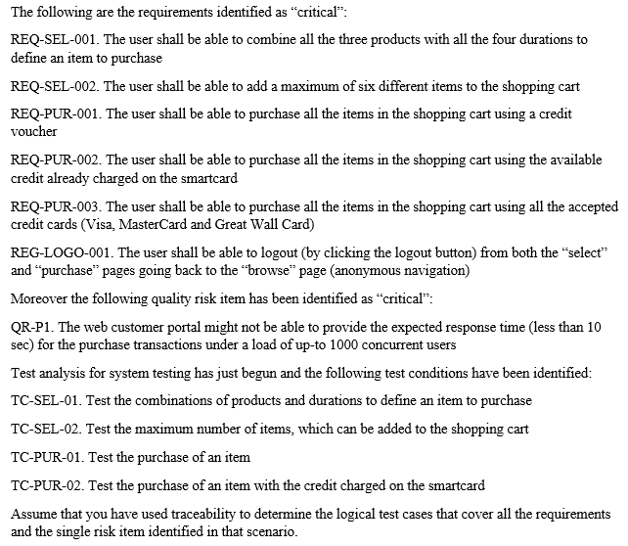
a.
On the purchase page (“purchase state”), click the logout button; verify that the browse page (“browse state”) is displayed
b.
On the select page (“select state”), click the logout button
c.
On the purchase page (“purchase state”), click the logout button; verify that the “Impossible to logout – complete or cancel the current transaction” message is displayed
d.
On the browse page (“browse state”), click the logout button

Đáp án: A

Câu hỏi 15
Which of the following is a positive logical test that is complete and correct, and covers the REQ-SEL-4 requirement?
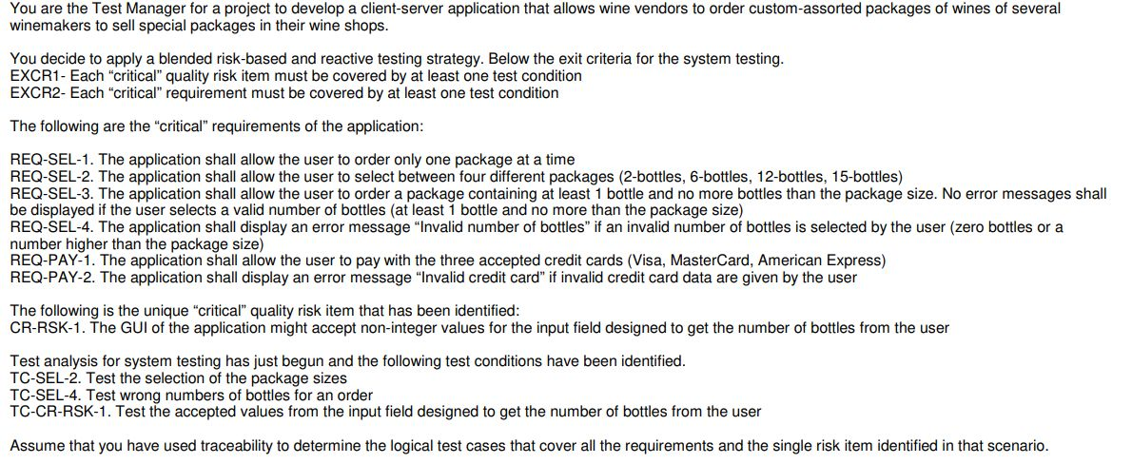
a.
Select a 6-bottles package, then try to insert 5 bottles; verify that no error messages are displayed
b.
Select a 6-bottles package, then try to insert 7 bottles; verify that no error messages are displayed
c.
Select a 6-bottles package, then try to insert 7 bottles; verify that the 'Invalid number of bottles' message is displayed
d.
Select a 6-bottles package, then try to insert 7 bottles

Đáp án: C

Lời giải: REQ-SEL-4: user nhập 1 số bị sai như là 0 hoặc lớn hơn 6 ( vì họ chọn package 6-bottles) thì hệ thống sẽ thông báo lỗi, vậy chọn đáp án để ra được thông báo lỗi là TC đúng với REQ-SEL-4.
Câu hỏi 16
Q5. Which one of the following is LEAST likely to be involved in the review of requirements specifications? [K2]
a.
Business Analyst
b.
Customer
c.
User
d.
Project Manager
e.
Stakeholder

Đáp án: D

Lời giải: Người ít tham gia vào hoạt động review requirement nhất là PM ( ông này tập trung vào quản lý dự án). Còn custeomer, user , stakeholder là những người hoàn toàn rất hữu ích giúp review requirement, cần kéo, mời họ vào hoạt động này.
Câu hỏi 17
Identify THREE items that would be part of the work-breakdown structure showing the key testing activities for the acceptance test project.
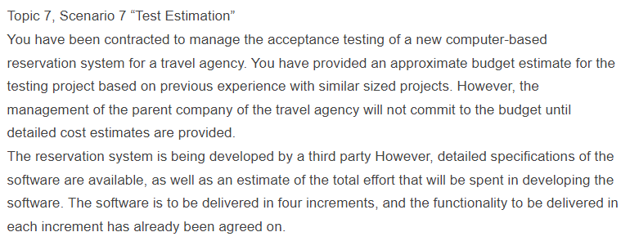
a.
Test planning, test case preparation and test execution for each of the four iterations
b.
Work should be explicitly allocated to test completion, test management, installation and to training on using the system
c.
Activities to deploy the system in the user environment
d.
Regression testing in the second, third and fourth iterations
e.
Development activities for unit and integration testing
f.
Reviews on requirements documentation
g.
Defining test environment requirements for system testing

Đáp án: A,B,D

Lời giải: Câu này hiểu đơn giản WBS sử dụng để estimate cho các hoạt động test, vậy các hoạt động chính nào của test cần phải được đưa vào bản estimation
Câu hỏi 18
If you are flying with an economy ticket, there is a possibility that you may get upgraded to business class, especially if you hold a gold card in the airline's frequent flier program. If you don't hold a gold card, there is a possibility that you will get 'bumped' off the flight if it is full and you check in late. Note that each box (i.e. statement) has been numbered. Three tests have been run: Test 1: Gold card holder who gets upgraded to business class Test 2: Non-gold card holder who stays in economy Test 3: A person who is bumped from the flight What is the Decision coverage of these three tests?
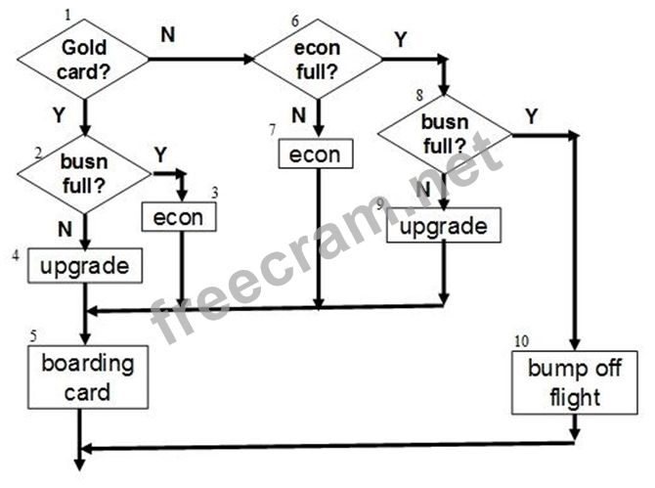
a.
60%
b.
70%
c.
75%
d.
80%

Đáp án: C

Lời giải: Cái này xem thêm chapter 4 phần white box test, sơ đồ kia có 10 statement ( trám và chữ nhật đều là statement, trám là statement đặc biệt gọi là decision), dùng bút vẽ vào sơ đồ 3 cái TC xem nó đã đi qua đc bao nhiêu trám và chữ nhật. Công thức tính statement coverage là số statement được test trên tổng số statement (10) nhân 100%
Câu hỏi 19
A booking system for a city bus service prices its fares according to the time of travel: Peak-time tariff starts at 06:00 and finishes at 10:00 am Off-peak tariff applied during all other times of services. The bus service does not operate between 23:00 and the start of the next day’s peak service. Note that all times mentioned are inclusive. When applying the equivalence partitioning test design technique, which of the following options shows test case inputs that each fall into a same equivalence partition?
a.
06:00, 10:00, 12:00
b.
10:01, 13:00, 22:59
c.
01:00, 08:00, 22:00
d.
24:00, 10:00, 23:01

Đáp án: B

Lời giải: chapter 4, vẽ sơ đồ Equivalence Partition ra là tìm đc
Câu hỏi 20
IEEE 1028 also defines "management review" as a type of review. What is the main purpose of a management review?
a.
Align technical concepts during the design phase
b.
Establish a common understanding of requirement
c.
Provide independent evaluation of compliance to process, regulation, standard, etc
d.
To monitoring progress, assess the status of a project, and make a decision about future actions

Đáp án: D

Lời giải: Xem tài liệu lý thuyết chapter 6, mục đích của management review
Câu hỏi 21
Which of the following interpretations of this chart provides a reason to not declare the system integration testing complete?
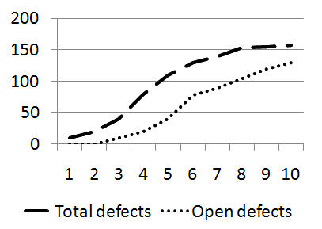
a.
The bug find rate has not leveled off.
b.
Developers aren't fixing bugs fast enough.
c.
The complete set of tests has not yet been run.
d.
A number of unresolved bugs remain in the backlog.

Đáp án: D

Lời giải: Câu này ở Chapter 3 vol 123 cũng có nhé, biểu đồ cho thấy còn 1 số lượng lỗi chưa xử lý hết nên chưa kết thúc đc
Câu hỏi 22
Scenario "Medical domain". You are working as a test manager in the medical domain leading a team of system testers. You are currently working on a major release of the product which gives customers many new features and resolves a number of problem reports from previous releases. Explain how the above mentioned report may differ from a report that you produce for the project manager, who is a test specialist. Select TWO items from the following options that can be used to report to the project manager and would not be included in a report to senior manager
a.
Show details on effort spent
b.
List of all outstanding defects with their priority and severity
c.
Give product risk status
d.
Show trend analysis
e.
State recommentdations for release

Đáp án: A,B

Lời giải: Vì Project manager theo sát dự án nên các thông tin báo cáo phải rất cụ thể, detail, còn senior manager là quản lý cấp cao không thường xuyên vào dự án nên các thông tin phải ở mức cao, tóm gọn và những cái quan trọng để giúp họ đưa ra các quyết định như Risk, biểu đồ,
Câu hỏi 23
Based on the tax system specification as described below, using boundary value analysis, which would be the best test set to explicitly test on single boundary value fully? Tax system A tax system needs to be updated due to new legislation. For a person with a salary of less than € 20 000 and who is married, the tax needs to be recalculated. If a person has at least three and less than six children, an additional 10% reduction is applicable.
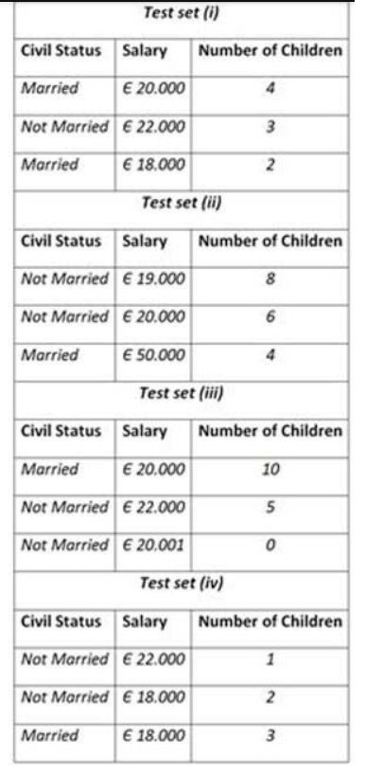
a.
(iv)
b.
(ii)
c.
(iii)
d.
(i)

Đáp án: A

Câu hỏi 24
Consider the following scenario for a metro fare system: If you take the metro before 9:30 am or in the afternoon between 5:00 pm until 7:00 pm, you must pay full fare A saver ticket is available for metro rides between 9:30 am and 5:00 pm [both inclusive], and after 7:00 pm. Which off the following test sets will provide the best equivalence partitioning coverage?
a.
9:29 am, 5 01 pm, 7:30 pm, 7:31 pm, 8:00 pm
b.
9:30 am, 4:00 pm, 6:00 pm, 8 00 pm, 8:30 pm
c.
9:30 am, 9:31 am, 4:59 pm, 5:00 pm, 8:00 pm
d.
8:00 am, 10:00 am, 5:15 pm, 7:01 pm, 11:00 pm

Đáp án: D

Câu hỏi 25
A car navigation system needs to be integrated in the overall car software It is important to verify that the car navigation is functioning correctly once integrated. Thus, functional correctness is considered to be important. Which of the following techniques is most likely to support the required functional correctness testing?
a.
Multiple condition testing
b.
State transition testing
c.
Heuristic evaluation
d.
Vulnerability scan

Đáp án: B

Lời giải: A là của White box, trong thực tế ko làm đc, D là của static analysis để test security, C giống như free test ko test correctness đc. Chỉ còn mỗi B để chọn
Câu hỏi 26
Which of the following is an appropriate task for the Test Analyst to perform during the test execution phase?
a.
Finalizing test data and test environments
b.
Creating automated tests
c.
Creating a test execution schedule
d.
Analysing anomalies to establish their likely causes

Đáp án: D

Lời giải: Xem cái báng task công việc của quy trình test ở mục 1.4 sách tóm tắt thì A B C đều là của hoạt động Preparation, (a test execution schedule là test procedures nhé) nên chọn đc đáp án D ( dịch là phân tích các điểm bất thường ( anomaly = incident) để xem có thể là nguyên nhân của lỗi không)
Câu hỏi 27
A PIN entry component of an ATM system has been developed using the following state table: Using the state transition test technique, how many 0-switch test cases are needed to achieve 100% 0-switch coverage?
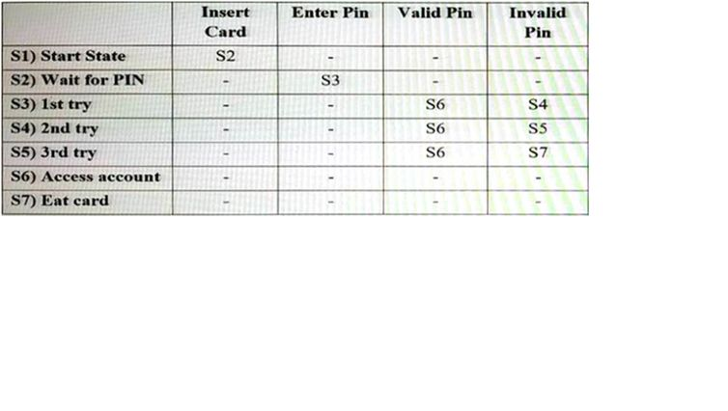
a.
4
b.
7
c.
8
d.
28

Đáp án: C

Lời giải: trường hợp này là 8 thôi nhé chỉ tính đến trường hợp đúng thôi, đề không hỏi invalid
Câu hỏi 28
In the recent past, you have learned that test automation just using capture & playback tooling, possibly enhanced with some test programming, has limitations. For the next banking project, that will be run using Agile methods, you want to implement a keyword-driven test automation approach. You have already started to define some high-level test cases for the account transfer user story: TC 1: transfer 150 from Lars to Ann, verify Ann's balance to be 150 TC 2: transfer 300 from Tim to Ann, verify Ann's balance to be 450 In the context of implementing the keyword-driven test automation approach, which of the following activities should now be conducted by the Test Analyst?
a.
Define keywords to be implemented, eg, check balance.
b.
Design test navigation scripts
c.
Select a tool to support keyword-driven testing
d.
Work together with a developer to define a test automaton architecture

Đáp án: A

Lời giải: TA thì chỉ có thể làm được A thôi bởi vì script thì cần phải biết code, TA định nghĩa ra các yêu cầu về Keywords để TTA viết thành script
Câu hỏi 29
You are testing the processing of a critical traffic control system to which various regulations apply The processing of the input variables is dependent on defined ranges within which the actual retrieved data values can lie. Which of the following black-box test techniques should you use to test the processing functionality of this system?
a.
Use case testing
b.
Pairwise testing
c.
Equivalence partitioning enhanced with boundary value analysis
d.
State transition testing

Đáp án: C

Lời giải: Chú ý "the input variables is dependent on defined ranges" các input dựa vào các vùng ranges = areas nên ta chọn EP và BVA
Câu hỏi 30
A new web site must operate correctly with different browsers (Internet Explorer, Google Chrome, Firefox, Opera, Safari), using different plug-ins (Realplayer, Mediaplayer), will be receiving pages from different servers (IIS, Apache and WebLogic) and will be running on various operating systems (Windows, Android, iOS and Linux). Which of the following test techniques should you use to define the required test cases for testing this new web site in its various environments?
a.
Pairwise testing
b.
Exploratory testing
c.
Use case testing
d.
Decision table testing

Đáp án: A

Lời giải: Mình chỉ chọn A thôi, với câu này họ chỉ chọn một đáp án và đang tập trung vào test trên nhiều môi trường khác nhau
Câu hỏi 31
Rather than developing an e-commerce product, management has decided to acquire a COTS package The e-commerce product needs to interface with backend applications such a finance, stock control and order delivery. You are asked to define a test plan for this project. Given just the information in the scenario, which of the following software quality characteristics must be included in your test plan?
a.
Portability
b.
Maintainability
c.
Interoperability
d.
Reliability

Đáp án: C

Lời giải: Trong đề nó chỉ nhắc đến interface với các hệ thống thì cái test Mình phải quan tâm nhất là interoperability, Nếu mà đề nó thêm một số mô tả nữa về việc tương lai sẽ phải kết nối thêm các hệ thống khác hay là cần phải nâng cấp cái gì đó lên thì mới quan tâm đến maintainability.
Câu hỏi 32
You are a Test Analyst in the banking domain. You have received the following requirement: "The system shall allow cash advances of at least 200 Euros for all supported credit cards. The following credit cards are supported: American Express, Diners, Visa, Mastercard and Eurocard. Which one of the findings described below is true regarding this requirement?
a.
The requirement is unclear in terms of advance limits.
b.
The requirement indicates potential performance problems
c.
The requirement indicates potential usability problems
d.
The requirement is ambiguous in terms of supported cards

Đáp án: A

Lời giải: chỗ này là các yêu cầu về functional, nó không nói về non- function nên không chọn B C đc, còn D thì card đã liệt kê rồi. Chốt lại chỉ thiếu advance limits
Câu hỏi 33
If you are flying with an economy ticket, there is a possibility that you may get upgraded to business class, especially if you hold a gold card in the airline's frequent flier program. If you don't hold a gold card, there is a possibility that you will get 'bumped' off the flight if it is full and you check in late. Note that each box (i.e. statement) has been numbered. Three tests have been run: Test 1: Gold card holder who gets upgraded to business class Test 2: Non-gold card holder who stays in economy Test 3: A person who is bumped from the flight What is the statement coverage of these three tests?
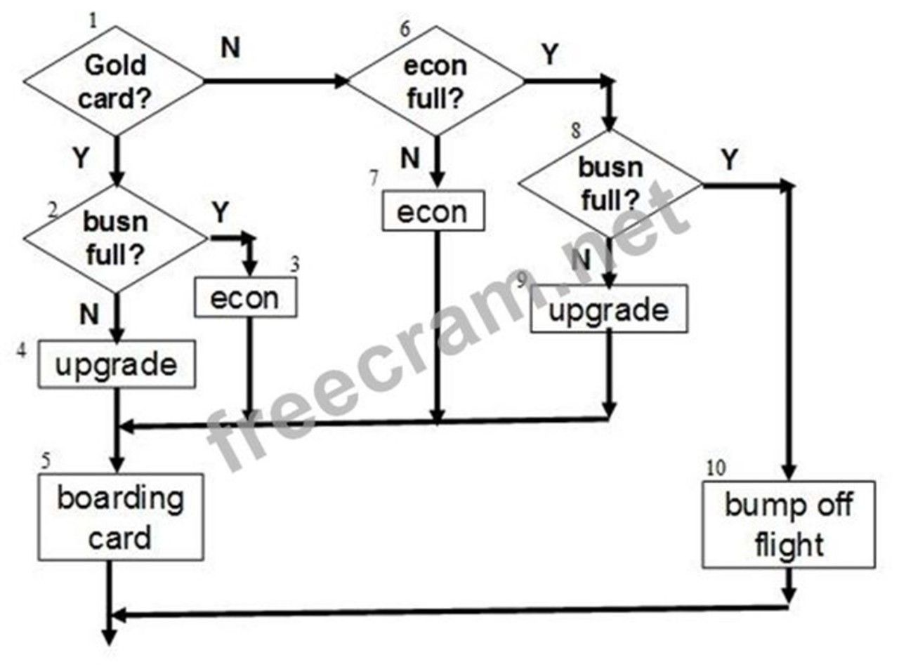
a.
40%
b.
60%
c.
80%
d.
100%

Đáp án: C

Câu hỏi 34
A new mobile app is to be developed for managing the membership of a soccer club which runs several teams. One of the key objectives of the club owners is to replace the outdated manual method required for registration of new members. The functionality of the app is to remain relatively simple because not all users will be familiar with modern user interfaces. The club owners have therefore placed emphasis on the ease with which users can navigate between the various screens and the usability of the application. An objective is also to manage the numbers of players who can register for a team. Limits are therefore to be enforced which may result in applicants being placed on a waiting list. Which TWO of the following test techniques would be MOST appropriate for testing the mobile app?
a.
State transition testing
b.
Decision table testing
c.
Boundary value analysis
d.
Use case testing
e.
Pairwise testing

Đáp án: A,C

Lời giải: Refer đề TA trên istqb.org. Chú ý vào 2 keyword là "navigate between the various screens" thì nên chọn đáp án A và "Limits are therefore to be enforced" cần test về giới hạn số lượng người đăng ký theo team thì nên chọn C
Câu hỏi 35
Considering only the READY state, what is the number of test cases required to achieve round-trip coverage for this state?
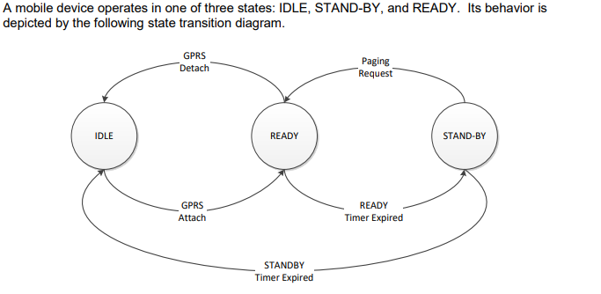
a.
3
b.
4
c.
6
d.
7

Đáp án: A

Lời giải: Round trip nghĩa là đi ra từ state nào thì về lại chính state đó đc gọi là 1 TC, ở đây chỉ tính cho READY thì có 3 case: 1. READY > STAND-BY > READY 2. READY > IDLE > READY 3. READY > STAND-BY > IDLE > READY
Câu hỏi 36
You are working as the Director of Testing for a company that sells smartphone applications for the ass consumer market. The CEO has stated the following quality related goals for the organization: 1. Minimize the number of customer complaints about the applications, especially on social media such as Twitter, Facebook, Google+, etc. 2. Deliver new applications, and features for those applications, to customers as quickly as possible while still maintaining the highest level of customer satisfaction. You are defining the test team’s mission for the organization. Select two of the options that belong in the test policy document as part of the mission for testing.
a.
Detect defects that would result in customer dissatisfaction.
b.
Work with marketing and project management to plan test execution cycles that minimize quality risk within schedule constraints.
c.
Ensure that 100% of the stated requirements work correctly, without any failures.
d.
Design tests using sophisticated techniques for compatibility testing including pairwise testing.
e.
Ensure 100% defect detection effectiveness for all releases of applications and features.
f.
Remove all defects that would affect customer satisfaction.
g.
Provide the development teams with feedback on the quality of individual developers’ work products.

Đáp án: B,G

Lời giải: Refer TM expert trên trang istqb.org câu số 12. Vì là nội dung cần đưa vào the test policy document nên cần phải chung chung về nguyên lý để hướng cho các dự án, phải bỏ các đáp án quá cụ thể và chi tiết đi nó ko hợp với policy. Như là C sai ở "100% of the stated requirements work correctly", D sai ở "compatibility testing including pairwise testing", E sai ở "100% defect detection effectiveness for all releases", F sai ở "Remove all defects ", F sai ở "quality of individual developers"
Câu hỏi 37
Which TWO of the defects listed below should be selected for a detailed root cause analysis?
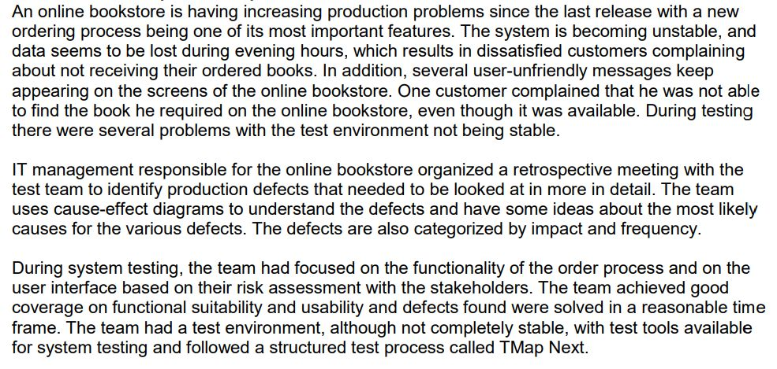
a.
User unfriendly messages
b.
Test environment problems
c.
Unstable production system
d.
Loss of data
e.
Compliance regarding the book not being found

Đáp án: C,D

Lời giải: Refer câu 17 đề expert trên istqb.org của module Test Processes (CTEL-ITP-ATP)
Câu hỏi 38
In your organization the following tools of the same vendor are currently in usE. a requirements management tool, a test management tool and a bug tracking tool. You are the Test Manager. You are currently evaluating a test automation tool of the same vendor (to complete the vendor's tool suitE. against an interesting open-source test automation tool under the GNU GPL (General Public LicensE.. There are no initial costs associated to that open-source tool. Which of the following statements associated to the selection of the open-source tool is correct in this scenario?
a.
The open-source tool can be modified but only if the community of developers of that tool gives you the formal permission to modify it
b.
There are no initial costs for the open-source tool but you should carefully consider the costs associated to the integration with the existing tools and also evaluate the recurring costs
c.
There are no initial costs for the open-source tool because open-source tools are usually low-quality, while vendor tools have always a better quality than the corresponding open-source tools
d.
The open-source tool can be modified but it can't be distributed further in any way
e.
There are initial costs for the open-source tool but you should carefully consider the costs associated to the integration with the existing tools and also evaluate the recurring costs

Đáp án: B

Câu hỏi 39
Consider a defect report and assume that a part of its life cycle includes the following states: New: Is the initial state Working. Means that the developers are addressing the defect in order to produce a fix for the defect Clarification: Means that the developers need more information from the tester to address the defect and produce a fix for the defect and the tester is working to provide this information to the developers Verification: Means that a fix for the defect has been produced and the tester is running the adequate tests to verify whether the fix solves the defect Closed: is the final state Which TWO of the following answers represents an invalid sequence of states that can't lead the bug report to the "Closed" state?
a.
New, Working, Verification, Working, Clarification, Working, Verification, Closed
b.
New, Working, Clarification, Working, Verification, Closed
c.
New, Working, Verification, Closed
d.
New, Working, Verification, Working, Clarification, Working, Closed
e.
New, Working, Clarification, Closed

Đáp án: D,E

Lời giải: Thứ tự nào sau đây sai về trạng thái của lỗi mà đi đến trạng thái cuối Closed ko đúng, chọn D và E vì Working hoặc Clarification xong chưa dc Verification thì ko thể đóng luôn đc
Câu hỏi 40
You are the Test Manager on a project following an iterative life-cycle model. The project should consist of nine iterations of one month duration each. It is planned to develop the most important features to have a stable core of the application in the first three iterations and to add the additional features in the last six iterations. At the beginning of the first iteration, only a draft version of the requirements specification document for the core features is available. Assume that during each of the first three iterations, the chosen features are fully completed and unit tested. Which of the following statements is true in this context?
a.
The system test phase should start when all the requirements are frozen
b.
You should allocate a large effort for system testing during the first three iterations
c.
You should allocate all the effort for the system test phase only in the last iteration
d.
You should apply the same test strategy as used in a sequential life cycle model
e.
You should allocate all effort for system testing during the first three iterations

Đáp án: B

Câu hỏi 41
Assume you have some data related to confirmation testing during system testing of a past project. In that project 240 bug reports have been opened once, 80 were opened twice, 10 were opened three times and no bug reports have been opened more than three times. You estimate that a bug report, which has failed its confirmation test, costs, on average, 3 person-hours. Which of the following statements correctly describe the value of these confirmatory testing activities based on cost of quality?
a.
300 person-hours have been spent on the project during the system testing phase, because of the failed confirmation tests and this cost belongs to the costs of internal failure
b.
340 person-hours have been spent on the project during the system testing phase, because of the failed confirmation tests and this cost belongs to the costs of external failure
c.
340 person-hours have been spent on the project during the system testing phase, because of the failed confirmation tests and this cost belongs to the costs of internal failure
d.
300 person-hours have been spent on the project during the system testing phase, because of the failed confirmation tests and this cost belongs to the costs of detection
e.
320 person-hours have been spent on the project during the system testing phase, because of the failed confirmation tests and this cost belongs to the costs of internal failure

Đáp án: A

Câu hỏi 42
Topic 3, Scenario 3 “Tool Selection and Implementation” Your company is considering whether or not to purchase a test tool suite from a respectable vendor. Your manager has searched the internet for comparable products but none of them meets his specific requirements. A tool demonstration has been arranged for next week and your team has been invited to attend. The tool suite consists of a test management tool, test execution tool and a requirements management tool. There is the possibility of adding a performance testing tool at a later stage. You have decided to attend the demo but raise some issues before hand regarding expectations. **************************** Select THREE issues from the options provided that should at least be raised.
a.
What are the problems we are trying to address?
b.
How will the implementation be organized?
c.
Which project will be selected to perform the tool pilot?
d.
Has there been sufficient comparison of tools?
e.
Do we have a set of tool requirements to validate the tool against?

Đáp án: A,D,E

Câu hỏi 43
Considering the following high-level activities: 1. Set context and establish sponsorship 2. Define performance indicators 3. Identify stimulus for improvement 4. Establish an improvement infrastructure (i.e., organization) 5. Set detailed objectives and establish test improvement team commitment 6. Plan an assessment 7. Define the impact of improvement measures Which of the high-level activities are parts of the “Initiating” phase of the IDEAL improvement model?
a.
Only 1, 3 and 4 are parts of the “Initiating” phase of the IDEAL improvement model
b.
Only 1, 2 and 5 are parts of the “Initiating” phase of the IDEAL improvement model
c.
Only 1, 2, 3, 4 and 5 are parts of the “Initiating” phase of the IDEAL improvement model
d.
Only 1 and 3 are parts of the “Initiating” phase of the IDEAL improvement model

Đáp án: B

Lời giải: Refer câu 23 đề expert trên istqb.org của module CTEL-ITP-Part_1 (Improving the Test Process)
Câu hỏi 44
An insurance company has a dedicated test team consisting of a small number of core testers that lead testing projects as part of the internally run software projects. They write and execute tests together with non-professional testers from the different departments that will later use the new or changed products. The test team has defined the following measurement goal to improve their test processes: xem ảnh Which of these should best be used in the GQM plan to fulfill the given goal?
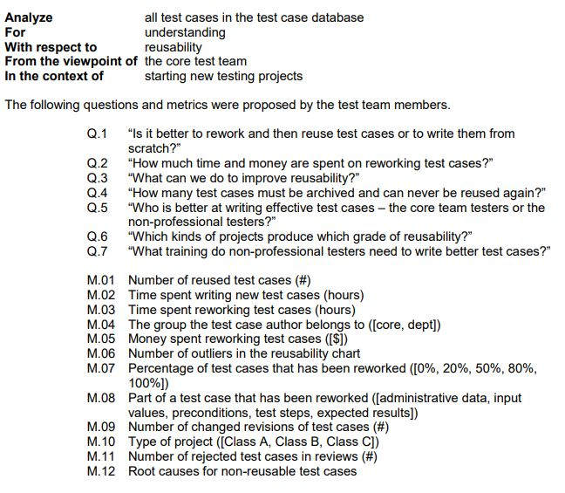
a.
Q.1 to Q.7 and M.01 to M.12 are all equally necessary
b.
Q.1, Q.2, Q4 and Q.6 with M.01 to M.05, M.07, M.08, and M.10 adhere to the given goal
c.
Q.3 is sufficient, but all M.01 to M.12 answer that question
d.
Q.1, Q.5 and Q.7 are the only questions that need to be answered, M.02 to M.04, M.09, M.11, and M.12 answer these questions

Đáp án: B

Lời giải: Refer câu 20 đề expert trên istqb.org của module CTEL-ITP-Part_1 (Improving the Test Process)
Câu hỏi 45
Consider the following metrics: i. The percentage of test cases for a given product which have been automated ii. The percentage of test effort saved for a given product due to test automation iii. The percentage of defects detected by a product test team during system testing iv. The number of people working on the test automation team v. The total number of years of experience for all the people working on the test automation team vi. The average cost to develop, execute, and maintain each automated test case Remember that good metrics map to specific objectives and motivate correct behavior by the people involved in the process being measured. Which one of the following statements is true?
a.
ii and iv are good metrics to show the efficiency with which the test automation team helps the Enterprise Test Group reduce risk.
b.
iv and v are good metrics of test automation team effectiveness within the Enterprise Test Group.
c.
iii is a good metric for the test automation team’s effectiveness at producing defect-finding test harnesses.
d.
i is a good metric for the ability of the test automation team to supply useful information to Enterprise Test Group stakeholders.

Đáp án: A

Lời giải: Refer câu 14 đề expert trên istqb.org của module TM
Câu hỏi 46
Which TWO of the following is true regarding the Test Manager’s role in change management?
a.
The Test Manager should be involved in impact analysis even when the proposed change is not expected to affect the schedule.
b.
The Test Manager should require documentation for any change proposed for an agile project.
c.
The Test Manager should not attend impact analysis sessions as it will tend to discourage others from speaking and participating.
d.
The Test Manager’s role in change management is not restricted to the testing aspects of the project.
e.
The Test Manager is responsible for the change management process.

Đáp án: A,E

Lời giải: Refer câu 8 đề expert trên istqb.org của module TM
Câu hỏi 47
Scenario 1 “Test Project Evaluation and Reporting” provides the context for this question. Your next task as Test Manager is to decide which metrics and indicators should be measured and analyzed. Consider the following indicators: i. The weekly rate at which actual versus planned test cases are being written ii. The amount of time per day that the test labs are inoperable when they are required for testing iii. Summary of unmitigated risks iv. Daily report of the re-opened defects v. Weekly defect discovery rate vi. Daily report of the number of newly opened show-stopper defects Which one of the following statements correctly defines indicators that should be measured and analyzed for internal test reporting (i.e., reporting within the test organization)?
a.
Indicators i, ii and v should be used.
b.
Indicators i, ii, iii and v should be used.
c.
All of these indicators should be used.
d.
Indicators i, ii, iv, v, and vi should be used.
Lời giải: Refer câu 2 đề expert trên istqb.org của module TM
Đáp án: D

Câu hỏi 48
Which one of the following statements correctly identifies basic quality control techniques that a Test Manager must understand and be able to implement in order to improve the test process?
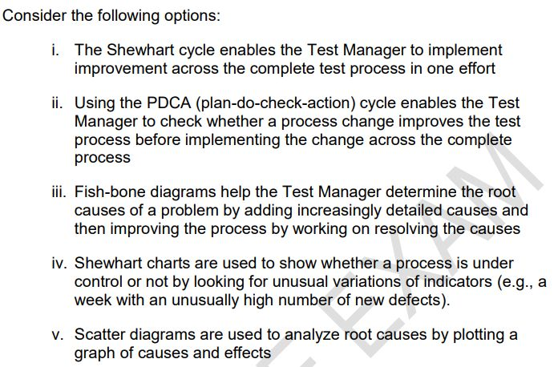
a.
Options i, iii and iv are correct.
b.
Options ii, iii and iv are correct.
c.
All the options are correct.
d.
Options ii, iv and v are correct.

Đáp án: B

Lời giải: Refer câu 4 đề expert trên istqb.org của module TM
Câu hỏi 49
Below is the pseudo-code for a program that calculates and prints sales commissions: (image) The code contains data flow anomalies on lines 6 and 12 (highlighted text). Which examples of data flow anomalies can be found on these lines?
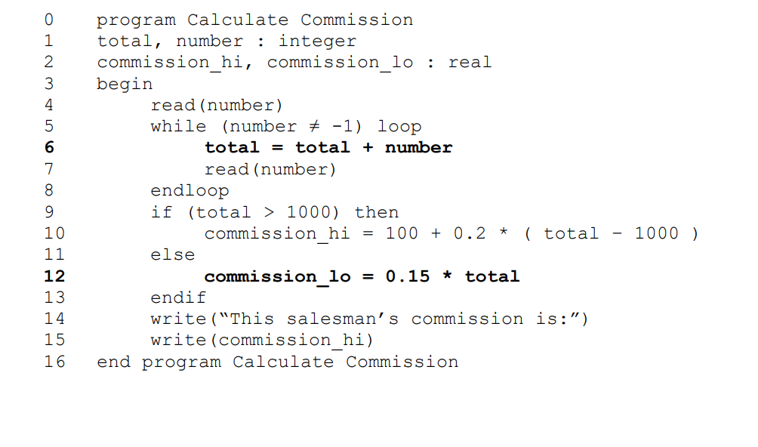
a.
line 6: variable “total” is not assigned a value before using it line 12: variable “commission_lo” is defined but subsequently not used
b.
line 6: an invalid value is assigned to variable “total” line 12: variable “commission_lo” is redefined before it is used
c.
line 6: variable “total” is out of scope line 12: the “hard-coded” value “0.15” should not be used
d.
line 6: the variable “number” is undefined line 12: the variable “total” is redefined before it is used

Đáp án: A

Lời giải: TM thi câu này, Refer câu 13 của đề TTA trên istqb.org. Đáp A, nhìn vào đoạn code ta thấy biến "total" ở dòng số 6 đang được sử dụng ( gọi đến) trước khi được khai báo, và biến “commission_lo” dòng code số 12 thì được khai báo nhưng ko đc sử dụng đến sau đó.
Câu hỏi 50
Which of the following statements is correct?
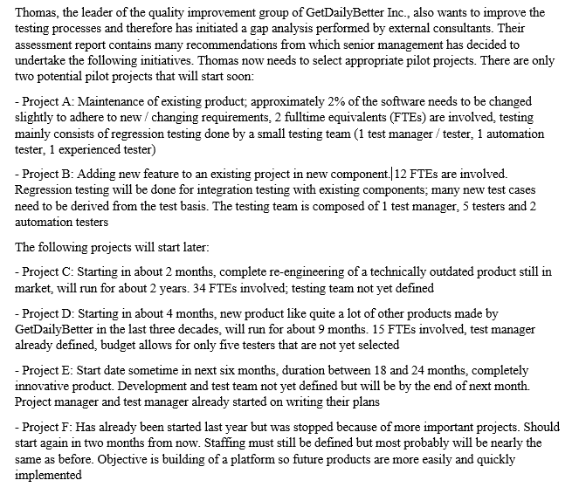
a.
Project A is a better pilot project for implementing a test automation strategy than Project D because it is a very typical project for GetDailyBetter Inc.
b.
Project E is not a good project to pilot the usage of new testing techniques because innovations are always too risky
c.
Project F is ideal to pilot the new defect report forms and analysis tools because quality is very important when building platforms
d.
Project D is favored to projects B and C in piloting the definition of test levels with entry and exit criteria, new test level plans and usage of new metrics

Đáp án: D

Lời giải: TM thi câu này Refer câu số 7 trong Improvement Process Part 2 expert trên istqb.org.
Câu hỏi 51
A company is planning its test process improvements and has asked for your advice on how best to organize the improvement. You are given the following background information: - The company is experiencing test process problems within many of its projects - Planned improvements to test automation shall be implemented at an offshore location - The organization has not assigned responsibility for developing the test process Which of the following organizational forms would you consider to be most appropriate?
a.
A Test Process Group is set up within a major in-house project and staffed from within the project. The Test Process Group implements improvements which are relevant to the project and reports to the project leader
b.
A Test Process Group is set up to co-ordinate improvement activities between the different projects. Staff from a discontinued in-house project are permanently assigned to the Test Process Group
c.
Establish a Management Steering Group (MSG) to coordinate test process improvements across the organization. The MSG has ownership of the test process. A Technical Working Group is set up to co-ordinate the test automation improvements and ensure good communication takes place
d.
Establish a Management Steering Group (MSG) to implement test process improvements across the organization. The MSG has ownership of the test process and manages the contractual issues with the offshore company implementing the test automation

Đáp án: C

Lời giải: TM thi câu này, Refer câu số 9 của Improvement Process part 2 expert trên istqb.org. EX-ITP-Part_2- Câu 9
Câu hỏi 52
Which of the following subsystems, based on the risk scores of the table, is most risky?
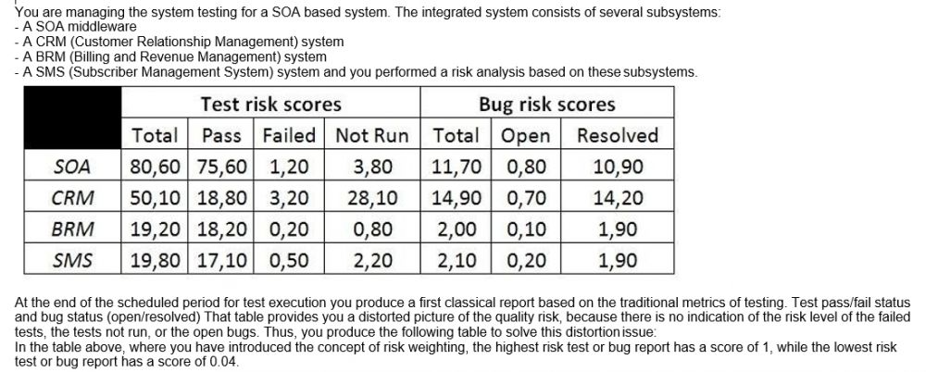
a.
SOA
b.
CRM
c.
BRM
d.
SMS
e.
SOA and CRM

Đáp án: B,E

Lời giải: Refer câu số 10 của đề TM12, họ chỉ thêm 1 đáp án E là có SOA và CRM, nếu tính toán thì CRM rủi ro cao nhất, ở câu này họ thêm đáp án E nên chúng tôi quyết định tính 2 đáp án cho an toàn
Câu hỏi 53
You are testing a photo-enforcement system for traffic control at an intersection. The requirements state a photo shall be taken if the signal light is red (RED), or the car is speeding (SPEED), and if the front wheels of the car are over the line marking the beginning of the intersection (WHEELS). The logic in the code looks like the following: (image) Assuming no short-circuiting, which set of test input values is required to achieve 50% multiple condition coverage?
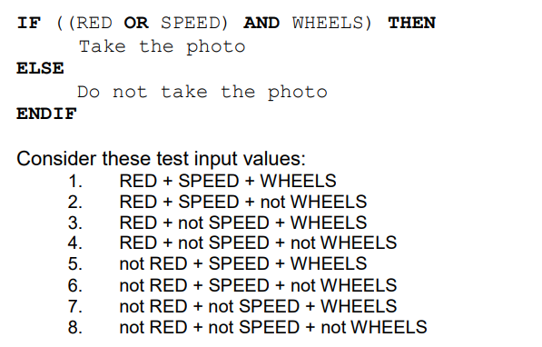
a.
3, 4, 5, 8
b.
1, 3, 5
c.
2, 4, 6, 7, 8
d.
2, 7

Đáp án: A

Lời giải: TM có thi câu này, Refer câu 7 đề TTA trên istqb.org. Ở đây ta có 3 biến RED, SPEED, WHEEL, mỗi biến có 2 giá trị T F, nếu đạt 100% multiple condition coverage thì cần có 8 test case như trong hình, nên để đạt được 50% thì ta cần 4 TC vậy nên chọn A
Câu hỏi 54
You are the Technical Test Analyst working on the testing of software that will control the movement of the roof on a new national sports stadium that seats 100,000 spectators. A failure analysis has shown that if the software system fails it may cause the roof to break up and fall on the spectators. The government has requested that the level of testing for this software exceeds that required by the IEC 61508 standard. Which level of test coverage would you expect to be achieved in the testing of the control software for the stadium roof?
a.
Decision coverage + Modified Condition/Decision coverage
b.
Decision coverage + Statement coverage
c.
Modified Condition/Decision coverage
d.
Multiple Condition coverage

Đáp án: D

Lời giải: TM có thi câu này, Refer câu số 9 đề TTA trên istqb.org. Vì mái nhà di chuyển của sân vận động có hơn 100.000 khán giả nên mức độ an toàn phải rất cao, ko đc xảy ra lỗi khi di chuyển, ở đây họ yêu cầu test "exceeds that required by the IEC 61508 standard" vượt qua cả mức tiêu chuẩn, mà tiêu chuẩn cao nhất chỉ yêu cầu MC/DC ở đáp án C thôi, nên nếu yêu câu cao hơn tiêu chuẩn thì phải là đáp án D
Câu hỏi 55
The result of a product risk analysis performed on components I, II and III of the airplane control system shows the following risk matrix: The project wants to mitigate the risks by defining different types of coverage depending on the risk level of the components. Which of the following would be a meaningful solution for setting the coverage targets? Number of correct answers: 1
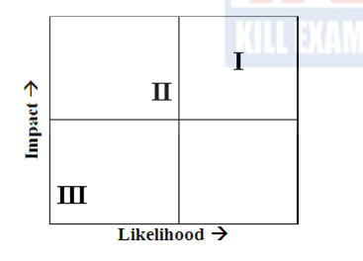
a.
I: Condition determination coverage, II: Decision Coverage, III: Statement coverage
b.
I: Condition determination coverage, II: Statement coverage, III: Decision coverage
c.
I: Decision coverage, II: Condition determination coverage, III: Statement Coverage
d.
I: Multiple condition coverage, II: Decision coverage, III: Condition determination coverage

Đáp án: A

Câu hỏi 56
You have tested the program and have found that with “bonus” a boundary value has not been implemented according to design. You have written an incident report. Which of the following is the incident report of the highest quality? Number of correct answers: 1
a.
Description: Boundary value not correctly implemented Priority: High Repeatability: Yes Tester: WVU Test case: 35 (test specification “bonus program”), V1.2
b.
Description: Boundary value not correctly implemented for bonus Priority: Medium Tester: WVU Test case: 35 (test specification “bonus program”)
c.
Description: Boundary value not correctly implemented for bonus (line 26: 10 according to design, now 5 implemented) Priority: High Repeatability: Yes Tester: WVU Test case: 35 (test specification “bonus program”), V1.2
d.
Description: Boundary value not correctly implemented for bonus Priority: High Repeatability: Yes Tester: WVU Test case: 35 (test specification “bonus program”), V1.2

Đáp án: C

Câu hỏi 57
Identify THREE type formal peer review?
a.
Inspection
b.
Management review
c.
Walkthrough
d.
Audit
e.
informal review
f.
Assessment
g.
Technical review

Đáp án: A,C,G

Lời giải: Peer review là review có nhóm từ 3 người trở lên và thường nói về review tài liệu kỹ thuật nên mình bỏ mấy cái thuộc về management reivew và audit đi, chỉ chọn đc A, C, G

EXAM 8 Advanced TM12- có video chữa đề
Câu hỏi 1
Based only on the given information, which of the following statements is true? K4 3 credits

a.
The approach described in the system test plan document is consistent with the test strategy
b.
The approach described in the system test plan document is consistent with the risk-based testing strategy, but it is inconsistent with the regression testing strategy
c.
The approach described in the system test plan document is consistent with the regression testing strategy, but it is inconsistent with the risk-based testing strategy
d.
The approach described the system test plan document is inconsistent with both the risk-based and regression testing strategies

Đáp án: D

Lời giải: Refer 2.2.1, Bạn cần gạch đầu dòng yêu cầu của công ty về test strategy và yêu cầu của dự án test approach ra nháp, bạn sẽ thấy sự mâu thuẫn của công ty và dự án. Test strategy của công ty: V-model, risk based, Regression-averse ( tự động hóa cao nhất), test approach của dự án là: manual test.
Câu hỏi 2
In the next two months some new features will be constantly added to new releases of a project you are working on as Test Manager. You have identified as one of the main project risks, that the requirements specification will still be incomplete when your team starts the test design and implementation phase. Some requirements will most likely be completed too late to allow a proper test preparation. You and your test team have already worked on several similar past projects in the same organization. Which one of the following options would you expect to be the most effective at mitigating this risk? K4 3 credits
a.
Don't prepare any test and just run the regression test suite to check that the new features don't introduce regression
b.
Make reasonable assumptions about the missing details and design lightweight tests that can be easily updated during test execution
c.
Don't design any test until the test execution starts, then communicate that test execution is blocked due to incomplete requirements
d.
Even if there are only few details missing, escalate the risk to the project manager without preparing any tests

Đáp án: B

Lời giải: Chapter 3 mục 3.2.3 , xem sách bản full có 10 cái Top risks khi nói về trường hợp Blank spot requirement thì cần thiết kế test case dạng đơn giản, đưa ra các giả định để test và dễ dàng update khi có đủ thông tin
Câu hỏi 3
Consider: I. Consultative test strategy II. Reactive test strategy III. Analytical test strategy IV. Process-compliant test strategy Consider also the following examples of test activities: 1. Prioritize the test cases, based on the results of a FMEA analysis, to ensure early coverage of the most important areas and discovery of the most important defects during test execution 2. Execute usability testing driven by the guidance of a sample of users (external to the test team) 3. Perform exploratory testing sessions throughout the system test phase 4. On an Agile project, execute tests that cover the test conditions identified for each user story of a feature planned for an iteration Which of the following correctly matches each test strategy with an appropriate example? K2 1 credit
a.
I-2; II-3; III-4; IV-1
b.
I-3; II-2; III-1; IV-4
c.
I-1; II-2; III-3; IV-4
d.
I-2; II-3; III-1; IV-4

Đáp án: D

Lời giải: Xem chapter 2, 2.2.1, có 7 cái test strategy, match các key word của bài với các nội dung của 7 cái test strategy này với nhau sẽ ra đáp án. cái số 1 có FMEA là phương pháp Risk based nên match với Analytical, số 2 guide bởi user match với Consultative, số 3 exploratory testing match với Reactive, số 4 Agile process match với Process compliance
Câu hỏi 4
You are the Test Manager of a new project that will have three formal levels of testinG. unit, integration and system testing. The testing strategy you decide to adopt a blend of risk-based testing and reactive testing strategies. Which of the following answers describes the most consistent example of implementation of this test strategy during the execution of the system tests? K2 1 credit
a.
Your test team executes exploratory tests following a session-based test management approach throughout the system test phase
b.
Your test team executes system tests under the guidance of a sample of users throughout the system test phase
c.
Your test team executes scripted tests designed and implemented before the execution of the system test phase, to cover the identified product risks. It also performs exploratory testing sessions throughout the system test phase
d.
Your test team autonomously performs some exploratory testing sessions and, at the very end of the system testing phase, it also executes more system tests under the guidance of a sample of users

Đáp án: C

Lời giải: bạn chọn đáp án làm sao nó chỉ ra được 2 cái mà dự án này đang dùng "risk-based testing and reactive testing strategies."
Câu hỏi 5
You are the Test Manager of a new project aimed at developing a software system that must be certified at level B of the DO-178B standard. The project will follow a V-Model software development life cycle and it will have four formal levels of testing: component, integration, system and acceptance testing. You must produce the test plan documentation for this project by providing an adequate coordination across the four levels of testing in order to assure audit ability. Which of the following answers would you expect to best describe how to organize the test plan? K3 2 credits
a.
Produce a single master test plan that covers in detail all four levels, describing the particular activities for all test levels
b.
B. Produce a master test plan that covers three levels (component, integration, system test) and a separate acceptance test plan
c.
Produce a master test plan describing the relationship between the four levels, and four separate detailed level test plans, one for each level
d.
Produce four separate detailed level test plans, one for each level, without a master test plan

Đáp án: C

Lời giải: Dự án lớn, có 4 test levels nên phải có 1 master test plan chung cho cả dự án, mỗi level test plan cho mỗi test level
Câu hỏi 6
Based on the historical data of 5 past and similar projects, you have calculated these average numbers of defects detected in system testinG. - For each 10000 LOC (lines of code), 200 defects - For each person-month of development team effort, 49 defects You want to use this information to perform estimation for a new project. The project manager tells you that he/she has estimated 20000 new LOC for this new project. Four developers work for four months on this project before system testing. During system testing, 797 defects are discovered. Assume that the system test of this new project is using the same amount of work as spent in the past projects. Based on this information only, which of the following statement is certainly true about this project? K3 3 credits
a.
The code for the new project contains a higher defect density than the code of the past projects
b.
The number of defects found during the system test phase on the new project is approximately proportional to the development team effort
c.
40000 LOC have been delivered to system testing (against the 20000 LOC planned by the project manager)
d.
More LOC than planned have been delivered to system testing with a higher defect density than the past projects

Đáp án: B

Câu hỏi 7
You are estimating the effort for the integration testing activities of a new project. Consider the following factors, which can affect that estimation: I.Availability of re-usable test systems and documentation from previous, similar projects II. Unexpected timing of components arrival III. Stability of the integration test team (no turnover) IV. Many and geographically distributed sub-teams Which of the following statements is true? K2 1 credit
a.
I. and II. can negatively affect the estimation; III. and IV. usually favor the accuracy of the estimation effort
b.
II. and III. can negatively affect the estimation; I and IV. usually favor the accuracy of the estimation effort
c.
II. and IV. can negatively affect the estimation; I and III. usually favor the accuracy of the estimation effort
d.
III. and IV. can negatively affect the estimation; Iand II. usually favor the accuracy of the estimation effort

Đáp án: C

Lời giải: refer 2.2.2 Test Estimation: ở đây xác định nhân tố ảnh hưởng tiêu cực và nhân tố ảnh hưởng tích cực là đc
Câu hỏi 8
The following chart plots the cumulative number of defects opened against the cumulative number of defects closed during system testing of a software product. Which of the following statements is true? K2 1 credit

a.
The chart indicates that you have plenty of problems left to find
b.
The chart can be used to reveal test progress problems
c.
The chart seems to indicate that the defect management process is not working well
d.
The chart seems to indicate that the defect management process is working well

Đáp án: D

Lời giải: Nhìn vào chart thấy tiến độ sửa lỗi bắt kịp tiến độ tìm lỗi, và lỗi tìm đc đang đi ngang
Câu hỏi 9
Which one of the following metrics to be produced needs traceability between the test cases and each item in a proper test basis? K2 1 credit
a.
Requirements coverage
b.
Trends in the lag time from defect reporting to resolution
c.
Mean time between failures for the system
d.
Cumulative number of reported defects versus cumulative number of resolved defects

Đáp án: A

Câu hỏi 10
Which of the following subsystems, based on the risk scores of the table, is most risky? K4 3 credits

a.
SOA
b.
CRM
c.
BRM
d.
SMS

Đáp án: B

Câu hỏi 11
For which of the following activities would the costs be classified as a cost of detection?
a.
Writing test specifications according to the test design
b.
Training developers to better understand the new features of the coding language they will use on the project
c.
Re-running a test case, during the system testing phase, to verify that a fix eliminates a previously found defect
d.
Fixing field failures

Đáp án: A

Câu hỏi 12
Assume you have some data related to confirmation testing during system testing of a past project. In that project 240 bug reports have been opened once, 80 were opened twice, 10 were opened three times and no bug reports have been opened more than three times. You estimate that a bug report, which has failed its confirmation test, costs, on average, 3 person-hours. Which of the following statements correctly describe the value of these confirmatory testing activities based on cost of quality? K3 2 credits
a.
300 person-hours have been spent on the project during the system testing phase, because of the failed confirmation tests and this cost belongs to the costs of internal failure
b.
340 person-hours have been spent on the project during the system testing phase, because of the failed confirmation tests and this cost belongs to the costs of external failure
c.
340 person-hours have been spent on the project during the system testing phase, because of the failed confirmation tests and this cost belongs to the costs of internal failure
d.
300 person-hours have been spent on the project during the system testing phase, because of the failed confirmation tests and this cost belongs to the costs of detection

Đáp án: A

Câu hỏi 13
Which of the following answers describes a factor that may reduce the effort spent when using distributed test teams without negatively affecting system quality? K2 1 credit
a.
Difficulties in communication between the distributed test teams due to time zone differences
b.
With several distributed test teams, every team assumes that some test conditions are covered by other teams but actually no one covers them
c.
With several distributed test teams, two or more teams assume some test conditions are covered by their team and their team alone. But all of the teams actually cover them
d.
With several distributed test teams, all of the distributed test teams use a single unified test dashboard

Đáp án: D

Lời giải: refer 3.5 Distributed, Outsourced, and Insourced Testing. Cách tốt để TM quản lý dc team phân tán là • Alignment of methodologies vì thế mà phải "use a single unified test dashboard"
Câu hỏi 14
You are the Test Manager on a project following an iterative life-cycle model. The project should consist of nine iterations of one month duration each. It is planned to develop the most important features to have a stable core of the application in the first three iterations and to add the additional features in the last six iterations. At the beginning of the first iteration, only a draft version of the requirements specification document for the core features is available. Assume that during each of the first three iterations, the chosen features are fully completed and unit tested. Which of the following statements is true in this context? K4 3 credits
a.
The system test phase should start when all the requirements are frozen
b.
You should allocate a large effort for system testing during the first three iterations
c.
You should allocate all the effort for the system test phase only in the last iteration
d.
You should apply the same test strategy as used in a sequential life cycle model

Đáp án: B

Lời giải: Mô hình iterative bạn nhớ là mỗi giai đoạn test nhiều test levels khác nhau, nên system test được thực hiện rất sớm và tập trung luôn vào 3 iteration đầu tiên
Câu hỏi 15
Which of the following statements, about the test reporting activities for a project adopting an iterative lifecycle model with very short iterations (e.g. two weeks iterations), is correct? K2 1 credit
a.
Test reporting activities can't be influenced by the use of an iterative lifecycle model with short iterations
b.
Test reporting activities are not important for projects adopting an iterative lifecycle model with short iterations
c.
Test reporting activities are less important for projects adopting an iterative life cycle model with short iterations. They should be performed at the end of the last iteration
d.
Test reporting activities are still important with an iterative lifecycle. The reports can be used to conduct post-iteration review sessions before starting with the next iteration

Đáp án: D

Lời giải: Nói chung iterative ngắn hay dài thì cũng phải làm báo cáo test, và nó giúp summary thông tin test, sử dụng cho retrospective meeting
Câu hỏi 16
Consider an agile team adopting Extreme Programming (XP) with five developers and one tester without any coding experience. To which of the following activities would you expect the tester will contribute most? K2 1 credit
a.
Developing unit tests
b.
Executing unit tests
c.
Planning and executing tests during the integration test phase to detect interface defects
d.
Supporting the customer in the execution of acceptance testing

Đáp án: D

Lời giải: XP là 1 model của Agile, phát triển nhanh, thường xuyên demo cho KH nên TA hỗ trợ KH làm acceptance test là có ý nghĩa
Câu hỏi 17
Which of the following statements best describes an appropriate approach for managing exploratory testing? Number of correct responses: 1 K2 1 credit
a.
Define very detailed mission statements, which allow testing work to be broken into sessions of up to 10 minutes duration in which testing is guided by these mission statements
b.
Break the testing work in 30 to 120 minutes sessions and use properly defined mission statements consisting of two or three sentences to guide testing during these sessions
c.
Define very generic charters to drive exploratory testing sessions of 2 days where testers are completely free to decide what to test
d.
Exploratory testing should not be managed because such testing is inherently unmanageable and not measurable

Đáp án: B

Lời giải: refer 3.7 Managing reactive test strategies and experience-based test techniques
Câu hỏi 18
The main objectives the senior management team wants to achieve are: - to reduce the costs associated with dynamic testing - to use reviews to ensure that the project is on course for success and following the plan - to use reviews as a well-documented and effective bug-removal activity following a formal process with well-defined roles - to determine the effectiveness of reviews in terms of phase containment - to improve phase containment effectiveness Which of the following answers would you expect to describe the best way to achieve these objectives? K4 3 credits
a.
You should plan for lightweight exit-phase reviews at the end of each development and testing phase, and plan for a process of gathering information from testing to perform an analysis aimed at identifying the larger cluster of defects
b.
You should plan for formal exit-phase reviews at the end of each development and testing phase, and plan for a process of gathering information from testing to perform an analysis aimed at identifying the larger cluster of defects
c.
You should plan for formal exit-phase reviews at the end of each development phase and testing phase, and plan for a process of gathering information from testing to perform an analysis of the bugs found during testing to determine the people responsible for those bugs
d.
You should plan for formal exit-phase reviews at the end of each development and testing phase, and plan for a process of gathering information from testing to perform an analysis of the bugs found during testing to determine the phase in which they have been introduced

Đáp án: D

Lời giải: refer 6.1.4 Managing Formal Reviews. Để đạt được các objective trên phải áp dụng các tiêu chí của formal review : planning đầy đủ, define entry exit criteria, có đo đạc metrics
Câu hỏi 19
Consider the following list of statements about audits and management reviews: I. Audits are usually more effective than management reviews at finding defects II. Audits and management reviews have the same main goals, the only difference is related to the roles and level of formality III. A typical outcome of an audit includes observations and recommendations, corrective actions and a pass/fail assessment IV. An audit is not the appropriate mechanism to use at the code review in order to detect defects prior to dynamic testing Which of the following statements is true? K2 1 credit
a.
I. and III. are true; II. and IV. are false;
b.
II. and III are true; I. and IV. are false;
c.
I, III and IV are true; II. is false;
d.
III. and IV. are true; I and II are false;

Đáp án: D

Lời giải: refer 6.1 Review types and responsibility: xem định nghĩa về audit và management review
Câu hỏi 20
You are a Test Manager working for a software organization where reviews have never been applied. After a meeting with your managers examining a business case for reviews, (including their costs, benefits, and potential issues), the management finally decides to adopt formal reviews for future projects. You have been given a budget that you have spent to provide training in the review process and to introduce the review process on a pilot project. On that pilot project the introduction of reviews has been very positive in terms of positive involvement from all the participants. All the reviews applied to different documents have been very effective for their purposes (especially at revealing defects). Which of an important factor for the introduct of formal reviews which is missing? 3 P
a.
Management support
b.
Participant support
c.
Definition and use of metrics to measure the ROI (Return On Investment)
d.
Training in the review process

Đáp án: C

Lời giải: Câu này dựa vào keyword của đề bài ta thấy "the management finally decides to adopt formal reviews for future projects." là có A rồi, "provide training in the review process" là có D rồi, "positive involvement from all the participant" là có B rồi, thiếu mỗi C
Câu hỏi 21
Which of the following factors could negatively influence a review? K2 1 credit
a.
Include people with the adequate level of knowledge, both technical and procedural
b.
Include people who are detail-oriented and scrupulous at finding issues
c.
Include as many people as possible in order to have more viewpoints about possible problems on the item under review
d.
Include people able to contribute to a clear, thoughtful, constructive and objective discussion

Đáp án: C

Lời giải: Nhân tố ảnh hưởng tiêu cực đến Review là "as many people " mà ko phải là những người cần thiết, ở đây chỉ nói nhiều người
Câu hỏi 22
You are the Test Manager of a project that adopts a V-model with four formal levels of testinG. unit, integration, system and acceptance testing. On this project reviews have been conducted for each development phase prior to testing, which is to say that reviews of requirements, functional specification, high-level design, low-level design and code have been performed prior to testing. Assume that no requirements defects have been reported after the release of the product. Which TWO of the following metrics do you need in order to evaluate the requirements reviews in terms of phase containment effectiveness? K3 2 credits
a.
Number of defects found during the requirements review
b.
Total number of defects attributable to requirements found during unit, integration, system and acceptance testing
c.
Total number of defects found during functional specification review, high-level design review, low- level design review, code review, unit testing, integration testing, system testing and acceptance testing
d.
Time to conduct the requirements review
e.
Total number of defects attributable to requirements, found during functional specification review, high-level design review, low-level design review, code review, unit testing, integration testing, system testing and acceptance testing

Đáp án: A,E

Lời giải: refer chapter 7, phase containment là "the defect was introduced and found in the same phase " nên ta phải có 2 thông tin: A lỗi tìm đc bởi review, E lỗi tìm được ở các phase sau requirement và được sếp vào thuộc tính là sai requirement
Câu hỏi 23
Which of the following information would you expect to be the most useful to perform a defect clustering analysis? K2 1 credit
a.
The trend in the lag time from defect reporting to resolution
b.
The defect component information
c.
The lifecycle phase in which the defect has been introduced
d.
The defect removal efficiency information

Đáp án: B

Lời giải: " a defect clustering" cụm lỗi thì bạn cần báo cáo Pareto chart thống kê lỗi theo module hoặc function để xem lỗi đang tập trung vào đâu nhiều nhất
Câu hỏi 24
During the system testing phase a tester from your test team observes a failure in the system under test and he/she decides to create an incident report. The incident report is currently in a "new" state, indicating it needs to be investigated. Which THREE of the following information items can't yet be present in the incident report? K3 2 credits (2 credits out of 3 credits correct, 1 credit point)
a.
The type of defect that caused the failure
b.
The actual and the expected result highlighting the failure
c.
The lifecycle phase in which the defect has been introduced
d.
What really caused the failure (actual cause)
e.
Steps to reproduce the failure, including screenshots, database dumps and logs where applicable

Đáp án: A,C,D

Lời giải: refer 7.3 Defect Classification theo keyword mà chọn các thông tin ACD là cần phân loại ở giai đoạn investigation chứ không phải Recognization ( lỗi đang ở trạng thái New)
Câu hỏi 25
Assume you are working on a defect management process to be used by a software organization to track the current status of the defects reports for several projects. When a defect is found for investigation a defect report is created in "Opened" state that is the unique initial state. The defect report status has also a unique finale state that is the "Closed" state. The following state transition diagram describes the states of this defect management process: Where only the initial ("Opened") and final ("Closed") states are indicated while the remaining states (V, W, X, Y, Z) have yet to be named. Which of the following assignments would you expect to best complete the defect management process? K3 2 credits

a.
V=Rejected , W=Corrected , X=Validated, Y=Re-Opened, Z=Assigned
b.
V=Assigned, W=Validated , X=Corrected, Y=Re-Opened, Z=Rejected
c.
V=Assigned, W=Corrected , X=Validated, Y=Re-Opened, Z=Rejected
d.
V= Corrected, W=Assigned, X=Validated, Y=Corrected, Z=Rejected

Đáp án: C

Lời giải: Chapter 7
Câu hỏi 26
Consider a defect report and assume that a part of its lifecycle includes the following states: New: Is the initial state Working. Means that the developers are addressing the defect in order to produce a fix for the defect Clarification: Means that the developers need more information from the tester to address the defect and produce a fix for the defect and the tester is working to provide this information to the developers Verification: Means that a fix for the defect has been produced and the tester is running the adequate tests to verify whether the fix solves the defect CloseD. is the final state Which of the following answers represents an invalid sequence of states that can't lead the bug report to the "Closed" state?
a.
New, Working, Verification, Working, Clarification, Working, Verification, Closed
b.
New, Working, Clarification, Working, Verification, Closed
c.
New, Working, Verification, Closed
d.
New, Working, Verification, Working, Clarification, Working, Closed

Đáp án: D

Lời giải: refer chapter 7. Thứ tự các trạng thái của lỗi mà không đi đến Đóng, chọn D vì Working xong chưa được Verification thì ko thể Closed được.
Câu hỏi 27
Consider the following statements describing the importance of improving the test process: I. Test process improvement is important because being focused only on the test process it can provide recommendations to improve the test process itself, but it can't indicate or suggest improvement to areas of the development process II. Because it is much more effective than software process improvement to improve the quality of a software system III. Because several process improvement models (STEP, TPI Next, TMMi) have been developed over the years IV. Because every organization should always achieve the maximum level of maturity of testing described in in the test improvement models such as TMMi Which of the following answers is correct? K2 1 credit
a.
I. and IV. are true; II. and III. are false
b.
I., II., III. and IV are false
c.
I., II. and III are true; IV. is false
d.
I., II. and III. are false; IV. is true

Đáp án: B

Lời giải: chapter 8. I sai vì only, II sai vì "more effective than software process improvement " ko đúng, ko có so sánh này, III cũng đều sai, IV sách không nói là lúc nào cũng phải đạt dược level cao nhất
Câu hỏi 28
Which of the following statements about the TMMi test process improvement model is true? K2 1 credit
a.
In TMMi all the process areas at lower levels must be 75% complete by achieving specific and generic goals in order to claim the higher level
b.
TMMi provides an approach for test process improvement such as the IDEAL (Initiating, Diagnosing, Establishing, Acting and Learning) model
c.
TMMi has a staged architecture for process improvement with seven maturity levels
d.
At TMMi level 1 testing is chaotic without a defined process, and it is often seen as the same as debugging

Đáp án: D

Lời giải: refer 8.4 Improving the Testing Process with TMMi: Level 1 được coi là dự án cứ test và fix bug mà không theo quy trình nào cả. đáp án A thông tin 75% là ko có trong sách, C sai vì 7 level, B sai vì nó bảo giống IDEAL
Câu hỏi 29
Which of the following statements about the STEP test process improvement model is true? K2 1 credit
a.
In the STEP model, tests validate the requirements and use cases when they are developed
b.
The STEP model stresses defect detection and demonstration of capability, whereas the defect prevention is a secondary potential goal of testing
c.
The STEP model assures that the system requirements specification and the test design specification processes don't overlap
d.
In the STEP model, testware design occurs after coding

Đáp án: A

Lời giải: Refer 8.7 Improving the Testing Process with STEP để loại đc BCD
Câu hỏi 30
A chart showing the trend in the lag time from defect reporting to resolution during system testing is also available. The chart shows that the daily closure period is consistently and significantly above the rolling closure period for a long period of the system testing phase. Almost all defects found during system testing have been related to the system as a whole, not related to single units or integrations issues. Almost all quality risks have been addressed during the unit and integration testing phase and no residual quality risks were present in the integrated system. Exploratory testing sessions performed during system testing, targeted at finding defects in these quality risk areas. Which one of areas would you considered more in the retrospective meeting in order to be improved?
a.
The requirements review
b.
The defect management process
c.
The quality risk analysis process
d.
The system design and architecture design reviews

Đáp án: B

Lời giải: retrospective cần đưa ra quy trình quản lý defect management vì đề bài cập nhật đến các vấn đề về báo cáo lỗi ( nhưng không nói là nó đã tốt hay chưa nhé, chỉ là báo cáo chỉ ra "the lag time" "daily closure period "
Câu hỏi 31
After the presentation, you are asked to explain the chart. Assume you have applied a full risk-based testing strategy. Which of the following answers would you expect to best describe the pie chart? K4 3 credits

a.
All the risk items have been covered with tests. No more risk items remain to test
b.
According to the full risk-based testing strategy applied, it is very likely that the highest-risk items, tests and bugs remain in the blue and red areas. Therefore, it is very risky to release the application
c.
Only the lowest-risk items, tests and bugs should remain in the blue and red areas. Therefore the application can be released at any time subject to management of the items identified in those areas
d.
97 percent of the risk items has been tested. No open bugs or test failures remain. Only 3 percent of risk items remains to be covered by the remaining test

Đáp án: C

Lời giải: Vì dự án này theo chiến lược risk based nên chắc chắn là rủi ro cao đã đc chạy trước rồi, nhìn vào cái hình ta thấy còn 1 tỷ lệ nhỏ những cái rủi ro chưa test hoặc chưa sửa hết là của low-risk
Câu hỏi 32
Assume you are managing a test automation project for a mission-critical system. Because vendor provided tools and open source solutions don't meet the needs of this project, you ask your test team to develop a custom automation framework. Which of the following management issues associated to the development of this custom automation framework is least likely to manage? K2 1 credit
a.
Proper testing for the custom automation framework must be performed
b.
The custom automation framework will require an adequate documentation
c.
The changes to the custom automation framework should be communicated to all external users of this tool under the GNU license
d.
The custom automation framework will need proper maintenance

Đáp án: C

Lời giải: Câu hỏi là ít phù hợp nhất. Chọn C vì "communicated to all external users" làm sao mà trao đổi với tất cả các user bên ngoài đc
Câu hỏi 33
In your organization the following tools of the same vendor are currently in use. a requirements management tool, a test management tool and a bug tracking tool. You are the Test Manager. You are currently evaluating a test automation tool of the same vendor (to complete the vendor's tool suite) against an interesting open-source test automation tool under the GNU GPL (General Public License). There are no initial costs associated to that open-source tool. Which of the following statements associated to the selection of the open-source tool is correct in this scenario? K2 1 credit
a.
The open-source tool can be modified but only if the community of developers of that tool gives you the formal permission to modify it
b.
There are no initial costs for the open-source tool but you should carefully consider the costs associated to the integration with the existing tools and also evaluate the recurring costs
c.
There are no initial costs for the open-source tool because open-source tools are usually low-quality, while vendor tools have always a better quality than the corresponding open-source tools
d.
The open-source tool can be modified but it can't be distributed further in any way\

Đáp án: B

Lời giải: Open source là rẻ và không mất chi phí mua tool
Câu hỏi 34
Which of the following are the three main concerns related to that open-source tool selection? K4 3 credits (2 credits out of 3 credits correct, 1 credit point)

a.
Does the tool support all the types of code coverage required from the three levels A, B, C of the DO-178B standard?
b.
Is the installation procedure of the tool easy?
c.
Does the tool require a system with more than 4GB of RAM memory?
d.
Is the licensing scheme of the tool compatible with the confidentiality needs of the avionics company?
e.
What are the costs to qualify the tool as a verification tool under the DO-178B?
f.
Does the tool have a good general usability?

Đáp án: A,D,E

Lời giải: refer 9.2.3 Return on Investment (ROI): chi phí cost, bản quyền license, và tool có đo được các loại công thức về coverage không. B loại 4GB ko phải tool nào yêu cầu thế, E loại vì usability là không cần thiết với đội làm kỹ thuật
Câu hỏi 35
Which of the following phases in the lifecycle of the new tool has NOT been adequately considered in this description? K2 1 credit

a.
Acquisition
b.
Support and maintenance
c.
Evolution
d.
Retirement

Đáp án: C

Lời giải: xem video, Evolution là tiến hóa, cải tiến tool là không được nhắc đến
Câu hỏi 36
Assume you are a Test Manager involved in system testing of a CRM application for a Pay-TV company. Currently the application is able to support a proper number of users assuring the required responsiveness. Since the business is expected to grow, you have been asked to evaluate the ability of the application to grow to support more users while maintaining the same responsiveness. Which of the following tools would you expect to be the most useful at performing this evaluation? K2 1 credit
a.
Coverage tools
b.
Test management tools
c.
Static analysis tools
d.
Performance tools

Đáp án: D

Lời giải: dựa vào đề bài " grow to support more users" chọn D
Câu hỏi 37
Which of these people, based on this analysis, would you expect to be most suitable to work specifically as test designer? K4 3 credits

a.
Alex
b.
Roberta
c.
John
d.
Mark

Đáp án: B

Câu hỏi 38
Who in your test team would you expect to be most suitable at doing these tasks? K4 3 credits

a.
Mary
b.
Bob
c.
Mark
d.
Dave

Đáp án: A

Lời giải: Nhìn vào bảng chọn người phù hợp là người có kỹ năng tốt nhất
Câu hỏi 39
Assume you are managing the system testing execution phase of a project. The system test execution period for that project is scheduled for eighteen weeks and the release date is scheduled at the end of system testing. During the sixth week of system test execution, at the staff meeting, the project manager informs you that the project deadlines are changed and the release date that is only three weeks ahead. This new release will not allow the completion of the system tests. Suppose also that you have followed a risk-driven test approach for this project. Which of the following statements represents the worst way to lead your test team in the next three weeks? K2 1 credit
a.
Neglect your management activities and work side-by-side with your test team executing tests
b.
Considering the executed tests, you should reduce the test coverage back on the risk analysis and adjust downward the priority of the associated risk items
c.
Convince all the people of your test team that each of them is an important and needed member, and that their contribution is fundamental to the success of the team
d.
Favor and encourage a proactive attitude where people ask for new tasks as soon as they finish their current tasks

Đáp án: A

Lời giải: Câu hỏi là cách nào tệ nhất, chọn A vì bạn bỏ qua công việc quản lý, chạy vào test cùng với test team chưa chắc đã hiệu quả, ko quản lý, hướng dẫn, động viên, ra quyết định cho test thì còn nhiều issue nữa
Câu hỏi 40
An agile development team decides to hire a tester who has always worked. - in independent test teams, reporting the problems found in a defect tracking system - in safety-critical projects, with a stronger focus on the quality of the product than on time and budget. This agile team is focused on short-term goals to get the product released on time and within budget. Which of the following answers would you expect to be most likely true in this scenario? K2 1 credit
a.
Agile teams like the presence of a tester in their teams and the tester will be able to adapt to the new context without any issue
b.
The developers will immediately follow the guidelines described by the tester
c.
The tester can continue to report the problems found in a defect tracking system and be more focused on the quality than on time and budget constraints
d.
The tester's mission could be to verify adherence to requirements, instead of reporting formally the problems in a defect tracking system

Đáp án: C

Lời giải: Vì là dự án Agile, tập trung vào việc hoàn thành theo thời gian ngắn nên cần phải đưa nhiệm vụ rõ ràng cho tester tập trung kiểm tra requirement, sử dụng giao tiếp và các kỹ thuật informal để làm việc nhanh hơn là report bug formal
Câu hỏi 41
Which of the following would you expect to be most likely an example of a motivating factor for testers? K2 1 credit
a.
The resources allocated for the testing activities are not sufficient and don't allow the testers to contribute to the quality of the product
b.
The testers contribution to the quality of the software products developed from an organization is recognized with increased responsibilities
c.
The same regressions tests are executed manually by the same testers, for every product release, without any progression in content
d.
The testers are asked to perform, in parallel with their testing tasks, other tasks unrelated to their testing responsibilities

Đáp án: D

Lời giải: refer 10.3 Motivation
Câu hỏi 42
Which of the following would you expect to be most likely an example of a demotivating factor for testers? K2 1 credit
a.
The management asks the testers to be kept informed about the intensity, quality and results of testing
b.
The testers' recommendations to improve the system or its testability are adopted by the development team
c.
The same regressions tests are manually executed by the same testers, for every product release, without regression test tools
d.
The testers are assessed on whether and how often they detect important and critical failures
e.
Test quality is measured by counting the number of customer/user reported problems.

Đáp án: C,E

Lời giải: refer 10.3 Motivation, triệt tiêu động lực của tester là khi họ phải làm đi làm lại 1 việc bằng tay hàng ngày đáp án C và chất lượng của test được đo bằng cách đếm số lỗi của KH đáp án E. Mình hiểu là số lỗi của KH dùng để đánh giá chất lượng của cả dự án thì đúng hơn.
Câu hỏi 43
Based only on the given information, which of the following answers would you expect to be the best option to achieve your objective? K4 3 credits

a.
Send Robert to a performance testing training course
b.
Send Alex to a performance testing training course
c.
Send John to a performance testing training course
d.
Send Mark to a test automation training course

Đáp án: B

Lời giải: Map vào cái bảng kỹ năng bạn chọn người có thiên hướng về kỹ thuật test tốt và kỹ năng đào tạo tốt để sau này họ về đào tạo cho team của bạn
Câu hỏi 44
Which of the following statements describing the consequences of specifying test conditions at a detailed level is NOT true? K2 1 credit
a.
In an environment where the test basis is continuously changing, it is recommended to specify test conditions at a detailed level in order to achieve a better maintainability
b.
The specification of test conditions at a detailed level can be effective when no formal requirements or other development work products are available
c.
The specification of test conditions at a detailed level can require the implementation of an adequate level of formality across the team
d.
For system testing, the specification of test conditions at a detailed level, carried out early in the project as soon as the test basis is established, can contribute to defect prevention

Đáp án: A

Lời giải: Refer 2.3 Test analysis: test basis is continuously changing thường xuyên thì rất mất thời gian để cập nhật Test condition chi tiết
Câu hỏi 45
Which of the following test activities would you expect to be the less important ones to achieve the test objectives in this scenario? K4 3 credits

a.
Perform unit performance testing for each single web service
b.
Monitor the SLAs after the system has been released into the production environment
c.
Perform system performance testing, consisting of several performance testing sessions, to verify if all the SLAs have been met
d.
Perform static performance testing by reviewing the architectural model of the system under various load levels

Đáp án: B

Lời giải: chọn B vì "after the system has been released" sau khi bàn giao thì không còn làm gì đc nữa, ko thể đưa ra các test control để đạt được test objective nữa
Câu hỏi 46
Which of the following answers best describes the test activities (assuming it is possible to perform all of them) you should plan for? K4 3 credits

a.
You should plan for an informal and minimal acceptance test of the two off-the-shelf systems and then a single end-to-end test of the overall integrated system
b.
You should directly plan for a single end-to-end test focused on end-to-end tests of the overall integrated system without an acceptance test of the two off-the-shelf systems
c.
You should plan for two levels: a system integration test and an end-to-end test of the overall integrated system
d.
You should plan for adequate re-testing of both the systems followed by a system integration test and an end-to-end test of the overall integrated system

Đáp án: D

Lời giải: refer 1.3 systems of systems. Đầu tiên bạn mua hệ thống về phải làm Cái test nghiệm thu từng hệ thống, sau đó test tích hợp với hệ thống của mình, rồi lại test lại toàn bộ các hệ thống ( để bài nó bảo nếu có thể nên ta ko cần nghĩ đến time và effort)
Câu hỏi 47
The following are the exit criteria described in the test plan of a software product: EX1. The test suite for the product must ensure that at least each quality risk item is covered by at least one test case (a quality risk item can be covered by more test cases). EX2. All test cases in the test suite must be run during the execution phase. EX3. Defects are classified into two categories: "C" (critical defect) and "NC" (non-critical defect). No known C defects shall exist in the product at the end of the test execution phase. Which of the following information is useless when the specified exit criteria is evaluated? K2 1 credit
a.
A traceability matrix showing the relationships between the product risk items and the test cases
b.
A list of all the open defects with the associated classification information extracted from the defect tracking system
c.
A chart, showing the trend in the lag time from defect reporting to resolution, extracted from the defect tracking system
d.
The execution status of all the test cases extracted from the test management tool

Đáp án: C

Lời giải: refer 2.2.1. Tiêu chí kết thúc để đánh giá cho việc có release được hay không, chọn C ít hữu ích vì "trend in the lag time from defect reporting to resolution"
Câu hỏi 48
Which of the following is an example of the test closure activity indicated as "lessons learned"? K2 1 credit
a.
Archive all the test results of the acceptance testing phase
b.
Deliver a list of the open defects of a software product released into production to the service desk team
c.
Participate in a meeting at the end of a project aimed at better managing the events and problems of future projects
d.
Deliver an automated regression test suite, used during the system test phase of a software product released into production, to the team responsible for maintenance testing

Đáp án: C

Lời giải: refer 2.8 Test Closure Activities: Lesson learned = Retrospective meeting trong Agile, tham gia thảo luận về những issue, risks, các điểm cần cải tiến cho tương lai ta chọn C, A là của Archiving, BD là của Handover
Câu hỏi 49
Which of the following answers would you expect to best describe the residual risks associated with the identified product risks, at the end of the first week of test execution? K3 2 credits

a.
Since R3 is the only risk for which all test cases have passed, the risk has been reduced by 20%
b.
The test execution status table indicates that the risk has been reduced by 56%
c.
The residual risk level can't be determined, because it requires that all the test cases have been executed
d.
The test execution table doesn't give an indication of the risk level of the open defects and the test cases that failed or are not run yet

Đáp án: D

Lời giải: Nhìn vào đề bài đang không chỉ ra mối quan hệ giữa risk level được tính toán như thế nào với số lượng lỗi tìm được và TC chạy được
Câu hỏi 50
Which of the following is a positive logical test that is complete and correct, and covers the REQ-SEL- 4 requirement? K3 2 credits

a.
Select a 6-bottles package, then try to insert 5 bottles; verify that no error messages are displayed
b.
Select a 6-bottles package, then try to insert 7 bottles; verify that no error messages are displayed
c.
Select a 6-bottles package, then try to insert 7 bottles; verify that the
d.
Select a 6-bottles package, then try to insert 7 bottles; verify that the

Đáp án: C

Câu hỏi 51
What is the MINIMUM number of test conditions that must be added to fulfill both the EXCR1 and EXCR2 exit criteria? K3 2 credits

a.
1
b.
2
c.
3
d.
4

Đáp án: C

Lời giải: Chú ý ID của test case được đặt cho phép bạn map với REQ hoặc RISK, bạn chỉ cần map số REQ, RISK với TC là tìm ra số còn thiếu, vì EXCR1, EXCR2 yêu cầu có ít nhất một TC thiết kế cho mỗi REQ, RISK
Câu hỏi 52
Which of the following answers describes the best execution schedule in this scenario? K3 3 credits

a.
1- Test the acceptance of transactions coming from the IVR channel2- Test the correct charge of the Smart Card with the required contents3- Test the correct pre-activation of the Smart Card4- Test the correct activation of the Smart Card
b.
1- Test the correct pre-activation of the Smart Card; 2- Test the correct charge of the Smart Card with the required contents; 3- Test the correct activation of the Smart Card; 4- Test the acceptance of transactions coming from the IVR channel
c.
1- Test the correct activation of the Smart Card2- Test the correct pre-activation of the Smart Card3- Test the correct charge of the Smart Card with the required contents4- Test the acceptance of transactions coming from the IVR channel
d.
1- Test the correct pre-activation of the Smart Card 2- Test the correct activation of the Smart Card3- Test the correct charge of the Smart Card with the required contents4- Test the acceptance of transactions coming from the IVR channel

Đáp án: D

Lời giải: Bảng này mô tả risk, bạn nhân 2 cột likelihood và impact để tính ra risk level. Risk nào cao nhất thì phải chạy trước
Câu hỏi 53
What is the MINIMUM number of test conditions that must be added to fulfill both the EXCR1 and EXCR2 exit criteria? K3 2 credits

a.
4
b.
3
c.
2
d.
1

Đáp án: A

Lời giải: Chú ý ID của test case được đặt cho phép bạn map với REQ hoặc RISK, bạn chỉ cần map số REQ, RISK với TC là tìm ra số còn thiếu, vì EXCR1, EXCR2 yêu cầu có ít nhất một TC thiết kế cho mỗi REQ, RISK
Câu hỏi 54
Which of the following answers describes the best test execution schedule in this scenario? K3 2 credits

a.
T1, T2, T3, T4, T5, T6, T7, T8, T9, T10
b.
T1, T3, T5, T7, T9, T2, T4, T6, T8, T10
c.
T10, T9, T8, T7, T6, T5, T4, T3, T2, T1
d.
T10, T8, T6, T4, T2, T9, T7, T5, T3, T1

Đáp án: B

Lời giải: Vì là chiến lược theo chiều rộng nên mỗi rủi ro cần được đánh giá ít nhất bởi một TC để xem rủi ro nào xảy ra lỗi, còn thời gian sẽ tiếp tục chạy lượt 2
Câu hỏi 55
Which of the following statements represents the most effective contribution of the stakeholders to the completion of the failure mode analysis table? K4 3 credits

a.
The aircraft pilot and the customer representative should contribute to assess the detection. The chief software engineer, the system architect and the expert tester should contribute to assess the priority.
b.
The aircraft pilot and the customer representative should contribute to assess the priority. The chief software engineer, the system architect and the expert tester should contribute to assess the detection.
c.
The system architect and the chief software engineer should contribute to assess the priority. The expert tester is the only one who should contribute to assess the detection.
d.
The aircraft pilot is the only one qualified to contribute to assess the priority and thus should be assigned this task. The customer representative should contribute to assess the detection.

Đáp án: B

Lời giải: refer 3.4 How to Do Risk-Based Testing, related-test project risk. Chú ý các đối tượng stakeholder có vài trò khác nhau: BA, Product Owner, TA, Customer care, customer hữu ích trả lời về Impact, Developer, designer, TTA, technical leader hữu ích trả lời về likelihood
Câu hỏi 56
What is the MINIMUM number of the remaining test cases that must be successfully executed to fulfill the EX1 exit criteria? K3 2 credits

a.
4
b.
5
c.
6
d.
7

Đáp án: A

Lời giải: Chú ý TC ID có đánh mã theo REQ ID nên dễ dàng map được TC và REQ, RISK, tìm ra số case thiếu
Câu hỏi 57
You can count on well-written requirements, but you can't count on an adequate contribution of the stakeholders to the quality risk analysis. You have to mitigate the insufficient contribution of the stakeholders because the risk-based testing approach shall minimize the product risks. Your test team has one expert tester in security testing. Which of the following test activities would you expect to be the less important in this context? K4 3 credits
a.
Extract from the defect tracking system of the previous project all the security defects and failures, and classify them to support design and execution of specific tests
b.
Automate all functional and non-functional system tests
c.
Apply systematic and exploratory testing for integration and system test
d.
Perform exploratory testing sessions with adequate charters covering security aspects

Đáp án: B

Lời giải: Chọn B vì "Automate all" là không thể, không quan trọng
Câu hỏi 58
During the follow-up phase the following conditions are checked: X1. The code has been completely reviewed X2. All the identified defects have been correctly fixed and the modified code has been compiled successfully and run through all the static analyzers used by the project without warnings and errors X3. The modified code is available under the configuration management system with a new version number for the specified CI If these conditions are fulfilled then the review process terminates. Which of the following characteristics of a formal review is missing in this description? K2 1 credit
a.
Defined entry and exit criteria
b.
Checklists to be used by the reviewers
c.
Deliverables such as reports, evaluation sheets or other review summary sheets
d.
Metrics for reporting on the review effectiveness, efficiency, and progress

Đáp án: D

Lời giải: refer 6.1.4 Managing Formal Reviews
Câu hỏi 59
Assume you are managing the system testing phase of a project. The system test execution period is scheduled to twenty weeks. All tests are manual tests. You are following a risk-driven test approach. During the last staff meeting the project manager tells you new deadlines that will not allow completion of all the system tests. Which of the following would you expect to be the best way to respond to this situation? K2 1 credit
a.
Prioritize executing the tests for the highest product risks and track these risks
b.
Remove testers from your test team, so that they can be assigned to other projects
c.
Automate all remaining tests
d.
No action is needed, test as much as possible in the remaining time period

Đáp án: A

Lời giải: dự án này theo hướng "a risk-driven test approach" nên phải sắp xếp ưu tiên dựa vào rủi ro
Câu hỏi 60
You are performing a quality risk analysis for a CSCI (Computer Software Configuration Item) used to implement a CBIT (Continuous Built-In Test) module of a safety-critical system. During the quality risk analysis you are trying to identify the ways in which failures of the CBIT module can occur, for each of them trying to determine the potential causes and likely effects, and the risk level (calculated as the product of three factors: severity, occurrence and detection). Which of the following risk analysis techniques are you working with? K2 1 credit
a.
A lightweight product risk analysis technique
b.
Failure Mode and Effect Analysis
c.
Wide Band Delphi
d.
Cost of Exposure

Đáp án: B

Lời giải: refer 3.2 Risk categories "a safety-critical system"
Câu hỏi 61
Based only on the given information, which of the following is NOT a product risk that could be identified during the quality risk analysis? K4 3 credits

a.
The late delivery of the authentication feature to the test team causes delays in the start of test execution and this could result in a shorter test period
b.
The authentication system denies access for a special user with a wrong password, but doesn't display a special warning on the system console
c.
The authentication system grants access to a normal user with a wrong password
d.
The authentication system grants access to a special user with a wrong password

Đáp án: A

Lời giải: ba câu BCD loại trừ đì vì nó ko phải là risk mà là lỗi
Câu hỏi 62
Which of the following statements describing how identified product quality risks should be mitigated and managed, is true? K2 1 credit
a.
The extent of re-testing and regression testing activities should be based on the risk level
b.
The identification of new risks, the re-assessment of the level of existing risks and the evaluation of the effectiveness of risk mitigation activities should only occur at the very beginning of a project
c.
Risk mitigation of product quality risks can be effective only after starting test execution
d.
The priority of the development and execution of tests should not be based on the risk level but only on the likelihood

Đáp án: A

Lời giải: 3 câu còn lại BCD loại trừ đi vì vô lý
Câu hỏi 63
Which of the following statements about management of product quality risks in mature organizations with respect to the lifecycle, is true? K2 1 credit
a.
Mature organizations address product quality risks associated to non-functional characteristics only during the system test phase
b.
Mature organizations are aware that the contribution of testing to analysis of product quality risks is very important. The analysis should occur throughout the entire lifecycle
c.
Mature organizations don't waste time identifying the sources of risks. They only focus on identifying product quality risks
d.
Mature organizations are aware that risk management of product quality risks only occurs during testing

Đáp án: B

Lời giải: Câu B đúng, hiểu nôm na là phải quản lý risk xuyên xuốt life cycle
Câu hỏi 64
Assume you are currently working on a project developing a system where functional requirements are very well specified. Unfortunately non-functional requirements do almost not exist. You are the Test Manager. You have to choose a technique for test selection that allows testing of non- functional characteristics, especially reliability. Which of the following techniques for test selection do you expect being most useful in this scenario? K2 1 credit
a.
A model-based technique based on the creation of operational profiles
b.
Ambiguity reviews
c.
Test condition analysis
d.
Cause-effect graphing

Đáp án: A

Lời giải: Search thêm trên Vol 1 về test Reliability có đề cập đến kỹ thuật dựa vào operational profiles là phù hợp để test, hiểu nôm na là dựa vào lịch sử vẫn hành của hệ thống để đưa ra yêu cầu test cho non-functional khi nó ko có requirement

EXAM 9 AL2021-Update 2021- ko video chữa đề
Câu hỏi 1
Regarding these risk items, which one of the following should the Test Manager do? [K4]

a.
Adjust the existing test estimates for i. All others should be monitored by project management.
b.
Set triggers for i, iii, iv, v. Initiate control measures for vi. Monitor ii.
c.
Monitor i, ii, iii. Set a trigger date for iv. Initiate control measures for v. Adjust the existing test estimates for vi.
d.
Ignore i and ii as those are issues for the development team. Adjust existing test estimates for iv, v, vi. Transfer iii to the business team.

Đáp án: C

Lời giải: chapter 3. Ignore là ko đc loại D, A cũng loại vì chưa biết risk có xảy ra ko đã điều chỉnh estimation, còn lăn tăng BC
Câu hỏi 2
You have been asked to create a presentation regarding the role of quality management in your organization. Which of the following points should be included in your presentation to ensure that the audience understands the scope and importance of quality management? (pick three)
a.
Quality management requires software quality assurance activities to be integrated into the project lifecycle.
b.
Quality assurance and testing should not be merged into one team so that the focus of quality assurance is not confused with the scheduling aspects of testing.
c.
Quality management practices must be assessed by an external audit team to ensure compliance.
d.
Unit test documentation is a deliverable that is part of quality management.
e.
Quality management excludes activities to deliver projects within budget.
f.
The test plan is the basis for forming quality policies for an organization.
g.
Tracking metrics is an important aspect of quality management.

Đáp án: A,D,G

Câu hỏi 3
Which one of the following is an efficiency metric for the test process?
a.
The average number of days from defect discovery and reporting to the ultimate resolution of the defect report
b.
The number of defects detected by testing divided by the sum of the number of defects detected by testing and the number of defects subsequently detected by users
c.
The person hours of test design and implementation effort divided by the number of test basis elements covered by the tests cases produced
d.
The total amount of effort expended on a project, including all activities in the fundamental test process

Đáp án: C

Câu hỏi 4
Which one of the following statements best summarizes which test strategies can be used for this project?

a.
Strategies i, iii, iv, v, and vi can be used.
b.
All of these strategies can be used.
c.
Strategies i, iv, and vi can be used.
d.
Strategies i, v, and vi can be used.

Đáp án: A

Câu hỏi 5
Which one of the following is LEAST likely to be involved in the review of requirements specifications?
a.
Business Analyst
b.
Customer
c.
User
d.
Project Manager

Đáp án: D

Câu hỏi 6
Which one of the following BEST matches the following scenarios with the most effective means of communication? i. Brainstorming to identify risks to the test project and item under test ii. Informing offshore testers regarding updates to incident status iii. Reporting the weekly test status to interested stakeholders iv. Informing the Project Manager of the suspension of testing due to test environment failure v. Communicating dates for the internal test conferences for the next year vi. Reporting an incident to a specific developer
a.
email – iii; post to intranet – iv; group meeting – vi; face-toface – ii.
b.
email – ii; post to intranet – vi; group meeting – iv; face-toface –v.
c.
email –iv; post to intranet –vi; group meeting – v; face-toface – i.
d.
email –v; post to intranet – iii; group meeting – i; face-toface – iv.

Đáp án: D

Câu hỏi 7
A multi-use testing tool, MULTI-TOOL, is used within your organization to support all testing projects. It includes test management, incident management and dynamic testing support tools. However, the clients for a major new project use the INCITOOL incident management tool, and require this tool to be used for this project. It has been suggested that INCITOOL be integrated into MULTI-TOOL and replace the current incident management functionality. Which one of the following activities is LEAST likely to be performed in response to this suggested change?
a.
A contract will be signed to make the client jointly-responsible for maintenance of the integrated INCITOOL data and functionality.
b.
An impact analysis shall be performed to determine which users will be affected by the change and by how much.
c.
An analysis of the technical feasibility of the change and the available capabilities of staff to perform the change will be performed.
d.
The migration of the MULTI-TOOL incident database into INCITOOL shall be studied to determine if this is possible without compromising the quality of the original data.

Đáp án: A

Câu hỏi 8
Scenario 5 “Testing for TransGlobe” provides the context for this question. As Test Manager in IO-IS you have made a draft of an induction training program for the new testers in the offshore team. Pick the three options that are LEAST likely to be included in your draft.

a.
Training in using TransGlobe’s systems and familiarity with project documentation
b.
Training in using the debugging tools for the web applications
c.
Test training in standard test fundamentals
d.
Walkthrough of the test model and test procedures used by IO-IS
e.
Overview of and walkthrough of samples from the existing regression tests
f.
Introduction to java and walkthrough of selected java modules
g.
Training in using the test management and defect management tools used by IO-IS

Đáp án: B,C,F

Câu hỏi 9
Analyze the scenario to determine the appropriate level of testing required of the onsite test team in relation to the third party freight schedule planning system provided by FS_Planner. Which three of the options will most likely be chosen?.

a.
Regression testing at component level
b.
Regression testing at integration level
c.
User acceptance testing
d.
Manual regression testing at system level
e.
System integration testing
f.
Automated system regression tests
g.
Hardware software integration testing

Đáp án: C,E,F

Câu hỏi 10
Select one of the following options. [K4]

a.
i, iii, iv,vi
b.
i, ii, iii, vi
c.
iii, iv, v, vii
d.
I, ii, iii, iv

Đáp án: A

Câu hỏi 11
Scenario 5 “Testing for TransGlobe” provides the context for this question. The delivery manager at the offshore site has defined S.M.A.R.T goals for both the developers and testers of the offshore teams working for IO-IS on the systems of TransGlobe. Your task as Test Manager is to review and comment on the goals regarding the offshore testers. Which two of the following items do you consider most appropriate as S.M.A.R.T goals seen in relation to the test strategy defined for the first year of transition?
a.
Able to prevent 98 % of all regression defects to escape to production after three months
b.
Able to design test cases without consulting onsite senior Business Analysts and senior onsite tester after four months
c.
Able to create automated regression test scripts after six months
d.
Able to operate all standard functions of the test management and defect management tool after two weeks
e.
Able to execute 90% of the manual regression tests after three months

Đáp án: D,E

Câu hỏi 12
Which technique is most appropriate to use for the suitability test? For the on-line portal a test will be planned that will focus on suitability. Which technique is most appropriate to use for the suitability test?
a.
Use Cases
b.
Equivalence Partitioning and Boundary Value Analysis
c.
State Transition Testing
d.
Pairwise Testing

Đáp án: A

Lời giải: Refer chapter 5, test cho suitability là 1 sub-characteristics của functional đó, chọn kỹ thuật use case để tìm các lỗi trong business flow và lỗi trong thực tế sử dụng của hệ thống
Câu hỏi 13
It is possible that the test execution phase will be shortened and that test cases will need to be prioritised. What is the main reason to prioritise the test cases?
a.
Get the areas the programmer is most worried about finished first
b.
Get finished within the time and budget available
c.
Ensure that when you stop you have done the best tests in the time available
d.
To ensure as many tests as possible are run

Đáp án: C

Lời giải: Chú ý vào câu "test execution phase will be shortened" giai đoạn test bị cắt ngắn thì cần phải sắp xếp priority cho TC, vì đảm bảo rằng những cái quan trọng nhất sẽ test trước tiên và bạn có thể dừng test trong thời gian hạn hẹp cho phép chứ ko cần chạy hết test case như D, hay A, B đều vô lý
Câu hỏi 14
A remote subsystem developer has delivered a module that decides whether to sound an alarm based on three inputs (a HEAT sensor, a SMOKE sensor, and a user-triggered BUTTON). An alarm should sound if both the HEAT sensor and the SMOKE sensor are triggered, or if the alarm BUTTON is triggered. What is the minimum set of test combinations from the following sets of input values that achieve 100% Decision Condition coverage? 1. HEAT=true, SMOKE=true, BUTTON=false 2. HEAT=true, SMOKE=true, BUTTON=true 3. HEAT=true, SMOKE=false, BUTTON=false 4. HEAT=false, SMOKE=false, BUTTON=true 5. HEAT=false, SMOKE=false, BUTTON=false 6. HEAT=false, SMOKE=true, BUTTON=false
a.
3 and 6
b.
1 and 4
c.
2, 4, and 6
d.
2 and 5

Đáp án: D

Câu hỏi 15
Which of the following is a positive logical test that is complete, is correct, and covers this risk item?

a.
Click rapidly on company enrollment button to see what happens.
b.
Click on URL for our home page; check that home page displays.
c.
Click on company enrollment button; verify that you go to that company’s enrollment page.
d.
Click on company enrollment button; verify that you go to our home page.

Đáp án: C

Câu hỏi 16
You have received the following use case steps: 1. Returning user logs into the application. 1a. User is new and decides to create an account 1b. User creates account and is returned to login 2. User selects calendar duration (6, 12 or 18 months) 3. User selects standard day captions 3a. User chooses custom day captions 3b. User is taken to other application to define captions 3c. After captions defined, user is returned 4. User selects standard pictures 4a. User chooses custom pictures 4b. User is taken to other application to upload pictures 4c. After pictures are uploaded, user is returned 5. User enters shipping information 6. User purchases calendar 6a. User cancels purchase 7. User exits What is the minimum number of test cases needed to test this use case?
a.
2
b.
4
c.
5
d.
7

Đáp án: C

Lời giải: Basic flow: 1 ◊ 2 ◊ 3 ◊ 4◊ 5 ◊ 6 ◊ 7 Exception 1: 1a, 1b Exception 2: 3a, 3b, 3c Exception 3: 4a, 4b, 4c Exception 4: 6a
Câu hỏi 17
In what ways should a Technical Test Analyst respond to risks that are identified after testing has started?
a.
Work closely with end-users to better define needs in areas identified as having additional risk
b.
Re-order test cases if test results have caused a reprioritization of risks
c.
Re-order test cases if numerous usability issues are noted during demonstrations
d.
Continue testing to the original risk analysis and address new risks when the scheduled testing is completed

Đáp án: B

Câu hỏi 18
You have now also been given the task to identify the key fields for logging the incident reports. So far the following fields have been in use in the Excel sheet: - Incident description - Date - Author - State Which of the following would you recommend as the best combination of fields to add?
a.
Priority, version of software under test, incident identification
b.
Date to be fixed, priority, incident identification
c.
Developer assigned to the fix, version of software under test, incident identification
d.
Priority, version of software under test, date to be fixed

Đáp án: A

Câu hỏi 19
Identify TWO main advantages of this approach to incident management

a.
Quick to set up and cheap
b.
Electronic rather than manual
c.
Allows attachments (e.g. screen prints) to be linked to the incident reports
d.
Can easily be integrated with open source tools
e.
Large files are not a problem

Đáp án: A,B

Câu hỏi 20
You are testing a set of signal changes at a railway station. The system is newly build using a traditional V-model approach. A full set of documentation is available that can be used as a test basis. Furthermore the system is identified as being safety critical. Which technique would you most likely use?
a.
Equivalence Partitioning
b.
Exploratory Testing
c.
State transition Testing
d.
Boundary Value Analysis

Đáp án: C

Câu hỏi 21
As a technical test analyst, you have found out during test case design that the design document is incomplete. Which is an example of a good way to communicate that problem in an email?

a.
E-mail: “Until I have received an updated version of the design document, I will not do any work on the test design.”
b.
E-mail: “When will it be possible to receive the missing information? Test design is impeded by a lack of clarity here.”
c.
E-mail: “Here we go again. The developer gave us incomplete and ambiguous design specifications. Typical.”
d.
Do not communicate the problem, just log the delaying effect of the information problem and be ready to explain the delays to the test manager later.

Đáp án: B

EXAM 10 AL2023_ update 2023 có video
Câu hỏi 1
Consider the following code fragment: if (a>b && (b>c) { b = (a+c/2; } Assume that, in the following options, each of the three numbers in parentheses represents the inputs for a test case, where the first number is a, the second number b, and the third number c. Which of the following gives a set of test case inputs that achieves decision coverage for this fragment of code in the minimum number of test cases?
a.
(5, 3, 2)
b.
(5, 3, 2); (5, 4, 0)
c.
(5, 4, 0); (4, 5, 0)
d.
(4, 5, 0); (5, 4, 5)
e.
(5, 3, 2); (5, 4, 5)

Đáp án: C,E

Lời giải: Chapter 4 whitebox test, cả C,E đều thỏa mãn chạy đc TF
Câu hỏi 2
The main objectives the senior management team wants to achieve are: - to reduce the costs associated with dynamic testing - to use reviews to ensure that the project is on course for success and following the plan - to use reviews as a well-documented and effective bug-removal activity following a formal process with well-defined roles - to determine the effectiveness of reviews in terms of phase containment - to improve phase containment effectiveness Which of the following answers would you expect to describe the best way to achieve these objectives? K4 3 credits
a.
You should plan for lightweight exit-phase reviews at the end of each development and testing phase, and plan for a process of gathering information from testing to perform an analysis aimed at identifying the larger cluster of defects
b.
You should plan for formal exit-phase reviews at the end of each development and testing phase, and plan for a process of gathering information from testing to perform an analysis aimed at identifying the larger cluster of defects
c.
You should plan for formal exit-phase reviews at the end of each development phase and testing phase, and plan for a process of gathering information from testing to perform an analysis of the bugs found during testing to determine the people responsible for those bugs
d.
You should plan for formal exit-phase reviews at the end of each development and testing phase, and plan for a process of gathering information from testing to perform an analysis of the bugs found during testing to determine the phase in which they have been introduced
e.
You should plan for informal exit-phase reviews at the end of each development and testing phase, and plan for a process of gathering information from testing to perform an analysis of the bugs found during testing to determine the phase in which they have been introduced

Đáp án: D

Lời giải: refer 6.1.4 Managing Formal Reviews. Để đạt được các objective trên phải áp dụng các tiêu chí của formal review : planning đầy đủ, define entry exit criteria, có đo đạc metrics
Câu hỏi 3
Which of the following activities would the costs be classified as a cost of detection?
a.
Writing test specifications according to the test design
b.
Training developers to better understand the new features of the coding language they will use on the project
c.
Re-running a test case, during the system testing phase, to verify that a fix eliminates a previously found defect
d.
Fixing field failures
e.
Re-running a test case after the system testing phase

Đáp án: A

Câu hỏi 4
Which of the following is a type of testing that someone in the role of a test analyst, working with the test manager, should typically consider and plan for?
a.
Security testing
b.
Reliability testing
c.
Accessibility testing
d.
Performance testing
e.
Automation test

Đáp án: C

Lời giải: Refer chapter 5 bảng ISO25010, mảng mà TA phải chịu trách nhiệm thì Accessibility testing là thuộc tính con của Usability test
Câu hỏi 5
Which of the following tasks and responsibilities do NOT belong to that of a test analyst in the context of evaluating exit criteria and reporting?
a.
The test analyst is responsible for supplying accurate information
b.
The test analyst should be able to use the reporting tools
c.
The test analyst will contribute to the final report at the end of the testing
d.
The test analyst should write final test reports objectively
e.
The test analyst should create master test plan

Đáp án: D,E

Lời giải: Refer chapter 10 đã bổ sung bảng task của test leader và tester.
Câu hỏi 6
Identify THREE main advantages of this approach to incident management.

a.
Quick to set up and cheap
b.
Electronic rather than manual
c.
Allows attachments (e.g. screen prints) to be linked to the incident reports
d.
Can easily be integrated with open source tools
e.
High level of Usability
f.
Large files are not a problem

Đáp án: A,B,E

Lời giải: Quản lý lỗi bằng một công cụ Word process, mỗi lỗi là 1 file riêng và được quản lý các thông tin quan trọng trong 1 spreedsheet, nên chọn đc ABE, Còn lại các vấn đề kỹ thuật khác ko đc nhắc đến trong bài nên ta ko thể bảo nó có chứa Large file đc ko ở F, Integrated với tool khác đc ko cũng ko biết ở D, attachments ko rõ ở C
Câu hỏi 7
What is the MINIMUM number of test conditions that must be added to fulfill both the EXCR1 and EXCR2 exit criteria?

a.
1
b.
2
c.
3
d.
4

Đáp án: C

Lời giải: Câu này cứ đếm số Req và số risk và map với TC đã cho thì tìm ra test case còn thiếu theo EXCR1 và EXCR2 là mỗi cái phải có ít nhất 1 test case để kiểm tra
Câu hỏi 8
You are a Test Manager working for a software organization where reviews have never been applied. After a meeting with your managers examining a business case for reviews, (including their costs, benefits, and potential issues), the management finally decides to adopt formal reviews for future projects. You have been given a budget that you have spent to provide training in the review process and to introduce the review process on a pilot project. On that pilot project the introduction of reviews has been very positive in terms of positive involvement from all the participants. All the reviews applied to different documents have been very effective for their purposes (especially at revealing defects). Which of an important factor for the introduce of formal reviews which is missing? 3 P
a.
Management support
b.
Participant support
c.
Definition and use of metrics to measure the ROI (Return On Investment)
d.
Training in the review process
e.
Stakeholder support

Đáp án: C

Lời giải: Câu này dựa vào keyword của đề bài ta thấy "the management finally decides to adopt formal reviews for future projects." là có A rồi, "provide training in the review process" là có D rồi, "positive involvement from all the participant" là có B rồi, thiếu mỗi C nên là đáp án đúng, Còn E là không yêu cầu trong nhân tố thành công của Review
Câu hỏi 9
Topic 8, Scenario 8, V2 “Test Project Improvement’ You have raised the issue that improving the testing process is also dependent on the status of the software development process. ******************************* During test process improvement it is recommended to use standards where possible. Standards originate from various sources and they cover different subjects in relation to testing Pick TWO sources of software standards, useful to software testing from the ones mentioned below.
a.
ISO 9126-1 ‘Software engineering- Product quality Part 1: Quality model’ is an international standard, that provides a basis on which to define quality assurance solutions.
b.
ISA 4126-1 ‘Software engineering- Product quality Part 1: Quality model’ is an international standard, that provides a basis on which to define quality assurance solutions
c.
BS-7925-2 ‘Software testing. Software component testing is a national standard used internationally. It covers a number of testing techniques that may be useful both on component testing level and on system testing level.
d.
SY-395-01 ‘Standard for East Coast Hospital software’ is a regional standard adapted from a national one. Besides hospital software, this standard ought to be used also by other types of software system in the region.
e.
IEEE 829 ‘standard for software test documentation’ is an international standard to be following mandatory by all testing origination regardless of lifecycle models.

Đáp án: A,C

Câu hỏi 10
You are testing an ATM based on the following use case; ATM start screen is showing 1. The user inserts card 2. The user types in PIN 3. The user selects `cash with receipt' 4. The user selects 50 5. The user selects `no further service' Expected results - The ATM provides 50 to the user - The ATM return the card and balance slip - The ATM clears the screen - The ATM returns to start menu In your test log which of the following could be noted as part of additional attention points? [K3] 2 credits
a.
Issues regarding time-behavior
b.
Issues regarding interoperability
c.
More test cases needed to achieve full coverage
d.
Expected results not clearly defined
e.
Performance issue

Đáp án: A,E

Lời giải: Xem hình của câu 32 đề TM12 sẽ thấy họ đánh dấu vấn đề cần thêm vào mô tả cho Use case này là Additional attention points: Note Response times
Câu hỏi 11
During the follow-up phase the following conditions are checked: X1. The code has been completely reviewed X2. All the identified defects have been correctly fixed and the modified code has been compiled successfully and run through all the static analyzers used by the project without warnings and errors X3. The modified code is available under the configuration management system with a new version number for the specified CI If these conditions are fulfilled then the review process terminates. Which of the following characteristics of a formal review is missing in this description? K2 1 credit
a.
Defined entry and exit criteria
b.
Checklists to be used by the reviewers
c.
Deliverables such as reports, evaluation sheets or other review summary sheets
d.
Metrics for reporting on the review effectiveness, efficiency, and progress
e.
Project documents fully and detail

Đáp án: D

Câu hỏi 12
The test improvement project will take place in an organization developing a safety-critical avionics application. Which one of the following standards do you believe would be most appropriate to take into account for compliance during your assignment?
a.
ISO 9126
b.
IEEE 829
c.
BS 7925/2
d.
DO-178B

Đáp án: D

Câu hỏi 13
Consider an agile team adopting Extreme Programming (XP) with five developers and one tester without any coding experience. To which of the following activities would you expect the tester will contribute most?
a.
Developing unit tests
b.
Executing unit tests
c.
Planning and executing tests during the integration test phase to detect interface defects
d.
Supporting the customer in the execution of acceptance testing

Đáp án: D

Lời giải: AB thì là của Developer không phù hợp để tester làm, C là task của TM, chọn D thôi
Câu hỏi 14
Which of the following is a positive logical test that is complete, is correct, and covers the REG-LOGO-001 requirement?

a.
On the purchase page (“purchase state”), click the logout button; verify that the browse page (“browse state”) is displayed
b.
On the select page (“select state”), click the logout button
c.
On the purchase page (“purchase state”), click the logout button; verify that the “Impossible to logout – complete or cancel the current transaction” message is displayed
d.
On the browse page (“browse state”), click the logout button

Đáp án: A

Câu hỏi 15
Which of the following is a positive logical test that is complete and correct, and covers the REQ-SEL-4 requirement?

a.
Select a 6-bottles package, then try to insert 5 bottles; verify that no error messages are displayed
b.
Select a 6-bottles package, then try to insert 7 bottles; verify that no error messages are displayed
c.
Select a 6-bottles package, then try to insert 7 bottles; verify that the 'Invalid number of bottles' message is displayed
d.
Select a 6-bottles package, then try to insert 7 bottles

Đáp án: C

Lời giải: REQ-SEL-4: user nhập 1 số bị sai như là 0 hoặc lớn hơn 6 ( vì họ chọn package 6-bottles) thì hệ thống sẽ thông báo lỗi, vậy chọn đáp án để ra được thông báo lỗi là TC đúng với REQ-SEL-4.
Câu hỏi 16
Q5. Which one of the following is LEAST likely to be involved in the review of requirements specifications? [K2]
a.
Business Analyst
b.
Customer
c.
User
d.
Project Manager
e.
Stakeholder

Đáp án: D

Lời giải: Người ít tham gia vào hoạt động review requirement nhất là PM ( ông này tập trung vào quản lý dự án). Còn custeomer, user , stakeholder là những người hoàn toàn rất hữu ích giúp review requirement, cần kéo, mời họ vào hoạt động này.
Câu hỏi 17
Identify THREE items that would be part of the work-breakdown structure showing the key testing activities for the acceptance test project.

a.
Test planning, test case preparation and test execution for each of the four iterations
b.
Work should be explicitly allocated to test completion, test management, installation and to training on using the system
c.
Activities to deploy the system in the user environment
d.
Regression testing in the second, third and fourth iterations
e.
Development activities for unit and integration testing
f.
Reviews on requirements documentation
g.
Defining test environment requirements for system testing

Đáp án: A,B,D

Lời giải: Câu này hiểu đơn giản WBS sử dụng để estimate cho các hoạt động test, vậy các hoạt động chính nào của test cần phải được đưa vào bản estimation
Câu hỏi 18
If you are flying with an economy ticket, there is a possibility that you may get upgraded to business class, especially if you hold a gold card in the airline's frequent flier program. If you don't hold a gold card, there is a possibility that you will get 'bumped' off the flight if it is full and you check in late. Note that each box (i.e. statement) has been numbered. Three tests have been run: Test 1: Gold card holder who gets upgraded to business class Test 2: Non-gold card holder who stays in economy Test 3: A person who is bumped from the flight What is the Decision coverage of these three tests?

a.
60%
b.
70%
c.
75%
d.
80%

Đáp án: C

Lời giải: Cái này xem thêm chapter 4 phần white box test, sơ đồ kia có 10 statement ( trám và chữ nhật đều là statement, trám là statement đặc biệt gọi là decision), dùng bút vẽ vào sơ đồ 3 cái TC xem nó đã đi qua đc bao nhiêu trám và chữ nhật. Công thức tính statement coverage là số statement được test trên tổng số statement (10) nhân 100%
Câu hỏi 19
A booking system for a city bus service prices its fares according to the time of travel: Peak-time tariff starts at 06:00 and finishes at 10:00 am Off-peak tariff applied during all other times of services. The bus service does not operate between 23:00 and the start of the next day’s peak service. Note that all times mentioned are inclusive. When applying the equivalence partitioning test design technique, which of the following options shows test case inputs that each fall into a same equivalence partition?
a.
06:00, 10:00, 12:00
b.
10:01, 13:00, 22:59
c.
01:00, 08:00, 22:00
d.
24:00, 10:00, 23:01

Đáp án: B

Lời giải: chapter 4, vẽ sơ đồ Equivalence Partition ra là tìm đc
Câu hỏi 20
IEEE 1028 also defines "management review" as a type of review. What is the main purpose of a management review?
a.
Align technical concepts during the design phase
b.
Establish a common understanding of requirement
c.
Provide independent evaluation of compliance to process, regulation, standard, etc
d.
To monitoring progress, assess the status of a project, and make a decision about future actions

Đáp án: D

Lời giải: Xem tài liệu lý thuyết chapter 6, mục đích của management review
Câu hỏi 21
Which of the following interpretations of this chart provides a reason to not declare the system integration testing complete?

a.
The bug find rate has not leveled off.
b.
Developers aren't fixing bugs fast enough.
c.
The complete set of tests has not yet been run.
d.
A number of unresolved bugs remain in the backlog.

Đáp án: D

Lời giải: Câu này ở Chapter 3 vol 123 cũng có nhé, biểu đồ cho thấy còn 1 số lượng lỗi chưa xử lý hết nên chưa kết thúc đc
Câu hỏi 22
Scenario "Medical domain". You are working as a test manager in the medical domain leading a team of system testers. You are currently working on a major release of the product which gives customers many new features and resolves a number of problem reports from previous releases. Explain how the above mentioned report may differ from a report that you produce for the project manager, who is a test specialist. Select TWO items from the following options that can be used to report to the project manager and would not be included in a report to senior manager
a.
Show details on effort spent
b.
List of all outstanding defects with their priority and severity
c.
Give product risk status
d.
Show trend analysis
e.
State recommentdations for release

Đáp án: A,B

Lời giải: Vì Project manager theo sát dự án nên các thông tin báo cáo phải rất cụ thể, detail, còn senior manager là quản lý cấp cao không thường xuyên vào dự án nên các thông tin phải ở mức cao, tóm gọn và những cái quan trọng để giúp họ đưa ra các quyết định như Risk, biểu đồ,
Câu hỏi 23
Based on the tax system specification as described below, using boundary value analysis, which would be the best test set to explicitly test on single boundary value fully? Tax system A tax system needs to be updated due to new legislation. For a person with a salary of less than € 20 000 and who is married, the tax needs to be recalculated. If a person has at least three and less than six children, an additional 10% reduction is applicable.

a.
(iv)
b.
(ii)
c.
(iii)
d.
(i)

Đáp án: A

Câu hỏi 24
Consider the following scenario for a metro fare system: If you take the metro before 9:30 am or in the afternoon between 5:00 pm until 7:00 pm, you must pay full fare A saver ticket is available for metro rides between 9:30 am and 5:00 pm [both inclusive], and after 7:00 pm. Which off the following test sets will provide the best equivalence partitioning coverage?
a.
9:29 am, 5 01 pm, 7:30 pm, 7:31 pm, 8:00 pm
b.
9:30 am, 4:00 pm, 6:00 pm, 8 00 pm, 8:30 pm
c.
9:30 am, 9:31 am, 4:59 pm, 5:00 pm, 8:00 pm
d.
8:00 am, 10:00 am, 5:15 pm, 7:01 pm, 11:00 pm

Đáp án: D

Câu hỏi 25
A car navigation system needs to be integrated in the overall car software It is important to verify that the car navigation is functioning correctly once integrated. Thus, functional correctness is considered to be important. Which of the following techniques is most likely to support the required functional correctness testing?
a.
Multiple condition testing
b.
State transition testing
c.
Heuristic evaluation
d.
Vulnerability scan

Đáp án: B

Lời giải: A là của White box, trong thực tế ko làm đc, D là của static analysis để test security, C giống như free test ko test correctness đc. Chỉ còn mỗi B để chọn
Câu hỏi 26
Which of the following is an appropriate task for the Test Analyst to perform during the test execution phase?
a.
Finalizing test data and test environments
b.
Creating automated tests
c.
Creating a test execution schedule
d.
Analysing anomalies to establish their likely causes

Đáp án: D

Lời giải: Xem cái báng task công việc của quy trình test ở mục 1.4 sách tóm tắt thì A B C đều là của hoạt động Preparation, (a test execution schedule là test procedures nhé) nên chọn đc đáp án D ( dịch là phân tích các điểm bất thường ( anomaly = incident) để xem có thể là nguyên nhân của lỗi không)
Câu hỏi 27
A PIN entry component of an ATM system has been developed using the following state table: Using the state transition test technique, how many 0-switch test cases are needed to achieve 100% 0-switch coverage?

a.
4
b.
7
c.
8
d.
28

Đáp án: C

Lời giải: trường hợp này là 8 thôi nhé chỉ tính đến trường hợp đúng thôi, đề không hỏi invalid
Câu hỏi 28
In the recent past, you have learned that test automation just using capture & playback tooling, possibly enhanced with some test programming, has limitations. For the next banking project, that will be run using Agile methods, you want to implement a keyword-driven test automation approach. You have already started to define some high-level test cases for the account transfer user story: TC 1: transfer 150 from Lars to Ann, verify Ann's balance to be 150 TC 2: transfer 300 from Tim to Ann, verify Ann's balance to be 450 In the context of implementing the keyword-driven test automation approach, which of the following activities should now be conducted by the Test Analyst?
a.
Define keywords to be implemented, eg, check balance.
b.
Design test navigation scripts
c.
Select a tool to support keyword-driven testing
d.
Work together with a developer to define a test automaton architecture

Đáp án: A

Lời giải: TA thì chỉ có thể làm được A thôi bởi vì script thì cần phải biết code, TA định nghĩa ra các yêu cầu về Keywords để TTA viết thành script
Câu hỏi 29
You are testing the processing of a critical traffic control system to which various regulations apply The processing of the input variables is dependent on defined ranges within which the actual retrieved data values can lie. Which of the following black-box test techniques should you use to test the processing functionality of this system?
a.
Use case testing
b.
Pairwise testing
c.
Equivalence partitioning enhanced with boundary value analysis
d.
State transition testing

Đáp án: C

Lời giải: Chú ý "the input variables is dependent on defined ranges" các input dựa vào các vùng ranges = areas nên ta chọn EP và BVA
Câu hỏi 30
A new web site must operate correctly with different browsers (Internet Explorer, Google Chrome, Firefox, Opera, Safari), using different plug-ins (Realplayer, Mediaplayer), will be receiving pages from different servers (IIS, Apache and WebLogic) and will be running on various operating systems (Windows, Android, iOS and Linux). Which of the following test techniques should you use to define the required test cases for testing this new web site in its various environments?
a.
Pairwise testing
b.
Exploratory testing
c.
Use case testing
d.
Decision table testing

Đáp án: A

Lời giải: Mình chỉ chọn A thôi, với câu này họ chỉ chọn một đáp án và đang tập trung vào test trên nhiều môi trường khác nhau
Câu hỏi 31
Rather than developing an e-commerce product, management has decided to acquire a COTS package The e-commerce product needs to interface with backend applications such a finance, stock control and order delivery. You are asked to define a test plan for this project. Given just the information in the scenario, which of the following software quality characteristics must be included in your test plan?
a.
Portability
b.
Maintainability
c.
Interoperability
d.
Reliability

Đáp án: C

Lời giải: Trong đề nó chỉ nhắc đến interface với các hệ thống thì cái test Mình phải quan tâm nhất là interoperability, Nếu mà đề nó thêm một số mô tả nữa về việc tương lai sẽ phải kết nối thêm các hệ thống khác hay là cần phải nâng cấp cái gì đó lên thì mới quan tâm đến maintainability.
Câu hỏi 32
You are a Test Analyst in the banking domain. You have received the following requirement: "The system shall allow cash advances of at least 200 Euros for all supported credit cards. The following credit cards are supported: American Express, Diners, Visa, Mastercard and Eurocard. Which one of the findings described below is true regarding this requirement?
a.
The requirement is unclear in terms of advance limits.
b.
The requirement indicates potential performance problems
c.
The requirement indicates potential usability problems
d.
The requirement is ambiguous in terms of supported cards

Đáp án: A

Lời giải: chỗ này là các yêu cầu về functional, nó không nói về non- function nên không chọn B C đc, còn D thì card đã liệt kê rồi. Chốt lại chỉ thiếu advance limits
Câu hỏi 33
If you are flying with an economy ticket, there is a possibility that you may get upgraded to business class, especially if you hold a gold card in the airline's frequent flier program. If you don't hold a gold card, there is a possibility that you will get 'bumped' off the flight if it is full and you check in late. Note that each box (i.e. statement) has been numbered. Three tests have been run: Test 1: Gold card holder who gets upgraded to business class Test 2: Non-gold card holder who stays in economy Test 3: A person who is bumped from the flight What is the statement coverage of these three tests?

a.
40%
b.
60%
c.
80%
d.
100%

Đáp án: C

Câu hỏi 34
A new mobile app is to be developed for managing the membership of a soccer club which runs several teams. One of the key objectives of the club owners is to replace the outdated manual method required for registration of new members. The functionality of the app is to remain relatively simple because not all users will be familiar with modern user interfaces. The club owners have therefore placed emphasis on the ease with which users can navigate between the various screens and the usability of the application. An objective is also to manage the numbers of players who can register for a team. Limits are therefore to be enforced which may result in applicants being placed on a waiting list. Which TWO of the following test techniques would be MOST appropriate for testing the mobile app?
a.
State transition testing
b.
Decision table testing
c.
Boundary value analysis
d.
Use case testing
e.
Pairwise testing

Đáp án: A,C

Lời giải: Refer đề TA trên istqb.org. Chú ý vào 2 keyword là "navigate between the various screens" thì nên chọn đáp án A và "Limits are therefore to be enforced" cần test về giới hạn số lượng người đăng ký theo team thì nên chọn C
Câu hỏi 35
Considering only the READY state, what is the number of test cases required to achieve round-trip coverage for this state?

a.
3
b.
4
c.
6
d.
7

Đáp án: A

Lời giải: Round trip nghĩa là đi ra từ state nào thì về lại chính state đó đc gọi là 1 TC, ở đây chỉ tính cho READY thì có 3 case: 1. READY > STAND-BY > READY 2. READY > IDLE > READY 3. READY > STAND-BY > IDLE > READY
Câu hỏi 36
You are working as the Director of Testing for a company that sells smartphone applications for the ass consumer market. The CEO has stated the following quality related goals for the organization: 1. Minimize the number of customer complaints about the applications, especially on social media such as Twitter, Facebook, Google+, etc. 2. Deliver new applications, and features for those applications, to customers as quickly as possible while still maintaining the highest level of customer satisfaction. You are defining the test team’s mission for the organization. Select two of the options that belong in the test policy document as part of the mission for testing.
a.
Detect defects that would result in customer dissatisfaction.
b.
Work with marketing and project management to plan test execution cycles that minimize quality risk within schedule constraints.
c.
Ensure that 100% of the stated requirements work correctly, without any failures.
d.
Design tests using sophisticated techniques for compatibility testing including pairwise testing.
e.
Ensure 100% defect detection effectiveness for all releases of applications and features.
f.
Remove all defects that would affect customer satisfaction.
g.
Provide the development teams with feedback on the quality of individual developers’ work products.

Đáp án: A,B

Lời giải: Refer TM expert trên trang istqb.org câu số 12. Vì là nội dung cần đưa vào the test policy document nên cần phải chung chung về nguyên lý để hướng cho các dự án, phải bỏ các đáp án quá cụ thể và chi tiết đi nó ko hợp với policy. Như là C sai ở "100% of the stated requirements work correctly", D sai ở "compatibility testing including pairwise testing", E sai ở "100% defect detection effectiveness for all releases", F sai ở "Remove all defects ", F sai ở "quality of individual developers"
Câu hỏi 37
Which TWO of the defects listed below should be selected for a detailed root cause analysis?

a.
User unfriendly messages
b.
Test environment problems
c.
Unstable production system
d.
Loss of data
e.
Compliance regarding the book not being found

Đáp án: C,D

Lời giải: Refer câu 17 đề expert trên istqb.org của module Test Processes (CTEL-ITP-ATP)
Câu hỏi 38
In your organization the following tools of the same vendor are currently in usE. a requirements management tool, a test management tool and a bug tracking tool. You are the Test Manager. You are currently evaluating a test automation tool of the same vendor (to complete the vendor's tool suitE. against an interesting open-source test automation tool under the GNU GPL (General Public LicensE.. There are no initial costs associated to that open-source tool. Which of the following statements associated to the selection of the open-source tool is correct in this scenario?
a.
The open-source tool can be modified but only if the community of developers of that tool gives you the formal permission to modify it
b.
There are no initial costs for the open-source tool but you should carefully consider the costs associated to the integration with the existing tools and also evaluate the recurring costs
c.
There are no initial costs for the open-source tool because open-source tools are usually low-quality, while vendor tools have always a better quality than the corresponding open-source tools
d.
The open-source tool can be modified but it can't be distributed further in any way
e.
There are initial costs for the open-source tool but you should carefully consider the costs associated to the integration with the existing tools and also evaluate the recurring costs

Đáp án: B

Câu hỏi 39
Consider a defect report and assume that a part of its life cycle includes the following states: New: Is the initial state Working. Means that the developers are addressing the defect in order to produce a fix for the defect Clarification: Means that the developers need more information from the tester to address the defect and produce a fix for the defect and the tester is working to provide this information to the developers Verification: Means that a fix for the defect has been produced and the tester is running the adequate tests to verify whether the fix solves the defect Closed: is the final state Which TWO of the following answers represents an invalid sequence of states that can't lead the bug report to the "Closed" state?
a.
New, Working, Verification, Working, Clarification, Working, Verification, Closed
b.
New, Working, Clarification, Working, Verification, Closed
c.
New, Working, Verification, Closed
d.
New, Working, Verification, Working, Clarification, Working, Closed
e.
New, Working, Clarification, Closed

Đáp án: D,E

Lời giải: Thứ tự nào sau đây sai về trạng thái của lỗi mà đi đến trạng thái cuối Closed ko đúng, chọn D và E vì Working hoặc Clarification xong chưa dc Verification thì ko thể đóng luôn đc
Câu hỏi 40
You are the Test Manager on a project following an iterative life-cycle model. The project should consist of nine iterations of one month duration each. It is planned to develop the most important features to have a stable core of the application in the first three iterations and to add the additional features in the last six iterations. At the beginning of the first iteration, only a draft version of the requirements specification document for the core features is available. Assume that during each of the first three iterations, the chosen features are fully completed and unit tested. Which of the following statements is true in this context?
a.
The system test phase should start when all the requirements are frozen
b.
You should allocate a large effort for system testing during the first three iterations
c.
You should allocate all the effort for the system test phase only in the last iteration
d.
You should apply the same test strategy as used in a sequential life cycle model
e.
You should allocate all effort for system testing during the first three iterations

Đáp án: B

Câu hỏi 41
Assume you have some data related to confirmation testing during system testing of a past project. In that project 240 bug reports have been opened once, 80 were opened twice, 10 were opened three times and no bug reports have been opened more than three times. You estimate that a bug report, which has failed its confirmation test, costs, on average, 3 person-hours. Which of the following statements correctly describe the value of these confirmatory testing activities based on cost of quality?
a.
300 person-hours have been spent on the project during the system testing phase, because of the failed confirmation tests and this cost belongs to the costs of internal failure
b.
340 person-hours have been spent on the project during the system testing phase, because of the failed confirmation tests and this cost belongs to the costs of external failure
c.
340 person-hours have been spent on the project during the system testing phase, because of the failed confirmation tests and this cost belongs to the costs of internal failure
d.
300 person-hours have been spent on the project during the system testing phase, because of the failed confirmation tests and this cost belongs to the costs of detection
e.
320 person-hours have been spent on the project during the system testing phase, because of the failed confirmation tests and this cost belongs to the costs of internal failure

Đáp án: A

Câu hỏi 42
Topic 3, Scenario 3 “Tool Selection and Implementation” Your company is considering whether or not to purchase a test tool suite from a respectable vendor. Your manager has searched the internet for comparable products but none of them meets his specific requirements. A tool demonstration has been arranged for next week and your team has been invited to attend. The tool suite consists of a test management tool, test execution tool and a requirements management tool. There is the possibility of adding a performance testing tool at a later stage. You have decided to attend the demo but raise some issues before hand regarding expectations. **************************** Select THREE issues from the options provided that should at least be raised.
a.
What are the problems we are trying to address?
b.
How will the implementation be organized?
c.
Which project will be selected to perform the tool pilot?
d.
Has there been sufficient comparison of tools?
e.
Do we have a set of tool requirements to validate the tool against?

Đáp án: A,D,E

Câu hỏi 43
Considering the following high-level activities: 1. Set context and establish sponsorship 2. Define performance indicators 3. Identify stimulus for improvement 4. Establish an improvement infrastructure (i.e., organization) 5. Set detailed objectives and establish test improvement team commitment 6. Plan an assessment 7. Define the impact of improvement measures Which of the high-level activities are parts of the “Initiating” phase of the IDEAL improvement model?
a.
Only 1, 3 and 4 are parts of the “Initiating” phase of the IDEAL improvement model
b.
Only 1, 2 and 5 are parts of the “Initiating” phase of the IDEAL improvement model
c.
Only 1, 2, 3, 4 and 5 are parts of the “Initiating” phase of the IDEAL improvement model
d.
Only 1 and 3 are parts of the “Initiating” phase of the IDEAL improvement model

Đáp án: A

Lời giải: Refer câu 23 đề expert trên istqb.org của module CTEL-ITP-Part_1 (Improving the Test Process)
Câu hỏi 44
An insurance company has a dedicated test team consisting of a small number of core testers that lead testing projects as part of the internally run software projects. They write and execute tests together with non-professional testers from the different departments that will later use the new or changed products. The test team has defined the following measurement goal to improve their test processes: xem ảnh Which of these should best be used in the GQM plan to fulfill the given goal?

a.
Q.1 to Q.7 and M.01 to M.12 are all equally necessary
b.
Q.1, Q.2, Q4 and Q.6 with M.01 to M.05, M.07, M.08, and M.10 adhere to the given goal
c.
Q.3 is sufficient, but all M.01 to M.12 answer that question
d.
Q.1, Q.5 and Q.7 are the only questions that need to be answered, M.02 to M.04, M.09, M.11, and M.12 answer these questions

Đáp án: B

Lời giải: Refer câu 20 đề expert trên istqb.org của module CTEL-ITP-Part_1 (Improving the Test Process)
Câu hỏi 45
Consider the following metrics: i. The percentage of test cases for a given product which have been automated ii. The percentage of test effort saved for a given product due to test automation iii. The percentage of defects detected by a product test team during system testing iv. The number of people working on the test automation team v. The total number of years of experience for all the people working on the test automation team vi. The average cost to develop, execute, and maintain each automated test case Remember that good metrics map to specific objectives and motivate correct behavior by the people involved in the process being measured. Which one of the following statements is true?
a.
ii and iv are good metrics to show the efficiency with which the test automation team helps the Enterprise Test Group reduce risk.
b.
iv and v are good metrics of test automation team effectiveness within the Enterprise Test Group.
c.
iii is a good metric for the test automation team’s effectiveness at producing defect-finding test harnesses.
d.
i is a good metric for the ability of the test automation team to supply useful information to Enterprise Test Group stakeholders.

Đáp án: A

Lời giải: Refer câu 14 đề expert trên istqb.org của module TM
Câu hỏi 46
Which TWO of the following is true regarding the Test Manager’s role in change management?
a.
The Test Manager should be involved in impact analysis even when the proposed change is not expected to affect the schedule.
b.
The Test Manager should require documentation for any change proposed for an agile project.
c.
The Test Manager should not attend impact analysis sessions as it will tend to discourage others from speaking and participating.
d.
The Test Manager’s role in change management is not restricted to the testing aspects of the project.
e.
The Test Manager is responsible for the change management process.

Đáp án: A,D

Lời giải: Refer câu 8 đề expert trên istqb.org của module TM
Câu hỏi 47
Scenario 1 “Test Project Evaluation and Reporting” provides the context for this question. Your next task as Test Manager is to decide which metrics and indicators should be measured and analyzed. Consider the following indicators: i. The weekly rate at which actual versus planned test cases are being written ii. The amount of time per day that the test labs are inoperable when they are required for testing iii. Summary of unmitigated risks iv. Daily report of the re-opened defects v. Weekly defect discovery rate vi. Daily report of the number of newly opened show-stopper defects Which one of the following statements correctly defines indicators that should be measured and analyzed for internal test reporting (i.e., reporting within the test organization)?
a.
Indicators i, ii and v should be used.
b.
Indicators i, ii, iii and v should be used.
c.
All of these indicators should be used.
d.
Indicators i, ii, iv, v, and vi should be used.

Đáp án: D

Lời giải: Refer câu 2 đề expert trên istqb.org của module TM
Câu hỏi 48
Which one of the following statements correctly identifies basic quality control techniques that a Test Manager must understand and be able to implement in order to improve the test process?

a.
Options i, iii and iv are correct.
b.
Options ii, iii and iv are correct.
c.
All the options are correct.
d.
Options ii, iv and v are correct.

Đáp án: B

Lời giải: Refer câu 4 đề expert trên istqb.org của module TM
Câu hỏi 49
Below is the pseudo-code for a program that calculates and prints sales commissions: (image) The code contains data flow anomalies on lines 6 and 12 (highlighted text). Which examples of data flow anomalies can be found on these lines?

a.
line 6: variable “total” is not assigned a value before using it line 12: variable “commission_lo” is defined but subsequently not used
b.
line 6: an invalid value is assigned to variable “total” line 12: variable “commission_lo” is redefined before it is used
c.
line 6: variable “total” is out of scope line 12: the “hard-coded” value “0.15” should not be used
d.
line 6: the variable “number” is undefined line 12: the variable “total” is redefined before it is used

Đáp án: A

Lời giải: TM thi câu này, Refer câu 13 của đề TTA trên istqb.org. Đáp A, nhìn vào đoạn code ta thấy biến "total" ở dòng số 6 đang được sử dụng ( gọi đến) trước khi được khai báo, và biến “commission_lo” dòng code số 12 thì được khai báo nhưng ko đc sử dụng đến sau đó.
Câu hỏi 50
Which of the following statements is correct?

a.
Project A is a better pilot project for implementing a test automation strategy than Project D because it is a very typical project for GetDailyBetter Inc.
b.
Project E is not a good project to pilot the usage of new testing techniques because innovations are always too risky
c.
Project F is ideal to pilot the new defect report forms and analysis tools because quality is very important when building platforms
d.
Project D is favored to projects B and C in piloting the definition of test levels with entry and exit criteria, new test level plans and usage of new metrics

Đáp án: D

Lời giải: TM thi câu này Refer câu số 7 trong Improvement Process Part 2 expert trên istqb.org.
Câu hỏi 51
A company is planning its test process improvements and has asked for your advice on how best to organize the improvement. You are given the following background information: - The company is experiencing test process problems within many of its projects - Planned improvements to test automation shall be implemented at an offshore location - The organization has not assigned responsibility for developing the test process Which of the following organizational forms would you consider to be most appropriate?
a.
A Test Process Group is set up within a major in-house project and staffed from within the project. The Test Process Group implements improvements which are relevant to the project and reports to the project leader
b.
A Test Process Group is set up to co-ordinate improvement activities between the different projects. Staff from a discontinued in-house project are permanently assigned to the Test Process Group
c.
Establish a Management Steering Group (MSG) to coordinate test process improvements across the organization. The MSG has ownership of the test process. A Technical Working Group is set up to co-ordinate the test automation improvements and ensure good communication takes place
d.
Establish a Management Steering Group (MSG) to implement test process improvements across the organization. The MSG has ownership of the test process and manages the contractual issues with the offshore company implementing the test automation

Đáp án: C

Lời giải: TM thi câu này, Refer câu số 9 của Improvement Process part 2 expert trên istqb.org. EX-ITP-Part_2- Câu 9
Câu hỏi 52
Which of the following subsystems, based on the risk scores of the table, is most risky?

a.
SOA
b.
CRM
c.
BRM
d.
SMS
e.
SOA and CRM

Đáp án: B,E

Lời giải: Refer câu số 10 của đề TM12, họ chỉ thêm 1 đáp án E là có SOA và CRM, nếu tính toán thì CRM rủi ro cao nhất, ở câu này họ thêm đáp án E nên chúng tôi quyết định tính 2 đáp án cho an toàn
Câu hỏi 53
You are testing a photo-enforcement system for traffic control at an intersection. The requirements state a photo shall be taken if the signal light is red (RED), or the car is speeding (SPEED), and if the front wheels of the car are over the line marking the beginning of the intersection (WHEELS). The logic in the code looks like the following: (image) Assuming no short-circuiting, which set of test input values is required to achieve 50% multiple condition coverage?

a.
3, 4, 5, 8
b.
1, 3, 5
c.
2, 4, 6, 7, 8
d.
2, 7

Đáp án: A

Lời giải: TM có thi câu này, Refer câu 7 đề TTA trên istqb.org. Ở đây ta có 3 biến RED, SPEED, WHEEL, mỗi biến có 2 giá trị T F, nếu đạt 100% multiple condition coverage thì cần có 8 test case như trong hình, nên để đạt được 50% thì ta cần 4 TC vậy nên chọn A
Câu hỏi 54
You are the Technical Test Analyst working on the testing of software that will control the movement of the roof on a new national sports stadium that seats 100,000 spectators. A failure analysis has shown that if the software system fails it may cause the roof to break up and fall on the spectators. The government has requested that the level of testing for this software exceeds that required by the IEC 61508 standard. Which level of test coverage would you expect to be achieved in the testing of the control software for the stadium roof?
a.
Decision coverage + Modified Condition/Decision coverage
b.
Decision coverage + Statement coverage
c.
Modified Condition/Decision coverage
d.
Multiple Condition coverage

Đáp án: D

Lời giải: TM có thi câu này, Refer câu số 9 đề TTA trên istqb.org. Vì mái nhà di chuyển của sân vận động có hơn 100.000 khán giả nên mức độ an toàn phải rất cao, ko đc xảy ra lỗi khi di chuyển, ở đây họ yêu cầu test "exceeds that required by the IEC 61508 standard" vượt qua cả mức tiêu chuẩn, mà tiêu chuẩn cao nhất chỉ yêu cầu MC/DC ở đáp án C thôi, nên nếu yêu câu cao hơn tiêu chuẩn thì phải là đáp án D
Câu hỏi 55
The result of a product risk analysis performed on components I, II and III of the airplane control system shows the following risk matrix: The project wants to mitigate the risks by defining different types of coverage depending on the risk level of the components. Which of the following would be a meaningful solution for setting the coverage targets? Number of correct answers: 1

a.
I: Condition determination coverage, II: Decision Coverage, III: Statement coverage
b.
I: Condition determination coverage, II: Statement coverage, III: Decision coverage
c.
I: Decision coverage, II: Condition determination coverage, III: Statement Coverage
d.
I: Multiple condition coverage, II: Decision coverage, III: Condition determination coverage

Đáp án: A

Câu hỏi 56
You have tested the program and have found that with “bonus” a boundary value has not been implemented according to design. You have written an incident report. Which of the following is the incident report of the highest quality? Number of correct answers: 1
a.
Description: Boundary value not correctly implemented Priority: High Repeatability: Yes Tester: WVU Test case: 35 (test specification “bonus program”), V1.2
b.
Description: Boundary value not correctly implemented for bonus Priority: Medium Tester: WVU Test case: 35 (test specification “bonus program”)
c.
Description: Boundary value not correctly implemented for bonus (line 26: 10 according to design, now 5 implemented) Priority: High Repeatability: Yes Tester: WVU Test case: 35 (test specification “bonus program”), V1.2
d.
Description: Boundary value not correctly implemented for bonus Priority: High Repeatability: Yes Tester: WVU Test case: 35 (test specification “bonus program”), V1.2

Đáp án: C

Câu hỏi 57
Identify THREE type formal peer review?
a.
Inspection
b.
Management review
c.
Walkthrough
d.
Audit
e.
informal review
f.
Assessment
g.
Technical review

Đáp án: A,C,G

Lời giải: Peer review là review có nhóm từ 3 người trở lên và thường nói về review tài liệu kỹ thuật nên mình bỏ mấy cái thuộc về management reivew và audit đi, chỉ chọn đc A, C, G

EXAM 11 Advanced TA1 có video chữa đề
Câu hỏi 1
Which of the following BEST explains the use of cause-effect graphing? [K2] 1 credit
a.
Useful to gain a graphical overview of a program's logical structure and are typically used as the basis for creating decision tables.
b.
Used with the purpose that with a limited set of test cases a reasonable level of coverage can be achieved.
c.
Used to test the ability of the software to enter into and exit from defined states via valid and invalid transitions.
d.
Used as a clear method to verify testing of all pertinent combinations of conditions and to verify that all possible combinations are handled by the software under test

Đáp án: A

Lời giải: Refer 4.1.4 Cause effect graph: • Generated from any source which describes the functional logic (i.e., the "rules") of a program, such as user stories or flow charts. • Useful to gain a graphical overview of a program's logical structure. Used as the basis for creating decision tables
Câu hỏi 2
How do user stories and testing relate in an agile project? [K2] 1 credit
a.
User stories provide the flow of events which are to be used by the tester to define test cases.
b.
User stories provide the user requirement and acceptance criteria being two important inputs for the tester.
c.
The tester will typically gather and document the user stories, and use them for testing.
d.
User stories drive the regression test.

Đáp án: B

Lời giải: refer 4.1.9 User Story Testing User stories include functionality and non-functional criteria, and also include acceptance criteria that must be met for the user story to be considered complete
Câu hỏi 3
A new banking system has 2 customers' types, 2 account types and will operate in two different countries? How many test cases will be needed using the pair wise testing technique and the appropriate 2-wise orthogonal array? [K3] 3 credits
a.
2
b.
4
c.
5
d.
8

Đáp án: B

Lời giải: refer 4.1.8 Pairwise Testing/ Orthogonal Arrays/ 2-wise, cặp 2x2 là lớn nhất nên bảng có 4 rows= 4 test case, 3 cột
Câu hỏi 4
Tax system A tax system needs to be updated due to new legislation. For a person with a salary of less than 20.000 and who is married, the tax needs to be re-calculated. If the person also has more than two and less than five children, an additional 10% reduction is applicable. How many cases are required to test the "Tax system" specification using a decision table which is not collapsed? [K3] 2 credits
a.
2
b.
4
c.
6
d.
8

Đáp án: D

Lời giải: Refer 4.1.3 Decision tables. Bảng full decision thì số cột là 2 mũ n ( n là số input conditions) đây ta có 3 inputs: a salary of less than 20.000, who is married, has more than two and less than five children
Câu hỏi 5
Tax system A tax system needs to be updated due to new legislation. For a person with a salary of less than 20.000 and who is married, the tax needs to be re-calculated. If the person also has more than two and less than five children, an additional 10% reduction is applicable. How many input classes can be distinguished when applying equivalence partitioning to the "Tax System" specification? [K3] 2 credits
a.
5
b.
6
c.
7
d.
8

Đáp án: C

Lời giải: Vẽ ra theo phương pháp Equivalence partitioning: salary có 2 class: <20.000 và >= 20.000, Married và not married, children: <=2 con, từ 3-4 và 5 con trở lên. Tổng là 7 class
Câu hỏi 6
Tax system A tax system needs to be updated due to new legislation. For a person with a salary of less than 20.000 and who is married, the tax needs to be re- calculated. If the person also has more than two and less than five children, an additional 10% reduction is applicable. Applying equivalence partitioning to the "Tax System" specification, which of the following set of equivalence classes is most effective in testing the processing the number of children? [K3] 2 credits
a.
2, 4 and 6 children
b.
2, 4 and 5 children
c.
1, 3 and 6 children
d.
3, 4 and 6 children

Đáp án: B

Lời giải: theo EP: children có 3 phân vùng: <=2 con, từ 3-4 và 5 con trở lên, thì cả A,BC đều đúng, ta chọn B vì nó tốt nhất test cả được giá trị biên
Câu hỏi 7
For a tax system the earnings 4.000 are tax free, the following 1.500 are charged at 10%, the following 28.000 at 20% and the remainder above 40%. All values are rounded to 1. What test case could result from a boundary value analysis? [K3] 2 credits
a.
1500
b.
33501
c.
4499
d.
28001

Đáp án: B

Lời giải: Chia mức lương để tính thuế ta có các vùng: <= 4.000, <=5.500, <=33.500 và lớn hơn 33.500. nên giá trị BVA là đáp án B
Câu hỏi 8
How many cases are left when this decision table is collapsed? [K3] 3 credits

a.
2
b.
3
c.
4
d.
5

Đáp án: C

Lời giải: Thu gọn bảng từ full decision thành collapse decision, ta gọn từ cột 5-8 về thành 1 cột vì action cho ra giống nhau, cột 3-4 về một cột. Cuối cùng ta còn 4 cột
Câu hỏi 9
A temperature unit holds the temperature between - 10 degrees Celcius and 10 degrees Celcius. If the temperature drops below 10 or rises above 10 then an alarm rings. Boundary Value Analysis tests are drawn up using the approach of two test cases per boundary. The temperatures to be tested are: [K3] 2 credits
a.
11, 10, -11, -10
b.
11, 10, 9, -11, -10, -9
c.
11, 9, -9, -11
d.
10, 9, -9, -10

Đáp án: A

Câu hỏi 10
A specification states: "If the fossil is Jurassic in origin then it must be catalogued under Mesozoic post Triassic and cross referred to politic limestone. If it is a tooth, then it must be catalogued under Dental remains. If the fossil is both Jurassic in origin and a tooth it will be catalogued under Mesozoic post Triassic and cross referred to politic limestone only. " The tester analyses this for decision table testing and finds the following conditions and actions: C1: Jurassic C2: tooth A1: Catalogue as Mesozoic post Triassic A2: Cross refer to politic limestone A3: Catalogue as Dental remains How many test cases will a collapsed decision table have? [K3] 2 credits
a.
2
b.
3
c.
4
d.
5

Đáp án: B

Câu hỏi 11
Analyzing the requirement, "The system shall allow cash advances of at least 200 Euros for all supported credit cards. The correct list of credit cards is American Express, Diners, VISA, Mastercard and Eurocard." There are arguments to be made for several test design techniques. Which of the following test design techniques is LEAST likely to be used for identifying test cases for the requirement? [K4] 3 credits
a.
Boundary value analysis
b.
Equivalence Partitioning
c.
Classification Tree Method
d.
State Transition Testing

Đáp án: D

Lời giải: Ít phù hợp nhất
Câu hỏi 12
A route calculation for a car navigation system has been developed using the following state table: How many test cases are needed to achieve 0-switch coverage?

a.
3
b.
6
c.
7
d.
12

Đáp án: B

Câu hỏi 13
How many invalid test cases can be identified from the "Route Calculation" state table provided? You may assume all actions are different and independent. [K3] 3 credits

a.
6
b.
8
c.
102
d.
12

Đáp án: A

Câu hỏi 14
Apart from state transition testing, which other specification-based technique would you additionally choose to test the interfaces between components of "Route Calculation" and thus typically find different types of defects? Identify the MOST likely technique from the following list. [K4] 3 credits

a.
Equivalence Partitioning
b.
Use Case Testing
c.
Orthogonal Arrays
d.
Decision Testing

Đáp án: A

Câu hỏi 15
A diamond retailer is introducing a new stock taking system. Each diamond is assigned a character that represents the colour. The valid domain for the character ranges from D to Z. The colour is then graded using the following scale: Which of the following test sets will provide the best equivalence partitioning coverage?

a.
D, F, G, H, K, M, N, P, T, Z
b.
D, G, K, N, S
c.
A, E, H, L, P, T,
d.
E, H, L, M, U,

Đáp án: C

Câu hỏi 16
For an ATM banking project introduced earlier, "When the user first inserts a valid credit card type, the system considers the user to be in an unauthenticated state. When requesting a cash advance, the user must be in an authenticated state. The user authenticates by entering the proper PIN code. When authenticating the user, the system shall allow the user to enter their PIN code up to three times before falling the authentication and rejecting the card. On the first and second try, the system shall prompt the user to re-enter the PIN code." Suppose you are concerned that, depending on the exact number of invalid PIN codes entered, the system might behave improperly. Which of the following test design techniques is specifically targeted at such failures? [K4] 3 credits
a.
Equivalence Partitioning extended by boundary value analysis
b.
Pairwise Testing with orthogonal arrays
c.
State Transition Testing using 1-switch coverage
d.
Classification Tree Method

Đáp án: C

Lời giải: theo sơ đồ state transition tìm ra lỗi chính xác số lần nhập invalide PIN. chưa làm lại đc video
Câu hỏi 17
Study the "Supercar" classification tree, which of the following statements is correct? [K3] 2 credits
a.
The classification tree is correct and complete
b.
The options for for
c.
Order information is missing
d.
The error message is missing

Đáp án: B

Lời giải: Đọc cái đề bài ở câu 31 sẽ ra đáp án vì sao chưa define cho in-stock
Câu hỏi 18
Using the state diagram (based on the "Route Calculation"), how many test cases are needed to achieve 1-switch coverage?

a.
9
b.
10
c.
11
d.
12

Đáp án: C

Lời giải: Tôi quay về chọn 11 vì chỉ đếm đc 11. Mạng nó để 12 kệ nó
Câu hỏi 19
Using the "Tax System" specification scenario as described above, using boundary value analysis, which would be the most interesting test set to explicitly test one single boundary value as defined in the "Tax System" specification?

a.
(i)
b.
(ii)
c.
(iii)
d.
(iv)

Đáp án: D

Lời giải: Cái này vẽ ra.
Câu hỏi 20
You are testing the processing of a critical traffic control system to which various regulations apply. The processing of the input variables is dependent of defined ranges within which the actual retrieved data values can lie. Which of the following test techniques will you use to the processing functionality of the traffic control system? [K4] 3 credits
a.
defect taxonomies
b.
exploratory testing
c.
equivalence partitioning enhanced with boundary value analysis
d.
state transition testing

Đáp án: C

Lời giải: Đề bài có đoạn "the input variables is dependent of defined ranges within which the actual retrieved data values can lie." input dựa vào các vùng Ranges được lấy từ dữ liệu thực tế để test, Range đó là ra đáp án C à.
Câu hỏi 21
Which of the following descriptions is an example of the use of defect taxonomies? Number of correct answers: 1 [K2] 1 credit
a.
Grouping defects found in execution by functional areas
b.
Following a defect management process through testing
c.
Running tests with the aim of finding as many defects as possible
d.
Using a list of known defect types to penetrate the security of computer systems

Đáp án: D

Lời giải: Refer 4.3.1 Defect Taxonomies/ Category: Câu hỏi là "the use of defect taxonomies" giống như mục đích sử dụng chứ ko hỏi định nghĩa như câu A,
Câu hỏi 22
Which of the following statements fits the principles of experience-based testing? [K2] 1 credit
a.
Coverage calculations can be used to determine the amount of testing required
b.
Different people will have a different experience level regarding usability testing
c.
Models can be used to derive the required test cases
d.
Experience in test execution is more important than experience in test design

Đáp án: D

Lời giải: refer chương 4: Categories of Test Techniques . Loại C vì là của black box, A là white box, B người ở đây có kinh nghiệm sử dụng chứ ko phải là kinh nghiệm test. Chọn D
Câu hỏi 23
A new web site must operate correctly with different browsers (Internet Explorer, Google Chrome, Firefox, Netscape, Mozilla), using different plug-ins (Realplayer, Mediaplayer), will be receiving pages from different servers (IIS, Apache and WebLogic) and will be running on various server operation systems (windows 2007, XP, Linux) Which of the following test techniques will you use to test this new web site in its various environments? [K4] 3 credits
a.
pairwise testing
b.
exploratory testing
c.
use case testing
d.
decision table testing

Đáp án: A

Lời giải: refer 4.1.8 Pairwise Testing/ Orthogonal Arrays/ 2-wise - combinations of the values of configuration
Câu hỏi 24
A car navigation system needs to be integrated in the overall car software. Interoperability testing is thus considered to be important. Which of the following techniques is most likely be used to support interoperability tests? [K2] 1 credit
a.
Equivalence Partitioning
b.
Statement testing
c.
Vulnerability Scan
d.
Defect Taxonomies

Đáp án: A

Lời giải: 5.1.2 Interoperability (= Interaction test) (Compatibility) - Cover all the intended target environments (including variations in the hardware, software, middleware, operating system, etc.) to ensure the data exchange will work properly - Test types: use cases, pairwise testing, classification trees = Equivalence partition nếu ko yêu cầu combination gì với nhau
Câu hỏi 25
A company wants to develop a web site to implement an on-line sales channel. The company has decided to do some usability testing, but resources are limited. The usability testing has therefore to be done as efficient as possible. Which THREE techniques would you recommend? [K4] 3 credits, 2 out of 3 correct 1 credit
a.
SUMI
b.
Usability laboratory
c.
Use case testing
d.
Heuristic evaluation
e.
Equivalence partitioning
f.
Pairwise testing
g.
Exploratory testing

Đáp án: A,C,D

Lời giải: refer 5.1.3 Usability Test techniques: Heuristic evaluation (Reactive), review, surveys and questionnaires (such as SUMI (Software Usability Measurement Inventory) and WAMMI (Website Analysis and MeasureMent Inventory). Đã chọn Heuristic evaluation thì ko chọn Exploratory testing vì 2 cái là bằng nhau
Câu hỏi 26
As part of defining an approach the usability, acceptance criteria need to be defined. Which of the following acceptance criteria would be appropriate for operability? [K4] 3 credits
a.
Percentage of participants who completed each task correctly
b.
Mean extent to which each task was completely and correctly achieved, scored as a percentage
c.
Mean time taken to complete each task (for correctly completed tasks)
d.
SUMI user satisfaction score

Đáp án: C

Lời giải: Refer chương 5. "acceptance criteria" phải được định nghĩa rõ ràng về usability và tốt nhất phải đo đạc được, ngoài ra ko chọn D nhé vì đang đo cho phần Operational testing là phần vận hành của System administrator của hệ thống. Tốt nhất là đo thời gian trung bình các task họ làm
Câu hỏi 27
A SUMI test was performed at an early stage within the system test. Hereafter you find the results of the SUMI test. Based on these results, what would you recommend as the most appropriate approach for usability testing? [K4] 3 credits

a.
Since the SUMI scores are largely above market average no further action on usability is needed
b.
Since the standard deviation of most SUMI scales is much too large, a new SUMI test must be performed
c.
Since the scores are not really showing a high level of user-satisfaction additional usability testing based on use case is needed
d.
Since the SUMI results do not provide details, an additional focused heuristic evaluation on the lower scales is recommended

Đáp án: D

Lời giải: refer 5.1.3 Usability. Các bảng này chưa đủ chi tiết, cần thêm thông tin tập trung vào các khoảng giá trị thấp
Câu hỏi 28
During the test execution defects are found on non-compliancy to requirements, calculations that produce incorrect results, and improper handling of data or situations. Which of the following test types is most likely being performed? [K2] 1 credit
a.
Usability testing
b.
Interoperability testing
c.
Accuracy testing
d.
Suitability testing

Đáp án: C

Lời giải: Refer chương 5. Để ý "incorrect results" là ra được C. Correctness = accuracy
Câu hỏi 29
Which of the following comments would be the MOST important one you would make? [K3] 2 credits
a.
Description of flow is not detailed enough
b.
Specific characteristics of actor(s) are missing
c.
No usability acceptance criteria
d.
User tasks not defined

Đáp án: B

Lời giải: Câu này thiếu hình ảnh, tìm mãi mạng mà ko có, bỏ qua đi
Câu hỏi 30
You are a test analyst in the banking domain. You have received the following requirement: "The system shall allow cash advances of at least 200 Euros for all supported credit cards. The correct list of credit cards is American Express, Diners, VISA, Mastercard and Eurocard. Which one of the findings described below is true regarding this requirement? [K3] 2 credits
a.
The requirement is ambiguous in terms of supported cards
b.
The paragraph indicates potential performance problems
c.
The paragraph is unclear in terms of advance limits
d.
The paragraph indicates potential usability problems

Đáp án: C

Lời giải: Chú ý "at least 200 Euros" là không rõ ràng
Câu hỏi 31
Supercar is an online vehicle sales website specializing in a single manufacturer's Sports Utility Vehicles (SUVs) and saloons. A vehicle has two key elements, power unit and body style. The manufacturer offers three choices of power unit: petrol, diesel and hybrid. There are 3 main body styles: Saloon, Hatchback and SUV. SUVs only come as petrol and diesel options. Hybrid is available for Hatchback only. The site will allow an order to be processed if at least one of the chosen vehicle configuration is in stock, otherwise a message will be displayed asking the user to try again later. As a tester you are asked to review the "Supercar" specification before starting to design the corresponding test cases. Which of the comments below would you make? [K3] 2 credits
a.
I have no comments, specification looks ok
b.
Boundaries for stock levels are ambiguous
c.
Dependencies power unit and body styles are ambiguous
d.
It is not clear which message will be displayed when

Đáp án: D

Lời giải: Đọc đề bài thấy message chưa được nói rõ
Câu hỏi 32
As a tester you are asked to review the ATM use case provided below. The use case will be used as a basis for functionality testing to be performed later. Which one of the comments, described hereafter, would be the MOST important one you would make? [K3] 2 credits

a.
Acceptance criteria not defined
b.
Business priority is missing
c.
Post condition not defined
d.
Alternative flows are missing

Đáp án: D

Lời giải: Refer: 4.1.6 Use case testing: 1 Use case includes: + 1 basic flow (mainstream) + n alternative flow (exception) + some errors
Câu hỏi 33
You are starting to review some of the incident reports that have been submitted as a result of test execution. Which THREE of the comments would be your main findings when you have reviewed the following incident report? [K4] 3 credits, 2 out of 3 correct 1 credit

a.
Should have been two defect reports
b.
Ambiguous description
c.
Actual cause is missing
d.
Reproducibility is not indicated
e.
Defect type is missing
f.
Date to be fixed not defined
g.
Both severity and priority do not make sense

Đáp án: A,B,D

Lời giải: refer chapter 7. Đầu tiên mô tả này là 2 lỗi riêng biệt "strange tab" và "wrong error message" Description không rõ ràng, khả năng Reprocedure không chỉ ra. Do lỗi mới log ở giai đoạn Reconization nên các thông tin khác của lỗi là chưa bắt buộc và cần thiết nên ta loại Actual cause, Defect type,
Câu hỏi 34
How does phase containment contribute to reducing the cost of development? [K2] 1 credit

a.
By eliminating defects as early as possible to minimize defect propagation
b.
By ensuring that the deliverables from any life cycle phase are tested only in that phase
c.
By using specific test techniques at each level and only at that level
d.
By concentrating the testing effort on the phases where failures occur

Đáp án: A

Lời giải: Refer 7.2.1. Phase containment means the defect was introduced and found in the same phase and didn’t “escape” to a later phase. Triệt tiêu lỗi càng sớm càng tốt ngay trong phase nó phát sinh lỗi
Câu hỏi 35
Which TWO of the following items may more frequently need to be explained in greater detail for non- functional defect reports than for a functional defect report? [K2] 1 credit

a.
Expected results
b.
Steps to reproduce the defect
c.
Test data used to identify the fault
d.
Level of load on the system at the time of failure
e.
Actual results

Đáp án: A,D

Lời giải: Refer 7.2.2 Defect Report Fields. • Non-functional defect reports: require more details regarding the environment, other performance parameters (e.g., size of the load), sequence of steps and expected results nên chọn A,D nếu được chọn hơn sẽ chọn thêm B
Câu hỏi 36
Your test team is currently executing interoperability testing. Consider the following excerpt from the failure description of an interoperability defect report: 1. Connect external camera to a Windows Vista PC. 2. Start the camera application on the PC. Application starts normally and recognizes connected camera. 3. Attempt to download the recorded data from the camera. 4. Data does not download. 5. Attempt to download the data three times. Data will not down--load. Based on this information alone, which of the problems described hereafter exists in this defect report? [K4] 3 credits
a.
Lack of structured testing
b.
Inadequate classification information
c.
Insufficient isolation
d.
Poorly documented steps to reproduce

Đáp án: B,C

Lời giải: Refer chapter 7. Ở đây tra trên mạng thì họ chọn là B, nhưng cũng câu này trong chương 7 gần tương tự thì đáp án sách Vol 1 là C. Mình thiên về C hơn vì nó thiếu thông tin để cô lập lỗi cụ thể là chưa nói về connect qua cổng nào giữa camera và PC. Mình vẫn chọn 2 cho an toàn
Câu hỏi 37
Consider the following description in a defect report "Nasty bug trashed contents of new file that I created by formatting some text in symbol font, wasting my time." Which TWO of the following comments would you immediately make based on the defect description above? [K4] 3 credits, 1 out of 2 correct 1 credit
a.
Needs to be neutralized
b.
Steps to reproduce are unclear
c.
No attempt to isolate the defect
d.
More than one defect in one report
e.
Possible duplicate

Đáp án: A,B

Lời giải: Refer chương 7. "Nasty bug" "wasting my time" là câu cửa miệng khi bực mình Lỗi rác rưởi, nên cần có A, và các bước mô tả không rõ ràng nên cần B
Câu hỏi 38
We now make the assumption that in the scenario described as above, exploratory testing was selected as being the main test technique. You have now been given the task of specifying, executing and recording the exploratory test sessions. Select TWO of the options below to define what you will typically use for specifying, executing and recording the sessions? [K3] 2 credits

a.
Record the results in email and send the email to the test manager.
b.
Use external testers on the team to provide a new approach and fresh view to the testing effort.
c.
Create test charters for planned test session.
d.
Use debriefing sessions with stakeholders and other testers to discuss the findings and new risks identified
e.
Define concrete test cases to be executed by the developers.

Đáp án: C,D

Lời giải: refer 4.3.4 Exploratory Testing: use session-based: write a test charter contain some guidelines for test within a defined time-box, ta dựa vào keyword test session, test charter, time-box để chọn
Câu hỏi 39
Which of the of the following represents the best choice of testing techniques in this scenario? [K4] 3 credits

a.
Equivalence partitioning and boundary value analysis using the storyboard ideas as a basis to maximize functional coverage.
b.
Decision testing to ensure that there is no redundant code
c.
Exploratory testing to maximize the value of the team' experience
d.
State transition testing to test the web site's availability statuses

Đáp án: C

Lời giải: Test team đã có kinh nghiệm test Web, dự án theo Agile, rất ít tài liệu nên kỹ thuật phù hợp nhất là Exploratory testing
Câu hỏi 40
In an organization using keyword-driven automation, which of the following activities typically is the responsibility of the test analyst? [K2] 1 credit
a.
Write the code to automate the key processes
b.
Work with the users to define the key usability aspects of the software
c.
Identify the key business processes that must be tested
d.
Write manual tests for the key business processes that can then be automated

Đáp án: C

Lời giải: Refer syllabus của TA, 6.3.3 Automated Test Execution Tools. Nói chung TA không thể viết code được nên chỉ có thể đưa ra các yêu cầu về nghiệp vụ cần phải được test tự động, TTA sẽ là người viết code và thư viện.
Câu hỏi 41
To enhance both the effectiveness and efficiency of the test design phase the purchase of a test design tool is being considered. Which one of the statements here after best characterizes a test design tool? [K2] 1 credit
a.
It validates models of the software
b.
It enables tests to be executed automatically
c.
It enables individual tests to be traced to requirements
d.
It generates test inputs or executable tests from requirements

Đáp án: D

Lời giải: refer 9.1. Test design là công cụ hỗ trợ sinh ra test inputs, test case. Loại C vì là của requirement management tool, B là của automation tool. A ko rõ
Câu hỏi 42
Which of the following criteria on test progress would enable the business to determine a likely `go live' date? (i) Number of tests planned versus number of tests executed (ii) Number of high priority defects outstanding (iii) The test team's timesheets in order to show how much effort has been devoted to testing (iv) Number of tests passed and number failed (v) Number of defects found in each development area (vi) The rate at which defects are being found [K2] 1 credit
a.
(ii), (iii), (iv)
b.
(i), (iii), (v)
c.
(i), (ii), (vi)
d.
(iv), (v), (vi)

Đáp án: C

Lời giải: Refer 2.1. Tiêu chí xác định ngày Go live là Exit criteria dựa vào 5 tiêu chí: coverage, defect, cost, time, residual risk chọn i, ii, vi. iii là timesheets loại, iv ko ra được coverage, v về mật độ lỗi dùng cho giai đoạn chạy xác định chỗ nào cần test nhiều hơn
Câu hỏi 43
As a test analyst you are involved in the early stages of an acceptance test for a Product Data Management system. You are asked to write test designs and test cases based on use cases. An early version of the system is also already available. It is a known fact that on the implementation level many things will change (including the user-interface). The tests will be carried by end-users with much domain knowledge who have also been involved in the project defining the user requirements and reviewing documentation. What is the BEST option regarding the level of detail and documentation required for test cases in the project? [K4] 3 credits
a.
Detailed concrete test cases since many re-runs of the tests are expected
b.
Logical test cases supported by concrete test cases to allow for traceability and enable future changes
c.
Concrete test cases only since the end-users have extensive domain knowledge
d.
Logical test cases only since the end-user have extensive domain knowledge and many changes are expect reducing testware maintenance efforted thus

Đáp án: D

Lời giải: Vì "end-users with much domain knowledge " là người định nghĩa ra requirement rồi nên ko cần test case chi tiết, và vì "many things will change " nên ko thể viết tài liệu chi tiết đc, rất tốn effort
Câu hỏi 44
As a test analyst you are gathering data to support accurate metrics. Which of the THREE metrics would be MOST appropriate to use to monitor product quality? [K2] 1 credit
a.
Defects found versus defects expected
b.
Test resources spent versus budget
c.
Compliance to entry criteria
d.
Product risks outstanding and new risks introduced
e.
Tests run and tests passed

Đáp án: A,D,E

Câu hỏi 45
Which of the following tasks and responsibilities do NOT belong to that of a test analyst in the context of evaluating exit criteria and reporting? [K2] 1 credit
a.
The test analyst should be able to use the reporting tools
b.
The test analyst is responsible for supplying accurate information
c.
The test analyst will contribute to the final report at the end of the testing
d.
The test analyst should write final test reports objectively

Đáp án: D

Lời giải: Chapter 10 đã có bảng task của test leader và tester. Chọn D vì đây là task của test leader không phải của Test analyst
Câu hỏi 46
What is the MOST important reason why test conditions should be understandable by stakeholders? [K2] 1 credit
a.
They should be able to review the test conditions and provide feedback to the test analyst
b.
They should be able to use them as a basis for designing test cases
c.
They should be able to use them to establish traceability to requirements
d.
Test documentation should always be understandable by all stakeholders

Đáp án: A

Lời giải: refer 2.3. stakeholders hiểu là các bên liên quan đến đội test như PM, BA, Developer, Customer, supporter...., nếu họ hiểu được họ sẽ review và có phản hồi cho test
Câu hỏi 47
Working together with the test manager during test planning, which of the following activities is NOT expected to be performed by the test analyst? [K2] 1 credit
a.
Review the test estimates of the test manager
b.
Review the test plan for non-functional testing
c.
Organize adequate test resources
d.
Being involved in risk management sessions

Đáp án: C

Lời giải: refer chapter 10 có bổ sung bảng task của test manager và test analyst. Mấy công việc của organization này là của Test manager
Câu hỏi 48
Which of the following statements is TRUE with respect to when the test analyst should become involved during different lifecycle models? [K2] 1 credit
a.
In a sequential V-model project the test analyst should start test analysis and design concurrently with coding
b.
In Agile projects the test analyst should start test analysis and design concurrently with coding
c.
In a sequential model project the test analyst should start test analysis and design concurrently with software design
d.
In an embedded iterative model the test analyst should expect to be involved in the standard planning and design aspects

Đáp án: C

Lời giải: refer 1.1 Development models. nói chung TA vào dự án càng sớm càng tốt. AB sai vì vào lúc "concurrently with coding", C sai vì concurrently with software design, chỉ có D là sớm nhất
Câu hỏi 49
Which of the following is a type of testing that someone in the role of a test analyst, should typicall consider and plan for?
a.
Security testing
b.
Reliability testing
c.
Accessibility testing
d.
Performance testing

Đáp án: C

Lời giải: refer chapter 5 bảng ISO 25010, accessibility là thuộc tính con của Usability
Câu hỏi 50
Which of the following is a typical work product that the Test Analyst would deliver as part of the test closure activities? [K2] 1 credit
a.
A list of all deferred defects
b.
A list of all rejected defect reports
c.
A list of all defects found in production and fixed in this release
d.
A list of all resolved defects

Đáp án: A

Lời giải: Refer 2.8 Test Closure Activities, Mục Test completion - All planned tests should be either run or skipped ? All known defects should be either fixed, deferred e, or accepted?
Câu hỏi 51
You are working as a tester on a project to develop a point-of-sales system for grocery stores. Which of the following is a product risk that could be identified for such a system? [K3] 2 credits
a.
The arrival of a more reliable competing product on the market
b.
Delivery of an incomplete test release to the first cycle of system test
c.
An excessively high number of defect fixes fail during re-testing
d.
Failure to accept allowed credit cards

Đáp án: D

Lời giải: refer 3.2 Risk categories. ABC đều là project risk, D là product risk
Câu hỏi 52
Which of the following is the LEAST appropriate action to mitigate product risks for a web application? [K3] 2 credits
a.
Initiate reviews of test design
b.
Use professional and skilled testers with appropriate technical knowledge
c.
Run tests in multiple operational environments
d.
Allocate more time to high risk areas

Đáp án: A

Lời giải: refer chương 10 bảng task của TM và TA, "LEAST appropriate action" hành động ít phù hợp để giảm risk là "Initial" là task của TM làm ban đầu, làm 1 ít để hướng dẫn người khác làm theo nên ít giá trị giảm product risk
Câu hỏi 53
According to the ISTQB Advanced syllabus, which of the following would be the MOST effective method of communication between test team members who are distributed across several time zones? [K2] 1 credit
a.
Accurate recording of defect information in the defect tracking system
b.
Accepting frequent builds from the developers to keep all testers working on the same version at the same time
c.
Skype meetings for personal interaction
d.
Weekly, mandatory meeting with all personnel present

Đáp án: A

Lời giải: refer 3.5 Distributed, Outsourced, and Insourced Testing. Test Analyst solutions: • Pay special attention to effective communication and information transfer • Defects that are accurately recorded can be routed to co-workers for follow-up as needed
Câu hỏi 54
A company offering house insurance policies has several policy options. They depend on the following factors: - Building type: house, semi-detached, apartment building, cottage Material: wood, concrete, brick, mixed Location: city, suburb, countryside, wilderness It has been decided to use the pair wise test technique and apply 2-wise coverage. To design the test case an appropriate orthogonal array needs to be located. Like this image Which of the following orthogonal arrays is to be selected for testing the house insurance policies? [K3] 3 credits

a.
orthogonal arrays 5 columns and 18 rows
b.
orthogonal arrays 8 columns and 18 rows
c.
orthogonal arrays 3 columns and 16 rows
d.
orthogonal arrays 3 columns and 12 rows

Đáp án: C

Lời giải: refer 4.1.8 Pairwise Testing/ Orthogonal Arrays/ 2-wise, cặp 4x4 là lớn nhất quyết định số row của bảng là 16, Đề bài cho 3 factors hay còn gọi là 3 cái inputs nên có 3 cột.
Câu hỏi 55
Based on the classification tree show below, how many test cases are required using the classification tree method? [K3] 2 credits

a.
2
b.
3
c.
4
d.
6

Đáp án: B

Lời giải: refer: 4.1.7 Classification Tree Method • Similar to equivalence partitioning: a leaf in a classification tree is similar to a class in an equivalence partitioning. Nếu không nói gì thì nó giống với EP, input nào nhiều giá trị nhất sẽ quyết định số test case tối thiểu
Câu hỏi 56
You are applying pairwise testing and using orthogonal arrays. The following steps are all part of the process to be followed. i) Determine the number of choices for each variable ii) Map the test problem onto the orthogonal array iii) Construct the test cases iv) Identify the variables v) Locate an appropriate orthogonal array What is the correct order of the above mentioned process steps? [K3] 2 credits
a.
i, ii, iv, v, iii
b.
iv, ii, v, iii, i
c.
iv, i, iii, v, ii
d.
iv, i, v, ii, iii

Đáp án: D

Lời giải: Refer 4.1.8 Pairwise Testing/ Orthogonal Arrays/ 2-wise các bước để lập bảng ma trận
Câu hỏi 57
While identifying scenario's for the use case "copy A4 A4" for a new copier, the following scenario's were identified: Basic scenario: single side to single side Deviations: single side to double side, copy of a set, copy using the automatic document feeder Failures: no paper in paper tray, paper jam, out of staples How many test cases will be needed to achieve minimum coverage? [K3] 2 credits
a.
1
b.
4
c.
5
d.
7

Đáp án: D

Lời giải: minimum coverage thì cứ mỗi 1 trường hợp được test bởi 1 test case là đủ
Câu hỏi 58
While identifying scenario's for the use case "copy A4 A4" for a new copier, the following scenario's were identified: Basic scenario: single side to single side Deviations: single side to double side, copy of a set, copy using the automatic document feeder Failures: no paper in paper tray, paper jam, out of staples During interviews with both development and end-users it has been established that the failure scenario's can occur during the basic scenario and during each of the deviations. How many test cases will be needed to achieve full coverage both for valid and invalid situations? [K3] 2 credits
a.
10
b.
12
c.
16
d.
20

Đáp án: C

Lời giải: full coverage both for valid and invalid thì ta phải tính thế này: valid là 1 case cho basic + 3 case cho Deviations, Invalid là 3 cái error nhân với (1 case cho basic + 3 case cho Deviations) là trường hợp đang sử dụng máy copier thì gặp lỗi gọi là case invalid.
Câu hỏi 59
You are testing an ATM based on the following use case; ATM start screen is showing 1. The user inserts card 2. The user types in PIN 3. The user selects `cash with receipt' 4. The user selects 50 5. The user selects `no further service' Expected results - The ATM provides 50 to the user - The ATM return the card and balance slip - The ATM clears the screen - The ATM returns to start menu In your test log which of the following could be noted as part of additional attention points? [K3] 2 credits
a.
Issues regarding time-behavior
b.
Issues regarding interoperability
c.
More test cases needed to achieve full coverage
d.
Expected results not clearly defined

Đáp án: A

Lời giải: additional attention points cái này chỉ cần kéo lên xem bảng của câu số 32 ra đáp án A
Câu hỏi 60
Supercar Supercar is an online vehicle sales website specializing in single manufacturer's Sports Utility Vehicles (SUVs) and saloons. A vehicle has two key elements, power unit and body style. The manufacturer offers three choices of power unit: petrol, diesel and hybrid. There are 3 main body styles: Saloon, Hatchback and SUV. SUVs only come as petrol and diesel options. Hybrid is available for Hatchback only. The site will allow an order to be processed if the chosen vehicle configurations are in stock, otherwise a message will be displayed asking the user to try again later. Which test case is needed to complete the set? [K3] 2 credits
a.
Power Unit: Hybrid, Body Style: Saloon
b.
Power Unit: Diesel, Body Style: Hatchback
c.
Power Unit: Petrol, Body Style: Saloon
d.
Power Unit: Hybrid, Body Style: Hatchback

Đáp án: D

Lời giải: Câu này hiểu "complete the set" như là cần 1 case valid để kiểm tra các TH cơ bản Valid cho đủ với đề bài

EXAM 12 AL2019-TTA1- không video chữa đề
Câu hỏi 1
Definition-use pairs are identified during which of the following static analysis activities? Number of correct answers: 1
a.
Control flow analysis
b.
Data flow activities
c.
Coding standards analysis
d.
Cyclomatic complexity analysis

Đáp án: B

Câu hỏi 2
As part of a risk analysis, technical risks are analyzed. Which TWO factors influence technical risk? Number of correct answers: 2
a.
Complexity of technology
b.
Frequency of use of the affected failure
c.
Interfacing and integration issues
d.
Damage to image
e.
Lack of reasonable workaround

Đáp án: A,C

Câu hỏi 3
The result of a product risk analysis performed on components I, II and III of the airplane control system shows the following risk matrix: The project wants to mitigate the risks by defining different types of coverage depending on the risk level of the components. Which of the following would be a meaningful solution for setting the coverage targets? Number of correct answers: 1

a.
I: Condition determination coverage, II: Decision Coverage, III: Statement coverage
b.
I: Condition determination coverage, II: Statement coverage, III: Decision coverage
c.
I: Decision coverage, II: Condition determination coverage, III: Statement Coverage
d.
I: Multiple condition coverage, II: Decision coverage, III: Condition determination coverage

Đáp án: A

Câu hỏi 4
If you are flying with an economy ticket, there is a possibility that you may get upgraded to business class, especially if you hold a gold card in the airline’s frequent flier program. If you don’t hold a gold card, there is a possibility that you will get ‘bumped’ off the flight if it is full and you check in late. This is shown in the figure hereafter. Note that each box (i.e. statement) has been numbered. Three tests have been run: Test 1: Gold card holder who gets upgraded to business class Test 2: Non-gold card holder who stays in economy Test 3: A person who is bumped from the flight What is the statement coverage of these three tests? Number of correct answers: 1

a.
60%
b.
70%
c.
80%
d.
90%

Đáp án: C

Câu hỏi 5
An embedded software company is considering to improve the quality of its software components to be delivered to the integration team. After studying various experience papers that report a higher level of quality for software components, two main alternative techniques are identified: static analysis and dynamic analysis. In deciding which one is most applicable and how they relate to each other a detailed study is performed. Which of the following are TWO key similarities between static analysis and dynamic analysis? Number of correct answers: 2
a.
Both are performed using requirements as its major input document
b.
Both are usually undertaken by integration testers
c.
Both are usually undertaken by development during coding and unit testing
d.
Both are related to reviews
e.
Both usually use a toolv

Đáp án: C,E

Câu hỏi 6
If we say that a set of tests has achieved 100% structural decision coverage on a particular module in a program, what does that mean? Number of correct answers: 1
a.
That all bugs present in that module were necessarily revealed by those tests.
b.
That every control flow branch had been executed at least once by those tests.
c.
That every dataflow in that module was exercised at least once bythose tests.
d.
That every path through that module was exercised at least once by those tests
Đáp án: B

Câu hỏi 7
Which of the following is a dynamic analysis technique related to improving application performance? Number of correct answers: 1
a.
Code complexity analysis
b.
Profiling
c.
Network package sniffing
d.
Spelling and grammar checking

Đáp án: B

Câu hỏi 8
A component has been analyzed as being highly critical. Which of the following structure-based test design techniques provides the highest level of coverage? Number of correct answers: 1
a.
Statement testing
b.
Decision testing
c.
Condition determination testing
d.
Multiple condition testing

Đáp án: C

Câu hỏi 9
Consider the following fault attack: “Force all possible incoming errors from the software/OS interfaces to the application”. Which of the following is the kind of failure you are looking for when using this attack? Number of correct answers: 1
a.
Application crashes when unsupported characters are pasted into an input field using the windows clipboard
b.
Front page of the application has incorrect spelling of the company name
c.
Application fails to display financial numbers in the correct currency format in reports
d.
Application miscalculates total monthly balance due on credit cards

Đáp án: A

Câu hỏi 10
The comment frequency of the code fragment is 13%. To which ISO 9126 quality attribute does a good level of comment frequency especially contribute? Number of correct answers: 1
a.
Portability
b.
Maintainability
c.
Usability
d.
Efficiency

Đáp án: A

Câu hỏi 11
Which specification-based technique could be used to enhance coverage for this code fragment? Number of correct answers: 1
a.
Boundary value analysis
b.
Exploratory testing
c.
State transition testing
d.
Use case testing

Đáp án: A

Câu hỏi 12
Consider the following code fragment If (a>b) and (b>c) then b = (a+c)/2 End if Assume that in the following options, each of the three numbers in parenthesis represent the inputs for a test case, where the first number represents variable “a”, the second number represents variable “b”, and the third number represents variable “c”. Which of the following gives a set of test case inputs that achieves 100% decision coverage for this fragment of code with the minimum number of test cases? Number of correct answers: 1
a.
(5, 3, 2)
b.
(5, 3, 2); (5, 4,0)
c.
(5, 4, 0); (4, 5, 0)
d.
(4, 5, 0); (5, 4, 5)

Đáp án: C

Câu hỏi 13
For the control flow, what is the correct labelling? Number of correct answers: 1
a.
Nodes Link Region
b.
Nodes Region Link
c.
Region Link Nodes
d.
Region Nodes Link

Đáp án: A

Câu hỏi 14
During code reviews, it is the author’s responsibility… Number of correct answers: 1
a.
to address all major and minor defects as stated in the defect log
b.
to fix all major and minor defects as stated in the defect log
c.
to take action on only improvement suggestions from the defect log
d.
to correct source documents that have major defects

Đáp án: A

Câu hỏi 15
Which TWO additional structure-based test design techniques could be used to dynamically test the code? Number of correct answers: 2
a.
Condition testing
b.
Multiple condition testing
c.
Equivalence partitioning
d.
Cause/effect graphing
e.
Code reviews

Đáp án: A,B

Câu hỏi 16
You have tested the program and have found that with “bonus” a boundary value has not been implemented according to design. You have written an incident report. Which of the following is the incident report of the highest quality? Number of correct answers: 1
a.
Description: Boundary value not correctly implemented Priority: High Repeatability: Yes Tester: WVU Test case: 35 (test specification “bonus program”), V1.2
b.
Description: Boundary value not correctly implemented for bonus Priority: Medium Tester: WVU Test case: 35 (test specification “bonus program”)
c.
Description: Boundary value not correctly implemented for bonus (line 26: 10 according to design, now 5 implemented) Priority: High Repeatability: Yes Tester: WVU Test case: 35 (test specification “bonus program”), V1.2
d.
Description: Boundary value not correctly implemented for bonus Priority: High Repeatability: Yes Tester: WVU Test case: 35 (test specification “bonus program”), V1.2

Đáp án: C

Câu hỏi 17
Which of the following is the most important benefit of making exploratory testing part of your test approach for the “Bonus Program”? Number of correct answers: 1
a.
The ability to utilize a very experienced test team
b.
The ability to accurately predict the residual risk prior to delivery
c.
The ability to prevent defects during requirements analysis
d.
The ability to test effectively without a complete test basis

Đáp án: D

Câu hỏi 18
An organisation has already implemented a static analysis tool and is considering whether code reviews would have any added value. Which of the following defect types can only be found by means of code reviews? Number of correct answers: 1
a.
Conformance to coding standards
b.
Conformance to design
c.
Endless loop
d.
Cyclomatic complexity too high

Đáp án: B

Câu hỏi 19
The Bonus Program is perceived by management to be critical. Defects in the program would almost immediately lead to financial loss. In the past an improvement program has been run to implement review based on IEEE 1028. Knowledge and skills on both formal and informal reviews are available. There is also an existing pool of review leaders. Which of the following review types would you choose to review the program? Number of correct answers: 1
a.
Informal review
b.
Inspection
c.
Walkthrough
d.
Management review

Đáp án: B

Câu hỏi 20
Which of the following is a valid way to calculate the cyclomatic complexity? Number of correct answers: 1
a.
Number of decisions + 2
b.
Number of enclosed regions - 1
c.
Number of statements - 2
d.
Links - Nodes + 2

Đáp án: D

Câu hỏi 21
Applying exploratory testing (ET) during unit testing is being considered. Which ET deliverable would be the primary candidate for informal reviews? Number of correct answers: 1
a.
Test log &coverage outline
b.
Test charter
c.
Heuristics
d.
Test case specification

Đáp án: B

Câu hỏi 22
To support code reviews a checklist will be developed. Which TWO questions from the list would you implement as part of the code review checklist? Number of correct answers: 2
a.
Are any magic numbers (numeric literals) used, other than 0 or 1?
b.
Can each item be implemented with the techniques, tools, and resources available?
c.
Is it possible during acceptance testing to verify whether the item has been satisfied?
d.
Is the item specified in an exact, unambiguous way?
e.
Is there any logic containing no statements and no explanation as to why it is empty?

Đáp án: A,E

Câu hỏi 23
The application of multiple condition testing is also being considered. Which specification-based technique is largely based on the principle of multiple condition testing? Number of correct answers: 1
a.
Equivalence Partitioning
b.
State Transition Testing
c.
Decision Table Testing
d.
Use Cases

Đáp án: C

Câu hỏi 24
Which additional set of test cases is needed to achieve both 100% statement coverage and 100% decision coverage? Number of correct answers: 1

a.
1
b.
2
c.
3
d.
4

Đáp án: C

Câu hỏi 25
When performing code reviews, which of the following defect types will be most difficult to find? Number of correct answers: 1
a.
Dead code
b.
Variable used that is not defined
c.
Memory issues
d.
Conformance to design

Đáp án: C

Câu hỏi 26
It has been decided to improve the efficiency and effectiveness of unit testing by acquiring a number of test tools. Which TWO of the following tools would you select to support unit testing? Number of correct answers: 2
a.
Dynamic analysis
b.
Review tool
c.
Coverage measurement tool
d.
Monitoring
e.
Test management

Đáp án: A,C

Câu hỏi 27
What are the TWO most significant pitfalls the organisation should be aware of? Number of correct answers: 2
a.
Lack of good process as a baseline
b.
Cost of maintenance of test scripts
c.
Test management will become more time-consuming
d.
Need to train testers and gain skills
e.
Coverage measurements are often difficult

Đáp án: B,D

Câu hỏi 28
A new web site has been launched for a conference organisation. There are a number of links to other related websites for information purposes. Customers like the new site but complaints are being made that some (not all) of the links to other sites do not work. Number of correct answers: 1
a.
Performance tool
b.
Hyperlink tool
c.
Usability testing tool
d.
Static analysis tool

Đáp án: B

Câu hỏi 29
A developer has spent three days looking at a system that crashes now and then. The problem was caused by two coding faults: i. A variable was being used but had not been defined; ii. There was a ‘goto’ statement to an undefined label Number of correct answers: 1
a.
Static analysis tool
b.
Code coverage tool
c.
Dynamic analysis tool
d.
Test execution tool

Đáp án: A

Câu hỏi 30
What are the TWO most significant benefits a test execution tool should bring to the organisation? Number of correct answers: 2
a.
Less expensive and time consuming regression testing
b.
More structured incident management
c.
Improved control and monitoring
d.
Visibility on test coverage
e.
More coverage during regression testing

Đáp án: A,E

Câu hỏi 31
Select TWO solutions how the team could achieve significant benefits in the use of this tool within the next 6 months? (3 credits, for 1 out of 2 correct 1 credit) Number of correct answers: 2
a.
Introduce data-driven or keyword driven scripting techniques
b.
Change the development process
c.
Select and implement a test management tool to complement the test suite
d.
Identify critical parts of the system and concentrate on automating some of those tests for that particular area
e.
Get business testers involved in the automation process

Đáp án: A,D

Câu hỏi 32
You have been asked to select a number of tools to support the performance testing. Which TWO of the following tools would you recommend? Number of correct answers: 2
a.
Test management tool
b.
Load testing tool
c.
Static analysis tool
d.
Monitoring tool
e.
Test oracle tool

Đáp án: B,D

Câu hỏi 33
Which of the following is the best example of a reliability failure for the application? Number of correct answers: 1
a.
Slow response time
b.
Excessive memory consumption
c.
Random application termination
d.
Failure to encrypt data

Đáp án: C

Câu hỏi 34
It has been suggested to organise a performance test to find out more regarding the third risk. Which of the following would you use to quantify the situation and as a basis for defining a performance exit criteria? Number of correct answers: 1
a.
Defect analysis time
b.
Change parameter success ratio
c.
Number of errors made by the user
d.
Time to perform the function

Đáp án: D

Câu hỏi 35
To address reliability a number of measures will be taken throughout the development and testing process. Select TWO appropriate measures that are typically taken as part of reliability engineering and/or testing of an application. Number of correct answers: 2
a.
Define Operational Profiles
b.
State Transition Testing
c.
Usability testing
d.
Perform design FMEAs
e.
Exploratory test

Đáp án: A,D

Câu hỏi 36
It has been decided by management to ask an external consultant to perform a reliability assessment. The external consultant will use a checklist to support the assessment. Select TWO checklist items that are most likely to be part of a reliability checklist. Number of correct answers: 2
a.
Are traceability matrices provided to the requirements?
b.
Is all code supported by a reviewed design document?
c.
Is the comment frequency at the correct level?
d.
Is a dual set of hardware available?
e.
Are features available for a periodic check of the database consistency?

Đáp án: D,E

Câu hỏi 37
At which test level would performance testing most likely be performed? Number of correct answers: 1
a.
Component Testing
b.
Integration Testing
c.
System Testing
d.
User Acceptance Testing

Đáp án: C

Câu hỏi 38
A company wants to develop a web site to implement an on-line sales channel. Which TWO ISO 9126 quality attributes are most likely to be of importance? Number of correct answers: 2
a.
Usability
b.
Accuracy
c.
Portability
d.
Fault-tolerance
e.
Install ability

Đáp án: A,C

Câu hỏi 39
To address the second risk mentioned in the scenario, security testing will be performed. Which test techniques would be most applicable for security testing? Number of correct answers: 1
a.
Boundary Value Analysis
b.
Statement Testing
c.
Use Cases
d.
Fault Attacks

Đáp án: D

Câu hỏi 40
Consider the following decision table, How many cases are left when this decision table is collapsed? Number of correct answers: 1

a.
2
b.
3
c.
4
d.
5

Đáp án: C

Câu hỏi 41
You are testing a set of signal changes at a railway station. The system is newly build using a traditional V-model approach. A full set of documentation is available that can be used as a test basis. Furthermore the system is identified as being safety critical. Which technique would you most likely use? Number of correct answers: 1
a.
Equivalence Partitioning
b.
Exploratory Testing
c.
State transition Testing
d.
Boundary Value Analysis

Đáp án: C

Câu hỏi 42
For equivalence partitioning based on this specification, how many input classes can be determined?

a.
4
b.
5
c.
6
d.
8

Đáp án: A

Câu hỏi 43
How many test cases are required to test a specification that has three conditions using a decision table testing which is not collapsed? Number of correct answers: 1
a.
2
b.
4
c.
6
d.
8

Đáp án: D

Câu hỏi 44
For equivalence partitioning based on this specification, how many output classes can be determined?

a.
2
b.
3
c.
4
d.
5

Đáp án: B

Câu hỏi 45
Which of the following is an example of testing as part of the software design phase? Number of correct answers: 1
a.
A design review meeting
b.
An architect translating requirements into design
c.
Performing unit tests against design
d.
A test log showing code coverage achieved

Đáp án: A

Câu hỏi 46
Which TWO of the following artefacts can be useful as a test oracle the first time a test case is run? Number of correct answers: 2
a.
Incident report.
b.
Requirements Specification
c.
Test summary report
d.
Legacy system
e.
Test plan

Đáp án: B,D

Câu hỏi 47
As a technical test analyst, you have found out during test case design that the design document is incomplete. Which is an example of a good way to communicate that problem in an email? Number of correct answers: 1
a.
E-mail: “Until I have received an updated version of the design document, I will not do any work on the test design.”
b.
E-mail: “When will it be possible to receive the missing information? Test design is impeded by a lack of clarity here.”
c.
E-mail: “Here we go again. The developer gave us incomplete and ambiguous design specifications. Typical.”
d.
Do not communicate the problem, just log the delaying effect of the information problem and be ready to explain the delays to the test manager later.

Đáp án: B

Câu hỏi 48
Identify the most significant risk introduced by this approach to incident management. Number of correct answers: 1

a.
Excel list may not be in synchronisation with Word documents
b.
Low level of usability
c.
Spreadsheet/text files may not be complete
d.
Does not map to IEEE 1044

Đáp án: A

Câu hỏi 49
As a technical test analyst, which documents would you typically create? Number of correct answers: 1
a.
Test plan, test design, test cases and test log
b.
Test plan, test log, test design and test summary report
c.
Test script, test log, incident report and test design
d.
Incident report, test item transmittal report, test cases and test procedure

Đáp án: C

Câu hỏi 50
In which of the following test documents would you expect to find the preconditions to start executing a set of test cases? Number of correct answers: 1
a.
Level test plan
b.
Test procedure specification
c.
Test design specification
d.
Master test plan

Đáp án: B

Câu hỏi 51
The development manager asks you to identify suitable test coverage entry criteria for a component test. Which TWO of the following would you recommend as appropriate for entry criteria to a component testing phase? Number of correct answers: 2
a.
100% statement coverage B.
b.
No critical outstanding defects
c.
Test log available
d.
Code review completed
e.
Static analysis shows no major violations

Đáp án: D,E

Câu hỏi 52
As a technical test analyst, you are involved in a risk analysis session using the Failure Mode and Effect Analysis technique. You are calculating risk priorities. Which of the following are the major factors in this exercise? Number of correct answers: 1
a.
Severity and priority
b.
Functionality, reliability, usability, maintainability, efficiency and portability
c.
Likelihood and impact
d.
Financial damage, frequency of use and external visibility

Đáp án: A,C

Câu hỏi 53
Identify TWO main advantages of this approach to incident management. Number of correct answers: 2
a.
Quick to set up and cheap
b.
Electronic rather than manual
c.
Allows attachments (e.g. screen prints) to be linked to the incident reports
d.
Can easily be integrated with open source tools
e.
Large files are not a problem

Đáp án: A,B

Câu hỏi 54
Which of the following would you recommend as the best combination of fields to add? Number of correct answers: 1

a.
Priority, version of software under test, incident identification
b.
Date to be fixed, priority, incident identification
c.
Developer assigned to the fix, version of software under test, incident identification
d.
Priority, version of software under test, date to be fixed

Đáp án: A

Câu hỏi 55
Defects are discovered through test analysis and design because… Number of correct answers: 1
a.
the tasks involve extracting information from the test basis
b.
developers are involved in writing test cases
c.
the cost of fixing a defect will increase if found later on
d.
the author of the test basis will have made errors

Đáp án: A

Câu hỏi 56
How many test cases are needed to test code fragment lines 26 – 32 to achieve 100% multiple condition coverage? Number of correct answers: 1

a.
2
b.
3
c.
4
d.
8

Đáp án: D

EXAM 13 AL2020-de-update-2020-48282
Câu hỏi 1
You want to test a new e-commerce application using exploratory testing. Which of the following would be a good charter to use to guide the testing of a particular element of the software?
a.
Purchase a variety of items using valid and invalid credit and debit cards
b.
Log in and buy some items.
c.
Log in, search, buy items, remove some from the shopping cart, buy more
d.
Test the e-commerce application by emulating a user

Đáp án: A

Lời giải: sử dụng exploratory testing thì phải dùng kinh nghiệm và kết hợp của nhiều thứ với nhau mới tìm ra lỗi khác được, ví dụ nhiều action, nhiều điều kiện, nhiều data khác nhau

Câu hỏi 2
For a tax system the earnings 1.000 are tax free, the add more 2.500 are charged at 10%, the add more 25.000 at 20% and the remainder above 40%. All values are rounded to 1. What test case could result from a boundary value analysis?
a.
1500
b.
3501
c.
4499
d.
28001

Đáp án: B

Câu hỏi 3
You have A use case: 1. Returning user logs into the application. 1A. User is new and decides to create an account 1B. User creates account and is returned to login 2. User selects calendar duration (6, 12 or 18 months) 3. User selects standard day captions 3A. User chooses custom day captions 3B. User is taken to other application to define captions 3C. After captions defined, user is returned 4 User selects standard pictures 4A. User chooses custom pictures 4B. User is taken to other application to upload pictures 4C. After pictures are uploaded, user is returned 5. User enters shipping information 6. User purchases calendar 6A. User cancels purchase 7. User exits You have tested the following:1, 2, 3, 4a, 4b, 4c, 5, 6, 7 1, 2, 3a, 3b, 3c, 4, 5, 6, 7 What level of coverage?
a.
40% of minimum coverage
b.
50% of minimum coverage
c.
80% of minimum coverage
d.
100% of minimum coverage

Đáp án: A

Lời giải: 1 case cho luồng basic flow, 4 case mỗi case cho 1 TH exception. Tổng cần 5 case để đi hết 100%, Đề bài mới cho 2 case nên ta có 2/5=40%

Câu hỏi 4
To address reliability, a number of measurement will be taken throughout the development and testing process. Select TWO appropriate measures that are typically taken as part of reliability engineering and/or testing of an application
a.
Define Operational Profiles
b.
State Transition Testing
c.
Usability testing
d.
Perform design FMEAs
e.
Exploratory test

Đáp án: A,D

Lời giải: Cái này tra thêm sách Vol 1 Chapter 5 có nói về việc dựa vào Define Operational Profiles lịch sử vận hành của các hệ thống để đưa ra yêu cầu cho test reliability

Câu hỏi 5
You have received the following use case steps: 1. Returning user logs into the application. 1A. User is new and decides to create an account 1B. User creates accountand is returned to login 2. User selects calendar duration (6, 12 or 18 months) 3. User selects standard day captions 3A. User chooses custom day captions 3B. User is taken to other application to define captions 3C. After captions defined, user is returned 4. User selects standard pictures 4A. User chooses custom pictures 4B. User is taken to other application to upload pictures 4C. After pictures are uploaded, user is returned 5. User enters shipping information 6. User purchases calendar 6A.User cancels purchase 7. User exits What is the minimum number of test cases needed to test this use case?
a.
2
b.
4
c.
5
d.
7

Đáp án: C

Lời giải: 1 case cho luồng basic flow, 4 case mỗi case cho 1 TH exception. Tổng cần 5 case để đi hết 100%

Câu hỏi 6
You are testing an e-commerce application and are concentrating on testing the handling of debit and credit cards. Of particular interest is the handling of purchases that exceed or meet the credit card or debit card limit. There have been a number of defects documented regarding purchases that exceeded the limit on the card. Which of the following is the best set of techniques to use for this situation?
a.
Boundary value analysis and domain analysis.
b.
State transition diagrams and decision tables.
c.
Cause-effect diagrams and boundary value analysis
d.
Error guessing and checklist-based testing

Đáp án: A

Lời giải: dựa vào "exceeded the limit on the card." thì đã ra kỹ thuật BVA ( hoặc domain test cũng là gợi ý test giới hạn IN, ON, OUT, OFF)
Câu hỏi 7
Analyzing the requirement, "The system shall allow cash advances of at least 200 Euros for all supported credit cards. The correct list of credit cards is American Express, Diners, VISA, Mastercard and Eurocard." There are arguments to be made for several test design techniques. Which of the following test design techniques is MOST likely to be used for identifying test cases for the requirement?
a.
Boundary value analysis
b.
Equivalence Partitioning
c.
Classification Tree Method
d.
State Transition Testing

Đáp án: B

Lời giải: Requirement này là test 5 card và ít nhất 200 Euros thì chỉ có EP là phù hợp

Câu hỏi 8
Which of the following proposals best supports the given scenario?

a.
Defect base testing
b.
Exploratory testing and defect-based testing
c.
Exploratory testing
d.
State Transition Testing

Đáp án: B

Lời giải: chapter 5. Test security chỉ có dựa vào past defect là hợp lý, ngoài ra team này làm theo Agile nên cần có thêm exploratory testing

Câu hỏi 9
I. Consultative test strategy II. Reactive test strategy III. Analytical test strategy IV. Process-compliant test strategy Consider also the following examples of test activities: 1. Prioritize the test cases, based on the results of a FMEA analysis, to ensure early coverage of the most important areas and discovery of the most important defects during test execution 2. Execute usability testing driven by the guidance of a sample of users (external to the test team) 3. Perform exploratory testing sessions throughout the system test phase 4. On an Agile project, execute tests that cover the test conditions identified for each user story of a feature planned for an iteration Which of the following correctly matches each test strategy with an appropriate example?
a.
I-2; II-3; III-4; IV-1
b.
I-3; II-2; III-1; IV-4
c.
I-1; II-2; III-3; IV-4
d.
I-2; II-3; III-1; IV-4

Đáp án: D

Lời giải: refer 2.2.1 Test plan, 7 cái chiến lược test. 1. có FMEA là risk based nên đi với III, 2. có guidance of users nên đi với I, 3 có exploratory testing nên đi với II, 4 có Agile đi với IV

Câu hỏi 10
A new banking system has 2 customers' types, 2 account types and will operate in two different countries? How many test cases will be needed using the pair wise testing technique and the appropriate 2-wise orthogonal array?
a.
2
b.
4
c.
5
d.
8

Đáp án: B

Lời giải: 2x2 là cặp lớn nhất

Câu hỏi 11
An organisation has already implemented a static analysis tool and is considering whether code reviews would have any added value. Which of the following defect types can only be found by means of code reviews?
a.
Conformance to coding standards
b.
Conformance to design
c.
Endless loop
d.
Cyclomatic complexity too high

Đáp án: B

Lời giải: Câu này dễ nhầm nè: code reviews là hoạt động này tôi sẽ chọn Conformance to design vì review chủ yếu dựa vào tài liệu. Có một câu khác đổi câu hỏi là static analysis tool thì mới chọn Conformance to coding standards ( phải tool mới làm đc điều này, manual không thể)

Câu hỏi 12
To support code review, a checklist will be developed. Which TWO question from list would you implement as part of code review checklist?
a.
Are any magic numbers ( numberic literals) used, other than 0 and 1?
b.
Can each item be implemented with the techinques, tools and resources available?
c.
Is it possible during the acceptance test to verify whether the item has been satisfied?
d.
Is the item specific in an exact, unambiguous way?
e.
Is there any logic containing no statements and no explanation as to why it is empty?

Đáp án: A,E

Lời giải: refer checklist review code trong syllabus của TTA nhé

Câu hỏi 13
A test team is keeping logs of the incidents that thay observe. They use a commonly- available word processor to write the incident reports in individual file. Which are held in shared storage. They track the incidents along with some incident details, in a spreadsheet. You have now also been given the task to identify the key fields for logging the incident reports. So far the following fields have been in use in the Excel sheet: -Incident description -Date -Author -State Which of the following would you recommend as the best combination of fields to add?
a.
Priority, version of software under test, incident identification
b.
Date to be fixed, priority, incident identification
c.
Developer assigned to the fix, version of software under test, incident identification
d.
Priority, version of software under test, date to be fixed

Đáp án: A

Lời giải: refer 7.2.2 Defect Report Fields. vì họ làm excel nền phải thêm cột ID ( nếu log vào tool cột này đã tự động), A được nhiều thông quan trọng nhất

Câu hỏi 14
Give is the following defect removal chart reported at the end of system tessing- showing total defects detected and closed defects (fixed and successully retested..) A number of open defects are classified as critical. All tests have been executed. Based on the chart above, what is the most appropriate next test phase?

a.
Acceptance testing to verify the business process
b.
Acceptance testing to verify operational requirements
c.
Requirements testing as part of testing regulatory compliance
d.
Another system test cycle to verify defect resolution

Đáp án: D

Lời giải: Cái báo cáo đó chỉ ra lỗi vẫn còn open, all test case đã chạy hết rồi nhưng chưa có tỉ lệ pass, fail. Cần thêm vòng test nữa chứ ko kết thúc đc bây giờ

Câu hỏi 15
Explain how the above mentioned report may differ from a report that you produce for the project manager, who is a test specialist. Select TWO items from the following options that can be used to report to the project manager and would not be included in a report to senior management.
a.
Show details on effort spent
b.
List of all outstanding defects with their priority and severity
c.
Give product risk status
d.
Show trend analysis
e.
State recommendations for release

Đáp án: A,B

Lời giải: Báo cáo gửi cho project manager thì phải gửi thông tin cụ thể chi tiết của dự án vì ông này theo sát dự án, gửi cho senior management là ông ở mức cao nên bỏ những thông tin quá chi tiết cụ thể đi

Câu hỏi 16
Which of the following would you recommend as the most important field to add?

a.
Priority
b.
Incident identification
c.
Developer assigned to the fix
d.
Date to be fixed

Đáp án: A

Câu hỏi 17
Given the following figures for the testing on a project, and assuming the failure rate for initial tests remains constant and that all retests pass, what number of tests remain to be run?

a.
700
b.
720
c.
784
d.
570

Đáp án: B

Câu hỏi 18
Which three major conments would you make having reviewed following incident report?

a.
Should have been two defect reports
b.
Ambiguous description
c.
Both severity and priority do not make sense
d.
Actual cause is missing
e.
Reproducibility is not indicated
f.
Defect type is missing
g.
Date to be fixed not defined

Đáp án: A,B,E

Câu hỏi 19
Which TWO types of risks are related to complaint (i) and (ii)?

a.
Functionality
b.
Usability
c.
Efficiency
d.
Portability
e.
Maintainability

Đáp án: D,E

Câu hỏi 20
Which of test case is invalid?

a.
A
b.
B
c.
C
d.
D

Đáp án: D

Câu hỏi 21
The development manager asks you to identify suitable test coverage entry criteria for the “Supercar” system test. Which of the following would you recommend as appropriate for entry criteria to a system testing phase? (i) 100% business requirements coverage (ii) 100% statement coverage (iii) 75% decision coverage (iv) Availability of test release notes (v) Design review completed

a.
(ii), (iii), (iv)
b.
(ii), (iv), (v)
c.
(i), (iv), (v)
d.
(i), (ii), (iii)

Đáp án: A

Câu hỏi 22
Based on this image

a.
A
b.
B
c.
C
d.
D

Đáp án: D

Câu hỏi 23
You have been asked to write a testing strategy for the company. Which statement best explains how risk can be addressed within the testing strategy?

a.
A test strategy should address identified generic product risks and present a process for mitigating those risks in line with the testing policy.
b.
A test strategy identifies the specific product for a project risk and defines the approach for the test project.
c.
A test strategy is derived from the test policy and describes the way risk assessments are performed in projects.
d.
A test strategy is the result of a project risk analysis and defines the approach and resources for testing.

Đáp án: A

Lời giải: Refer 2.1 test strategy là tài liệu ở mức công ty, quy định những methods chung chung cho tất cả các dự án thực hiện theo, nên các cái quá cụ thể sẽ không đc ghi trong test strategy

Câu hỏi 24
Part of the testing strategy indicates that you are going to be using systematic test design techniques. Your manager has asked that you present the main advantages of using these techniques at the next board meeting. Identify THREE main benefits of using systematic test design techniques within this company.
a.
Easier to quickly adapt testing to changing requirements compared to experienced-based testing
b.
Targets certain types of faults
c.
Will guide experienced testers to find defects
d.
Provides a way to differentiate depth of testing based on product risks by using different techniques
e.
More enhanced documentation and therefore higher repeatability and reproducibility
f.
Will make non-systematic testing redundant
g.
Will reduce the need for early reviews

Đáp án: B,D,E

Câu hỏi 25
In addition to risk, identify TWO other components of a testing strategy.

a.
The entry and exit criteria for each test phase
b.
Test training needs for the project resources
c.
The test design techniques to be used
d.
Test performance indicators
e.
The test schedule

Đáp án: A,C

Câu hỏi 26
What is the Risk Priority Number for risk item number 2?

a.
16
b.
2
c.
1
d.
63

Đáp án: D

Lời giải: Risk level = likelihood x impact

Câu hỏi 27
What would be a test approach regarding the test design techniques to be applied that would fit an item with the highest risk?
a.
Component testing: decision testing; System testing: exploratory testing
b.
Component testing: decision testing; System testing: decision table testing
c.
Component testing: statement testing; System testing: equivalence partitioning
d.
Component testing: statement testing; System testing: decision table partitioning

Đáp án: B

Lời giải: rủi ro cao, dùng kỹ thuật cao, component test thì decision testing là cao hơn statement testing, system test thì dùng decision table chặt chẽ logic hơn kỹ thuật khác

Câu hỏi 28
A number of options have been suggested for the level of independence to be employed for the testing on the next project, and are shown below. i. External test specialists perform non-functional testinG. ii. Testing is outsourced. iii. Testing is carried out by the developer. iv. A separate test team carries out the testing. v. Testing is performed by the business. vi. Testing is performed by a different developer. Which of the following orders the above in a correct order of independence?
a.
i, ii, iv, vi
b.
ii, i, v, vi
c.
ii, v, i, iii
d.
i, iv, v, vi

Đáp án: B

Lời giải: Refer chương 10 đã bổ sung các mức độ của test independence

Câu hỏi 29
Which of the following are valid reasons for adopting a different life cycle (from the V model), for increments after the first year? i. We do not have a clear understanding of the requirements from a customer perspective. ii. We see the risk of delivering requested functionality late as being higher than the risk of delivering a lower quality product. iii. We do not have a budget for additional regression testing which is needed to ensure that existing functionality is not compromised by future iterations. iv. The company test strategy does not fit well within the V life cycle model.

a.
(i) and (ii)
b.
(i) and (iv)
c.
(ii) and (iii)
d.
(ii) and (iv)

Đáp án: A

Câu hỏi 30
Topic 3, Scenario 3 “Tool Selection and Implementation” Your company is considering whether or not to purchase a test tool suite from a respectable vendor. Your manager has searched the internet for comparable products but none of them meets his specific requirements. A tool demonstration has been arranged for next week and your team has been invited to attend. The tool suite consists of a test management tool, test execution tool and a requirements management tool. There is the possibility of adding a performance testing tool at a later stage. You have decided to attend the demo but raise some issues before hand regarding expectations. **************************** Select THREE issues from the options provided that should at least be raised.
a.
Has there been sufficient comparison of tools?
b.
What are the problems we are trying to address?
c.
Do we have a set of tool requirements to validate the tool against?
d.
How will the implementation be organized?
e.
Which project will be selected to perform the tool pilot?
f.
Is customized training available?
g.
How will the change process be managed?

Đáp án: A,B,C

Câu hỏi 31
When preparing for an exploratory test, which of the following sets of artefacts would be the most appropriate to produce?
a.
Charter outlining tasks (tests) to be performed and objectives to be met, plus a set of heuristics to follow
b.
Charter outlining tasks (tests) to be performed and objectives to be met, plus a set of heuristics to follow and the completed session sheets
c.
Charter outlining tasks (tests) to be performed and objectives to be met, plus a set of defect types to be targeted and a list of new issues encountered
d.
Charter outlining objectives to be met, plus a set of heuristics to follow

Đáp án: A

Lời giải: Câu này học thuộc, ko giải thích đc

Câu hỏi 32
Which are tool only used to Developer?
a.
Coverage measurement
b.
Dynamic analysis tool
c.
Test comparators
d.
Data preparation
e.
Incident management

Đáp án: A,B

Lời giải: Refer chapter 9, bảng Category of tools, Các công cụ chỉ dùng cho Developer được đánh dấu (D)

